Ginebra, 2 de noviembre de 2007
UNIÓN INTERNACIONAL DE TELECOMUNICACIONES
Oficina de Normalización
de las Telecomunicaciones

Ref.: | Circular TSB 175 | - A las Administraciones de los Estados Miembros de la Unión  - A los Miembros del Sector UIT-T  - A los Asociados del UIT-T
Tel.:  Fax:  Correo-e: | +41 22 730 5851  +41 22 730 5853  standards@itu.int | Copia:  - A los Presidentes y Vicepresidentes de las Comisiones de Estudio del UIT-T;  - Al Director de la Oficina de Desarrollo de las Telecomunicaciones;  - Al Director de la Oficina de Radiocomunicaciones;  - Al Secretario General de la ISO;  - Al Secretario General de la CEI

Asunto: | Cuestionario sobre el Programa de Capacitación de Gestión de Normas
Muy señora mía/Muy señor mío:
La Cooperación en Normas Mundiales (WSC), que componen la UIT, la ISO y la CEI, en el marco de sus esfuerzos por la promoción y armonización de las normas internacionales organizó dos cursos para personal ejecutivo de sus organizaciones miembros en octubre de 2004 y abril de 2005. Teniendo en cuenta a su éxito, la WSC se propone organizar un nuevo curso en 2008.
Se invita a los miembros de la UIT a rellenar el cuestionario que figura en el Anexo 1 adjunto, indicando su posible interés en la participación en un curso de este tipo en 2008. Se ruega a los interesados que hagan llegar sus respuestas de ser posible antes del 15 de diciembre de 2007 al Sr. Paolo Rosa, Jefe de la División de Seminiarios y Promoción (correo-e: standards@itu.int - fax: +41 22 730 5853).
A título informativo, el programa del último curso, celebrado en abril de 2005 figura en el Anexo 2.
Atentamente,

Malcolm Johnson
Director de la Oficina de
Normalización de las Telecomunicaciones

Anexos: 2
ANNEX 1
(to TSB Circular 175)

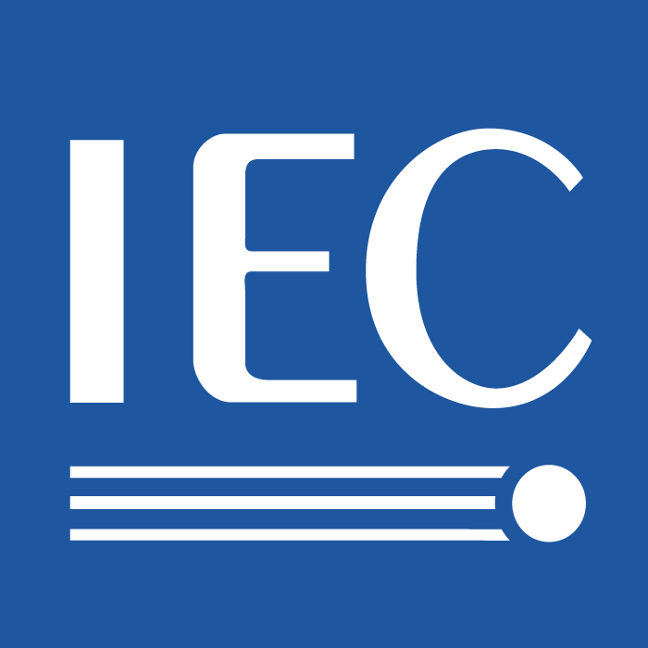 | 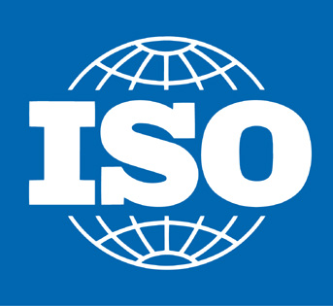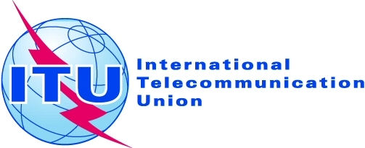

Standards Management Training Courses

Under the auspices of WSC (World Standards Cooperation), IEC, ISO and ITU have organized two series of courses for managers of their members. Theses courses took place in October 2004 and April 2005. The courses lasted for 5 days and the agenda for the second course is attached as a reminder.

The courses were intended for managers of the members of IEC, ISO and ITU, in particular those members with officers in the technical work. They were intended to prepare these managers for their participation in the future development of the international standardization community and provide them with a detailed insight into the business of international standardization. They explained the role of standards in trade and commerce, the operation of standards organizations, both at the national and international level and provided plenty of opportunity for the participants to exchange experiences.

The members of IEC, ISO and ITU are invited to fill in the following questionnaire, to indicate interest in a further course for those who have not taken part in the previous courses.

Name of member body:

My organization would be interested in taking part in a Standards Management Training Course:
Yes No

I would like to send ____ participant(s) to the course.
Organization | Name | Position | E-mail

The following time periods would be most suitable:
March 2008
April 2008
May 2008
September 2008

Other suggestions (including topics for inclusion in the programme):

Please return this page only of the questionnaire as appropriate to:
Jack Sheldon  IEC Central Office  E-mail: jrs@iec.ch  Fax: +41 22 919 0300 | Daniele Gerundino  ISO Central Secretariat  E-mail: gerundino@iso.org  Fax: +41 22 733 3430 | Paolo Rosa  ITU  E-mail: Paolo.Rosa@itu.int  Fax: +41 22 730 5853
ANNEX 2
(to TSB Circular 175)

Agenda of the Course held in April 2005

Day 1, Monday – April 11, 2005
8:30 Registration at Conference Centre of Varembé, 7- 9 Rue de Varembé, Geneva (CCV), conference room C
9:00 – 12:30 What are International Standards?

9:00 – 10:30 Session Chairman –

- Definitions
- History
- Position today

IEC –
ITU –
11:00 – 12:30 Session Chairman –
Why are International Standards Essential?

      - International Standards benefits
      - Regulation

ISO –
12:30 – 14:00 Lunch

14:00 – 17:30 How are International Standards used?
Session Chairman –

      - As specifications –
      - Conformity assessment –
      - ISO’s view on CA/CASCO –
19:30 – 21:30 Welcome Cocktail –

Day 2, Tuesday – April 12, 2005
9:00 – 12:30 How are International Standards used? (continued)
Session Chairman –

- ISO’s view on regional Agreements (Vienna Agreement) –
- Regional and international agreements –
- Strategic role of standardization –
- Case study – WTO conflict resolution –
12:30 – 14:00 Lunch
14:00 – 17:30 How are International Standards made?
Session Chairman –

- Fundamentals –
- IPR issues –
- Standards development – general (initiation, development, distribution and maintenance) –

Day 3, Wednesday – April 13, 2005
9:00 – 12:00 How do International Standards bodies function?
Session Chairman –
9:00 – 10:30
- IEC technical management
- ISO technical management –
- ITU technical management –

Session Chairman –
11:00 – 12:30
- IEC Marketing and Communications –
- ISO Marketing and Communications –
- ITU Marketing and Communications –
12:00 – 13:30 Lunch

13:30 – 17:30 Standards in action –
Day 4, Thursday – April 14, 2005
9:00 – 12:30 How do International Standards bodies function?
Session Chairman –
9:00 – 10:30
- IEC standards development –
- ISO standards development –
- ITU standards development –
11:00 – 12:30
Session Chairman –

- IEC IT tools and services –
- ISO IT tools and services –
- ITU IT tools and services –

12:30 – 14:00 Lunch
14:00 – 17:30 How do International Standards bodies function?
(three break out sessions by organization)

ISO | ITU | IEC
Session Chairman –  - ISO Members and related issues  - ISO Governance Bodies, Policy Development Committees (CASCO, COPOLCO, DEVCO),  CASCO –  COPOLCO –  DEVCO –  - ISO Technical work | Session Chairman –  - ITU-T within the context of ITU and communication strategy  - Organization of the work - study groups and other groups  - Electronic working methods | Session Chairman –  - IEC management structure and governance  - Technical committees  - AC ACET, Liaisons  - Strategic role of information technology in Central Office

19:30 – 21:00 Cocktail

Day 5, Friday – April 15, 2005
9:00 – 12 :30 How do International Standards bodies function?
(three break out sessions by organization)

ISO | ITU | IEC
Session Chairman –  - Role of the ISO Central Secretariat: overview  - Support to Standards Development  - Support to Developing Countries  - Marketing and promotion of ISO standards  - ISO e-services | Session Chairman –  - Products and services (website etc.)  - Development and approval processes  - Special Projects and study topics | Session Chairman –  - Advisory Committees (except ACET), Sector Boards  - Function of the Central Office  - Marketing and selling Electrotechnical standards  - IEC reaches out to developing nations

12:30 – 14:00 Lunch

14:00 – 16:30 Conclusions (at CCV, conference room C)

- The future
- Feedback
- Final summary, discussion

______________

If a further course is organized, the programme will be updated, taking into account the experience from the previous sessions, including the feedback from the participants and the suggestions made in the responses to this questionnaire.

