INTERNATIONAL TELECOMMUNICATION UNION |  | Consultation Meeting on Cooperation between  ITU-T and Universities
TELECOMMUNICATION  STANDARDIZATION SECTOR  STUDY PERIOD 2005-2008 |  | UNI-C-5
 |  | Original: English
 |  | Geneva, 18-19 January 2007
CONTRIBUTION
Source: | Korea University
Title: | Contribution from Korea University

- Background
Since standardization is an integral product of basic scientific R&D, manufacturing/production engineering, market management, and even social culture, it is required not only to mange human resources, those who are standard experts in each field, but also to incorporate standards into education curriculum systematically so that students have a competitive edge with a diverse background. Today, students and faculties recognize ITU, IETF, IEEE etc as important sources of information for their study/work/carrier. Their valuable research outputs are essential parts of standards. However the access to the resources is not easy and cost too much for students and faculties, those who are key contributors to the standardization. Standardization within and amongst academic institutions can help the followings

- Locate technical problems found in the process of standardization.
- Educate and train students so that they are familiar with the relevant to their major and industry.
- Provide an introduction to the standardization.
Now it is time that all standardization bodies including ITU recognize academic institution or university as a key developer of standards.

- Operation of “ITU Academy”
It is recommended to found an “ITU Academy” to facilitate the academic human resources to bring standards to their research and education. Now ITU-T already decided to provide the followings:
- To open all recommendations available to the public.
- To provide web services to the members or non-members.
- To provide a platform to share views, idea, and needs on new emerging technologies thru “technology watch correspondence groups”
In addition, ITU Academy shall provide the followings:
- To reserch mid-term or long-term standard objectives like IRTF vs IETF in internet.
- To provide a limited access for students and faculty to stable working documents and meeting reports.
- To provide digital subscriptions service to the registered members
- To publish ITU journal (like IEEE magazine, or CISCO IP journals), consisting of introduction of standards, new emerging technologies, and so on. Especially it is explained how and why the final standard is stabilized.

To operate ITU Academy, the following three bodies shall work together.
(a) ITU Academy
- To coordinate standardization in ITU-T SG’s or FG’s and research in universities
- To provide a channel so that academic personnel to participate as an O member in SG’s standardization meeting.
- To manage Membership and correspondence groups
- To provide digital subscription service. Subscription fee should be less then US$1000.00 a year.
- To organize conferences and its proceedings
- To publish ITU journal
- To manages officers and committees
  - secretariat
  - publications: solicitation, review, and publication for ITU journal articles
  - research: correspondence groups
  - activities: conferences, tutorials,

(b) SG’s or FG’s
- To submit an introduction of standard as an article form
- To submit an explanation for standard as an article form
- To solicit solution or alternatives for on-going standard item to universities.
- To define mid/long term research topics.

(c) Universities
- To register as a ITU academy member
- To subscribe digital subscription
- To participate in correspondence groups or forum
- To contribute to the on-going standard item
- To incorporate standards to the curriculum to promote standard minds.

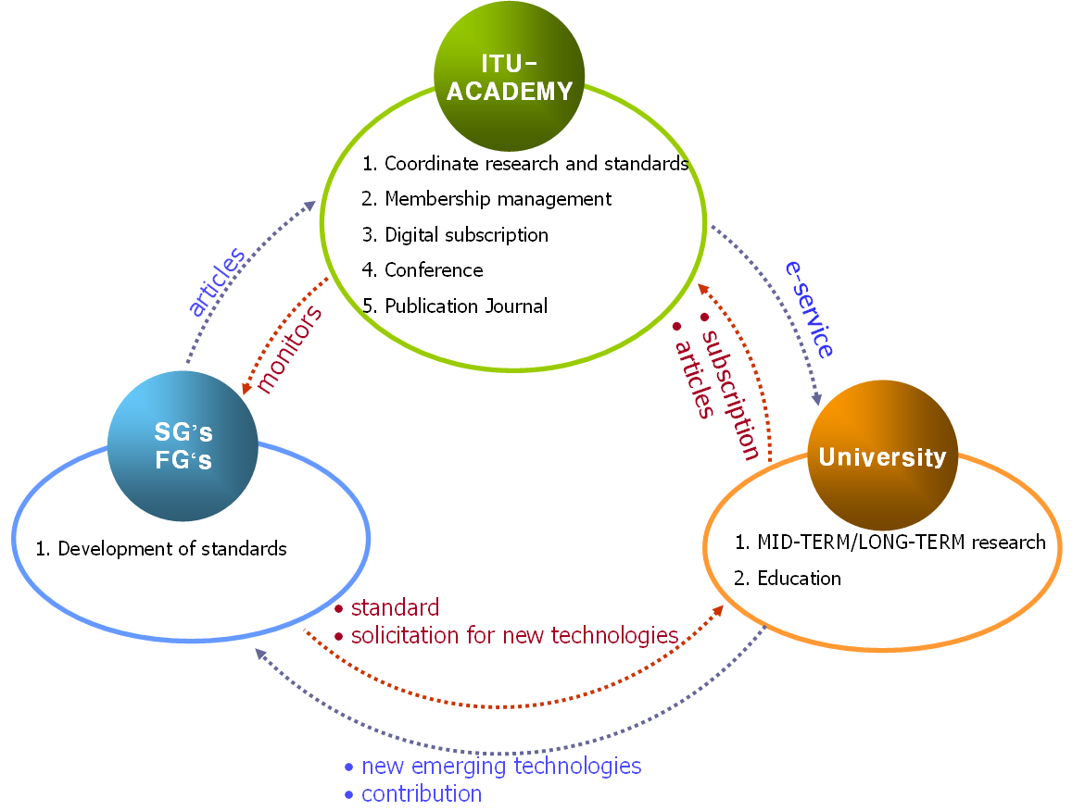

[references]
[1] http://www.itu.int/ITU-T/
[2] www.ietf.org
[3] http://www.bsieducation.org/Education/HE/default.shtml BSI Education
[4] http://www.ansi.org/education_trainings/overview.aspx?menuid=9 Education and Training

