INTERNATIONAL TELECOMMUNICATION UNION |  | Consultation Meeting on Cooperation between  ITU-T and Universities
TELECOMMUNICATION  STANDARDIZATION SECTOR  STUDY PERIOD 2005-2008 |  | UNI-C-9
 |  | Original: English
 |  | Geneva, 18-19 January 2007
CONTRIBUTION
Source: | Tsinghua University
Title: | Contribution from Tsinghua University

Thanks for your letter of requiring comments on the “University Cooperation” issue. I agree that the exchanging ideas between universities and standardization groups are very important, since university are working on the scientific and technology front and universities need to know the industrial current states which are on some extent being standardized. In university side, there is also a need to tell students to search not only the journal or conference publications, but also patented ideas (which are possibly included in standards).

From Tsinghua University Library website, Fig. 1 and Fig. 2, we can see many publication database which can be accessed for full text, for example: IEEE/IEE, SPIE, ISI Web of Science (which includes Elsevier collections),..... I am sure there are the negotiated agreements between the database authorities and the university, and I notice that the accessing can be only conducted from inside of the campus and not accepted from outside of it.
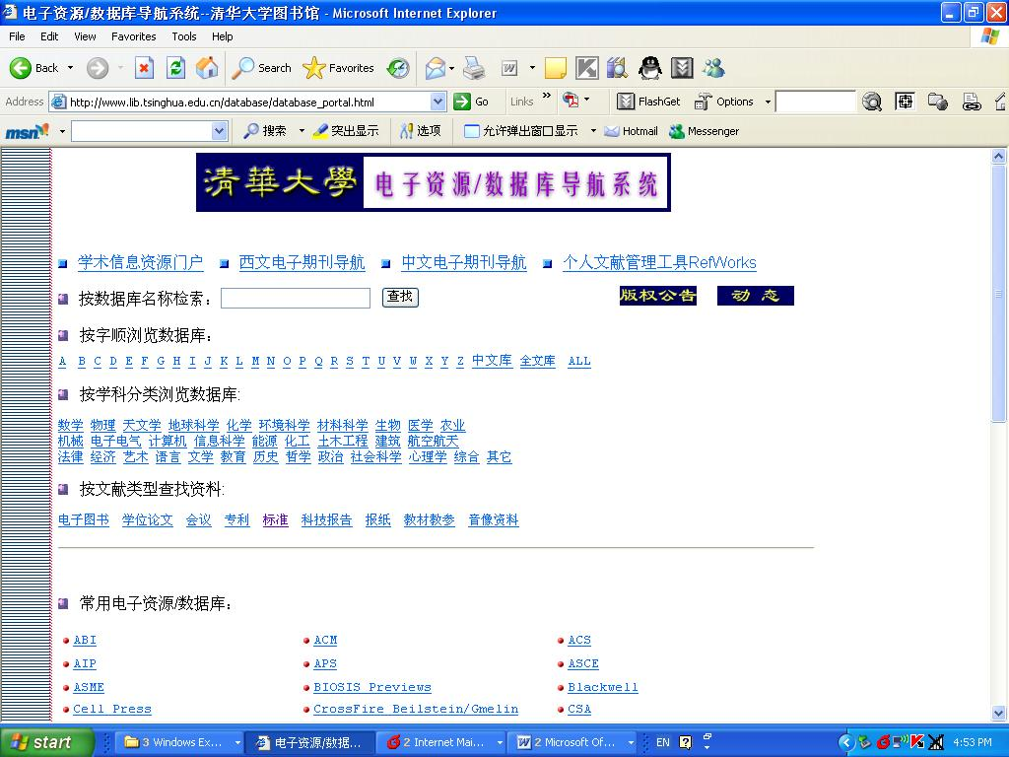
Fig. 1: the top part of the main menu for the “electronic materials in Tsinghua University Library”. The “standards”(标准) can be entered from here.
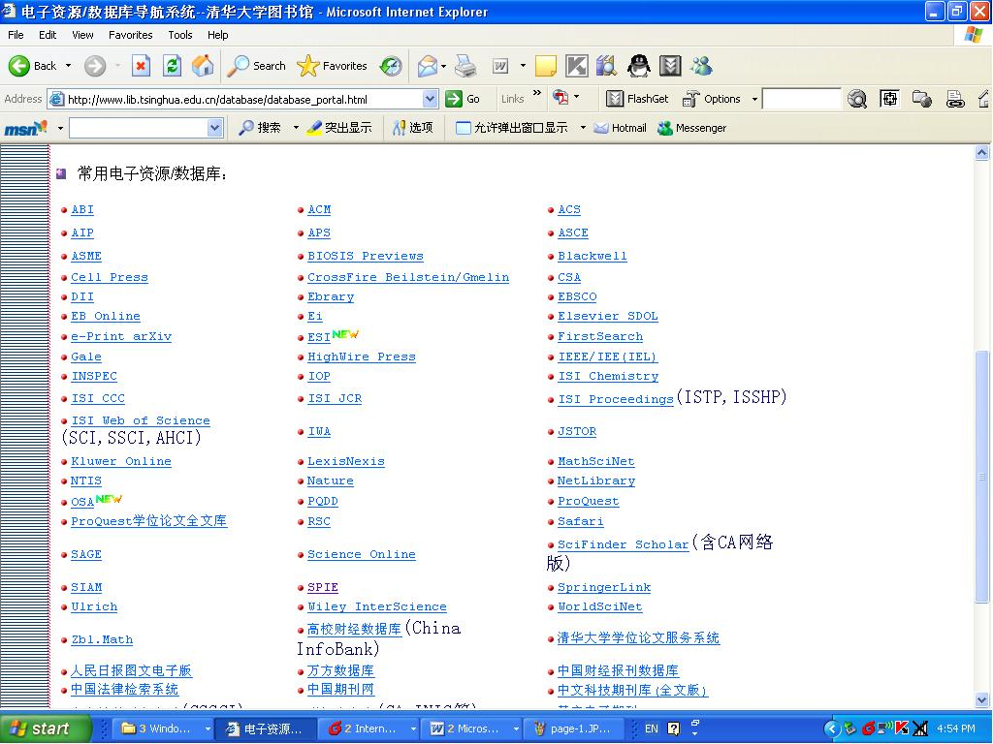
Fig. 2: the middle part of the main menu for the “electronic materials in Tsinghua University Library”. IEEE/IEE, SPIE, ISI Web of Science, can be entered here, and the full text can be downloaded. When we get into the “standards” (标准) from the main menu, and finally enter the ITU link (Fig.3), the ITU-T home page is shown (Fig. 4), but the documents accessing is controlled by password or purchasing payment.

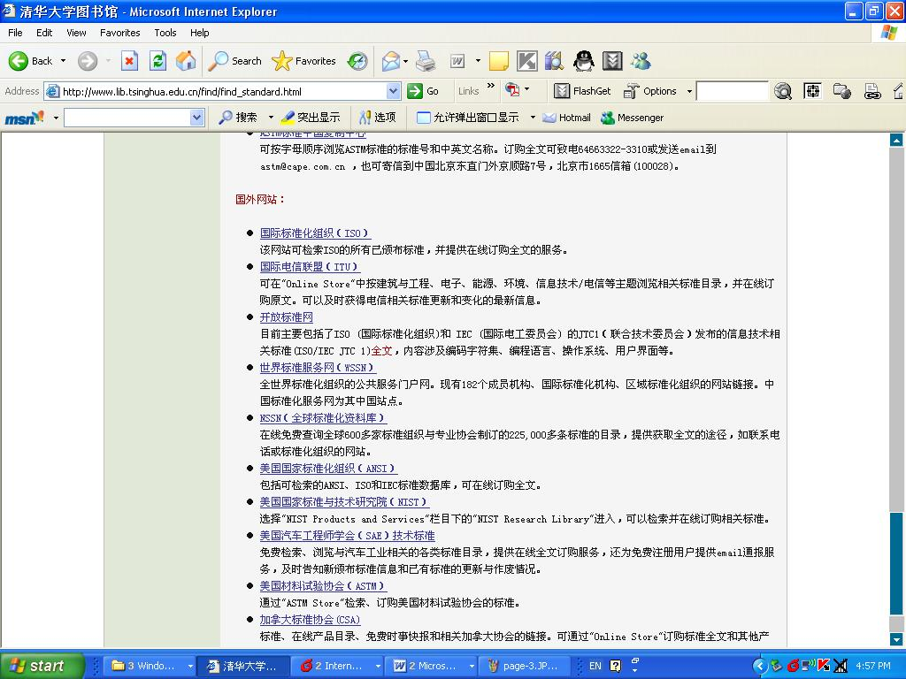
Fig. 3: the page to enter ITU.
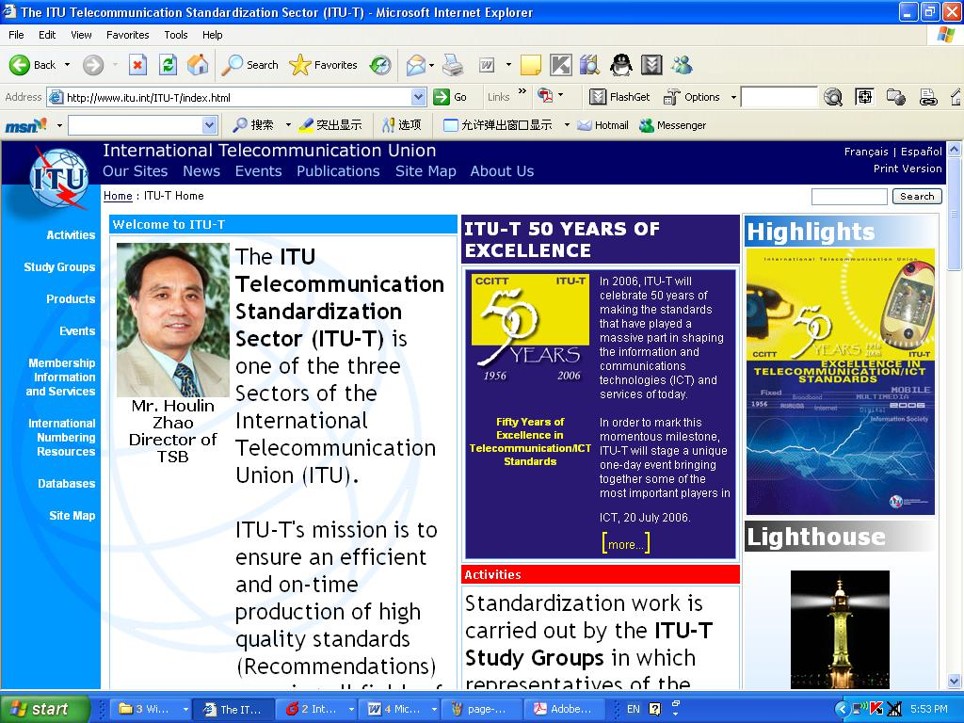
Fig. 4: when enter ITU link, ITU-T homepage is shown.
From above observation, I think there is a way to bridge the connection between Tsinghua University and ITU-T for the documents accessing. Both ITU-T and Tsinghua University can discuss the way of opening database contents to students and professors without charge. From my knowledge, the working group documents and the existing standard recommendations should be welcome in the university.

Another way to introduce ITU-T is organizing lectures in universities. In Tsinghua University, each year there are many seminars related to the standardization progresses. Among them, I see many of those are given by the university professors, for examples, H.261, H.262 and H.264. If ITU-T can organize senior experts to give lectures, it should be a good chance for students to learn more in addition to from the academic angle.

For university, the major issue of participating standardization is the financial problem. To resolve this, cooperation between industry and university is always suggested. There are many successful examples can be given I suppose. I am now attending the JVT meeting in Hang Zhou, I see many university colleagues over the world here though they attend from MPEG national body delegations.

Yun He

Professor of Tsinghua University
Beijing
China
October 20th, 2006 in Hang Zhou

