INTERNATIONAL TELECOMMUNICATION UNION |  | Focus Group On "From/In/To Cars Communication II"
TELECOMMUNICATION  STANDARDIZATION SECTOR  STUDY PERIOD 2009-2012 |  | FG CarCom-C-16
English only
Original: English
 |  | Geneva, 6 March 2009
CONTRIBUTION
Source: | Chairman of the Focus Group
Title: | Input on SNR-based measures from Mats Forsen / Scott Pennock / Tim Haulick

Abstract
This contribution discusses limitations of the D-value and proposes some SNR-based measurements to address these limitations. The rationale and validity of several SNR-based measurements are discussed. The need for a Noisy Speech (NS) database is identified. Next steps in progressing SNR-based measurements are provided.

1.0 Introduction
Currently, the D-value is used as a measure of noise rejection performance of the vehicle microphone(s). It is also used to measure Noise Reduction (NR) performance of the entire Hands-Free (HF) system. However, there are several problems with the D-value.

First, the D-value does not take into account the absolute level of the acoustic noise—it is only a loss measurement. A vehicle with high noise in the cabin and at the output of the microphone can have the same D-value as a vehicle with low noise in the cabin and at the output of the microphone. This has traditionally not been a problem with measuring telephone terminals because the acoustic environment was assumed to be similar for all terminals and has not been considered part of the Device Under Test (DUT). However, automotive terminals are different. The acoustic environment created by the design of the vehicle cabin is considered part of the DUT. What really matters from a performance standpoint is the amount of noise pick-up by the microphone—not the electro-acoustic loss.

Second, it is not clear that D-value measurements will generalize to real-world use. This is because speech and noise is measured separately, and today’s terminals utilize time-variant signal processing (e.g., Automatic Gain Control) that can give different results as compared to when speech and noise is measured simultaneously (i.e., like in the real world).

Third, the D-value unnecessarily adds measurement error. However, referring the noise picked-up by the HF microphone to an Omni directional microphone positioned at HF terminal microphone only adds measurement error. What really matters is the noise that is picked-up by the HF microphone so there is no need to reference the noise back to the acoustic environment.

Last, the concept of the D-value is difficult for many to understand. This can result in confusion and inability to act on test results.

Speech-to-Noise Ratio (SpNR) based measures were identified as a supplement, or possibly a replacement, for D-value measures at the last FG CarCom meeting in Aachen, Germany. There are many different ways SpNR-based measures could be used. These include:
  - Microphone SpNR (SpNR_{mic})—Attempts to measure the ability of the vehicle platform to support high quality speech communications
    - SpNR_{mic} is measured at microphone output or DI-S2 (see Figure 1)
  - SpNR Noise Reduction Enhancement (SpNR_{NRE})—Attempts to measure the signal enhancement by Noise Reduction (NR) algorithms
    - SpNR_{NRE} is calculated by subtracting the SpNR measured at DI-S2 from the SpNR measured at DI-S1 (see Figure 1)
  - Enhanced Signal SpNR (SpNR_{ES})—Attempts to measure the ability of the combination of “vehicle platform + NR” to support high quality speech communications (i.e., represents impact on speech coders)
    - SpNR_{ES} is measured at DI-S1 (see Figure 1)
  - Point Of Interconnection SpNR (SpNR_{POI})—Attempts to measure the impact on perceived performance at a system level
    - SpNR_{POI} is measured at POI-Send (see Figure 1)

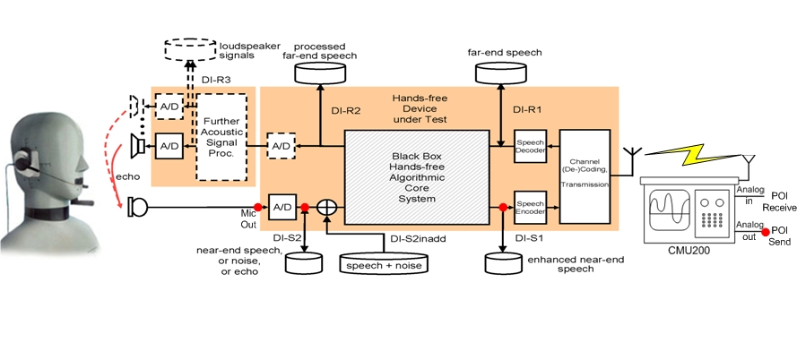
Figure 1. Possible SpNR measurement points. Red circles indicate signal capture points.

Sections 2-5 discuss the rationale and validity of each of these potential SpNR-based measurements in more detail. Section 6 discusses the need for a noisy speech database that can be used to validate SpNR-based measurements. Section 7 proposes next steps for progressing work of SpNR-based measurements.

2.0 Microphone SpNR (SpNR_{mic})
The ratio of speech-to-noise energy at the output of the vehicle microphone (i.e., SpNR_{mic}) is a valuable measure of performance. It reflects the ability of the vehicle platform to support high quality speech communications and is predictive of the impairments that will be introduced by NR algorithms and speech coders. For example, NR algorithms suppress speech if SpNR_{mic} is too low. Also, speech coders have trouble with pitch detection and assigning appropriate code-book values when SpNR_{mic} is low.

However, it is important to note that SpNR_{mic} does not completely characterize performance. Other key measurements are:
- Send reverberation (e.g., Early-to-late sound energy ratio)
- Send distortion (e.g., THD)
- Speech-to-Echo Ratio (e.g., SpER)

Therefore, good SpNR_{mic} values should be viewed as a necessary, but not sufficient, for high quality speech communications.

There is currently no standardized method for calculating SpNR_{mic}. However, there are many desirable characteristics that should be considered in the quest for such a measure. These include:
- Device-centric—A SpNR_{mic} measure should be device-centric instead of user-centric. In other words, it should reflect the impact of a noisy speech signal on the performance of NR and speech coding algorithms—not perceived performance of the raw microphone signal (e.g., MOS-LQO). The latter would simulate someone judging the quality of the raw microphone signal which does not make sense since users never listen to these signals without further processing.
- Real-time operation—It should be possible to calculate SpNR_{mic} on the combined “speech and noise” signal in real-time instead of having to measure speech and noise separately. This will allow consistent measurements between the lab and the real-world. The advantages of lab-based measurements (e.g., using HATS, noise simulation, and a standard set of speech recordings) are that they are more repeatable and can be used to define requirements. The advantages of real-world measurements are that they can be used for real-time monitoring of performance and validation of the more controlled lab-based measurements. Also, as discussed earlier, if speech and noise are measured separately it is not clear that the results will generalize to real-world use because the DUT may not be put in the same state as during actual use.
- Real-speech test signals—Lab-based measurements should use real speech as the test signals because they guarantee that the DUT is put into a valid state and are more comparable to real-world measurements. Of course, the real speech recordings must be chosen carefully to make sure they are representative of levels, gender, spectrum, vehicle noise environments (i.e., Lombard effect), languages, and speaking styles. The Lombard effect can be modeled by taking a finite set of clean speech recordings made while speakers were listening to noise (captures spectrum and level changes), and level adjusting the speech based on loudness of the current noise being tested.
- Robust to low SNR—The accuracy of SpNR_{mic} measurements should not be negatively affected by low SNR (e.g., P.56 has issues below 20dB SNR).

Appendix I describes a method for calculating SpNR_{mic} from QNX that meets the desirable characteristics mentioned above. Limited testing suggests it does a reasonably good job of predicting system level performance. SpNR_{mic} > 13dB was desirable to provide good quality, and SpNR_{mic} > 6dB was required to provide acceptable speech communications performance. Further validation is needed before adopting this approach. It is provided for informational purposes only.

Ideally, requirements based on SpNR_{mic} should define several Quality Of Service (QoS) levels—instead of a single pass/fail requirement. This will enable OEMs to:
- Specify vehicle interface performance for the vehicle platform teams
- Root-cause system level performance issues better
- Develop component level specs for Tier-1 suppliers (e.g., HF algorithm must meet system level performance “X” for a vehicle conforming to QoS level “Y”)

QoS levels will also help Tier-1 suppliers identify Tier-2 HF suppliers that are capable of meeting OEM system level requirements given their QoS constraints. For example, a vehicle platform with suboptimal design might have a QoS level of “3”. The better Tier-2 HF suppliers may be able to still meet OEM system level requirements with this challenging vehicle, while less experienced HF suppliers may not.

Pass/Fail thresholds for each of the QoS levels will depend on how SpNR_{mic} is calculated. This is also true for the more simple approach of using a single pass/fail requirement. Therefore, QoS levels can not be fully defined until a method for measuring SpNR_{mic} is agreed upon.

QoS requirements should be specified for typical user scenarios (see FG CarCom Aachen 2008 contribution titled “User scenarios for vehicle noise simulation”). This could be done by simply specifying a QoS level for each user scenario. For example, a high QoS level of “1” might be specified for most user scenarios, but a lower QoS level of “2” may be specified in user scenarios were user expectations are lower (e.g., HVAC fan on highest setting).

3.0 SpNR Noise Reduction Enhancement (SpNR_{NRE})
SpNR_{NRE} should not be used as a measure of NR algorithms because they do not capture degradations of the speech signal. All one needs to do to get the desired SpNR_{NRE} is to turn up the suppression value of the NR algorithm. However, this will also have negative effects on the quality of the speech that are not captured by the SpNR_{NRE} measure. Therefore, SpNR_{NRE} should not be used as the basis for comparing performance of noise reduction algorithms. Other objective measurements (e.g., P.OLQA, G-MOS, ASR-based methods, etc.) will need to be validated for this purpose.

4.0 Enhanced Signal SpNR (SpNR_{ES})
SpNR_{ES} can be used as a measure of the ability of the “vehicle platform + NR” to support high quality speech communications. For example, speech coders have trouble with pitch detection and assigning appropriate code-book values when SpNR_{mic} is low.

SpNR_{ES} should be used with caution. In addition to the limitations of SpNR-based measures as described in Section 2.0, SpNR_{ES} also suffers from the potential issue that the speech signal itself gets distorted by the NR system. Therefore, there is an increased risk of SpNR_{ES} indicating good performance when in fact it is bad. This risk can be reduced by also specifying a measure and requirement for signal distortion (e.g., S-MOS defined in ETSI EG 202 396-3, etc.).

There is currently no standardized method for calculating SpNR_{ES}. However, desirable characteristics for such a measure are similar to those of SpNR_{mic} as described in Section 2.0.

Requirements for SpNR_{ES} should be focused on the impact of SpNR_{ES} on speech coder performance. Different speech coders may require different QoS levels. For example, QoS=1 may be needed to support CDMA while only QoS=2 for GSM.

5.0 Point Of Interconnection SpNR (SpNR_{POI})
SpNR_{POI} can be used to detect and help diagnose performance issues at the network interface. However, all of the limitations described in Sections 2.0 and 4.0 also apply to SpNR_{POI}. Furthermore, speech coding impairments increase the risk of introducing distortions in the speech signal that are not accurately reflected in the SpNR_{POI} measurements.

There is currently no standardized method for calculating SpNR_{POI}. However, desirable characteristics for such a measure are similar to those of SpNR_{mic} as described in Section 2.0.

Requirements for SpNR_{POI} can indicate the impact of SpNR_{POI} on perceived intelligibility and quality—assuming there are minimal distortions of the speech signal. Previous research should give some guidance on this relationship. However, exact threshold values will depend on SpNR_{POI} is calculated.

6.0 Noisy Speech (NS) database for validation
Currently, there is no known dataset that can be used to validate the SNR-based measures proposed in this document—except for possibly SpNR_{POI} which could in principle be validated against existing NS databases that have been subjectively scored.

Therefore, there is a need to establish a new NS database with the following characteristics:
- Input stimuli used to create the database will consist of a representative set of speech and noise recordings
- Each noise recording will be played back at several different levels to produce a full range of SNRs in a controlled manner
- Several representative “systems under test” (e.g., NR implementations, speech coders, etc.) will also be used to create the database
- Recordings of performance will be made at several different tap points along the transmission path (SpNR_{mic}, SpNR_{ES}, SpNR_{POI})
- Subjective ratings of recordings at POI-Send will be used to validate SpNR_{POI} as well as upstream measures (e.g., SpNR_{mic})

Without such a database it is difficult to see how this work item can progress.

7.0 Next steps
Below is a proposed plan for progressing new SNR-based measures:
- Creation of NS database (June 2009)
- Define test method for SNR measures (June 2009)
  - See Appendix II for draft outline of test method used for determining compliance with SNR-based requirements
  - This is somewhat independent of how SNR is calculated
- SNR calculation proposals submitted (June 2009)
- Selection test plan for SNR calculations complete (June 2009)
- Selection testing of candidate SNR calculations complete (September 2009)
- Decide on SNR calculation and finalize test method for SNR measurements (September 2009)

Contributors will need to be identified in order for this plan to be realized. Some OEM, Tier-1, and Tier-2 suppliers have expressed interest in this work. However, no commitments to contribute have been made to date.
Appendix I

High-level description of a method for calculating SpNR_{mic} (for informational purposes)

This appendix contains a brief description of a method that could be used for calculating SpNR_{mic}. Limited testing showed that it did a reasonably good job at predicting system level performance when typical NR settings and the EVRCb speech coder were used. SpNR_{mic} > 13dB was found to provide good quality, and SpNR_{mic} > 6dB was required to provide acceptable speech communications performance. Further validation is needed before adopting this approach. It is also worth noting that this method may have to be modified slightly for use with wideband systems.

The current method calculates SpNR_{mic} by taking the weighted average of SpNR_{mic} in the following 3 passbands:

- Low passband
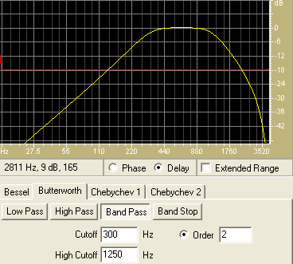

- Middle passband
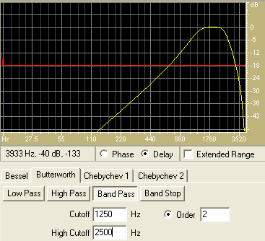

- High passband
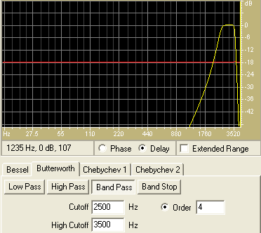

The Low, Middle, and High passbands are weighted by 3, 1, and 1, respectively. They reflect the relative importance to the NR and speech coding algorithms. SNR for each passband is calculated every speech frame by taking the ratio of speech to noise energy. The determination of speech versus noise energy is done by continuously tracking background noise levels in each of the frequency analysis bins.

Appendix II
Draft outline of test method used for determining compliance with requirements

- Test set-up
- User scenarios (defines noise and Lombard levels)
- Test signals (defines speech and Lombard level adjustments)
- Procedure:
  - For each user scenario, determine LL speech and adjustment based on measurement of noise at driver’s ear (should be collected during recording of noise)
  - Set-up HATS and noise playback system in vehicle under test
  - For each user scenario
    - Start playback of noise
    - Play level-adjusted LL speech for current noise condition
    - Record output of microphone or DI-S2
    - Calculate SNR and report QoS level

_______________

