INTERNATIONAL TELECOMMUNICATION UNION |  | Focus Group On "From/In/To Cars Communication II"
TELECOMMUNICATION  STANDARDIZATION SECTOR  STUDY PERIOD 2009-2012 |  | FG CarCom-C-24
English only
Original: English
 |  | Göteborg, 3-4 September 2009
CONTRIBUTION
Source: | Chairman of the Focus Group
Title: | Input from Mats Forsen / Scott Pennock – HATS positioning

Positioning of the HATS is an area which needs improvements.
Here are some thoughts how to improve the specification.

    - Positioning of the Hands-free Terminals
The position of the HATS can be defined relative reference points used by the car manufacturers.
Typical reference points are the eye ellipse or foot / pedal contact point.

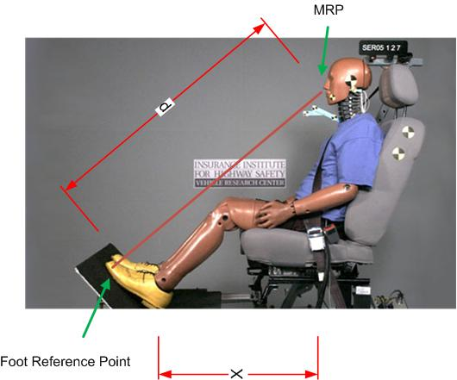
For example by using the foot reference point the distance to the MRP can be easily be defined by offset in x and d.

Also optional positions for short & tall drivers should be defined.

More input is appreciated.
______________

