INTERNATIONAL TELECOMMUNICATION UNION |  | Focus Group On  Car Communication
TELECOMMUNICATION  STANDARDIZATION SECTOR  STUDY PERIOD 2009-2012 |  | FG CarCOM-ADM-1
English only
Original: English
 |  | Vancouver, 28-29 January 2010
ADMIN DOCUMENT
Source: | FG Chairman
Title: | Invitation to the 1st Meeting of the Focus Group CarCOM

Aachen, 31 July 2026
Invitation to the 1th Focus Group Meeting to be held
January, 28-29 in Vancouver
Link to registration & meeting documents
http://www.itu.int/ITU-T/focusgroups/carcom/
Dear Colleague,
On behalf of the ITU-T Focus Group CarCOM I have the pleasure of informing you about the arrangements for the above-mentioned meeting hosted by QNX Software Systems.
Address of the meeting | Delta Suites Hotel, Somervell Room  Contact: Scott Pennock  Phone: +1 408.887.6455  Email: SPennock@qnx.com
mEETING SCHEDULE | The meeting will start on January, 28, 2010 at 9.00 am.  The meeting will end on January, 29, 2010 at 1.00 pm.
REGISTRAtion | Please register at the Focus Group Website before 15 January 2010  Please make hotel reservations as soon as possible
Documents for the meeting | Please send meeting documents in advance of the meeting to TSB for uploading to the Focus Group Website.

Hotel Information | Meetings will be held at the Delta Suites Hotel in downtown Vancouver on January 28th and 29th, 2010. General hotel information can be found at: http://www.deltahotels.com/hotels/hotels.php?hotelId=21  The easiest way to make a reservation at the meeting hotel is to contact their Reservations Department at 604-899-3038, toll free at 1-800-268-1133 or by email at vancouversuites@deltahotels.com and mention the group name "QNX Software Systems". The discounted rate for meeting participants is $159.00. Please note that we are not holding any guestrooms and the group rate and guest rooms are subject to availability and are not guaranteed. The hotel is currently sitting at almost 50% occupancy for January 28-30, 2009, therefore I highly recommend participants book their guestroom as soon as possible.
How to find the meeting place | Transportation from airport to meeting hotel:  The SKYTRAIN can be taken directly from the airport (YVR-Airport Station Eastbound) to a train station (Waterfront Station Northbound) within walking distance from the meeting hotel . Please see detailed directions below.  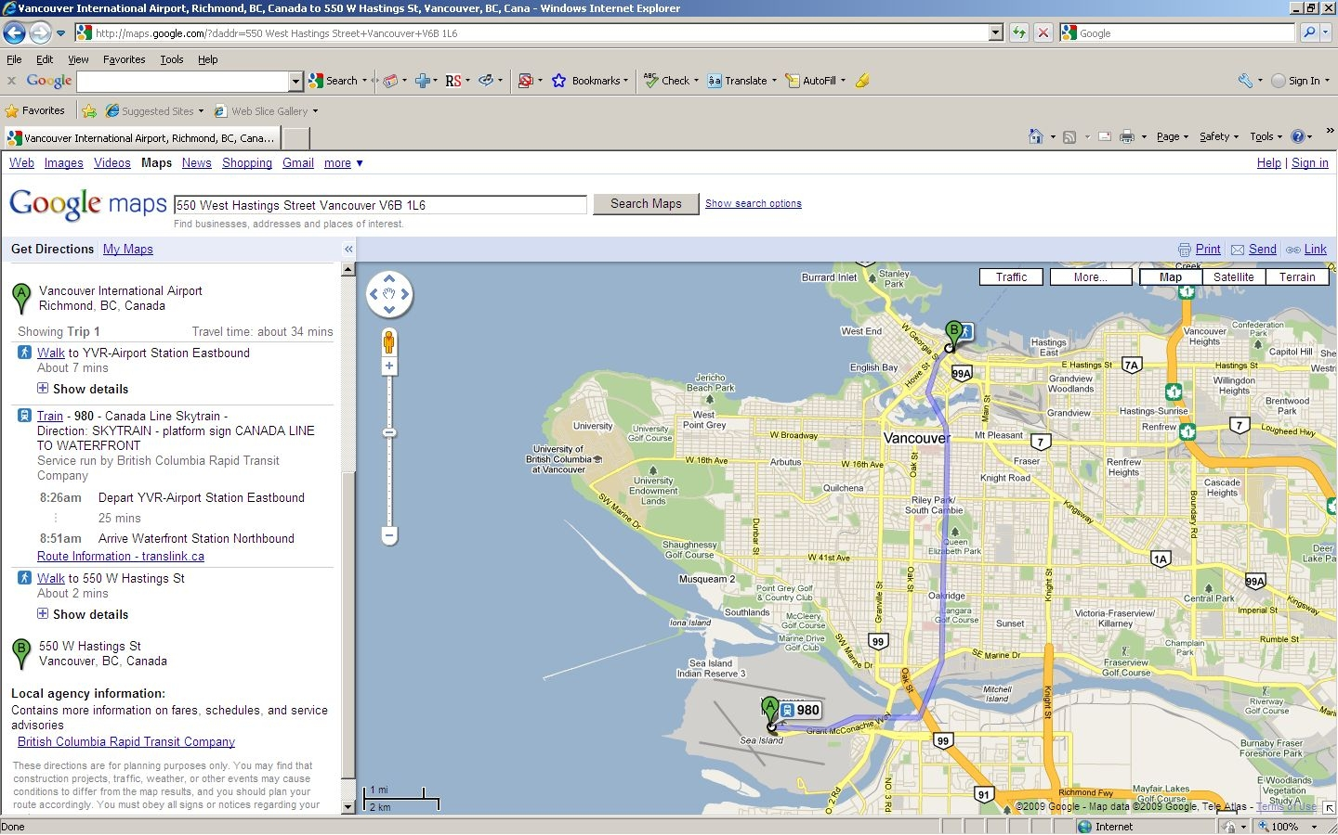  Detailed map of hotel location:  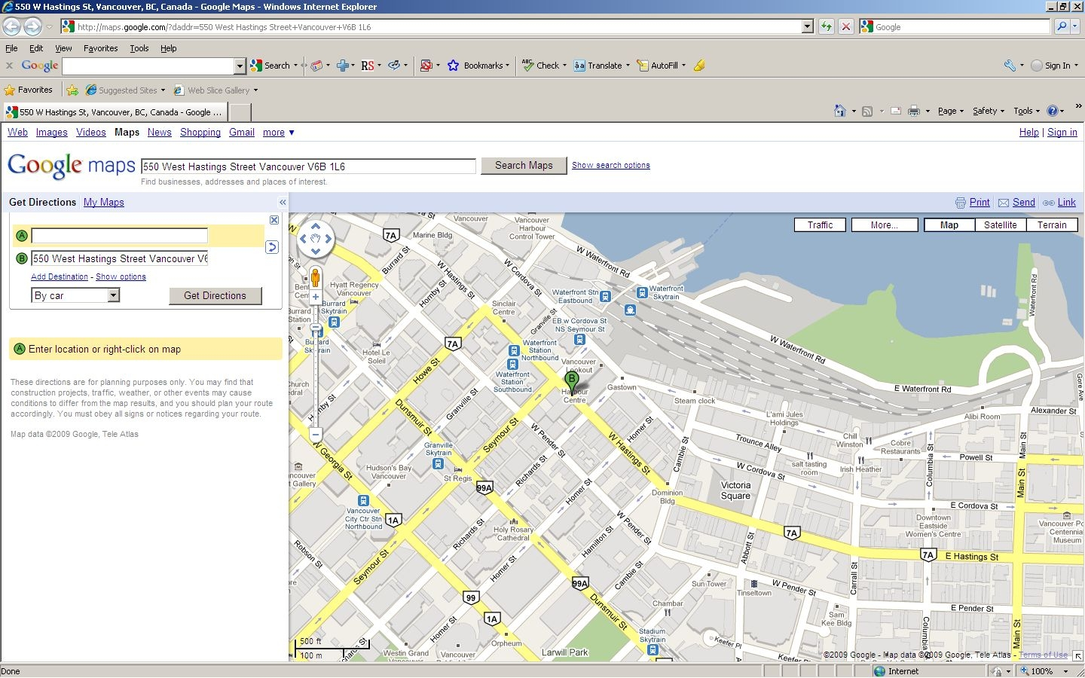
I look forward to seeing you in Vancouver
Yours sincerely
Hans W. Gierlich

