INTERNATIONAL TELECOMMUNICATION UNION |  | Focus Group On  Car Communication
TELECOMMUNICATION  STANDARDIZATION SECTOR  STUDY PERIOD 2009-2012 |  | CarCOM-ADM-11
English only
Original: English
 |  | Aachen, 9-10 June 2011
ADMIN DOCUMENT
Source: | FG Chairman
Title: | Invitation to the 6th Meeting of the Focus Group CarCOM

Invitation to the 6th Focus Group Meeting to be held
9-10 June 2011 in Aachen
Link to registration & meeting documents
http://www.itu.int/ITU-T/focusgroups/carcom/
Dear Colleagues,
On behalf of the ITU-T Focus Group CarCOM I have the pleasure of informing you of the arrangements for the above-mentioned meeting hosted by HEAD acoustics.
Address of the meeting | HEAD acoustics GmbH  Ebertstrasse 30a  D-52134 Herzogenrath-Kohlscheid  Phone: +49 (241) 57726  Fax: +49 (241) 577 99  Email: maria.kuck@head-acoustics.de
mEETING SCHEDULE | The meeting will start on 9 June 2011 at 9.00.  The meeting will end on 10 June 2011 at 13.00.
REGISTRAtion | Please register at the Focus Group Website before 27 May 2011
Documents for the meeting | Please send meeting documents in advance of the meeting to TSB for uploading to the Focus Group Website.
Hotel Information | HEAD acoustics has a special rate at the “Mercure Hotel Aachen am Dom”. Please refer to HEAD acoustics when booking your hotel room.  For directions please see:  http://www.mercure.com/mercure/fichehotel/de/mer/5326/fiche_situation.shtml

How to find the meeting place | See: http://www.head-acoustics.de/de/approach.htm  Please indicate “Alte Bahn 10, Herzogenrath-Kohlscheid, Germany” in the navigation device.
  HEAD acoustics Herzogenrath - How You Can Find Us
      Find us with Google Maps
      HEAD acoustics GmbH at Google Maps
      Coordinates for your navigation device
      N 50°49.893' | E 6°04.997'
      N 50.83155 | E 6.083283
      By car
      Autobahn A4 from Cologne or Autobahn A44 from Duesseldorf to interchange Aachen. Take Autobahn A4/ E314 towards Antwerpen (B)/ Heerlen (NL) until Exit Aachen- Laurensberg
      Turn left at the first traffic light towards Herzogenrath
      Continue along the road to Kohlscheid. Turn right at the traffic light in front of the Technology Parc area (TPH - Technologie Park Herzogenrath) into the Kaiserstrasse
      Turn left at the second entrance into the Technology Parc area. Continue along the road until you reach the premises of HEAD acoustics
      HEAD acoustics GmbH
      52134 Herzogenrath-Kohlscheid
      Ebertstrasse 30a
      By train /public transport
      From Aachen main station take the regional train to the train station Kohlscheid; then take the bus line 34 to the bus stop Technologie Park.
      or
      From Aachen main station take bus line 44 to the bus stop Berensberger Strasse. Then take bus line 47 until bus stop Technologie Park.
    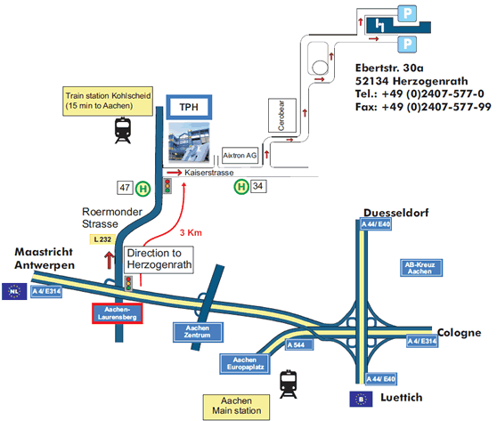
    HEAD acoustics GmbH, 52134 Herzogenrath-Kohlscheid, Ebertstrasse 30a
    Click here for a detailed view
  © 2011 HEAD acoustics®. All rights reserved.
I look forward to seeing you in Herzogenrath-Kohlscheid
Yours sincerely,
Hans W. Gierlich

