INTERNATIONAL TELECOMMUNICATION UNION |  | Focus Group On  Car Communication
TELECOMMUNICATION  STANDARDIZATION SECTOR  STUDY PERIOD 2009-2012 |  | FG CarCOM-ADM-19
English only
Original: English
 |  | Detroit, 16-17 July 2012
ADMIN DOCUMENT
Source: | FG Chairman
Title: | Invitation to the 10th Meeting of the Focus Group CarCOM

Invitation to the 10th Focus Group Meeting to be held
16-17 July 2012 in Detroit, Michigan, USA
Link to registration & meeting documents
http://www.itu.int/ITU-T/focusgroups/carcom/
Dear Colleagues,
On behalf of the ITU-T Focus Group CarCOM, I have the pleasure of informing you of the arrangements for the above-mentioned meeting hosted by QNX Software Systems and Bruel & Kjaer.
Address of the meeting | Bruel & Kjaer Instruments  6855 Commerce Boulevard  Canton, MI 48187  TEL 734-604-7559  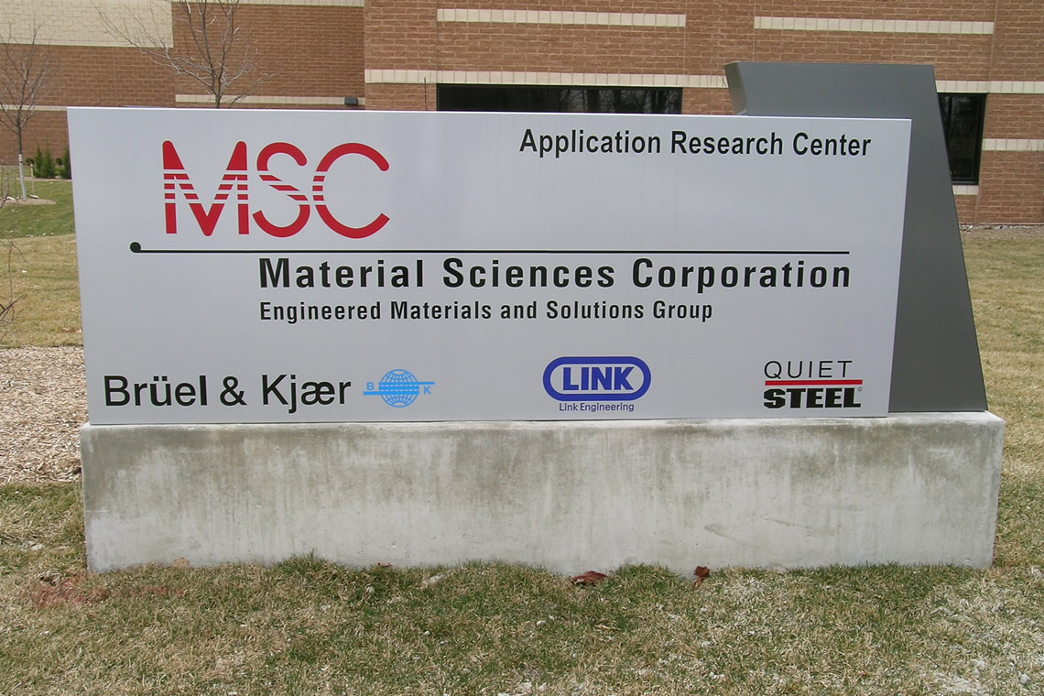  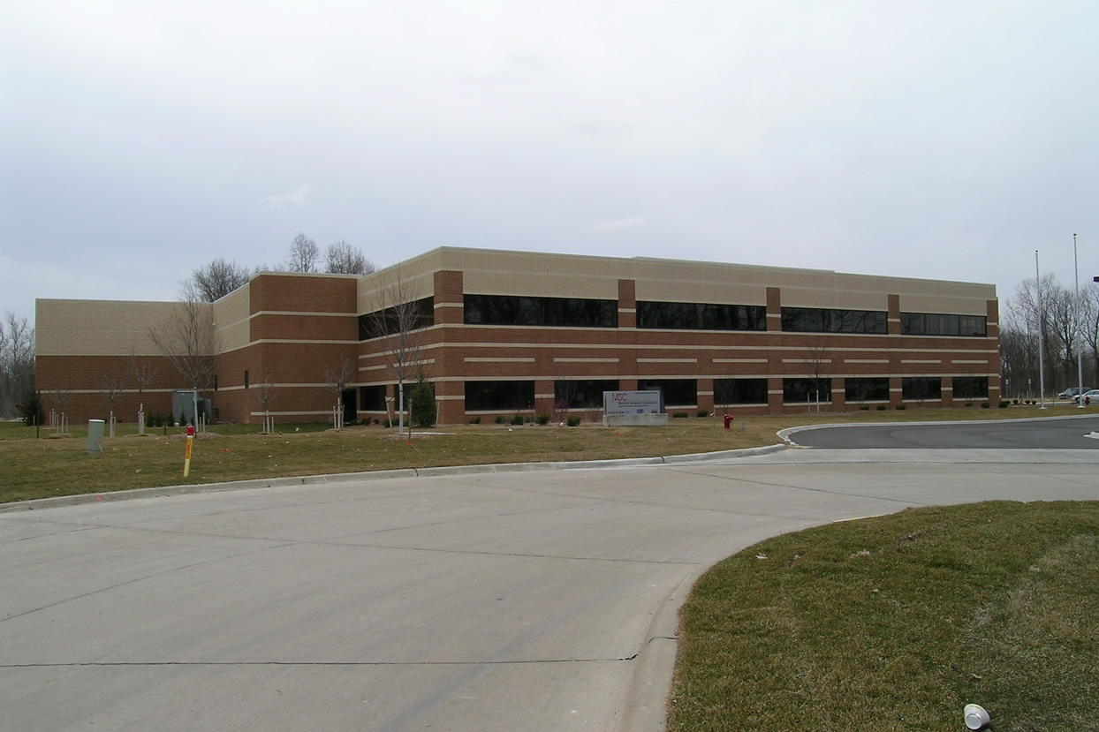  Hosts: QNX Software Systems and Bruel & Kjaer  Scott Pennock (spennock@qnx.com) and Gary Newton (Gary.Newton@bksv.com)
mEETING SCHEDULE | The meeting will start on 16 July 2012 at 09.00.  The meeting will end on 17 July 2012 at 13.00.
REGISTRAtion | Please register at the Focus Group website before 11 July 2012.
Documents for the meeting | Please send meeting documents in advance of the meeting to TSB for uploading to the Focus Group website.
Hotel Information | Below are some options for nearby hotel accommodations:  - Fairfield Inn Detroit West/Canton (http://www.marriott.com/hotels/maps/travel/dtwwe-fairfield-inn-detroit-west-canton/ ):  - Less expensive hotel  - O.K. breakfast included  - Free airport shuttle to hotel  - Meeting venue < 2 miles from hotel  - Hampton Inn & Suites Detroit-Canton (http://hamptoninn3.hilton.com/en/hotels/michigan/hampton-inn-and-suites-detroit-canton-DTTCNHX/index.html ):  - Some feel this hotel is a bit nicer than Option 1  - Breakfast included  - Free airport shuttle to hotel  - Meeting venue 2.1 miles from hotel  - Comfort Suites (http://www.comfortsuites.com/hotel-canton-michigan-MI291 )  - Americas Best Value Inn & Suites-Canton/Detroit (http://www.americasbestvalueinn.com/bestv.cfm?idp=1899 )
How to GET TO Hotels and meeting | The closest airport is Detroit Wayne County (DTW) airport. There are several hotels close to DTW and the meeting venue that offer free shuttle service to the airport. Some of these hotels are listed above in the “Hotel Information” section.  Since the meeting venue is only around 2 miles from nearby hotels, and there is free shuttle service between the airport and hotel, taxi service is a good option for transportation to the meeting venue. Car rental is another good option for those that want a little more freedom. Public transit is not very convenient in this area.

Map of  airport,  Venue,  and  some  of the  Hotels | Meeting venue (6855 Commerce Boulevard, Canton, MI 48187)  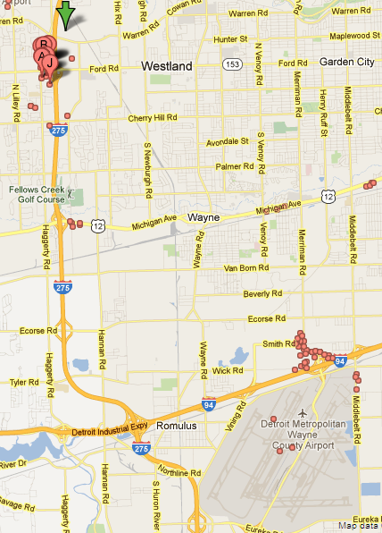  Nearby  Hotels  DTW  Airport
I look forward to seeing you in Detroit
Yours sincerely,
Hans W. Gierlich

