INTERNATIONAL TELECOMMUNICATION UNION |  | Focus Group On  Car Communication
TELECOMMUNICATION  STANDARDIZATION SECTOR  STUDY PERIOD 2009-2012 |  | FG CarCOM-C-28
English only
Original: English
 |  | Kyoto, 12-13 April 2012
CONTRIBUTION
Source: | FG Chairman
Title: | Draft 14 of FG.VSSR
FG.VSSR – Draft 14
FG CarCom SubSystem Requirements for Automotive Speech Services
Summary
This Specification defines test methodologies for and standard behaviour of subsystems used in automotive speakerphone terminals. The purpose is to provide guidance on the design and optimization of subsystems as well as diagnostic capabilities needed to give a consistent and high Quality of Service of the overall speakerphone terminal for the users of such devices. This specification is intended to give guidance to all parties involved in the design and integration of speakerphone terminals. This specification covers both, narrowband and wideband systems.

Keywords
Hands-Free, Speakerphone, Motor Vehicles, Subsystem, Quality of Service, QoS

Contents
To be added

Scope
The aim of this Specification is the definition of test methods and requirements for subsystems of automotive narrowband and wideband speakerphone terminals and other speech services using the speakerphone acoustic interface. The Specification covers
- Definition of subsystems based on different system architectures
- Performance requirements for subsystems
- Diagnostic information
- Guidance on component and subsystem optimization
- Coordination of subsystems
- Both, narrowband and wideband systems
- Acoustic interface requirements for other speech services such as speech recognition and application prompt playback

The methods, the analysis and the performance parameters described in this Specification are based on test signals and test procedures as defined in ITU-T Recommendations P.50 [10], P.501 [11], P.502 [12] and P.340 [18], P.380 [19], P.1100[xx], P.1110 [xx] and ETSI ES 202 739 [24] and ETSI ES 202 740 [25].

References
The following ITU-T Recommendations and other references contain provisions, which, through reference in this text, constitute provisions of this Recommendation. At the time of publication, the editions indicated were valid. All Recommendations and other references are subject to revision; users of this Recommendation are therefore encouraged to investigate the possibility of applying the most recent edition of the Recommendations and other references listed below. A list of the currently valid ITU-T Recommendations is regularly published.
The reference to a document within this Recommendation does not give it, as a stand-alone document, the status of a Recommendation
[1] Berger, J., Results of objective speech quality assessment including receiving terminals using the advanced TOSQA2001, ITU-T Contribution, Dec. 2000, COM 12-20-E
[2] ETSI EG 202 396-1: Speech quality performance in the presence of background noise; Part 1: Background noise simulation technique and background noise database.
[3] Fingscheidt, T., Suhadi, S.: Quality Assessment of Speech Enhancement Systems by Separation of Enhanced Speech, Noise, and Echo, INTERSPEECH 2007, Antwerp, Belgium, Aug. 2007.
[4] Steinert, K., Suhadi, S., Fingscheidt, T., A Comparison of Instrumental Measures for Wideband Speech Quality Assessment of Hands-free Systems in Echoic Condition, DAGA 2009, Rotterdam, The Netherlands, March 2009.
[5] IEC 61260: Electroacoustics - Octave-band and fractional-octave-band filters - Part 1: Specifications, 1995.
[6] IEC 60268-4: Sound system equipment - Part 4: Microphones, 2004.
[7] ITU-T Recommendation G.122: Influence of National Systems on Stability and Talker Echo in International Connections.
[8] ITU-T Recommendation P.340: Transmission Characteristics and Speech Quality Parameters of Hands-free Telephones.
[9] ITU-T Recommendation P.380: Electroacoustic Measurements on Headsets
[10] ITU-T Recommendation P.50 (1993) : Artificial Voices.
[11] ITU-T Recommendation P.501: Test Signals for Use in Telephonometry.
[12] ITU-T Recommendation P.502: Objective Analysis Methods for Speech Communication Systems, Using Complex Test Signals.
[13] ITU-T Recommendation P.56: Objective Measurement of Active Speech Level.
[14] ITU-T Recommendation P.57 : Artificial Ears.
[15] ITU-T Recommendation P.58: Head and Torso Simulators for Telephonometry.
[16] ITU-T Recommendation P.581 (05/00): Use of Head and Torso Simulators (HATS) for Hands-free Terminal Testing.
[17] ITU-T Recommendation P.79: Calculation of Loudness Rating for Telephone Sets.
[18] ITU-T Recommendation P.800: Methods for Subjective Determination of Transmission Quality.
[19] ITU-T Recommendation P.800.1: Mean Opinion Score (MOS) Terminology.
[20] ITU-T Recommendation P. 862.2: Wideband extension to Recommendation P.862 for the assessment of wideband telephone networks and speech codecs.
[21] ITU-T Recommendation P. 862.1: Mapping Function for Transforming P.862 Raw Result Scores to MOS-LQO.
[22] Sottek, R., Genuit, K.: Models of Signal Processing in Human Hearing, International Journal of Electronics and Communications, pp. 157-165, 2005.
[23] Kettler, F., Gierlich, H.W.: Evaluation of Hands-Free Terminals, in “Topics in Speech and Audio Processing” edited by E. Hänsler, G. Schmidt, Springer, ISBN: 978-3-540-70601-4.
[24] ETSI ES 202 739: Transmission requirements for wideband VoIP terminals (handset and headset) from a QoS perspective as perceived by the user
[25] ETSI ES 202 740: Transmission requirements for wideband loudspeaking and hands-free terminals from a QoS perspective as perceived by the user
[26] ETSI EG 202 396-3: Speech quality performance in the presence of background noise; Part 3: Background noise transmission - objective model.
[27] ISO 3745: Acoustics -- Determination of sound power levels of noise sources using sound pressure -- Precision methods for anechoic and hemi-anechoic rooms
P.1100
P.1110
G. 100.1

Definitions
Artificial ear: Device incorporating an acoustic coupler and a calibrated microphone for the measurement of the sound pressure and having an overall acoustic impedance similar to that of the median adult human ear over a given frequency band.
Codec: Combination of an analogue-to-digital encoder and a digital-to-analogue decoder operating in opposite directions of transmission in the same equipment.
Composite Source Signal (CSS): Signal composed in time by various signal elements.
Diffuse field equalization: Equalization of the HATS sound pick-up, equalization of the difference, in dB, between the spectrum level of the acoustic pressure at the ear Drum Reference Point (DRP) and the spectrum level of the acoustic pressure at the HATS Reference Point (HRP) in a diffuse sound field with the HATS absent using the reverse nominal curve given in Table 3 of ITU-T Recommendation P.58 [15].
Ear-Drum Reference Point (DRP): Point located at the end of the ear canal, corresponding to the ear-drum position.
Freefield reference point: Point located in the free sound field, at least in 1,5 m distance from a sound source radiating in free air (in case of a head and torso simulator [HATS] in the center of the artificial head with no artificial head present).
Freefield equalization: The transfer characteristic of the artificial head is equalized in such a way that for frontal sound incidence in anechoic conditions the frequency response of the artificial head is flat. This equalization is specific to the HATS used.
Hands-Free Reference Point (HFRP): A point located on the axis of the artificial mouth, at 50 cm from the outer plane of the lip ring, where the level calibration is made, under free-field conditions. It corresponds to the measurement point 11, as defined in ITU-T Rec. P.51.
Hands-free terminal: Telephone set that does not require the use of hands during the communications session; examples are headset, speakerphone and group-audio terminal.
Head And Torso Simulator (HATS) for telephonometry: Manikin extending downward from the top of the head to the waist, designed to simulate the sound pick-up characteristics and the acoustic diffraction produced by a median human adult and to reproduce the acoustic field generated by the human mouth.
Headset: Device which includes telephone receiver and transmitter which is typically secured to the head or the ear of the wearer.
MOS-LQO (Mean Opinion Score – Listening-only Quality Objective): The score is calculated by means of an objective model which aims at predicting the quality for a listening-only test situation. Objective measurements made using the model given in ITU-T Rec. P.862 give results in terms of MOS-LQO (for further information see Annex A).
MOS-TQO (Mean Opinion Score – Talking Quality Objective): The score is calculated by means of an objective model which aims at predicting the quality for a talking-only test situation. Methods generating a MOS-TQO are currently under development and not yet standardized.
Mouth Reference Point (MRP): The MRP is located on axis and 25 mm in front of the lip plane of a mouth simulator.
Nominal setting of the volume control: When a receive volume control is provided, the setting which is closest to the nominal RLR of 2 dB.
Receive loudness rating (RLR): The loudness loss between an electric interface in the network and the listening subscriber's ear. (The loudness loss is here defined as the weighted (dB) average of driving e.m.f. to measured sound pressure.)
Send loudness rating (SLR): The loudness loss between the speaking subscriber's mouth and an electric interface in the network. (The loudness loss is here defined as the weighted (dB) average of driving sound pressure to measured voltage.)
Wideband speech: Voice service with enhanced quality compared to PCM G.711 and allowing the transmission of a vocal frequency range of at least 150 Hz to 7 kHz

Abbreviations
ACR Absolute category rating
A/D Analogue/Digital
AGC Automatic Gain Control
AH,R Attenuation Range in receive direction
AH,R,dt Attenuation Range in receive direction during Double Talk
AH,S Attenuation Range in Send direction
AH,S,dt Attenuation Range in Send direction during Double Talk
BGN BackGround Noise
BT Bluetooth
BTR Bluetooth Reference Point
CSS Composite Source Signal
D/A Digital/Analogue
D D-Value is computed directly from measurements of the difference Δ_{Sm} between the send sensitivities for diffuse and direct sound, S_{si} (diff) and S_{si} (direct), respectively.
Δ_{Sm} = S_{si} (diff) − S_{si} (direct) (E-2)
D is computed as a weighted average of Δ_{Sm}
DELSM DELSM is sometimes used for Δ_{Sm}. (see D-Value)
DRP Drum Reference Point
DTX Discontinuous Transmission
DUT Device under Test
EC_{BD} Bidirectional Transport Echo Cancellation
EEB Early Energy Balance
ERL Echo Return Loss
ERP Ear Reference Point
FFT Fast Fourier Transform
FR_{AS} Frequency Response Audio Subsystem
FR_{BDR} Frequency Response Bidirectional Transport, Receive
FR_{BDS} Frequency Response Bidirectional Transport, Send
FR_{MS} Frequency Response Microphone, Send
FR_{UD} Frequency Response Unidirectional Transport
HATS Head And Torso Simulator
HATS-HFRP Head And Torso Simulator – Hands Free Reference Point
HF System Hands Free System
HFT Hands Free Terminal
HVAC Heating Ventilation Air Condition
JLR Junction Loudness Rating
JLR_{BDR} Junction Loudness Rating Bidirectional Transport, Receive
JLR_{BDS} Junction Loudness Rating Bidirectional Transport, Send
JLR_{UD} Junction Loudness Rating Unidirectional Transport
L_{S,min} minimum activation level (Send Direction)
L_{MS} Microphone Output Level, Send
LQ_{AS} Audio Subsystem Speech Quality
LQ_{BDR} Bidirectional Transport Speech Quality, Receive
LQ_{BDS} Bidirectional Transport Speech Quality, Send
LQ_{MS} Microphone Speech Quality, Send
LQ_{UD} Unidirectional Transport Speech Quality
LQS_{BDR} Bidirectional Transport Speech Quality Stability, Receive
LQS_{BDS} Bidirectional Transport Speech Quality Stability, Send
LQS_{UD} Unidirectional Transport Speech Quality Stability
LQBGN_{MS} Microphone Speech Quality with Background Noise, Send
MOS Mean Opinion Score
MRP Mouth Reference Point
N_{AS} Audio Subsystem Idle Noise
N_{BDR} Bidirectional Transport Idle Noise, Receive
N_{BDS} Bidirectional Transport Idle Noise, Send
N_{MS} Microphone Idle Noise, Send
N_{UD} Unidirectional Transport Idle Noise
NC Noise Criterion
NC_{BDR} Bidirectional Transport Noise Cancellation, Receive
NC_{BDS} Bidirectional Transport Noise Cancellation, Send
NC_{UD} Unidirectional Transport Noise Cancellation

NR Noise Reduction
OHC Overhead Console
OVL_{MS} Microphone Overload Point
PCM Pulse Code Modulation
RFIFAP Reference Interface Access Point
POI Point Of Interconnection
QoS Quality of Service
REV_{MS} Microphone Reverberation, Send
RLR Receive Loudness Rating
SINR Speech to idle noise ratio
SLR Send Loudness Rating
SRWAP Short Range Wireless Reference Access Point
Test Point Subsystem Access Point
S_{si}(diff) Diffuse field sensitivity
S_{si}(direct) Direct sound sensitivity
SNNR Signal to Noise Ratio
SNR_{M} Microphone SNR
T_{AS} Audio Subsystem Delay
T_{BDR} Bidirectional Transport Delay, Receive
T_{BDS} Bidirectional Transport Delay, Send
T_{UD} Unidirectional Transport Delay
TCLw weighted Terminal Coupling Loss
Tr,R built-up time (Receive Direction)
Tr,S built-up time (Send Direction)
T_{s} Send Delay hands-free terminal
T_{r} Receive Delay hands-free terminal
T_{rtd-HF} Round Trip Delay hands-free terminal

Conventions
dBm: absolute power level relative to 1 milliwatt, expressed in dB
dBm0: absolute power level in dBm referred to a point of zero relative level (0 dBr point)
dBm0p: weighted dBm0, according to ITU-T Recommendation O.41
dBm0(C): C weighted dBm0, according to ISO 1999
dBov: dB relative to the overload point of a digital system according to ITU-T Recommendation G.100.1dBPa: sound pressure level relative to 1 Pa, expressed in dB
dBPa(A): A-weighted sound pressure level relative to 1 Pa, expressed in dB
dBSPL: sound pressure level relative to 20µPa, expressed in dB; (94dBSPL=0dBPa)

dBV(P): P-weighted voltage relative to 1 V, expressed in dB, acc. to O.41

dBr: relative power level of a signal in a transmission path referred to the level at a reference point on the path (0 dBr point)
N: Newton
Vrms: Voltage – root mean square
cPa: Compressed Pascal, sound pressure at the output of the hearing model in the “Relative Approach” after nonlinear signal processing by the human ear

How to Use the Specification

Architectures

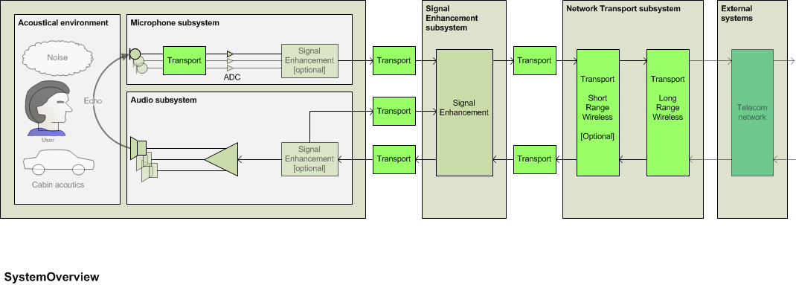
Fig. 7.1 Abstract architecture – System Overview
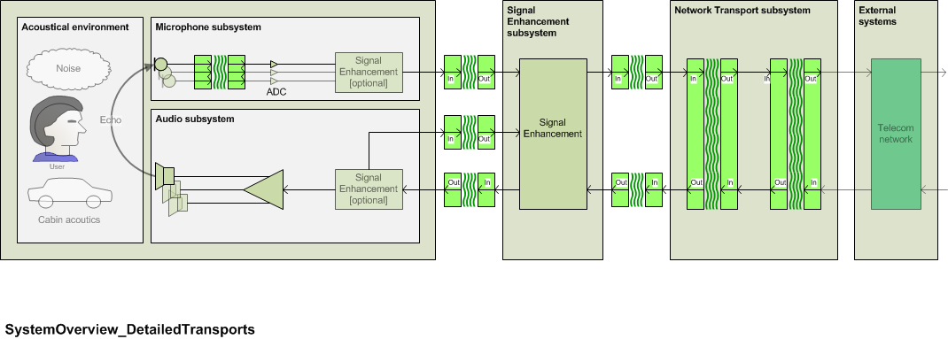
Fig. 7.2: System Overview with detailed transport

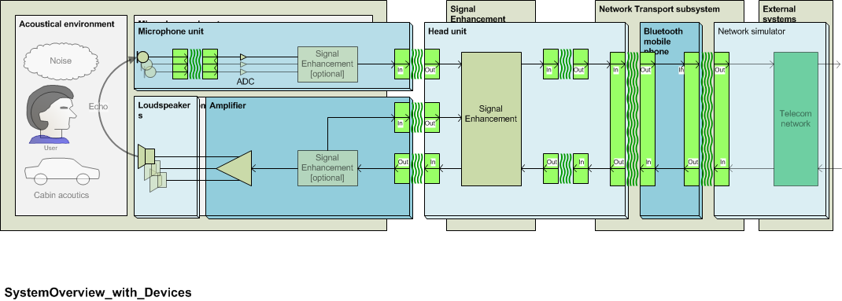
Fig. 7.3: System overview with the example of typical devices

Distributed speakerphone
The subsystems are tested as described in the different sections of this specification. The test points for the different subsystems are shown in Fig. 7.2
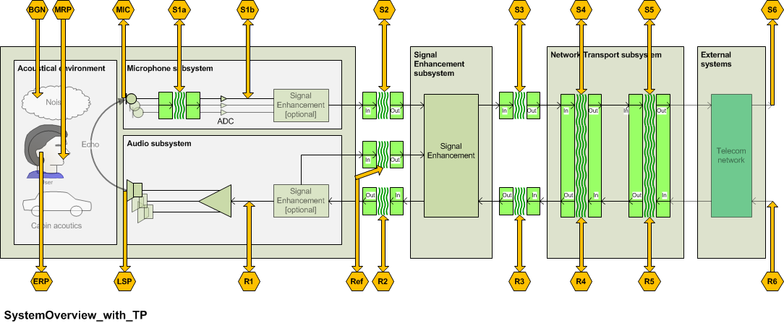

Fig. 7.4 Abstract architecture and Testpoints
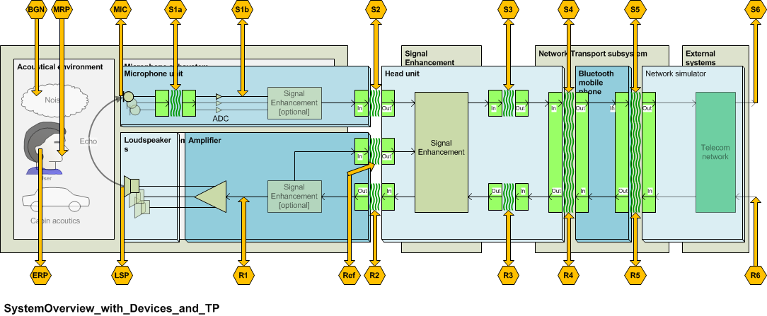
Fig. 7.5 System overview and test points, example of a typical implementation

System with integrated microphone
The system is tested as described in ITU-T Rec. P.1100 (for narrowband systems) or in ITU-T Rec. P.1110 (for wideband systems). If no network access is provided by the system the system is connected to a reference interface replacing the network access system. The requirements as given in ITU-T Recs. P.1100 and P.1110 apply.

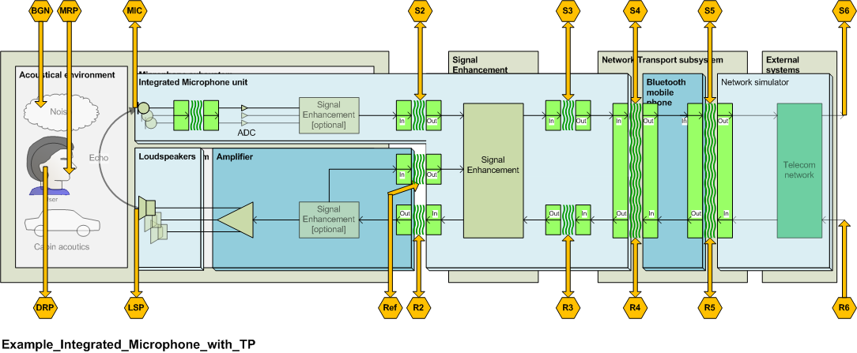
Fig. 7.6: System with integrated microphone
The loudspeaker subsystem is tested as described in section xx.
The network access subsystem is tested as described in section xx.

System with integrated speaker
The system is tested as described in ITU-T Rec. P.1100 (for narrowband systems) or in ITU-T Rec. P.1110 (for wideband systems). If no network access is provided by the system the system is connected to a reference interface replacing the network access system. The requirements as given in ITU-T Recs. P.1100 and P.1110 apply.

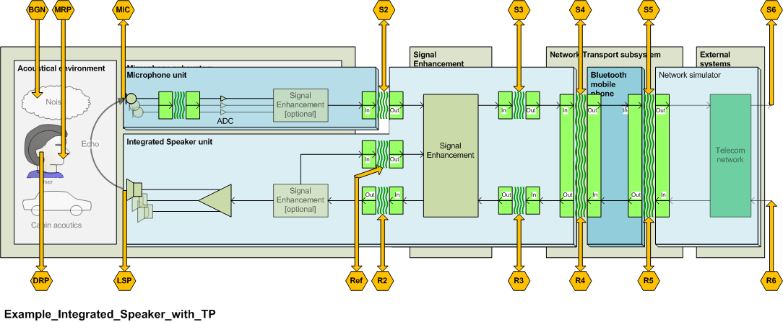
Fig. 7.7: System with integrated speaker
The microphone subsystem is tested as described in section xx.
The network access subsystem is tested as described in section xx.

System with integrated microphone and speaker
The system is tested as described in ITU-T Rec. P.1100 (for narrowband systems) or in ITU-T Rec. P.1110 (for wideband systems). If no network access is provided by the system the system is connected to a reference interface replacing the network access system. The requirements as given in ITU-T Recs. P.1100 and P.1110 apply.
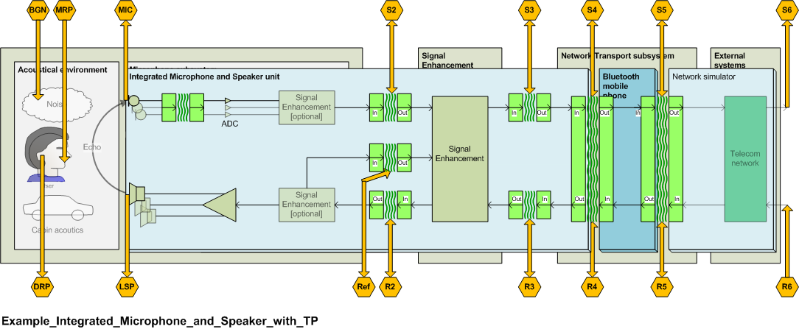
Fig. 7.8: System with integrated microphone and speaker

System Delay, Subsystem Delay and Buffering
- System Delay is measured acc. to P.1100/1110
- Subsystem Delay includes only Algorithmic Delay
- Buffering should be optimized to get a mostly low system delay
- Guidance is given in Annexxx
- Synchronization issues described in Annex xx.
To be included:
- Diagram showing all measurement points for each subsystem of this architecture
- Sections common to all subsystems (e.g., some set-up, etc.)
- Classify set of subsystem tests based on architecture
Note that architecture defined by both mic type (single, array w/non-linear processing, etc.) and measurement access points

  - Acoustic interface
    - All subsystem measurement parameters (regardless of applications)
  - SEL+LT subsystem
  - NT subsystem
  - SRW qualification for mobile phone used in P.1100 testing
  - Subsystem by Application requirements table

Subsystems

Test Interface description

Analog electrical interface
The analog interface of the test system should match the impedance and the sensitivity of the system under test.

Digital electrical interface
The digital interface of the test system should provide a dynamic range of at least 16 bit equivalent and otherwise should match the interface specification of the system under test.

Acoustic interface

Artificial mouth
The artificial mouth of the artificial head shall conform to ITU-T Recommendation P.58 [xx]. The artificial mouth is equalized at the MRP according to ITU-T Recommendation P.340 [xx].
The sound pressure level is calibrated at the HATS-HFRP so that the average level at HATS-HFRP is -28.7 dBPa. The sound pressure level at the MRP has to be corrected correspondingly. The detailed description for equalization at the MRP and level correction at the HATS-HFRP can be found in ITU-T Recommendation P.581 [xx].
When testing with vehicle noise, the output level of the mouth is increased to account for the “Lombard effect”. The Lombard effect refers to the change in speaking behaviour caused by acoustic noise. The level is increased by 3 dB for every 10 dB that the long-term A-weighted noise level exceeds 50 dB(A) [xx]. This relationship is shown in the following formula:
$$I\left(N\right)=\begin{aligned}\left\{0\text{for}N<\text{50} | \right.\left\{0\text{.}3\left(N−\text{50}\right)\text{for}\text{50}≤N≤\text{77} | \right.\end{aligned}$$
Where:
I = The dB increase in mouth output level due to noise level
N = The long-term A-weighted noise level measured near the driver’s head position
As an example, if the vehicle noise measures 70 dB(A), then the output of the mouth would be increased by 6 dB. No gain is applied for noise levels below 50 dB(A). The maximum amount of gain that can be applied is 8 dB. Vehicle noise levels are measured using a measurement microphone positioned near the driver’s head position.

Artificial ear
For speakerphone hands-free terminals the ear signals of both ears of the artificial head are used. The artificial head is free-field or diffuse-field equalized (see ITU-T Recs. P.1100 and P.1110), more detailed information can be found in ITU-T Recommendation P.581 [xx].

Wireless interface
The interface of the test system should conform to the interface specification of the wireless system under test.

Test signal levels
In general the test signal levels are individual to the system design and vary between implementations. However, if not stated otherwise as a general rule the following test signal levels shall be used:
For digital interfaces the nominal signal level is derived by measuring the signal level at the according digital input of the subsystem when applying a signal with nominal level either at the acoustical interface of the hands-free terminal or at the POI.
Typically the nominal test signal level should be -22 dBov at the digital interface for digital systems. (assuming a nominal signal level of -16dBm0 and an overload point of 3.14 dBm0 for digital transmission systems)
For analog interfaces a similar approach can be taken. The nominal signal level is derived by measuring the signal level at the according analog input of the subsystem when applying a signal with nominal level either at the acoustical interface of the hands-free terminal or at the POI.

Acoustic Subsystem
The acoustic subsystem and related test points are shown in Fig. 8.1. This figure also shows that the acoustic subsystem can be further divided into the following subsystems:
- Microphone subsystem (send path)
- Audio subsystem (receive path)
- Coupling between transducers subsystems (echo path).

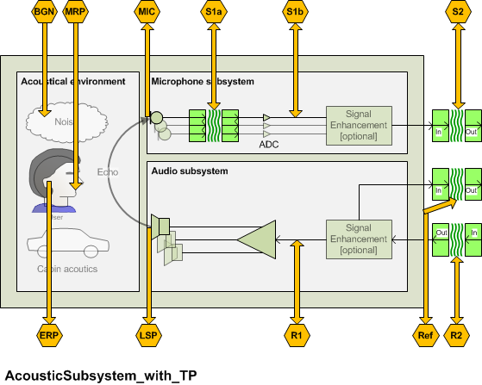
Fig. 8.1: Acoustic subsystem and test points

Microphone subsystem (send path)

        - Send Speech-to-Noise Ratio (SpNR)
          - Is application dependent?
          - Soft & loud speakers
          - Wind buffeting noise
          - Belt microphone noise issues; Structure borne noise
        - Cover spectral and time variant components
        - Send Distortion + Noise (SDN) ?
        - Delay
        - For multi microphone solutions only:
          - Delay variation (over sensors and time)
          - Frequency response variation (over sensors and time)
          - Level variation (over sensors and time)

The microphone subsystem may consist of one or more microphones and may include a signal enhancement layer for the microphone signal as well.

The purpose of this section is to provide guidance for positioning microphones and optimize the microphone performance parameters in such a way that the microphone provides optimum input signals to the speech enhancement.
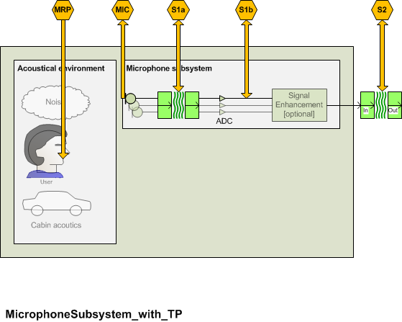
FIGURE

The DUT is connected to the reference interfaces. The reference interfaces are calibrated as specified in clause 8.1.

This clause is applicable to single microphones but not to the output of microphone arrays.

Microphone measurements in the car
Positioning of hands-free microphones
The speech quality in hands-free communication is significantly affected by the positioning of the hands-free microphone. As the optimal microphone position can vary strongly depending on vehicle design as well as on specific requirements, there is no universally valid rule for the positioning of the microphone. However, there are some guidelines which should be considered. Nevertheless, in practice, this often means to find the best compromise, as not all requirements can be equally fulfilled.
– The hands-free microphone should always be placed as close as possible to the speaker, as within the near field of a sound source (in a vehicle this is up to 80-100 cm) the speech level drops by 1/d². In practical applications, this typically means an analogous loss in signal-to-noise ratio. For this reason, a single microphone placed nearby might give a better performance than a microphone array, which is placed further away.
– There has to be a direct path between the speaker's mouth and the microphone. If this is not given, this might result in a significant decrease in signal-to-noise ratio as well as in speech quality since the speech signal becomes reverberant.
– The direction of the highest sensitivity of the microphone should point in the direction of the speaker's mouth. If different seating positions or several speakers are to be covered by one microphone, a compromise for the microphone position has to be found, as the direction of the highest sensitivity might not cover all. However, this often means a significantly reduced performance in comparison to an optimal alignment of the microphone for a single speaker. In this case, the application of additional microphones might be considered to achieve an optimal speech quality.
– A direct airstream to the microphone, e.g., from the air conditioning, has to be avoided as the speech signal might be highly disturbed by wind buffeting.
– Saturation of the microphone by loudspeakers nearby, e.g., by a centre-speaker, has to be avoided. If necessary, the levels of the affected loudspeakers have to be reduced.
Coupling of structure-borne sound to the microphone has to be avoided.
NOTE 1 – When the microphone is measured in the car, it is recommended to use the power supply provided by the car/car hands-free system.
NOTE 2 – If the microphone is integrated digitally in the car, it is recommended to measure the microphone at a digital access point, if available. Care should be taken in order to correctly calibrate the access point.
NOTE 3 – In case the car is not available it is recommended to integrate the microphone in a surrogate environment as close as possible to the production environment. In case wind noise may have a major influence on the microphone performance it is recommended to also simulate the wind noise.

Microphone overload point (in the car)

Parameter description
The microphone overload point OVL_{MS} is measured from the test point (Mic) to the test point (S1a) or the test point (S2).
The microphone overload point is determined by the highest signal which is received by the microphone in the car without distorting. This maybe the speech signal of the near end speaker, the background noise picked up by the hands-free microphone or the signal received from the car audio system.

Test
1) The maximum spectrum is recorded by a reference microphone close to the hands-free microphone (MIC) by generating, background noise, near end speech and the signal generated by the car audio system with maximum volume.
- The background noise conditions to be simulated are found in Annex D of ITU-T Rec. P.1100 and P.1110. The background noise producing the maximum level at the microphone is used.
- The maximum near end signal is generated by generating artificial voice with a level as described in 8.1.3.1.
- The maximum loudspeaker signal is generated by injecting artificial voice with a level of -16 dBm0 at the far end and setting the audio volume control to maximum.
2) For the signal producing the maximum level (Lev_{max}) the coherence between the reference microphone positioned at MIC and S2 is determined. The coherence is determined as an average of the coherence function in the frequency range from 100 Hz to 7 kHz.
3) The measurement is repeated by reducing the signal level of the worst case signal in steps of 1 dB until the required coherence is achieved.

NOTE: The artificial voice based tests are averaged over the complete artificial voice sequences including male and female artificial voice.

Classification of QoS level based on values of this parameter
To claim compliance with a certain QoS class the Microphone overload point has to meet the requirements for the applicable QoS classes for the Microphone overload point as defined in table xx:
Table xx –Limits for the Microphone overload point above 0.95 coherence

QoS Class | OVL re Lev_{max}
1 | 0 dB
2 | -3 dB
3 | -6 dB
4 | -9 dB

Design guidance and root-cause analysis
TBD

Microphone frequency response (in the car)

Parameter description
The microphone frequency response in send FR_{MS} is measured from the test point (Mic) to the test point (S1a) or the test point (S2).

Test
1) The test arrangement is according to clause .1.
2) The test signal artificial voice according to [ITU-T P.50] is used. Alternatively, a periodic noise signal or CS signal according to [ITU-T P.501] can be used. The correct activation of the measurement object during the measurement has to be ensured by the test lab. The artificial mouth is equalized at the MRP, the test signal level shall be –4.7 dBPa at the MRP. The test signal level is the average level of the complete test signal. Finally, the level at the HATS-HFRP is adjusted to –28.7 dBPa.
3) The measured power density spectrum at the MRP is used as the reference power density spectrum for determining the frequency response in send direction.
4) The sensitivity frequency response is determined in third octave intervals as given by [IEC 61260] for frequencies of 100 Hz and 8 kHz, inclusive. For calculation, the average measured level is referred to the level of the reference signal in each frequency band averaged over the complete test sequence length.
5) The sensitivity is determined in dBV/Pa.

Classification of QoS level based on values of this parameter
To claim compliance with a certain QoS class the frequency response has to meet the requirements for the applicable QoS classes for the microphone send sensitivity as defined in the tables below:
The masks are drawn by straight lines between the breaking points in Table 9-xx to 9-xx on a logarithmic (frequency) – linear (dB sensitivity) scale.
Table xx – Tolerance mask for the send sensitivity frequency response for QoS class 1
Frequency | Upper limit | Lower limit
100 Hz | 2 dB | –∞ dB
300 Hz | 2 dB | –2dB
500 Hz | 2 dB | -2 dB
1 000 Hz | 2 dB | –2 dB
2 500 Hz | 2 dB | -2 dB
3 100 Hz | (Note) | –2 dB
5 000 Hz | (Note) | -2 dB
7 000 Hz | 3 dB | -2 dB*
1100 Hz | 3 dB | –2 dB*
12 000 Hz | 3 dB | –∞ dB*
NOTE 1 – The limits for intermediate frequencies lie on a straight line drawn between the given values on a linear (dB) – logarithmic (Hz) scale. All sensitivity values are expressed in dB on an arbitrary scale.
* NOTE 2 – If the microphone is purely used for speech communication and not used for speech recognition or other services an upper limit of 7 kHz is sufficient.

Table xx – Tolerance mask for the send sensitivity frequency response for QoS class 2
Frequency | Upper limit | Lower limit
100 Hz | - | –∞ dB
300 Hz | 2 dB | –5 dB
500 Hz | 2 dB | -4 dB
1 000 Hz | 2 dB | –2 dB
2 500Hz | 4 dB | -2 dB
3 100 Hz | (Note) | –2 dB
5 000 Hz | (Note) | –∞ dB
6 300 Hz | 5 dB | –∞ dB
8 000 Hz | - | –∞ dB
NOTE – The limits for intermediate frequencies lie on a straight line drawn between the given values on a linear (dB) – logarithmic (Hz) scale. All sensitivity values are expressed in dB on an arbitrary scale.

Table xx – Tolerance mask for the send sensitivity frequency response for QoS class 3
Frequency | Upper limit | Lower limit
100 Hz | - | –∞ dB
300 Hz | 4 dB | –10 dB
500 Hz | 4 dB | -8 dB
1 000 Hz | 4 dB | –4 dB
2 500Hz | 8 dB | (Note)
3 100 Hz | 8 dB | –4 dB
5 000 Hz | 8 dB | –∞ dB
6 300 Hz | 8 dB | –∞ dB
8 000 Hz | - | –∞ dB
NOTE – The limits for intermediate frequencies lie on a straight line drawn between the given values on a linear (dB) – logarithmic (Hz) scale. All sensitivity values are expressed in dB on an arbitrary scale.
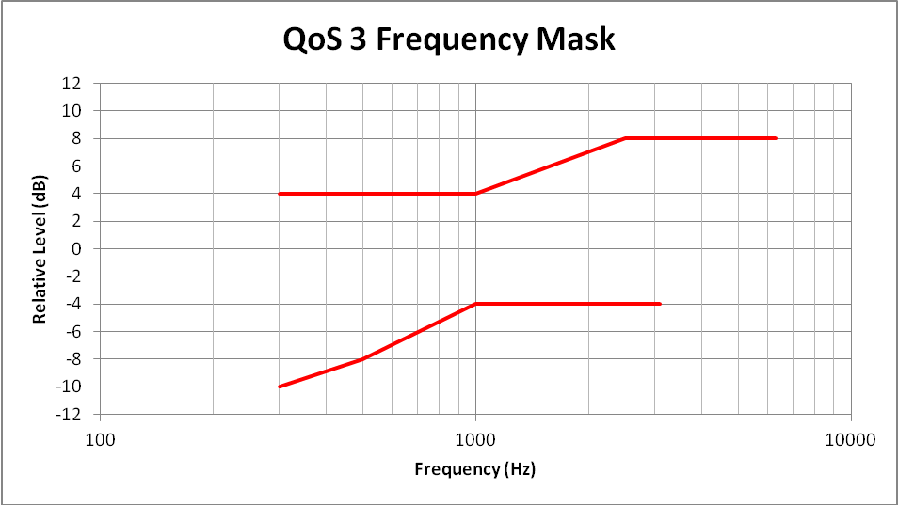

Table xx – Tolerance mask for the send sensitivity frequency response for QoS class 4
Frequency | Upper limit | Lower limit
100 Hz | N/A | N/A
300 Hz | N/A | N/A
500 Hz | N/A | N/A
1 000 Hz | N/A | N/A
2 500Hz | N/A | N/A
3 100 Hz | N/A | N/A
5 000 Hz | N/A | N/A
6 300 Hz | N/A | N/A
8 000 Hz | N/A | N/A
NOTE – The limits for intermediate frequencies lie on a straight line drawn between the given values on a linear (dB) – logarithmic (Hz) scale. All sensitivity values are expressed in dB on an arbitrary scale.

NOTE: QoS class 1 mask is intended to support high quality wideband with no need to equalize the response. QoS class 2 is intended to support high quality narrowband with no need to equalize the response. QoS class 3 is intended to support narrowband communication and some equalization may be required.

Design guidance and root-cause analysis
NOTE – Ideally, the response characteristics of the microphone should be flat in the frequency range of wideband transmission (100 Hz – 7 kHz). However, especially in the presence of background noise, a bandwidth limitation may be desirable. No explicit recommendation can be given here since such limitation would depend on the level and spectral content of the background noise and ideally should be adaptive. If, however, a bandwidth limitation is introduced, it should be made at both, the high and low frequencies.

Microphone idle channel noise (in the car)

Parameter description
The microphone idle channel noise in send N_{MS} is measured from the test point (Mic) to the test point (S1a) or the test point (S2).

Test
1) Artificial voice with an average signal level of -4.7 dBPa [ITU-T P.50] is applied at the MRP. The test signal level is the average level of the complete test signal. Finally, the level at the HATS-HFRP is adjusted to –28.7 dBPa. The output level at the hands-free microphone is measured using a speech level voltmeter according to ITU-T P.56. This level is the reference speech signal level.

2) For the noise measurement, no test signal is used. However, all sources which potentially contribute to noise at the output of the microphone such as GSM noise, electrical noise introduced by the car must be considered. In order to ensure a reliable activation of active microphone arrangements, an activation signal is inserted before the actual measurement. The activation signal consists of a sequence of 4 composite source signals according to [ITU-T P.501]. The spectrum of the test at the MRP is calibrated under free-field conditions. The level of the activation signal is –28.7 dBPa measured at the HATS-HFRP.
3) The test arrangement is according to clause 7.1.
The idle channel noise is measured at the output of the test circuit according to Figure 7-2 in the frequency range between 100 Hz and 8 kHz. The measurement requires a time window which starts exactly at the end of the activation signal. Any "ringing" of filters or receivers shall be taken into account, the time window must be shifted accordingly. The length of the time window is 1 second which is the averaging time for the idle channel noise. The test lab has to ensure the correct activation of the microphone/microphone arrangement during the measurement. If the microphone arrangement is deactivated during measurement, the measurement window has to be cut to the duration when the microphone remains activated.
The power density spectrum of the noise signal is determined using FFT (8 k samples/48 kHz sampling rate or equivalent). A Hann window is used.
If it is known that the microphone stays activated without any activation signal, no activation signal is required. In this case, a simple noise measurement is conducted.
4) The idle channel noise is determined by A-weighting and referring to the reference speech signal level as determined with artificial voice. Spectral peaks are measured in the frequency domain. The average noise spectrum used for determining the spectral peak should be calculated as the arithmetic mean of the noise spectrum values when stated in dBVP.

Classification of QoS level based on values of this parameter
To claim compliance with a certain QoS class the speech to idle noise ratio SINR has to meet the requirements for the applicable QoS classes for the SINR as defined in table xx:
Spectral peaks in the frequency domain shall not exceed the averaged spectrum by more than 10 dB.

Table xx –Limits for the idle channel noise re. reference speech signal level

QoS Class | SINR
1 | > 40 dB
2 | > 30 dB
3 | > 25 dB
4 | ≤ 20 dB

Design guidance and root-cause analysis
Be sure that receive path is deactivated, Check shielding, check microphone preamplifier should not demodulate RF into NF,

Microphone SNR (in the car)
        - Send Speech-to-Noise Ratio (SpNR)
          - Is application dependent?

Parameter description
The SNR measurement is based on individual broadband estimations of the speech signal power and the noise signal power and is performed using the reference-free measurement method described in [xx].
NOTE 1 – It is recognized that fan noise, which varies from car to car and depends upon the relative positioning of the microphone and fan, may contribute significantly to the noise perceived by the far end user. In order to determine the impact of the level and spectral content of this noise under different operating conditions, a noise test as described below may be used.
The microphone signal to noise ration SNR_{M} is measured at the test point (S1a) or the test point (S2). Test point (S2) should only be used if test point (S1a) is not accessible.

Test

- The test arrangement is according to clause 8.1.
- The speech test signal used is a concatenation of the English test sentences described in Annex B of ITU-T Recommendation P.501 [xx]. To account for the Lombard effect, the test signal level is adjusted to the level as specified in clause 8.1, the test signal level is measured as "active speech level" according to [ITU-T P.56].
- For the measurement speech and background noise are recorded simultaneously while driving.
- A reference measurement is conducted at 20 cm in front of the MRP. The reference microphone output signal is filtered by a highpass filter with 100 Hz and 24 dB/oct.
- The actual measurement is conducted with the hands-free microphone.
- The SNR is calculated according to [xx] for both microphones.
- The SNR difference between the hands-free microphone and the reference microphone is determined:

SNRD = SNR_{M} - SNR_{Ref}

Note: If different microphones or different positions are to be compared the measurements shall be conducted simultaneously.

Classification of QoS level based on values of this parameter
Background noises for driving speed ≤ 80 km/h:
To claim compliance with a certain QoS class the SNRD has to meet the requirements for the applicable QoS classes for the SNRD as defined in table xx:
Table xx –Limits for the SNRD

QoS Class | SNRD
1 | xx dB
2 | TBD
3 | TBD
4 | TBD

Background noises for driving speed ≤ 120 km/h:
To claim compliance with a certain QoS class the SNRD has to meet the requirements for the applicable QoS classes for the SNRD as defined in table xx:
Table xx –Limits for the SNRD

QoS Class | SNRD
1 | xx dB
2 | TBD
3 | TBD
4 | TBD

Design guidance and root-cause analysis
Influence of microphone directivity characteristics etc.

New tests to be defined

Microphone Send ReVerberation (SRV)

Parameter description
The microphone reverberation in send REV_{MS} is measured from the test point (MRP) to the test point (S1a) or the test point (S2).
A measure for determining the subjectively perceived reverberation is defined in ITU-T Recommendation P.340 [xx]. The Early Energy Balance is a measure which seems to correlate to the subjectively perceived reverberation when transmitting reverberant speech over hands-free terminals. The EEB is defined as:

Test

- The test arrangement is according to clause 8.1.
- The test signal should be composed of an activation signal (e.g. voiced sound of the CSS) and a maximal-length sequence of several periods as described in [ITU-T P.340] . The period length must be longer than the length at the impulse response of the system under test.
- The impulse response is calculated from the average of several periods, beginning with the second period.
- The delay introduced by the system under test and the test system has to be compensated for.
- From this the Early Energy Balance (EEB) is calculated.

Classification of QoS level based on values of this parameter
To claim compliance with a certain QoS class the EEB has to meet the requirements for the applicable QoS classes for the EEB as defined in table xx:
Table xx –Limits for the TBD

QoS Class | EEB
1 | x
2
3
4

Design guidance and root-cause analysis
Too high reverberation may lead to hollow sounding speech. The reverberation may be caused by positioning of the microphone(s) too close to reflecting surfaces (typically windows) or by insufficient damping of reflecting surfaces in a car. Additional damping of surfaces or changing the microphone position may help to correct the problem.

Microphone Send Input/Output Linearity

Parameter description

Test

Classification of QoS level based on values of this parameter
To claim compliance with a certain QoS class the TBD has to meet the requirements for the applicable QoS classes for the TBD as defined in table xx:
Table xx –Limits for the TBD

QoS Class | TBD
1 | x
2
3
4

Design guidance and root-cause analysis

Microphone Send speech quality

Parameter description
The microphone listening speech quality in send LQ_{MS} is measured from the test point (MRP) to the test point (S1a) or the test point (S2).
The test is intended to determine any impairment of the listening speech quality introduced by the microphone.

Test
The tests method to be used is ITU-T Recommendation P.863.
NOTE: ITU-T Recommendation P.863 [xx] does not provide a wideband mode. Wideband systems are evaluated on a superwideband scale. Therefore the MOS Requirements are given in MOS-LQOsw. See P.863 for more information.

1) The test signals used are the English test sequences as specified in [ITU-T P.501, Annex B] (2 male speakers, 2 female speakers, two sentences each). The test signal level is the nominal signal level measured as "active speech level" according to [ITU-T P.56]. The speech activity should be between 30% and 70%.
The original speech signal is used as the reference signal for the determination of the speech quality.
2) The test arrangement is according to clause 8.1. For wideband systems MOS-LQOsw is determined. For narrowband systems MOS-LQOn is determined
The calculation is made using the signal recorded at the test point (S2).

Classification of QoS level based on values of this parameter
To claim compliance with a certain QoS class the listening speech quality in send has to meet the requirements for the applicable QoS classes as given in the table below:
Table xx –Limits for the microphone listening speech quality in send

QoS Class | MOS-LQOn | MOS-LQOsw
1 | > 4.2 | > 4.5
2 | > 3.8 | > 4.1
3 | > 3.4 | > 3.7
4 | ≤ 3.4 | ≤ 3.7

Design guidance and root-cause analysis
No impairment on listening speech quality should be introduced by the microphone. Any degradation of listening speech quality will deteriorate the overall listening speech quality and should be avoided. Therefore the listening speech quality under quiet conditions is checked. Potential degradations of the microphone listening speech quality in send may be caused by noise (e.g. circuit noise), non optimum frequency response characteristics, additional reverberance or impairments introduced by signal processing such as non linearities.

Microphone Send speech quality with background noise

Parameter description
The microphone speech quality in send with background noise LQBGN_{MS} is measured at the test point (S1a) or the test point (S2) with the reference point (Mic) for the unprocessed speech + noise signal.
The speech quality in background noise is tested based on [b-ETSI EG 202 396-3]. The test method described leads to three MOS-LQO quality numbers:
N-MOS-LQO: Transmission quality of the background noise
S-MOS-LQO: Transmission quality of the speech
G-MOS-LQO: Overall transmission quality
For this test, the speech level is adjusted at the MRP to take into account the Lombard effect. The level adjustment is calculated according to clause 8.1.

Test
- The test arrangement is given in clause 8.1.
2) According to the specification of the manufacturer/test lab, the background noise is played back. The background noise should be applied for at least 5 s in case speech enhancement is used in order to adapt noise reduction algorithms in advance the test.
3) The near end speech signal consists of 8 sentences of speech (2 male and 2 female talkers, 2 sentences each). Appropriate speech samples can be found in [ITU-T P.501]. The preferred language for wideband is French since the objective method was validated with the French language. The preferred language in narrowband is English. The test signal level is the signal level according to clause 8.1 measured as "active speech level" according to [ITU-T P.56]. The speech activity should be between 30% and 70%.Three signals are required for the tests:
– The clean speech signal is used as the undisturbed reference (see [b-ETSI EG 202 396-3]).
– The speech plus undisturbed background noise signal is recorded at the microphone position (Mic) using an omnidirectional measurement microphone with a linear frequency response between 50 Hz and 12 kHz.
– The send signal is recorded at the test point (S2).
N-MOS-LQO, S-MOS-LQO and G-MOS-LQO are calculated as described in [b-ETSI EG 202 396-3].

Classification of QoS level based on values of this parameter
Background noises for driving speed ≤ 80 km/h:
To claim compliance with a certain QoS class the listening speech quality with background noise in send has to meet the requirements for the applicable QoS classes as given in the table below:
Table xx –Limits for the listening speech quality with background noise in send: N-MOS

QoS Class | N-MOS-LQOn | N-MOS-LQOw
1 | > 4.0 | > 4.0
2 | > 3.0 | > 3.0
3 | > 2.5 | > 2.5
4 | ≤ 2.5 | ≤ 2.5
Table xx –Limits for the listening speech quality with background noise in send: S-MOS

QoS Class | S-MOS-LQOn | S-MOS-LQOw
1 | > 4.0 | > 4.0
2 | > 3.0 | > 3.0
3 | > 2.5 | > 2.5
4 | ≤ 2.5 | ≤ 2.5

Table xx –Limits for the listening speech quality with background noise in send: G-MOS

QoS Class | G-MOS-LQOn | G-MOS-LQOw
1 | > 4.0 | > 4.0
2 | > 3.0 | > 3.0
3 | > 2.5 | > 2.5
4 | ≤ 2.5 | ≤ 2.5

Background noises for driving speed ≤ 120 km/h:
To claim compliance with a certain QoS class the listening speech quality with background noise in send has to meet the requirements for the applicable QoS classes as given in the table below:
Table xx –Limits for the listening speech quality with background noise in send: N-MOS

QoS Class | N-MOS-LQOn | N-MOS-LQOw
1 | > 3.5 | > 3.5
2 | > 2.5 | > 2.5
3 | > 2.0 | > 2.0
4 | ≤ 2.0 | ≤ 2.0
Table xx –Limits for the listening speech quality with background noise in send: S-MOS

QoS Class | S-MOS-LQOn | S-MOS-LQOw
1 | > 3.5 | > 3.5
2 | > 2.5 | > 2.5
3 | > 2.0 | > 2.0
4 | ≤ 2.0 | ≤ 2.0

Table xx –Limits for the listening speech quality with background noise in send: G-MOS

QoS Class | G-MOS-LQOn | G-MOS-LQOw
1 | > 3.5 | > 3.5
2 | > 2.5 | > 2.5
3 | > 2.0 | > 2.0
4 | ≤ 2.0 | ≤ 2.0

Design guidance and root-cause analysis
The microphone send speech quality with background noise mainly depends on the SNR at the hands-free microphone. Other factors which may influence the speech quality in background noise are the microphone placement (which may help to improve the SNR) and the microphone frequency response characteristics. Further impact can be expected by wind buffeting caused e.g. by poorly designed outlets for air conditioning or heating systems.
A methodology for more detailed investigation of background noise modulations due to noise cancelling algorithms can be found in Annex E.

Audio subsystem (receive path)
The audio subsystem and its related access points are shown in Fig. 8.xx. The audio subsystem may consist of one or more loudspeakers with associated amplifiers and an associated signal enhancement system. In difference to other subsystems the audio subsystem may provide an output signal (reference channel) for the echo canceller which is part of the signal enhancement subsystem (see 8.3).

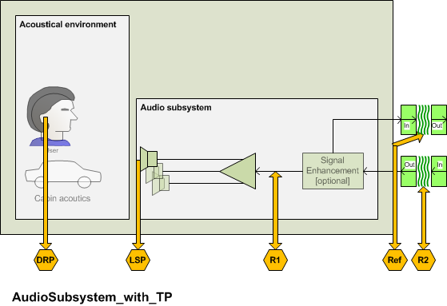
FIGURE

Note – All measurements and requirements are made for stand still or low speed conditions. Any speed or noise dependant equalization, compression or other functionality is not covered by the chapter because this functionality is considerd to be very car specific and no general recommendation can be given.

        - Receive Conversational Gain (RCG)
        - Receive speech quality (MOS-LQO)
        - Receive Intelligibility (RI)
        - Cabin Noise (CN)
        - Receive Input/Output Linearity

Audio subsystem delay

Parameter description
The delay T_{AS} is measured from the test point (R2) to the test point (DRP). The delay T_{AS} should be minimized. The measurement is conducted at nominal volume control setting.
The system delay t_{System} depends on the transmission method used and the delay of the reference interface. The delay t_{System} must be known and deducted from the test result.

Test
1) For the measurements, a composite source signal (CSS) according to [ITU-T P.501] is used. The pseudo random noise (pn)-part of the CSS has to be longer than the maximum expected delay. It is recommended to use a pn sequence of 16 k samples (with 48 kHz sampling rate). The test signal is inserted at test point (S3) at a level according to clause 8.1.5.
The reference signal is the original signal (test signal).
The test set-up is according to clause 8.1.
2) The delay is determined by cross-correlation analysis between the measured signal at the DRP and the original signal. The measurement is corrected by delays which are caused by the test equipment. The measurement is corrected by delays which are caused by the test equipment.
3) The delay is measured in ms and the maximum of the cross-correlation function is used for the determination.

T_{measure} = T_{AS} + T_{System}

Classification of QoS level based on values of this parameter
To claim compliance with a certain QoS class the delay in the send direction has to meet the requirements for the applicable QoS classes for the bidirectional transport delay T_{AS} as defined in table xx:
Table xx –Limits for the audio subsystem delay for speech communication services

QoS Class | T_{AS}
1 | < 7 ms
2 | < 12 ms
3 | < 30 ms
4 | ≥ 30 ms

Design guidance and root-cause analysis
Low delay is essential for a seamless conversational performance especially for highly interactive conversations. Delay also contributes to echo perception: Higher delay low leads to higher impairment resulting even from low level echo components (see ITU-T Rec. G. 111 [xx]). Therefore any design providing as low delay in the connection as possible is preferable. Furthermore higher delays may impair the performance of the echo canceller in the signal enhancement subsystem.

Audio subsystem sensitivity frequency response

Parameter description
The frequency response FR_{AS} is measured from the test point (R2) to the test point (DRP). The measurement is conducted at nominal volume control setting.
The sensitivity response on the audio subsystem should be mostly flat in the entire frequency range.

Test
1) The test signal used for the measurements shall be artificial voice according to [ITU-T P.50]. The test signal level is the nominal signal level , the level is averaged over the complete test signal.
Note: If the signal enhancement subsystem includes an equalization function for the receive path the equalization curve should be determined and applied to the test signal inserted. Such a pre-equalized signal is used for the measurements.
The measured power density spectrum at the test point (R2) interface is used as the reference power density spectrum for determining the audio subsystem sensitivity.
2) The test arrangement is according to clause 8.1. The audio subsystem frequency response is determined in third octave intervals, as given by [IEC 61260] for frequencies of 100 Hz and 8 kHz, inclusive. In each third octave band, the level of the measured signal is referred to the level of the reference signal averaged over the complete test sequence length.
3) The sensitivity is determined in dBPa/V.

Classification of QoS level based on values of this parameter
To claim compliance with a certain QoS class the frequency response has to meet the requirements for the applicable QoS classes for the unidirectional transport FR_{AS} as defined in the tables below:
The masks are drawn by straight lines between the breaking points in Table 8-xx to 8-xx on a logarithmic (frequency) – linear (dB sensitivity) scale.
Table xx – Tolerance mask for the audio subsystem sensitivity frequency response for QoS class 1
100 Hz | 3 dB | –∞ dB
250 Hz | 3 dB | -6 dB
315 Hz | 3 dB | –3 dB
7 000 Hz | 3 dB | –3 dB
8 000 Hz | 3 dB | –∞ dB
NOTE – The limits for intermediate frequencies lie on a straight line drawn between the given values on a linear (dB) – logarithmic (Hz) scale. All sensitivity values are expressed in dB on an arbitrary scale.
Table xx – Tolerance mask for the audio subsystem sensitivity frequency response for QoS class 2
Frequency | Upper limit | Lower limit
100 Hz | 8 dB | –∞ dB
250 Hz | 8 dB | -9 dB
315 Hz | 8 dB | –6 dB
400 Hz | 6 dB | -6 dB
5 000 Hz | 6 dB | -6 dB
7 000 Hz | 6 dB | –9 dB
8 000 Hz | 6 dB | –∞ dB
NOTE – The limits for intermediate frequencies lie on a straight line drawn between the given values on a linear (dB) – logarithmic (Hz) scale. All sensitivity values are expressed in dB on an arbitrary scale.
Table xx – Tolerance mask for the audio subsystem sensitivity frequency response for QoS class 3
Frequency | Upper limit | Lower limit
100 Hz | 8 dB | –∞ dB
250 Hz | 8 dB | -∞ dB
315 Hz | 8 dB | –9 dB
400 Hz | 6 dB | -6 dB
5 000 Hz | 6 dB | -9 dB
7 000 Hz | 6 dB | –12 dB
8 000 Hz | 6 dB | –∞ dB
NOTE – The limits for intermediate frequencies lie on a straight line drawn between the given values on a linear (dB) – logarithmic (Hz) scale. All sensitivity values are expressed in dB on an arbitrary scale.
Table xx – Tolerance mask for the audio subsystem sensitivity frequency response for QoS class 4
Frequency | Upper limit | Lower limit
100 Hz | N/A | N/A
250 Hz | N/A | N/A
315 Hz | N/A | N/A
400 Hz | N/A | N/A
5 000 Hz | N/A | N/A
7 000 Hz | N/A | N/A
8 000 Hz | N/A | N/A
NOTE – The limits for intermediate frequencies lie on a straight line drawn between the given values on a linear (dB) – logarithmic (Hz) scale. All sensitivity values are expressed in dB on an arbitrary scale.

Design guidance and root-cause analysis
Deviations from a flat frequency response characteristics may cause degradation of the listening speech quality in the receive direction or may result in insufficient listening speech quality. A flat frequency response mostly contributes to a good customer experience in the car.

Audio subsystem speech quality

Parameter description
The unirectional transport listening speech quality LQ_{AS} is measured from the test point (R2) to the test point (DRP). The measurement is conducted at nominal and at maximum volume control setting.
The test is intended to determine any impairment of the listening speech quality introduced by the unidirectional transport.

Test
The tests method to be used is ITU-T Recommendation P.863. NOTE: ITU-T Recommendation P.863 [xx] does not provide a wideband mode. Wideband systems are evaluated on a superwideband scale. Therefore the MOS Requirements are given in MOS-LQOsw. See P.863 for more information.

1) The test signals used are the English test sequences as specified in [ITU-T P.501] (2 male speakers, 2 female speakers, two sentences each). The test signal level is the nominal signal level, measured at the test point (R2), the test signal level is measured as "active speech level" according to [ITU-T P.56]. The speech activity should be between 30% and 70%.
The original speech signal is used as the reference signal for the determination of the speech quality.
Note: If the signal enhancement subsystem includes an equalization function for the receive path the equalization curve should be determined and applied to the test signal inserted. Such a pre-equalized signal is used for the measurements.
2) The test arrangement is according to clause 8.1. For wideband systems MOS-LQOsw is determined. For narrowband systems MOS-LQOn is determined
The calculation is made using the signal recorded at the test point (DRP).

Classification of QoS level based on values of this parameter
To claim compliance with a certain QoS class the listening speech quality has to meet the requirements for the applicable QoS classes as given in the table below:
Table xx –Limits for the audio subsystem listening speech quality at nominal volume control setting

QoS Class | MOS-LQOn | MOS-LQOsw
1 | > 4.2 | > 4.5
2 | > 3.8 | > 4.1
3 | > 3.4 | > 3.7
4 | ≤ 3.4 | ≤ 3.7

Table xx –Limits for the audio subsystem listening speech quality at maximum volume control setting

QoS Class | MOS-LQOn | MOS-LQOsw
1 | > 4.2 | > 4.5
2 | > 3.8 | > 4.1
3 | > 3.4 | > 3.7
4 | ≤ 3.4 | ≤ 3.7

Design guidance and root-cause analysis
No additional impairment on listening speech quality should be introduced by the audio subsystem. Any degradation of listening speech quality will deteriorate the overall listening speech quality for the user in the car and should be avoided. Therefore the listening speech quality under quiet conditions is checked.

Audio subsystem idle channel noise

Parameter description
The unidirectional transport idle channel noise in N_{AS} is measured from the test point (R2) to the test point (DRP). The measurement is conducted at nominal and at maximum volume control setting.

Test
1) Artificial voice with an average signal level of -16 dBm0 [ITU-T P.50] is applied at the test point (R2). The test signal level is the average level of the complete test signal. The output level is measured using a speech level voltmeter according to ITU-T P.56. This level is the reference speech signal level.

2) For the noise measurement, no test signal is used. However, all sources which potentially contribute to noise at the output of the unidirectional transport as GSM noise, electrical noise introduced by the car must be considered. In order to ensure a reliable activation, an activation signal is inserted before the actual measurement. The activation signal consists of a sequence of 4 composite source signals according to [ITU-T P.501]. The level of the activation signal is –16 dBm0.
3) The test arrangement is according to clause 8.1.
The idle channel noise is measured at the output in the frequency range between 100 Hz and 8 kHz. The measurement requires a time window which starts exactly at the end of the activation signal. Any "ringing" of filters or receivers shall be taken into account, the time window must be shifted accordingly. The length of the time window is 1 second which is the averaging time for the idle channel noise. The test lab has to ensure the correct activation of the audio subsystem during the measurement. If the audio subsystem is deactivated during measurement, the measurement window has to be cut to the duration when the Audio subsystem remains activated.
The power density spectrum of the noise signal is determined using FFT (8 k samples/48 kHz sampling rate or equivalent). A Hann window is used.
If it is known that the audio subsystem stays activated without any activation signal, no activation signal is required. In this case, a simple noise measurement is conducted.
4) The idle channel noise is determined by A-weighting and referring to the reference speech signal level as determined with artificial voice. Spectral peaks are measured in the frequency domain. The average noise spectrum used for determining the spectral peak should be calculated as the arithmetic mean of the noise spectrum values when stated in dBVP.

Classification of QoS level based on values of this parameter
To claim compliance with a certain QoS class the speech to idle noise ratio SINR has to meet the requirements for the applicable QoS classes for the SINR as defined in table xx:
Spectral peaks in the frequency domain shall not exceed the averaged spectrum by more than 10 dB.

Table xx –Limits for the idle channel noise re. reference speech signal level at nominal volume control setting

QoS Class | SINR
1 | > 70 dB
2 | > 60 dB
3 | > 40 dB
4 | ≤ 40 dB
Table xx –Limits for the idle channel noise re. reference speech signal level at maximum volume control setting

QoS Class | SINR
1 | > 70 dB
2 | > 60 dB
3 | > 40 dB
4 | ≤ 40 dB

Design guidance and root-cause analysis
Check shielding, connectors and cabling with respect to potentially induced interfering signals. Check quality of amplifiers used to insert signals and preamplifiers used to receive signals. Check power amplifiers. Verify that preamplifiers do not demodulate RF into NF, If upsampling is used check artefacts due to upsampling

Coupling between acoustical subsystems (echo path)
The focus of this test is to measure the electroacoustic coupling between loudspeaker and microphone. The test is targeted to optimize, positioning, packaging and type of microphone/speakers used by the hands-free system. The access points should be chosen as close as possible to the electro-acoustical components.
If speech enhancement is provided in the microphone subsystem, the measurement is conducted at S2.
Speech-to-Echo Ratio (SpER)
        - Echo Tail Delay (ETD)
        - Echo Tail coherence (ETco)
        - Check time invariance of processing (e.g. fixed beamformer…)

Signal Enhancement Subsystem

Ideally the access to the signal enhancement subsystem is made using the S3/R3 interface. However, if these interfaces are not available the S4/R4 or S5/R5 interface can be used applying the same requirements.

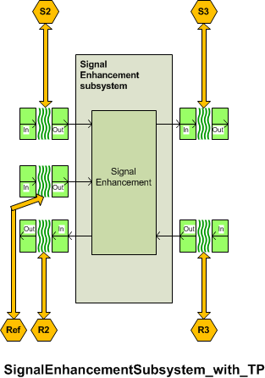

Send path
        - Enhanced Send Speech Level (SSLE)
        - Enhanced Speech-to-Noise Ratio (SpNRE)
        - Equalized Send Frequency Response (SFRE)
        - Enhanced Send ReVerberation (SRVE)
        - Enhanced Send Distortion + Noise (SDNE)

Echo path
        - Enhanced Speech-to-Echo Ratio (SpERE)
        - Enhancement layer Round-Trip Delay (RTDE)

Receive path
        - Enhanced Receive Speech Level (RSLE)
        - Enhanced Receive speech quality (MOS-LQOE)
        - Enhanced Receive Intelligibility (RIE)

Network Access Subsystem

Send path
        - Enhanced Send Speech Level (SSLE)
        - Enhanced Speech-to-Noise Ratio (SpNRE)
        - Equalized Send Frequency Response (SFRE)
        - Enhanced Send ReVerberation (SRVE)
        - Enhanced Send Distortion + Noise (SDNE)

Echo path
        - Enhanced Speech-to-Echo Ratio (SpERE)
        - Enhancement layer Round-Trip Delay (RTDE)

Receive path
        - Enhanced Receive Speech Level (RSLE)
        - Enhanced Receive speech quality (MOS-LQOE)
        - Enhanced Receive Intelligibility (RIE)

Send-receive path coupling

      - See section in P.1100

- Acoustic interface
  - For each measurement parameter:
    - Parameter description
    - Test method
    - Single Pass/Fail or multiple thresholds of degradation for measured value
- Speech enhancement layer
  - For each measurement parameter:
    - Parameter description
    - Test method
    - Classification of QoS level based on values of this parameter
    - Design guidance and root-cause analysis
- Local transport
  - For each measurement parameter:
    - Parameter description
    - Test method
    - Classification of QoS level based on values of this parameter
    - Design guidance and root-cause analysis
- Network transport
  - For each measurement parameter:
    - Parameter description
    - Test method
    - Classification of QoS level based on values of this parameter
    - Design guidance and root-cause analysis

Bidirectional Signal Transport: Wired and Short range Wireless Transmission
The purpose of this section is to ensure linearity (as far as possible) and time invariance of a bidirectional signal transport over a wired or a short range wireless transmission system. Any bidirectional signal transport system including the network transport system in conjunction with the devices it is integrated in should not introduce any additional signal processing. Any other function than pure speech data transmission should be avoided.
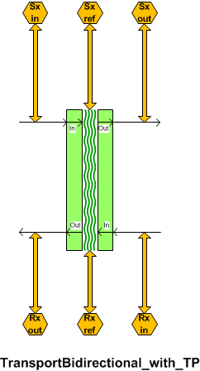
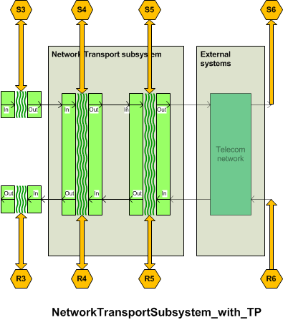

The DUT is connected to the reference interfaces. The reference interfaces are calibrated as specified in clause 8.1.

Bidirectional transport delay in send direction

Parameter description
The delay in send direction T_{BDS} is measured from the test point (S3) to the test point (S4) or to the POI (input of the reference speech coder of the system simulators) test point(S5). The test point (S3) may be the SRWAP. The delay T_{BDS} should be minimized.
The system delay t_{System} depends on the transmission method used, the delay of the reference interface and the network simulator. The delay t_{System} must be known and deducted from the test result.

Test
1) For the measurements, a composite source signal (CSS) according to [ITU-T P.501] is used. The pseudo random noise (pn)-part of the CSS has to be longer than the maximum expected delay. It is recommended to use a pn sequence of 16 k samples (with 48 kHz sampling rate). The test signal is inserted at test point (S3) at a level according to clause 8.1.5.
The reference signal is the original signal (test signal).
The test set-up is according to clause 9.1.
2) The delay is determined by cross-correlation analysis between the measured signal at the electrical access point and the original signal. The measurement is corrected by delays which are caused by the test equipment.
3) The delay is measured in ms and the maximum of the cross-correlation function is used for the determination.

T_{measure} = T_{BDS} + T_{System}

Classification of QoS level based on values of this parameter
To claim compliance with a certain QoS class the delay in the send direction has to meet the requirements for the applicable QoS classes for the bidirectional transport delay T_{BDS} as defined in table xx:
Table xx –Limits for the bidirectional transport delay in send direction for speech communication services

QoS Class | T_{BDS}
1 | < 2 ms
2 | < 10 ms
3 | < 30 ms
4 | ≥ 30 ms

Design guidance and root-cause analysis
Low delay is essential for a seamless conversational performance especially for highly interactive conversations. Delay also contributes to echo perception: Higher delay low leads to higher impairment resulting even from low level echo components (see ITU-T Rec. G. 111 [xx]). Therefore any design providing as low delay in the connection as possible is preferable.

Bidirectional transport delay in receive direction

Parameter description
The delay in receive direction T_{BDR} is measured from the test point (R4) or the POI (input of the reference speech coder of the system simulators) (R5) to the test point (R3) which may be the SRWAP (R3).
The system delay t_{System} depends on the transmission system, the delay of the reference interface and on the network simulator used. The delay t_{System} must be known and deducted from the test result.

Test
1) For the measurements, a composite source signal (CSS) according to [ITU-T P.501] is used. The pseudo random noise (pn)-part of the CSS has to be longer than the maximum expected delay. It is recommended to use a pn sequence of 16 k samples (with 48 kHz sampling rate). The test signal is applied at test point (R4) or the test point (R5) at a level according to clause 8.1.5.
The reference signal is the original signal (test signal).
2) The test arrangement is according to clause 9.1.
3) The delay is determined by cross-correlation analysis between the measured signal at the SRWR and the original signal. The measurement is corrected by delays which are caused by the test equipment.
4) The delay is measured in ms and the maximum of the cross-correlation function is used for the determination.
T_{measure} = T_{BDR} + T_{System}

Classification of QoS level based on values of this parameter
To claim compliance with a certain QoS class the delay in the receive direction has to meet the requirements for the applicable QoS classes for the bidirectional transport delay T_{BDR} as defined in table xx:
Table xx –Limits for the bidirectional transport delay in receive direction for speech communication services

QoS Class | T_{BDR}
1 | < 2 ms
2 | < 10 ms
3 | < 30 ms
4 | ≥ 30 ms

Design guidance and root-cause analysis
Low delay is essential for a seamless conversational performance especially for highly interactive conversations. Delay also contributes to echo perception: Higher delay low leads to higher impairment resulting even from low level echo components (see ITU-T Rec. G. 111 [xx]). Therefore any design providing as low delay in the connection as possible is preferable.

Bidirectional transport send junction loudness ratings

Parameter description
The send junction loudness rating JLR_{BDS} is measured from the test point (S3) to the test point (S4) or to the POI (input of the reference speech coder of the system simulators) (S5). The test point (S3) may be the SRWAP.
The JLR describes any amplification or attenuation on the network transport layer. The send junction loudness rating JLR_{BDS} should be 0 dB.

Test
1) The test signal used for the measurements shall be CSS according to [ITU-T P.501]. The test signal level is the nominal signal level, the level is averaged over the complete test signal.
The measured power density spectrum at the test point interface (S3)is used as the reference power-density spectrum for determining the bidirectional transport send sensitivity.
2) The test arrangement is according to clause 9.1. For wideband the bidirectional send sensitivity is calculated from each band of the 20 frequencies given in Table A.2 of [ITU-T P.79], bands 1-20. For narrowband bands 4-17 are used for calculation.
For the calculation, the average measured level at the electrical reference point for each frequency band is referred to the average test signal level measured in each frequency band at the reference interface.
3) The sensitivity is expressed in dBV/V, the junction loudness rating JLR_{BDS} shall be calculated according to [ITU-T P.79], Formula A-23d, bands 1-20, M = 0.175, and the weighting factors W_{J} for JLR according to Table A.2 of [ITU-T P.79]. For narrowband bands 4-17 are used for the calculation.

Classification of QoS level based on values of this parameter
To claim compliance with a certain QoS class the JLR in send has to meet the requirements for the applicable QoS classes for the bidirectional transport JLR_{BDS} as defined in table xx:
Table xx –Limits for the bidirectional transport JLR in send

QoS Class | JLR_{BDS}
1 | 0 ± 0.5 dB
2 | 0 ± 3 dB
3 | 0 ± 6 dB
4 | > ± 6 dB

Design guidance and root-cause analysis
Any deviation of the JLR_{BDS} from 0 dB may result either in insufficient or too high speech levels and thus may deteriorate the performance of the interconnected devices. and should be avoided.
However, it is recognized that different SRW implementations deviate significantly (±6 dB) from this level. In order to maintain a good system performance, appropriate corrections have to be integrated in the hands-free implementation to ensure a good system performance. Based on these tests, appropriate level corrections can be inserted.

Bidirectional transport receive loudness ratings

Parameter description
The receive junction loudness rating JLR_{BDR} is measured from the test point (R4) or the POI (input of the reference speech coder of the system simulators) (R5) to the test point (R3). The test point (R3) may be the SRWAP.
The JLR describes any amplification or attenuation on the network transport layer. The send junction loudness rating JLR_{BDR} should be 0 dB.

Test
1) The test signal used for the measurements shall be CSS according to [ITU-T P.501]. The test signal is the nominal signal level.
2) The test arrangement is according to clause 9.1. For the calculation, the averaged level at the test point (R4) (alternatively R5) interface is used. In wideband the test point receive sensitivity is determined by the bands 1-20 according to Table A.2 of [ITU-T P.79]. For narrowband systems bands 4-17 are used.
For the calculation, the average signal level of each frequency band is referred to the signal level of the reference signal measured in each frequency band.
3) The sensitivity is expressed in dBV/V, the test pointjunction loudness rating in receive JLR_{BDRv} shall be calculated according to [ITU-T P.79], Formula A-23d, bands 1-20, M = 0.175, and the weighting factors W_{J} for JLR according to Table A.2 of [ITU-T P.79]. For narrowband systems bands 4-17 are used for the calculation.

Classification of QoS level based on values of this parameter
To claim compliance with a certain QoS class the JLR in receive has to meet the requirements for the applicable QoS classes for the bidirectional transport JLR_{BDR} as defined in table xx:
Table xx –Limits for the bidirectional transport JLR in receive

QoS Class | JLR_{BDR}
1 | 0 ± 0.5 dB
2 | 0 ± 3 dB
3 | 0 ± 6 dB
4 | > ± 6 dB

Design guidance and root-cause analysis
Any deviation of the JLR_{BDR} from 0 dB may result either in insufficient or too high speech levels and thus may deteriorate the performance of the interconnected devices. and should be avoided.
However, it is recognized that different SRW implementations deviate significantly (±6 dB) from this level. In order to maintain a good system performance, appropriate corrections have to be integrated in the hands-free implementation to ensure a good system performance. Based on these tests, appropriate level corrections can be inserted.

Bidirectional transport linearity in send direction

Parameter description
The linearity of the send junction loudness rating JLR_{BDS} is measured from the test point (S3) to the test point (S4) or to the POI (input of the reference speech coder of the system simulators) (S5). The test point (S3) may be the SRWAP.
The test is aimed to detect any amplitude non-linearities including AGC or companding.

Test
1) The test signal used for the measurements shall be CSS according to [ITU-T P.501]. The test signals are in the range of –40 dBV to 5 dBV in steps of 5 dB relative to the nominal signal level, measured at the test point (S3). The test signal level is the average level of the complete test signal.
The measured power density spectrum at the test point (S3) is used as the reference power-density spectrum for determining the send sensitivity.
2) The test arrangement is according to clause 9.1. In wideband the test point send sensitivity is calculated from each band of the 20 frequencies given in Table A.2 of [ITU-T P.79], bands 1-20. For narrowband systems bands 4-17 are used.
For the calculation, the average measured level at the electrical reference point for each frequency band is referred to the average test signal level measured in each frequency band at the test point (S3) reference interface.
3) In wideband the sensitivity is expressed in dBV/V, the bidirectional junction loudness rating JLR_{BDS} shall be calculated according to [ITU-T P.79], Formula A-23d, bands 1-20, M = 0.175, and the weighting factors in send direction according to Table A.2 of [ITU-T P.79]. For narrowband systems bands 4-17 are used for the calculation.

Classification of QoS level based on values of this parameter
To claim compliance with a certain QoS class the JLR in send has to meet the requirements for the applicable QoS classes as defined in table xx. The bidirectional transport JLR_{BDS} deviation is measured relative to the measured JLR_{BDSnom} measured with nominal signal level:
Table xx –Limits for the bidirectional transport linearity in the send direction

QoS Class | Input signal level range | JLR_{BDS} re JLR_{BDSnom}
1 | –40 dB/+5 dB | 0 ± 0.5 dB
2 | –40 dB/+5 dB | 0 ± 3 dB
3 | –40 dB/+5 dB | 0 ± 6 dB
4 | –40 dB/+5 dB | > ± 6 dB

Design guidance and root-cause analysis
Any AGC or companding on the network transport should be avoided. Additional non-linearities of this type may counteract algorithms implemented in the signal processing subsystem and deteriorate it’s performance.

Bidirectional transport linearity in receive direction

Parameter description
The linearity of receive junction loudness rating JLR_{BDR} is measured from the test point (R4) or the POI (input of the reference speech coder of the system simulators) (R5) to the test point (R3). The test point (R3) may be the SRWAP.
The test is aimed to detect any amplitude non-linearities including AGC or companding.

Test
1) The test signal used for the measurements shall be CSS according to [ITU-T P.501]. The test signals are in the range of –40 dBV to 5 dBV in steps of 5 dB relative to the nominal signal level measured at test point (R4) (alternatively R5) . The test signal level is the average level of the complete test signal.
The measured power density spectrum at the test point (R4) (alternatively R5) is used as the reference power-density spectrum for determining the receive sensitivity.
2) In wideband the test arrangement is according to clause 9.1. The test point receive sensitivity is calculated from each band of the 20 frequencies given in Table A.2 of [ITU-T P.79], bands 1-20. For narrowband bands 4-17 are used.
For the calculation, the average measured level at the test point for each frequency band is referred to the average test signal level measured in each frequency band at the electrical reference interface.
3) The sensitivity is expressed in dBV/V, the bidirectional transport junction loudness rating JLR_{BDS} shall be calculated according to [ITU-T P.79], Formula A-23d, bands 1-20, M = 0.175, and the weighting factors in send direction according to Table A.2 of [ITU-T P.79]. For narrowband bands 4-17 are used for the calculation.

Classification of QoS level based on values of this parameter
To claim compliance with a certain QoS class the JLR in receive has to meet the requirements for the applicable QoS classes as defined in table xx. The bidirectional transport JLR_{BDR} deviation is measured relative to the measured JLR_{BDRnom} measured with nominal signal level:
Table xx –Limits for the bidirectional transport linearity in the receive direction

QoS Class | Input signal level range | JLR_{BDR} re JLR_{BDRnom}
1 | –40 dB/+5 dB | 0 ± 0.5 dB
2 | –40 dB/+5 dB | 0 ± 3 dB
3 | –40 dB/+5 dB | 0 ± 6 dB
4 | –40 dB/+5 dB | > ± 6 dB

Design guidance and root-cause analysis
Any AGC or companding on the network transport should be avoided. Additional non-linearities of this type may counteract algorithms implemented in the signal processing subsystem and deteriorate it’s performance.

Bidirectional transport send sensitivity frequency response

Parameter description
The send frequency response FR_{BDS} is measured from the test point (S3) to the test point (S4) or to the POI (input of the reference speech coder of the system simulators) (S5). The test point (S3) may be the SRWAP.The send sensitivity response on the network transport should be mostly flat in the entire frequency range in order not to interfere with any (wanted) response characteristic in the signal processing subsystem or the acoustical frontend.

Test
1) The test signal used for the measurements shall be artificial voice according to [ITU-T P.50]. The test signal level is the nominal signal level , the level is averaged over the complete test signal.
The measured power density spectrum at the test point (S3) interface is used as the reference power density spectrum for determining the bidirectional transport send sensitivity.
2) The test arrangement is according to clause 9.1. In wideband the bidirectional send sensitivity is determined in third octave intervals, as given by [IEC 61260] for frequencies of 100 Hz and 8 kHz, inclusive. In narrowband it is determined for frequencies from 200 Hz to 4kHz. In each third octave band, the level of the measured signal is referred to the level of the reference signal averaged over the complete test sequence length.
3) The sensitivity is determined in dBV/V.

Classification of QoS level based on values of this parameter
To claim compliance with a certain QoS class the frequency response in send has to meet the requirements for the applicable QoS classes for the bidirectional transport FR_{BDS} as defined in the tables below:
The masks are drawn by straight lines between the breaking points in Table 9-xx to 9-xx on a logarithmic (frequency) – linear (dB sensitivity) scale.
Table xx – Tolerance mask for the bidirectional transport wideband send sensitivity frequency response for QoS class 1
Frequency (Hz) | Upper limit | Lower limit
50 | 0.5 | –0.5
6 200 | 0.5 | –0.5
7 000 | 0.5 | –3
NOTE – All sensitivity values are expressed in dB on an arbitrary scale.

Table xx – Tolerance mask for the bidirectional transport wideband send sensitivity frequency response for QoS class 2
Frequency (Hz) | Upper limit | Lower limit
100 | 2 | –2
6 200 | 2 | –2
7 000 | 2 | –5
NOTE – All sensitivity values are expressed in dB on an arbitrary scale.

Table xx – Tolerance mask for the bidirectional transport wideband send sensitivity frequency response for QoS class 3
Frequency (Hz) | Upper limit | Lower limit
100 | 4 | –4
6 200 | 4 | –4
7 000 | 4 | –9
NOTE – All sensitivity values are expressed in dB on an arbitrary scale.
Table xx – Tolerance mask for the bidirectional transport wideband send sensitivity frequency response for QoS class 4
Frequency (Hz) | Upper limit | Lower limit
100 | NA | NA
6 200 | NA | NA
7 000 | NA | NA
NOTE – There is no frequency tolerance mask requirement for class 4.
Table xx – Tolerance mask for the bidirectional transport narrowband send sensitivity frequency response for QoS class 1
Frequency (Hz) | Upper limit | Lower limit
50 | 0.5 | –0.5
3 100 | 0.5 | –0.5
3 500 | 0.5 | –3
NOTE – All sensitivity values are expressed in dB on an arbitrary scale.

Table xx – Tolerance mask for the bidirectional transport narrowband send sensitivity frequency response for QoS class 2
Frequency (Hz) | Upper limit | Lower limit
100 | 2 | –2
3 100 | 2 | –2
3 500 | 2 | –5
NOTE – All sensitivity values are expressed in dB on an arbitrary scale.

Table xx – Tolerance mask for the bidirectional transport narrowband send sensitivity frequency response for QoS class 3
Frequency (Hz) | Upper limit | Lower limit
100 | 4 | –4
3 100 | 4 | –4
3 500 | 4 | –9
NOTE – All sensitivity values are expressed in dB on an arbitrary scale.
Table xx – Tolerance mask for the bidirectional transport narrowband send sensitivity frequency response for QoS class 4
Frequency (Hz) | Upper limit | Lower limit
100 | NA | NA
3 100 | NA | NA
3 500 | NA | NA
NOTE – There is no frequency tolerance mask requirement for class 4.

Design guidance and root-cause analysis
Deviations from a flat frequency response characteristics may cause degradation of the listening speech quality in the send direction or may result in insufficient listening speech quality in the presence of background noise which affects the listing speech quality perceived by the far end subscriber.

Bidirectional transport receive sensitivity frequency response

Parameter description
The receive frequency response FR_{BDR} is measured from the test point (R4) or the POI (input of the reference speech coder of the system simulators) (R5) to the test point (R3). The test point (R3) may be the SRWAP.

Test
1) The test signal used for the measurements shall be artificial voice according to [ITU-T P.50]. The test signal is the nominal signal level, measured at the test point (R4) (alternatively R5) and averaged over the complete test signal sequence.
2) The test arrangement is according to clause 9.1. For wideband the bidirectional transport receive sensitivity is determined in third octave intervals as given by [IEC 61260] for frequencies of 100 Hz and 8 kHz, inclusive. In narrowband it is determined for frequencies from 200 Hz to 4kHz. In each third octave band, the level of the measured signal is referred to the level of the reference signal, averaged over the complete test sequence length.
3) The sensitivity is determined in dBV/V.

Classification of QoS level based on values of this parameter
To claim compliance with a certain QoS class the frequency response in send has to meet the requirements for the applicable QoS classes for the bidirectional transport FR_{BDR} as defined in the tables below:
The masks are drawn by straight lines between the breaking points in Table 9-xx to 9-xx on a logarithmic (frequency) – linear (dB sensitivity) scale.
Table xx – Tolerance mask for the bidirectional transport wideband receive sensitivity frequency response for QoS class 1
Frequency (Hz) | Upper limit | Lower limit
50 | 0.5 | –0.5
6 200 | 0.5 | –0.5
7 000 | 0.5 | –3
NOTE – All sensitivity values are expressed in dB on an arbitrary scale.

Table xx – Tolerance mask for the bidirectional transport wideband receive sensitivity frequency response for QoS class 2
Frequency (Hz) | Upper limit | Lower limit
100 | 2 | –2
6 200 | 2 | –2
7 000 | 2 | –5
NOTE – All sensitivity values are expressed in dB on an arbitrary scale.

Table xx – Tolerance mask for the bidirectional transport wideband receive sensitivity frequency response for QoS class 3
Frequency (Hz) | Upper limit | Lower limit
100 | 4 | –4
6 200 | 4 | –4
7 000 | 4 | –9
NOTE – All sensitivity values are expressed in dB on an arbitrary scale.
Table xx – Tolerance mask for the bidirectional transport wideband receive sensitivity frequency response for QoS class 4
Frequency (Hz) | Upper limit | Lower limit
100 | NA | NA
6 200 | NA | NA
7 000 | NA | NA
NOTE – There is no frequency tolerance mask requirement for class 4.

Table xx – Tolerance mask for the bidirectional transport narrowband receive sensitivity frequency response for QoS class 1
Frequency (Hz) | Upper limit | Lower limit
50 | 0.5 | –0.5
3 100 | 0.5 | –0.5
3 500 | 0.5 | –3
NOTE – All sensitivity values are expressed in dB on an arbitrary scale.

Table xx – Tolerance mask for the bidirectional transport wideband receive sensitivity frequency response for QoS class 2
Frequency (Hz) | Upper limit | Lower limit
100 | 2 | –2
3 100 | 2 | –2
3 500 | 2 | –5
NOTE – All sensitivity values are expressed in dB on an arbitrary scale.

Table xx – Tolerance mask for the bidirectional transport wideband receive sensitivity frequency response for QoS class 3
Frequency (Hz) | Upper limit | Lower limit
100 | 4 | –4
3 100 | 4 | –4
3 500 | 4 | –9
NOTE – All sensitivity values are expressed in dB on an arbitrary scale.
Table xx – Tolerance mask for the bidirectional transport narrowband receive sensitivity frequency response for QoS class 4
Frequency (Hz) | Upper limit | Lower limit
100 | NA | NA
3 100 | NA | NA
3 500 | NA | NA
NOTE – There is no frequency tolerance mask requirement for class 4.

Design guidance and root-cause analysis
Deviations from a flat frequency response characteristics may cause degradation of the listening speech quality in the receive direction or may result in insufficient listening speech quality in the presence of background noise which affects the listing speech quality perceived by the subscriber in the car.

Bidirectional transport idle channel noise in send

Parameter description
The bidirectional transport idle channel noise in send N_{BDS} is measured from the test point (S3) to the test point (S4) or to the POI (input of the reference speech coder of the system simulators) (S5). The test point (S3) may be the SRWAP.

Test
1) Artificial voice with an average signal level of -16 dBm0 [ITU-T P.50] is applied at the test point (S3). The test signal level is the average level of the complete test signal. The output level is measured using a speech level voltmeter according to ITU-T P.56. This level is the reference speech signal level.

2) For the noise measurement, no test signal is used. However, all sources which potentially contribute to noise at the output of the bidirectional transport as GSM noise, electrical noise introduced by the car must be considered. In order to ensure a reliable activation, an activation signal is inserted before the actual measurement. The activation signal consists of a sequence of 4 composite source signals according to [ITU-T P.501]. The level of the activation signal is –16 dBm0.
3) The test arrangement is according to clause 9.1.
The idle channel noise is measured at the output in the frequency range between 100 Hz and 8 kHz. The measurement requires a time window which starts exactly at the end of the activation signal. Any "ringing" of filters or receivers shall be taken into account, the time window must be shifted accordingly. The length of the time window is 1 second which is the averaging time for the idle channel noise. The test lab has to ensure the correct activation of the bidirectional transport during the measurement. If the bidirectional transport is deactivated during measurement, the measurement window has to be cut to the duration when the transport system remains activated.
The power density spectrum of the noise signal is determined using FFT (8 k samples/48 kHz sampling rate or equivalent). A Hann window is used.
If it is known that the bidirectional transport stays activated without any activation signal, no activation signal is required. In this case, a simple noise measurement is conducted.
4) The idle channel noise is determined by A-weighting and referring to the reference speech signal level as determined with artificial voice. Spectral peaks are measured in the frequency domain. The average noise spectrum used for determining the spectral peak should be calculated as the arithmetic mean of the noise spectrum values when stated in dBVP.

Classification of QoS level based on values of this parameter
To claim compliance with a certain QoS class the speech to idle noise ratio SINR has to meet the requirements for the applicable QoS classes for the SINR as defined in table xx:
Spectral peaks in the frequency domain shall not exceed the averaged spectrum by more than 10 dB.

Table xx –Limits for the idle channel noise re. reference speech signal level

QoS Class | SINR
1 | > 70 dB
2 | > 60 dB
3 | > 40 dB
4 | ≤ 40 dB

Design guidance and root-cause analysis
Check shielding, connectors and cabling with respect to potentially induced interfering signals. Check quality of amplifiers used to insert signals and preamplifiers used to receive signals. Verify that preamplifiers do not demodulate RF into NF,

Bidirectional transport idle channel noise in receive

Parameter description
The bidirectional transport idle channel noise in send N_{BDR} is measured from the test point (R4) or the POI (input of the reference speech coder of the system simulators) (R5) to the test point (R3). The test point (R3) may be the SRWAP.

Test
1) Artificial voice with an average signal level of -16 dBm0 [ITU-T P.50] is applied at the test point (R4). The test signal level is the average level of the complete test signal. The output level is measured using a speech level voltmeter according to ITU-T P.56. This level is the reference speech signal level.

2) For the noise measurement, no test signal is used. However, all sources which potentially contribute to noise at the output of the bidirectional transport as GSM noise, electrical noise introduced by the car must be considered. In order to ensure a reliable activation, an activation signal is inserted before the actual measurement. The activation signal consists of a sequence of 4 composite source signals according to [ITU-T P.501]. The level of the activation signal is –16 dBm0.
3) The test arrangement is according to clause 9.1.
The idle channel noise is measured at the output in the frequency range between 100 Hz and 8 kHz. The measurement requires a time window which starts exactly at the end of the activation signal. Any "ringing" of filters or receivers shall be taken into account, the time window must be shifted accordingly. The length of the time window is 1 second which is the averaging time for the idle channel noise. The test lab has to ensure the correct activation of the bidirectional transport during the measurement. If the bidirectional transport is deactivated during measurement, the measurement window has to be cut to the duration when the transport system remains activated.
The power density spectrum of the noise signal is determined using FFT (8 k samples/48 kHz sampling rate or equivalent). A Hann window is used.
If it is known that the bidirectional transport stays activated without any activation signal, no activation signal is required. In this case, a simple noise measurement is conducted.
4) The idle channel noise is determined by A-weighting and referring to the reference speech signal level as determined with artificial voice. Spectral peaks are measured in the frequency domain. The average noise spectrum used for determining the spectral peak should be calculated as the arithmetic mean of the noise spectrum values when stated in dBVP.

Classification of QoS level based on values of this parameter
To claim compliance with a certain QoS class the speech to idle noise ratio SINR has to meet the requirements for the applicable QoS classes for the SINR as defined in table xx:
Spectral peaks in the frequency domain shall not exceed the averaged spectrum by more than 10 dB.

Table xx –Limits for the idle channel noise re. reference speech signal level

QoS Class | SINR
1 | > 70 dB
2 | > 60 dB
3 | > 40 dB
4 | ≤ 40 dB

Design guidance and root-cause analysis
Check shielding, connectors and cabling with respect to potentially induced interfering signals. Check quality of amplifiers used to insert signals and preamplifiers used to receive signals. Verify that preamplifiers do not demodulate RF into NF,

Bidirectional transport noise cancellation test in send direction

Parameter description
The send noise cancellation NC_{BDS} is measured from the test point (S3) to the test point (S4) or to the POI (input of the reference speech coder of the system simulators) (S5). The test point (S3) may be the SRWAP.
The objective of this test is to check whether no noise cancellation is active in send direction of the bidirectional transport.

Test
1) The test arrangement is according to clause 9.1.
2) The test signal used for the measurements shall be pink noise with a duration of 5 s followed by a pause of 3 s, both repeated 3 times. The test signal during the active parts of the signal isthe nominal signal level, the level is averaged over the active parts of the test signal.
3) The level of the transmitted signal is measured at the test point(S4) (alternatively S5) . The measured signal level is referred to the test signal level measured at test point (S3) and displayed vs time. The levels are calculated from the time domain using an integration time of 5 ms.
4) The attenuation vs time is determined for each pink noise section.
–

Classification of QoS level based on values of this parameter
To claim compliance with a certain QoS class the NC in send has to meet the requirements for the applicable QoS classes for the bidirectional transport NC_{BDS} as defined in table xx. The attenuation of the simulated background noise test signal (BGN) shall not deviate more than the given value in the relevant QoS class for all periods of the test signal.
Table xx – Tolerance for the bidirectional transport background noise attenuation

QoS Class | BGN attenuation
1 | <± 1 dB
2 | < ± 2 dB
3 | < ± 6 dB

Design guidance and root-cause analysis
Any activated (tandemed) noise cancellation would interfere with the noise cancellation in the signal processing subsystem and will lead to significant listening speech degradation in the send direction.
If a non-linear or time variant behaviour of the is observed, the tests, as described in ITU-T P.1100 [xx] clause 11.13 (for narrowband systems) or P.1110 [xx] clause 11.13 (for wideband systems), can be applied to determine the behaviour of the bidirectional transport in more detail. Instead of inserting the tests signals acoustically, they have to be inserted electrically.

Bidirectional transport one-way speech quality in send direction

Parameter description
The bidirectional transport listening speech quality in send LQ_{BDS} is measured from the test point (S3) to the test point (S4) or to the POI (input of the reference speech coder of the system simulators) (S5). The test point (S3) may be the SRWAP.
The test is intended to determine any impairment of the listening speech quality introduced by the bidirectional transport.

Test
The tests method to be used is ITU-T Recommendation P.863. NOTE: ITU-T Recommendation P.863 [xx] does not provide a wideband mode. Wideband systems are evaluated on a superwideband scale. Therefore the MOS Requirements are given in MOS-LQOsw. See P.863 for more information.

1) The test signals used are the English test sequences as specified in [ITU-T P.501] (2 male speakers, 2 female speakers, two sentences each). The test signal level is the nominal signal level, measured at thetest point (S3), the test signal level is measured as "active speech level" according to [ITU-T P.56]. The speech activity should be between 30% and 70%.
The original speech signal is used as the reference signal for the determination of the speech quality.
2) The test arrangement is according to clause 9.1. For wideband systems MOS-LQOsw is determined. For narrowband systems MOS-LQOn is determined
The calculation is made using the signal recorded at the test point (S4) (alternatively test point S5).

Classification of QoS level based on values of this parameter
To claim compliance with a certain QoS class the listening speech quality in send has to meet the requirements for the applicable QoS classes as given in the table below:
Table xx –Limits for the bidirectional transport listening speech quality in send

QoS Class | MOS-LQOn | MOS-LQOsw
1 | > 4.2 | > 4.5
2 | > 3.8 | > 4.1
3 | > 3.4 | > 3.7
4 | ≤ 3.4 | ≤ 3.7

Design guidance and root-cause analysis
No additional impairment on listening speech quality should be introduced by the network transport. Any degradation of listening speech quality will deteriorate the overall listening speech quality and should be avoided. Therefore the listening speech quality under quiet conditions is checked.

Bidirectional transport speech quality stability in send direction

Parameter description
The bidirectional transport listening speech quality stability in send LQS_{BDS} is measured from the test point (S3) to the test point (S4) or to the POI (input of the reference speech coder of the system simulators) (S5). The test point (S3) may be the SRWAP.
This test is intended to detect speech quality instabilities due to unreliable connection (speech frame loss....). This test should be repeated in different representative test configurations, e.g. positions of the phone within the vehicle, different SRW links active and different WIFI links active.

Test
Several measurements of MOS-LQOsw (for wideband systems) and MOS-LQOn (for narrowband systems) according to Section xx are performed in series within the same call or for different calls, within the test arrangement defined below. Typically, for the same call, a measurement each 20 s issufficient. The results are reported in terms of statistics.
The procedure is identical for narrowband and wideband systems. In narrowband systems MOS-LQOn ist used, in wideband systems MOS-LQOsw.
The assessment of Listening Speech Quality Stability is preformed in 5 steps:
- To measure the MOS-LQO periodically over the duration of one communication. N measurements provide N MOS-LQO values.
- For each MOS-LQO (i) value i from 2 to N, MOS-LQO_GAP(i) is calculated as the absolute difference with the previous value MOS-LQO (i-1):

MOS-LQO_GAP (i) =| MOS-LQO (i)- MOS-LQO (i-1)|

- In order to take into account the subjective perception and measurement accuracy, MOS-LQO_GAP (i) is set to 0 when the difference is equal or lower to THRESHOLD1:

- if MOS-LQO_GAP (i)> (2*THRESHOLD1), then MOS-LQO_GAP (i)= MOS-LQO_GAP (i)
- if THRESHOLD1 < MOS-LQO_GAP (i) ≦ 2*THRESHOLD1, then MOS-LQO_GAP (i)= [MOS-LQO_GAP (i) * 2] – (2*THRESHOLD1)
- if MOS-LQO_GAP (i)≦ THRESHOLD1, then MOS-LQO_GAP (i)=0

- The instability (INS_MOS-LQO) associated to the MOS-LQO over the whole N measurements is defined by mean value of MOS-LQO_GAP (i).
INS_MOS-LQO=1/(N-1)Σ MOS-LQO_GAP (i) with i=[2:N]

- A linear weighting function is applied in order to express Stability ST-MOS-LQO on a 0 to 100 scale.

This formulation used to determine the Listening Quality Stability (ST-MOS) as

ST-MOS=100-(250* INS_MOS)
and
ST-MOS= 0 if [100-(250* INS_MOS)] < 0

When ST-MOS is calculated within a single call, the call should be longer than 3 minutes (Recommended duration being between 3 and 5 minutes). The duration of each measurement depends on the length of the speech samples used for the test as described in xx
(As an example, if a sample is 15s length and the analysis is done every 20 s a minimum of 10 values will be measured).

Classification of QoS level based on values of this parameter
For the stability indicator about Listening Speech Quality, THRESHOLD1 = 0.1 and the linear weighting function applies in order to express Stability (ST-MOS) on a 0 to 100 scale. By definition Stability equals 100 when no variations occur and Stability ST-MOS equals 0 when MOS-LQO variation is equal or more than 0.4.
To claim compliance with a certain QoS class the listening speech quality stability in send has to meet the requirements for the applicable QoS classes as given in the table below:
Table xx –Limits for the bidirectional transport listening speech quality stability in send

QoS Class | ST-MOSn | ST-MOSsw
1 | > 95 | > 95
2 | > 80 | > 80
3 | > 50 | > 50
4 | ≤ 50 | ≤ 50

Design guidance and root-cause analysis
Listening quality stability during a call (if the position or transmission characteristics change during the call (or during several different calls) takes into account degradations generated on the signal by the transmission link impairment and the phone position.
In case of systems using SRW transmission it is the purpose to verify the integration of SRW radio network by evaluating change of speech quality over time. This will help in detect problems with RF coverage inside the car cabin and verify the error concealment (packet loss, bit errors) caused by weak RF link or interference with other radio.
A guidance to proceed is
1 - Check RF coverage from SRW unit to possible mobile positions (Protocol analyzer)
2 – Identify weak and bad reception areas inside the vehicle. (Protocol analyzer)
Check bit error rate, rate of packet loss …
3 – Use the speech quality measurement to rate the quality of error concealment in the weak areas identified in step 2 above and compare with measurements from areas with good coverage.
4 – Identify possible issues from interference with parallel SRW links or other networks. This will check how the SRW can handle interference and change to undisturbed channels. Speech quality measurements can be used to see the performance of handling these problems.
It’s recommended to use to a known link as reference.

Bidirectional transport one-way speech quality in receive direction

Parameter description
The bidirectional transport listening speech quality in receive LQ_{BDR} is measured from the test point (R4) or the POI (input of the reference speech coder of the system simulators) (R5) to the test point (R3). The test point (R3) may be the SRWAP.
The test is intended to determine any impairment of the listening speech quality introduced by the bidirectional transport.

Test
The tests method to be used is ITU-T Recommendation P.863.
NOTE: ITU-T Recommendation P.863 [xx] does not provide a wideband mode. Wideband systems are evaluated on a superwideband scale. Therefore the MOS Requirements are given in MOS-LQOsw. See P.863 for more information.
1) The test signals used are the English test sequences as specified in [ITU-T P.501] (2 male speakers, 2 female speakers, two sentences each). The test signal level ist the nominal signal level measured at test point (R4), alternatively (R5), the test signal level is measured as "active speech level" according to [ITU-T P.56]. The speech activity should be between 30% and 70%.
The original speech signal is used as the reference signal for the determination of the speech quality.
2) The test arrangement is according to clause 9.1. For wideband systems MOS-LQOsw is determined, for narrowband systems MOS-LQOn. The signal measured at the test point (R3) is used for the calculation

Classification of QoS level based on values of this parameter
To claim compliance with a certain QoS class the listening speech quality in send has to meet the requirements for the applicable QoS classes as given in the table below:
Table xx –Limits for the bidirectional transport listening speech quality in receive

QoS Class | MOS-LQOn | MOS-LQOsw
1 | > 4.2 | > 4.5
2 | > 3.8 | > 4.1
3 | > 3.4 | > 3.7
4 | ≤ 3.4 | ≤ 3.7

Design guidance and root-cause analysis
No additional impairment on listening speech quality should be introduced by the network transport. Any degradation of listening speech quality will deteriorate the overall listening speech quality and should be avoided. Therefore the listening speech quality under quiet conditions is checked.

Bidirectional transport speech quality stability in receive direction

Parameter description
The bidirectional transport listening speech quality in receive LQ_{BDR} is measured from the test point (R4) or the POI (input of the reference speech coder of the system simulators) (R5) to the test point (R3). The test point (R3) may be the SRWAP.
This test is intended to detect speech quality instabilities due to unreliable SRW connection (speech frame loss....). This test should be repeated in different representative positions of the phone within the vehicle, different SRW links active and different WIFI links active.

Test
The test procedure is described in Sectionxx.

Classification of QoS level based on values of this parameter
For the stability indicator about Listening Speech Quality, THRESHOLD1 = 0.1 and the linear weighting function applies in order to express Stability (ST-MOS) on a 0 to 100 scale. By definition Stability equals 100 when no variations occur and Stability ST-MOS equals 0 when MOS-LQO variation is equal or more than 0.4.
To claim compliance with a certain QoS class the listening speech quality stability in send has to meet the requirements for the applicable QoS classes as given in the table below:
Table xx –Limits for the bidirectional transport listening speech quality stability in receive

QoS Class | ST-MOSn | ST-MOSsw
1 | > 95 | > 95
2 | > 80 | > 80
3 | > 50 | > 50
4 | ≤ 50 | ≤ 50

Design guidance and root-cause analysis
Listening quality stability during a call (if the position or transmission characteristics change during the call (or during several different calls) takes into account degradations generated on the signal by the transmission link impairment and the phone position.
In case of systems using SRW transmission it is the purpose to verify the integration of SRW radio network by evaluating change of speech quality over time. This will help in detect problems with RF coverage inside the car cabin and verify the error concealment (packet loss, bit errors) caused by weak RF link or interference with other radio.
A guidance to proceed is
1 - Check RF coverage from SRW unit to possible mobile positions (Protocol analyzer)
2 – Identify weak and bad reception areas inside the vehicle. (Protocol analyzer)
Check bit error rate, rate of packet loss …
3 – Use the speech quality measurement to rate the quality of error concealment in the weak areas identified in step 2 above and compare with measurements from areas with good coverage.
4 – Identify possible issues from interference with parallel SRW links or other networks. This will check how the SRW can handle interference and change to undisturbed channels. Speech quality measurements can be used to see the performance of handling these problems.
It’s recommended to use to a known link as reference.

Verification of bidirectional transport disabled echo control

Parameter description
The bidirectional transport echo control EC_{BD} is measured from the test point (R4) or the POI (input of the reference speech coder of the system simulators) (R5) to the test point (S4) or the POI (input of the reference speech coder of the system simulators) (S5).
No acoustic echo control shall be active in the mobile phone.

Test
1) For the test, an artificial echo path is inserted at thetest point (R4), alternatively (R5). The artificial echo path consists of an attenuation of 20 dB/40 dB and a delay of 20 ms is inserted at the test point (S3/R3) interface. The test set-up is shown in Figure xx:
Figure 12-3 – Test set-up with artificial echo loss
2) The attenuation between the input of the test point (R4) to the output of the test point (R4) is measured using a speech-like test signal. Alternatively the measurement is conducted from the input of test point (R5) to the output of test point (S5).
3) Before the actual measurement, a training sequence consisting of 10 seconds of artificial voice (male) and 10 seconds of artificial voice (female), according to [ITU-T P.50], is inserted. The training sequence level is the nominal signal level.
4) The test signal is a pn sequence, according to [ITU-T P.501], with a length of 4 096 points (48 kHz sampling rate) and a crest factor of 6 dB. The duration of the test signal is 250 ms, the test signal level is -6 dBov as applicable to the individual interface. The low crest factor is achieved by random alternation of the phase between –180° and +180°.
5) TCL_{W} is calculated according to clause B.4 of [ITU-T G.122] (trapezoidal pseudo rule). For the calculation, the average measured echo level at each frequency band is referred to the average level of the test signal measured in each frequency band. For the measurement, a time window has to be applied which is adapted to the duration of the actual test signal (250 ms).
6) The difference between the echo loss measured with 20 dB echo loss and 40 dB echo loss is determined.

Classification of QoS level based on values of this parameter
The difference between the echo loss ELD_{BD} measured with 20 dB echo loss and 40 dB echo loss is measured. To claim compliance with a certain QoS class the listening speech quality stability in send has to meet the requirements for the applicable QoS classes as given in the table below:
Table xx –Limits for the bidirectional transport echo loss difference

QoS Class | ELD_{BDmin} | ELD_{BDmax}
1 | 19.8 dB | 20.2 dB
2 | N.A. | N.A.
3 | N.A. | N.A.
4 | ≤ 19.8 dB | ≥ 20.2 dB

Design guidance and root-cause analysis
Any additional echo cancellation would impair the performance of the acoustic echo cancellation integrated in the signal processing subsystem. As a result additional impairments on speech quality and double talk performance will occur.

Unidirectional Signal Transport: Wired and Short range Wireless Transmission
The purpose of this section is to ensure linearity (as far as possible) and time invariance of the signal transport over wired or a short range wireless transmission system. Any unidirectional transport system in conjunction with the devices it is integrated in should not introduce any additional signal processing. Any other functions than pure speech data transmission should be avoided.

Test setup

The DUT is connected to the reference interfaces. The reference interfaces are calibrated as specified in clause 8.1.

Unidirectional transport delay

Parameter description
The delay T_{UD} is measured from the test point (xx) to the test point (xy). The delay T_{UD} should be minimized.
The system delay t_{System} depends on the transmission method used, the delay of the reference interface and the network simulator. The delay t_{System} must be known and deducted from the test result.

Test
1) For the measurements, a composite source signal (CSS) according to [ITU-T P.501] is used. The pseudo random noise (pn)-part of the CSS has to be longer than the maximum expected delay. It is recommended to use a pn sequence of 16 k samples (with 48 kHz sampling rate). The test signal is inserted at test point (S3) at a level according to clause 8.1.5.
The reference signal is the original signal (test signal).
The test set-up is according to clause 9.1.
2) The delay is determined by cross-correlation analysis between the measured signal at the electrical access point and the original signal. The measurement is corrected by delays which are caused by the test equipment.
3) The delay is measured in ms and the maximum of the cross-correlation function is used for the determination.

T_{measure} = T_{UD} + T_{System}

Classification of QoS level based on values of this parameter
To claim compliance with a certain QoS class the delay in the send direction has to meet the requirements for the applicable QoS classes for the bidirectional transport delay T_{UD} as defined in table xx:
Table xx –Limits for the unidirectional transport delay for speech communication services

QoS Class | T_{UD}
1 | < 2 ms
2 | < 10 ms
3 | < 30 ms
4 | ≥ 30 ms

Design guidance and root-cause analysis
Low delay is essential for a seamless conversational performance especially for highly interactive conversations. Delay also contributes to echo perception: Higher delay low leads to higher impairment resulting even from low level echo components (see ITU-T Rec. G. 111 [xx]). Therefore any design providing as low delay in the connection as possible is preferable.

Unidirectional transport junction loudness ratings

Parameter description
The junction loudness rating JLR_{UD} is measured from the test point (xx) to the test point (xy).
The JLR describes any amplification or attenuation on the transport layer. The junction loudness rating JLR_{UD} should be 0 dB.

Test
1) The test signal used for the measurements shall be CSS according to [ITU-T P.501]. The test signal level is the nominal signal level, the level is averaged over the complete test signal.
The measured power density spectrum at the test point interface (S3)is used as the reference power-density spectrum for determining the unidirectional transport send sensitivity.
2) The test arrangement is according to clause 9.1. For wideband the unidirectional sensitivity is calculated from each band of the 20 frequencies given in Table A.2 of [ITU-T P.79], bands 1-20. For narrowband bands 4-17 are used for calculation.
For the calculation, the average measured level at the electrical reference point for each frequency band is referred to the average test signal level measured in each frequency band at the reference interface.
3) The sensitivity is expressed in dBV/V, the junction loudness rating JLR_{UD} shall be calculated according to [ITU-T P.79], Formula A-23d, bands 1-20, M = 0.175, and the weighting factors W_{J} for JLR according to Table A.2 of [ITU-T P.79]. For narrowband bands 4-17 are used for the calculation.

Classification of QoS level based on values of this parameter
To claim compliance with a certain QoS class the JLR has to meet the requirements for the applicable QoS classes for the bidirectional transport JLR_{UD} as defined in table xx:
Table xx –Limits for the unidirectional transport JLR

QoS Class | JLR_{UD}
1 | 0 ± 0.5 dB
2 | 0 ± 3 dB
3 | 0 ± 6 dB
4 | > ± 6 dB

Design guidance and root-cause analysis
Any deviation of the JLR_{BDS} from 0 dB may result either in insufficient or too high speech levels and thus may deteriorate the performance of the interconnected devices. and should be avoided.
However, it is recognized that different SRW implementations deviate significantly (±6 dB) from this level. In order to maintain a good system performance, appropriate corrections have to be integrated in the hands-free implementation to ensure a good system performance. Based on these tests, appropriate level corrections can be inserted.

Unidirectional transport linearity

Parameter description
The linearity of the junction loudness rating JLR_{UD} is measured from the test point (xx) to the test point (xy)
The test is aimed to detect any amplitude non-linearities including AGC or companding.

Test
1) The test signal used for the measurements shall be CSS according to [ITU-T P.501]. The test signals are in the range of –40 dBV to 5 dBV in steps of 5 dB relative to the nominal signal level, measured at the test point (xx). The test signal level is the average level of the complete test signal.
The measured power density spectrum at the test point (xx) is used as the reference power-density spectrum for determining the send sensitivity.
2) The test arrangement is according to clause 9.1. In wideband the sensitivity is calculated from each band of the 20 frequencies given in Table A.2 of [ITU-T P.79], bands 1-20. For narrowband systems bands 4-17 are used.
For the calculation, the average measured level at the electrical reference point for each frequency band is referred to the average test signal level measured in each frequency band at the test point (xx) reference interface.
3) In wideband the sensitivity is expressed in dBV/V, the bidirectional junction loudness rating JLR_{UD} shall be calculated according to [ITU-T P.79], Formula A-23d, bands 1-20, M = 0.175, and the weighting factors in send direction according to Table A.2 of [ITU-T P.79]. For narrowband systems bands 4-17 are used for the calculation.

Classification of QoS level based on values of this parameter
To claim compliance with a certain QoS class the JLR has to meet the requirements for the applicable QoS classes as defined in table xx. The bidirectional transport JLR_{UD} deviation is measured relative to the measured JLR_{UDnom} measured with nominal signal level:
Table xx –Limits for the bidirectional transport linearity

QoS Class | Input signal level range | JLR_{UD} re JLR_{UDnom}
1 | –40 dB/+5 dB | 0 ± 0.5 dB
2 | –40 dB/+5 dB | 0 ± 3 dB
3 | –40 dB/+5 dB | 0 ± 6 dB
4 | –40 dB/+5 dB | > ± 6 dB

Design guidance and root-cause analysis
Any AGC or companding on the network transport should be avoided. Additional non-linearities of this type may counteract algorithms implemented in the signal processing subsystem and deteriorate its performance.

Unidirectional transport sensitivity frequency response

Parameter description
The frequency response FR_{UD} is measured from the test point (xx) to the test point (xy)
The sensitivity response on the network transport should be mostly flat in the entire frequency range in order not to interfere with any (wanted) response characteristic in the signal processing subsystem or the acoustical frontend.

Test
1) The test signal used for the measurements shall be artificial voice according to [ITU-T P.50]. The test signal level is the nominal signal level , the level is averaged over the complete test signal.
The measured power density spectrum at the test point (xx) interface is used as the reference power density spectrum for determining the unidirectional transport send sensitivity.
2) The test arrangement is according to clause 9.1. In wideband the unidirectional send sensitivity is determined in third octave intervals, as given by [IEC 61260] for frequencies of 100 Hz and 8 kHz, inclusive. In narrowband it is determined for frequencies from 200 Hz to 4kHz. In each third octave band, the level of the measured signal is referred to the level of the reference signal averaged over the complete test sequence length.
3) The sensitivity is determined in dBV/V.

Classification of QoS level based on values of this parameter
To claim compliance with a certain QoS class the frequency response has to meet the requirements for the applicable QoS classes for the unidirectional transport FR_{UD} as defined in the tables below:
The masks are drawn by straight lines between the breaking points in Table 9-xx to 9-xx on a logarithmic (frequency) – linear (dB sensitivity) scale.
Table xx – Tolerance mask for the unidirectional transport wideband sensitivity frequency response for QoS class 1
Frequency (Hz) | Upper limit | Lower limit
50 | 0.5 | –0.5
6 200 | 0.5 | –0.5
7 000 | 0.5 | –3
NOTE – All sensitivity values are expressed in dB on an arbitrary scale.

Table xx – Tolerance mask for the unidirectional transport wideband sensitivity frequency response for QoS class 2
Frequency (Hz) | Upper limit | Lower limit
100 | 2 | –2
6 200 | 2 | –2
7 000 | 2 | –5
NOTE – All sensitivity values are expressed in dB on an arbitrary scale.

Table xx – Tolerance mask for the unidirectional transport wideband sensitivity frequency response for QoS class 3
Frequency (Hz) | Upper limit | Lower limit
100 | 4 | –4
6 200 | 4 | –4
7 000 | 4 | –9
NOTE – All sensitivity values are expressed in dB on an arbitrary scale.
Table xx – Tolerance mask for the unidirectional transport wideband sensitivity frequency response for QoS class 4
Frequency (Hz) | Upper limit | Lower limit
100 | NA | NA
6 200 | NA | NA
7 000 | NA | NA
NOTE – There is no frequency tolerance mask requirement for class 4.
Table xx – Tolerance mask for the unidirectional transport narrowband sensitivity frequency response for QoS class 1
Frequency (Hz) | Upper limit | Lower limit
50 | 0.5 | –0.5
3 100 | 0.5 | –0.5
3 500 | 0.5 | –3
NOTE – All sensitivity values are expressed in dB on an arbitrary scale.

Table xx – Tolerance mask for the unidirectional transport narrowband sensitivity frequency response for QoS class 2
Frequency (Hz) | Upper limit | Lower limit
100 | 2 | –2
3 100 | 2 | –2
3 500 | 2 | –5
NOTE – All sensitivity values are expressed in dB on an arbitrary scale.

Table xx – Tolerance mask for the unidirectional transport narrowband sensitivity frequency response for QoS class 3
Frequency (Hz) | Upper limit | Lower limit
100 | 4 | –4
3 100 | 4 | –4
3 500 | 4 | –9
NOTE – All sensitivity values are expressed in dB on an arbitrary scale.
Table xx – Tolerance mask for the unidirectional transport narrowband sensitivity frequency response for QoS class 4
Frequency (Hz) | Upper limit | Lower limit
100 | NA | NA
3 100 | NA | NA
3 500 | NA | NA
NOTE – There is no frequency tolerance mask requirement for class 4.

Design guidance and root-cause analysis
Deviations from a flat frequency response characteristics may cause degradation of the listening speech quality in the send direction or may result in insufficient listening speech quality in the presence of background noise which affects the listing speech quality perceived by the far end subscriber.

Unidirectional transport idle channel noise

Parameter description
The unidirectional transport idle channel noise in N_{UD} is measured from the test point (Sxx) to the test point (Sxy).

Test
1) Artificial voice with an average signal level of -16 dBm0 [ITU-T P.50] is applied at the test point (S3). The test signal level is the average level of the complete test signal. The output level is measured using a speech level voltmeter according to ITU-T P.56. This level is the reference speech signal level.

2) For the noise measurement, no test signal is used. However, all sources which potentially contribute to noise at the output of the unidirectional transport as GSM noise, electrical noise introduced by the car must be considered. In order to ensure a reliable activation, an activation signal is inserted before the actual measurement. The activation signal consists of a sequence of 4 composite source signals according to [ITU-T P.501]. The level of the activation signal is –16 dBm0.
3) The test arrangement is according to clause 9.1.
The idle channel noise is measured at the output in the frequency range between 100 Hz and 8 kHz. The measurement requires a time window which starts exactly at the end of the activation signal. Any "ringing" of filters or receivers shall be taken into account, the time window must be shifted accordingly. The length of the time window is 1 second which is the averaging time for the idle channel noise. The test lab has to ensure the correct activation of the unidirectional transport during the measurement. If the unidirectional transport is deactivated during measurement, the measurement window has to be cut to the duration when the transport system remains activated.
The power density spectrum of the noise signal is determined using FFT (8 k samples/48 kHz sampling rate or equivalent). A Hann window is used.
If it is known that the unidirectional transport stays activated without any activation signal, no activation signal is required. In this case, a simple noise measurement is conducted.
4) The idle channel noise is determined by A-weighting and referring to the reference speech signal level as determined with artificial voice. Spectral peaks are measured in the frequency domain. The average noise spectrum used for determining the spectral peak should be calculated as the arithmetic mean of the noise spectrum values when stated in dBVP.

Classification of QoS level based on values of this parameter
To claim compliance with a certain QoS class the speech to idle noise ratio SINR has to meet the requirements for the applicable QoS classes for the SINR as defined in table xx:
Spectral peaks in the frequency domain shall not exceed the averaged spectrum by more than 10 dB.

Table xx –Limits for the idle channel noise re. reference speech signal level

QoS Class | SINR
1 | > 70 dB
2 | > 60 dB
3 | > 40 dB
4 | ≤ 40 dB

Design guidance and root-cause analysis
Check shielding, connectors and cabling with respect to potentially induced interfering signals. Check quality of amplifiers used to insert signals and preamplifiers used to receive signals. Verify that preamplifiers do not demodulate RF into NF,

Unidirectional transport noise cancellation test

Parameter description
The send noise cancellation NC_{UD} is measured from the test point (xx) to the test point (xy)
The objective of this test is to check whether no noise cancellation is active in the unidirectional transport.

Test
1) The test arrangement is according to clause 9.1.
2) The test signal used for the measurements shall be pink noise with a duration of 5 s followed by a pause of 3 s, both repeated 3 times. The test signal during the active parts of the signal isthe nominal signal level, the level is averaged over the active parts of the test signal.
3) The level of the transmitted signal is measured at the test point(xy) . The measured signal level is referred to the test signal level measured at test point (xx) and displayed vs time. The levels are calculated from the time domain using an integration time of 5 ms.
4) The attenuation vs time is determined for each pink noise section.
–

Classification of QoS level based on values of this parameter
To claim compliance with a certain QoS class the NC in send has to meet the requirements for the applicable QoS classes for the unidirectional transport NC_{UD} as defined in table xx. The attenuation of the simulated background noise test signal (BGN) shall not deviate more than the given value in the relevant QoS class for all periods of the test signal.
Table xx – Tolerance for the unidirectional transport background noise attenuation

QoS Class | BGN attenuation
1 | <± 1 dB
2 | < ± 2 dB
3 | < ± 6 dB

Design guidance and root-cause analysis
Any activated (tandemed) noise cancellation would interfere with the noise cancellation in the signal processing subsystem and will lead to significant listening speech degradation in the send direction.
If a non-linear or time variant behaviour of the is observed, the tests, as described in ITU-T P.1100 [xx] clause 11.13 (for narrowband systems) or P.1110 [xx] clause 11.13 (for wideband systems), can be applied to determine the behaviour of the unidirectional transport in more detail. Instead of inserting the tests signals acoustically, they have to be inserted electrically.

Unidirectional transport speech quality

Parameter description
The unirectional transport listening speech quality LQ_{UD} is measured from the test point (xx) to the test point (xy).
The test is intended to determine any impairment of the listening speech quality introduced by the unidirectional transport.

Test
The tests method to be used is ITU-T Recommendation P.863. NOTE: ITU-T Recommendation P.863 [xx] does not provide a wideband mode. Wideband systems are evaluated on a superwideband scale. Therefore the MOS Requirements are given in MOS-LQOsw. See P.863 for more information.

1) The test signals used are the English test sequences as specified in [ITU-T P.501] (2 male speakers, 2 female speakers, two sentences each). The test signal level is the nominal signal level, measured at thetest point (S3), the test signal level is measured as "active speech level" according to [ITU-T P.56]. The speech activity should be between 30% and 70%.
The original speech signal is used as the reference signal for the determination of the speech quality.
2) The test arrangement is according to clause 9.1. For wideband systems MOS-LQOsw is determined. For narrowband systems MOS-LQOn is determined
The calculation is made using the signal recorded at the test point (xy).

Classification of QoS level based on values of this parameter
To claim compliance with a certain QoS class the listening speech quality has to meet the requirements for the applicable QoS classes as given in the table below:
Table xx –Limits for the unidirectional transport listening speech quality

QoS Class | MOS-LQOn | MOS-LQOsw
1 | > 4.2 | > 4.5
2 | > 3.8 | > 4.1
3 | > 3.4 | > 3.7
4 | ≤ 3.4 | ≤ 3.7

Design guidance and root-cause analysis
No additional impairment on listening speech quality should be introduced by the signal transport. Any degradation of listening speech quality will deteriorate the overall listening speech quality and should be avoided. Therefore the listening speech quality under quiet conditions is checked.

Unidirectional transport speech quality stability

Parameter description
The uidirectional transport listening speech quality stability LQS_{UD} is measured from the test point (xx) to the test point (xy).
This test is intended to detect speech quality instabilities due to unreliable connection (speech frame loss....). This test should be repeated in different representative test configurations, e.g. positions of the phone within the vehicle, different SRW links active and different WIFI links active.

Test
Several measurements of MOS-LQOsw (for wideband systems) and MOS-LQOn (for narrowband systems) according to Section xx are performed in series within the same call or for different calls, within the test arrangement defined below. Typically, for the same call, a measurement each 20 s issufficient. The results are reported in terms of statistics.
The procedure is identical for narrowband and wideband systems. In narrowband systems MOS-LQOn ist used, in wideband systems MOS-LQOsw.
The assessment of Listening Speech Quality Stability is preformed in 5 steps:
- To measure the MOS-LQO periodically over the duration of one communication. N measurements provide N MOS-LQO values.
- For each MOS-LQO (i) value i from 2 to N, MOS-LQO_GAP(i) is calculated as the absolute difference with the previous value MOS-LQO (i-1):

MOS-LQO_GAP (i) =| MOS-LQO (i)- MOS-LQO (i-1)|

- In order to take into account the subjective perception and measurement accuracy, MOS-LQO_GAP (i) is set to 0 when the difference is equal or lower to THRESHOLD1:

- if MOS-LQO_GAP (i)> (2*THRESHOLD1), then MOS-LQO_GAP (i)= MOS-LQO_GAP (i)
- if THRESHOLD1 < MOS-LQO_GAP (i) ≦ 2*THRESHOLD1, then MOS-LQO_GAP (i)= [MOS-LQO_GAP (i) * 2] – (2*THRESHOLD1)
- if MOS-LQO_GAP (i)≦ THRESHOLD1, then MOS-LQO_GAP (i)=0

- The instability (INS_MOS-LQO) associated to the MOS-LQO over the whole N measurements is defined by mean value of MOS-LQO_GAP (i).
INS_MOS-LQO=1/(N-1)Σ MOS-LQO_GAP (i) with i=[2:N]

- A linear weighting function is applied in order to express Stability ST-MOS-LQO on a 0 to 100 scale.

This formulation used to determine the Listening Quality Stability (ST-MOS) as

ST-MOS=100-(250* INS_MOS)
and
ST-MOS= 0 if [100-(250* INS_MOS)] < 0

When ST-MOS is calculated within a single call, the call should be longer than 3 minutes (Recommended duration being between 3 and 5 minutes). The duration of each measurement depends on the length of the speech samples used for the test as described in xx
(As an example, if a sample is 15s length and the analysis is done every 20 s a minimum of 10 values will be measured).

Classification of QoS level based on values of this parameter
For the stability indicator about Listening Speech Quality, THRESHOLD1 = 0.1 and the linear weighting function applies in order to express Stability (ST-MOS) on a 0 to 100 scale. By definition Stability equals 100 when no variations occur and Stability ST-MOS equals 0 when MOS-LQO variation is equal or more than 0.4.
To claim compliance with a certain QoS class the listening speech quality stability has to meet the requirements for the applicable QoS classes as given in the table below:
Table xx –Limits for the unidirectional transport listening speech quality stability

QoS Class | ST-MOSn | ST-MOSsw
1 | > 95 | > 95
2 | > 80 | > 80
3 | > 50 | > 50
4 | ≤ 50 | ≤ 50

Design guidance and root-cause analysis
Listening quality stability during a call (if the position or transmission characteristics change during the call (or during several different calls) takes into account degradations generated on the signal by the transmission link impairment and the phone position.
In case of systems using SRW transmission it is the purpose to verify the integration of SRW radio network by evaluating change of speech quality over time. This will help in detect problems with RF coverage inside the car cabin and verify the error concealment (packet loss, bit errors) caused by weak RF link or interference with other radio.
A guidance to proceed is
1 - Check RF coverage from SRW unit to possible mobile positions (Protocol analyzer)
2 – Identify weak and bad reception areas inside the vehicle. (Protocol analyzer)
Check bit error rate, rate of packet loss …
3 – Use the speech quality measurement to rate the quality of error concealment in the weak areas identified in step 2 above and compare with measurements from areas with good coverage.
4 – Identify possible issues from interference with parallel SRW links or other networks. This will check how the SRW can handle interference and change to undisturbed channels. Speech quality measurements can be used to see the performance of handling these problems.
It’s recommended to use to a known link as reference.

- Speech Recognition
- Prompts

- Appendix I-Design Guidance and Root-Cause Analysis

System with integrated microphone and speaker
The system is tested as described in ITU-T Rec. P.1100 (for narrowband systems) or in ITU-T Rec. P.1110 (for wideband systems). If no network access is provided by the system the system is connected to a reference interface replacing the network access system. The requirements as given in ITU-T Recs. P.1100 and P.1110 apply.
Annex A
Microphone measurements in anechoic conditions

The scope of these measurements is the verification of microphone parameters in a defined acoustic environment. The influence of integration such as mounting, orientation and in car acoustics is quite important for the overall performance and therefore it is recommended to integrate the microphone in a surrogate environment as close as possible to the production environment. In case wind noise may have a major influence on the microphone performance it is recommended to also simulate the wind noise in the anechoic environment.

Microphone sensitivity (in anechoic conditions)

Parameter description
Microphone sensitivity has to be measured in the free sound field. The sensitivity refers to the sound pressure of the undisturbed free sound field (in the absence of the microphone). The sensitivity is measured at the output of the test circuit according to Figure 7-2.
Microphone sensitivity at 1 kHz shall be measured in the direction of its maximum sensitivity.

Test
1) The test signal is a sine wave of 1 kHz at a level of 0 dBPa at the microphone position in the undisturbed free sound field.
2) The microphone is positioned in a distance of 1 m in the acoustic centre line of the loudspeaker.
3) The microphone is oriented toward the loudspeaker with its direction of maximum sensitivity.
4) The sensitivity is determined in mV/Pa.
Further information can be found in [b-IEC 60268-4].

Classification of QoS level based on values of this parameter
To claim compliance with a certain QoS class the Microphone Sensitivity has to meet the requirements for the applicable QoS classes for the Microphone Sensitivity as defined in table xx:
Table xx –Limits for the Microphone Sensitivity (in anechoic conditions)

QoS Class | Sensitivity
1 | 300 mV/Pa +/- 3 dB
2 | TBD
3 | TBD
4 | NA

Design guidance and root-cause analysis
With a nominal sensitivity of 300 mV/Pa there is a good balance between detecting speech accurately without causing clipping due to high audio level in the car (providing a Voltage supply of 8V).

Microphone frequency response (in anechoic conditions)
        - Send Frequency Response (SFR)

Parameter description
The microphone frequency response has to be measured in the free sound field. The frequency response refers to the sound pressure of the undisturbed free sound field (in the absence of the microphone). The frequency response is measured at the output of the test circuit according to Figure 7-2.

Test
1) The test signals are sine waves at a level of 0 dBPa at the microphone position in the undisturbed free sound field covering at least the defined frequency range.
2) The microphone is positioned in a distance of 1 m in the acoustic centre line of the loudspeaker.
3) The microphone is oriented toward the loudspeaker with its direction of maximum sensitivity.
4) The sensitivity for each frequency is determined in mV/Pa.
Further information can be found in [b-IEC 60268-4].

Classification of QoS level based on values of this parameter
To claim compliance with a certain QoS class the frequency response has to meet the requirements for the applicable QoS classes for the microphone send sensitivity as defined in the tables below:
The masks are drawn by straight lines between the breaking points in Table 9-xx to 9-xx on a logarithmic (frequency) – linear (dB sensitivity) scale.
Table xx – Tolerance mask for the microphone send sensitivity frequency response for QoS class 1
Frequency (Hz) | Upper limit | Lower limit
100 | N
125 | 0
200 | 0 | –14
315 | 0 | –13
400 | 0 | –12
500 | 0 | –11
630 | 0 | –10
1 000 | 0 | –8
1 300 | 2 | –8
1 600 | 3 | –8
2 000 | 4 | –8
3 100 | 4 | –8
4 000 | 4 | –8
8 000 | 4
NOTE – All sensitivity values are expressed in dB on an arbitrary scale.

Table xx – Tolerance mask for the microphone send sensitivity frequency response for QoS class 2
Frequency (Hz) | Upper limit | Lower limit
100
125
200
315
400
500
630
1 000
1 300
1 600
2 000
3 100
4 000
8 000
NOTE – All sensitivity values are expressed in dB on an arbitrary scale.

Table xx – Tolerance mask for the microphone send sensitivity frequency response for QoS class 3
Frequency (Hz) | Upper limit | Lower limit
100
125
200
315
400
500
630
1 000
1 300
1 600
2 000
3 100
4 000
8 000
NOTE – All sensitivity values are expressed in dB on an arbitrary scale.

Table xx – Tolerance mask for the microphone send sensitivity frequency response for QoS class 4
Frequency (Hz) | Upper limit | Lower limit
100 | NA | NA
125 | NA | NA
200 | NA | NA
315 | NA | NA
400 | NA | NA
500 | NA | NA
630 | NA | NA
1 000 | NA | NA
1 300 | NA | NA
1 600 | NA | NA
2 000 | NA | NA
3 100 | NA | NA
4 000 | NA | NA
8 000 | NA | NA
NOTE – All sensitivity values are expressed in dB on an arbitrary scale.

Design guidance and root-cause analysis
NOTE 1 – Depending on customer demands, other tolerance schemes than those described in Table 10-1. may be applied and have to be defined in an equivalent format.
NOTE 2 – Ideally the response characteristics of the microphone should be flat in the frequency range of wideband transmission (100 Hz – 7 kHz). However, especially in the presence of background noise, a bandwidth limitation may be desirable. No explicit recommendation can be given here since such limitation would depend on level and spectral content of the background noise and ideally should be adaptive. If, however, a bandwidth limitation is introduced, it should be made at both, the high and low frequencies.
NOTE 3 – Table 10-1 applies wider tolerances than Table 10-2 to achieve the freedom of adapting the microphones frequency response to the needs in the car.

Microphone directional characteristics (in anechoic conditions)

Parameter description
The directional characteristic of a microphone is described by different sensitivities at different angels of sound incidence.
The front to back ratio is the ratio between the sensitivity in direction of highest sensitivity and the sensitivity at the angle of lowest sensitivity expressed in dB at 1 kHz. The front to back ratio is measured at the output of the test circuit according to Figure 7-2.

Test
1) The test signal is a sine wave of 1 kHz at a level of 0 dBPa at the microphone position in the undisturbed free sound field.
2) The microphone is positioned in a distance of 1 m in the acoustic centre line of the loudspeaker.
3) The first measurement is done with the microphone oriented to the loudspeaker with its direction of maximum sensitivity. The second measurement is done with the microphone oriented toward the loudspeaker with its direction of minimum sensitivity. If the direction of minimum sensitivity is not known, it has to be determined by rotating the microphone until the minimum is found.
4) The front to back ratio is determined in dB.
Further information can be found in [b-IEC 60268-4].

Classification of QoS level based on values of this parameter
To claim compliance with a certain QoS class the Microphone directionality has to meet the requirements for the applicable QoS classes for the Microphone directional characteristics as defined in table xx:
Table xx –Limits for the Microphone directional characteristics

QoS Class | Front to Back Ratio
1 | >= 10 dB
2 | TBD
3 | TBD
4 | < TBD

Design guidance and root-cause analysis
To achieve appropriate noise reduction a high front to back ratio is desired.
NOTE – Depending on mounting and orientation, also lower front to back ratios can be an advantage.

Microphone distortion (in anechoic conditions)
        - Send Distortion + Noise (SDN)

Parameter description
The microphone distortion refers to the sound pressure of the undisturbed free field. The distortion is measured at the output of the test circuit according to Figure 7-2.
The harmonic distortion with a sound pressure level of 0 dBPa (94 dBSPL) at the position of the microphone shall be measured in the narrow-band frequency range.

Test
1) The test signal is a sine wave with a frequency of 300 Hz, 500 Hz, 1 kHz, 2 kHz at a level of 0 dBPa.
2) The microphone is positioned in an acoustic centre line of the loudspeaker.
3) The microphone is oriented toward the loudspeaker with its direction of maximum sensitivity.
4) The total harmonic distortion is expressed in %.
Care has to be taken that the loudspeaker is able to produce the required sound pressure level with a lower distortion than the microphone under test.
Further information can be found in [b-IEC 60268-4].

Classification of QoS level based on values of this parameter
To claim compliance with a certain QoS class the Microphone distortion has to meet the requirements for the applicable QoS classes for the Microphone distortion as defined in table xx:
Table xx –Limits for the Microphone distortion

QoS Class | SDN
1 | < 1%
2 | TBD
3 | TBD
4 | > TBD

Design guidance and root-cause analysis
TBD

Microphone maximum sound pressure level (in anechoic conditions)

Parameter description
The maximum sound pressure is defined by the sound pressure level where the total harmonic distortion of the microphone at 1 kHz is 3% in the narrow-band frequency range. The total harmonic distortion is measured at the output of the test circuit according to Figure 7-2.

Test
1) The test signal is a sine wave with a frequency of 1 kHz and an increasing level to determine the level of 3% total harmonic distortion.
2) The microphone is positioned in an acoustic centre line of the loudspeaker.
3) The microphone is oriented toward the loudspeaker with its direction of maximum sensitivity.
4) The maximum sound pressure level is expressed in dBSPL or dBPa.
Care has to be taken that the loudspeaker is able to produce the required sound pressure level with a lower distortion as the microphone under test.

Classification of QoS level based on values of this parameter
To claim compliance with a certain QoS class the Microphone sound pressure level has to meet the requirements for the applicable QoS classes for the Microphone maximum sound pressure level as defined in table xx:
Table xx –Limits for the Microphone maximum sound pressure level

QoS Class
1 | >= 106 dB SPL
2
3
4

Design guidance and root-cause analysis
The maximum sound pressure level should be higher than 106 dBSPL for a microphone with a typical sensitivity of 300 mV/Pa.
NOTE – With a good microphone design, the maximum sound pressure level is electrically limited by the supply circuit referred to in Figure 7-2. A microphone with higher sensitivity will reach the electrical output limits at a lower sound pressure level compared to another microphone with lower sensitivity.

Microphone self-noise (in anechoic conditions)

Parameter description
The maximum self-noise shall be measured at the output of the test circuit according to Figure 7-2 in quiet conditions.

Test
1) For the measurement, no test signal is used.
2) The microphone has to be powered with a low noise voltage supply.
3) The self-noise is measured at the output of the test circuit according to Figure 7-2 in the frequency range between 100 Hz and 8 kHz, A-weighting has to applied.
4) The self-noise is expressed in dBV(A).
Care has to be taken that the environmental noise is below the equivalent self-noise of the microphone.

Classification of QoS level based on values of this parameter
To claim compliance with a certain QoS class the TBD has to meet the requirements for the applicable QoS classes for the Microphone self-noise as defined in table xx:
Table xx –Limits for the Microphone self-noise

QoS Class
1 | < 72 dBV(A).
2 | TBD
3 | TBD
4 | > TBD

Design guidance and root-cause analysis
TBD

Annex D
Standard set of user scenarios.
Table D.1: Standard set of user scenarios used to collect noise recordings.

 |  | Vehicle settings |  |  |  |  |  | Environmental conditions
User scenario | Description | Vehicle speed | HVAC settings | Windows | Wipers | Turn signal | Back-ground talkers | Road surface (see Note 3) | Wind speed | Precipitation | Temp.
1 | Stationary vehicle with low HVAC noise | 0 km/h (at idle) | FAN=Lowest setting | Up | Off | Off | None | N/A | < 5 m/s (12mph) | None | > -20C and  < 40C
2 | City driving with high HVAC noise | 60 km/h (37mph) | FAN= Setting closest to 6 dB(A) above driving noise with FAN =lowest setting; AIRFLOW=Directed to windows | Up | Off | Off | None | Dry; Rough road | < 5 m/s (12mph) | None | > -20C and < 40C
3 | Highway driving with low HVAC noise | 120 km/h (75mph) | FAN=Lowest setting | Up | Off | Off | None | Dry; Rough road | < 5 m/s (12mph) | None | > -20C and < 40C
4 | Highway driving with high HVAC noise | 120 km/h (75mph) | FAN=Setting closest to 6 dB(A) above driving noise as in condition 3; AIRFLOW=Directed to windows | Up | Off | Off | None | Dry; Rough road | < 5 m/s (12mph) | None | > -20C and < 40C
5  see note 1 | Highway driving with high HVAC noise | ≥160 km/h (≥100 mph) | FAN=Lowest Setting AIRFLOW=Directed to windows | Up | Off | Off | None | Dry; Rough road | < 5 m/s (12mph) | None | > -20C and < 40C
6  see note 2 | Stationary vehicle with high HVAC noise | 0 km/h (at idle) | FAN=Highest setting, AIRFLOW= Directed to microphone if possible | Up | Off | Off | None | N/A | < 5 m/s (12mph) | None | > -20C and  < 40C
7  see note 3 | Highway driving with low HVAC noise; windows down and open roof (if possible) | 120 km/h (75mph) | FAN=Lowest settings | Up | Off | Off | None | Dry; Rough road | < 5 m/s (12mph) | None | > -20C and < 40C
Note 1: Optional test: If the hands-free system is to be deployed in countries where higher driving speeds are allowed, then testing at 160 k.p.h. or more should be performed in addition to the standard set of user scenarios.
Note 2: Required test if the airflow can be directed towards the microphone. (This may result in wind buffeting.)
Note 3: Optional test: This test is applicable if the hands-free system is required to work with windows down, roof open or convertibles.
Note 4: Smooth road surfaces that generate very little tire noise shall not be used. Also, road surfaces with bumps that cause significant impulse noises shall not be used either. If available, concrete surfaces are preferred because they often result in worst case conditions that cause impairments not seen on other road surfaces.
Note 5: AIRFLOW refers to the HVAC mode settings related to how air is directed into the cabin. For example, in North American vehicles there is typically a “Defrost” setting that will direct the flow of air onto the windows.
Annex E
Testing for Noise Distortion
This annex describes a test using an objective noise distortion measure, more specifically, an objective measure of the amount of musical tones. The system under test is the noise reduction functionality in the signal enhancement subsystem as described in section 8.3. If comfort noise generation is part of the system, it should be switched off. The purpose of the measure described in this Annex is to help to optimize the signal enhancement subsystem during the development and optimization process. The described test is recommended, although not mandatory.

  - Parameter description
The noise distortion is measured in send direction with the log-average kurtosis ratio LAKR of the signals at test point (S2) and at test point (S3) of the signal enhancement subsystem as shown in Fig. <SignalEnhancementSubsystem_with_TP>. The log-average kurtosis ratio LAKR describes the amount of musical tones by measuring the average change of the kurtosis of the unprocessed background noise signals and the processed background noise signals using the signal enhancement subsystem.

  - Test
In principle, the test can be carried out using noise signals acquired by the hands-free microphone in the car. A number of not less than 18 noise samples of length 8 seconds taken from typical stationary driving conditions should then be recorded and taken for the subsequent measurement.
An even more interesting problem may be, however, to allow comparison to tests carried out for other signal enhancement subsystems in other labs. Therefore, as the recommended alternative, the noise data should be taken from the inside-car background noise signals in section 8.2 (“Stereophonic Signals”) of [ETSI EG 202 396-1]. The left channel of all 9 signals including fullsize car1, midsize car1 and midsize car2 with 80 km/h, 100 km/h and 130 km/h are selected, respectively. Each signal is downsampled from 48 kHz to 16 kHz, the first 16 seconds are taken and segmented into 2 noise signals with a length of 8 seconds each. This leads to altogether 18 reference background noise signals. For the test of a wideband subsystem the ITU-T P.341 weighting filter [ITU-T P.341] for wideband signals (50-7000 Hz) is applied. For the test of a narrowband subsystem the modified IRS weighting filter according to ITU-T Recommendation P.830 [ITU-T P.830] is applied instead and subsequently downsampled to 8 kHz. The mean log-average kurtosis ratio LAKR is then computed from all 18 log-average kurtosis ratios. For each of the 18 background noise signals, each log-average kurtosis ratio LAKR is calculated as follows:

- The long-term rms level of the 16 kHz/8 kHz sampled background noise signal of length 8 seconds is adjusted to -26 dBov according to ITU-T Recommendation P.56 [13]. Then the signal is digitally stored as the reference signal, and fed into test point (S2) as an input to the signal enhancement subsystem.
- The background noise signal processed by the signal enhancement subsystem is taken from test point (S3) and also digitally stored.
- Now the signals are transformed into the Fourier domain. To accomplish this, a square root Hann window of length 512 (or 256 for narrowband signals) is applied, followed by a discrete Fourier transform (DFT) of the same length and a frame shift of 50%. These operations are separately performed for the stored reference signal and the processed noise signal, respectively.
- Based on the DFT coefficients of the reference signal and the processed background noise signal, the log-average kurtosis ratio LAKR =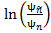 is computed, where is the natural logarithm, and are the average kurtosis of the reference signal and the processed noise signal, respectively. is calculated by averaging the instantaneous kurtosis of the squared amplitude reference signal DFT coefficientsover all frames

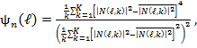 (1)
with 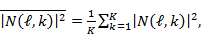 and being the frame index and frequency bin, respectively, and K being the DFT length. The average kurtosis can be calculated in the same way by using 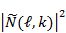 instead of in equation (1).
The noise distortion, i.e., the amount of musical tones produced by the signal enhancement subsystem, shall be evaluated in terms of the mean of the log-average kurtosis ratio LAKR. More details are described in [YU-KURTOSIS].

  - Classification of QoS level based on values of this parameter
To claim compliance with a certain QoS class the LAKR of the signal enhancement subsystem in send direction has to meet the requirement for the applicable QoS classes as defined in Table YYY for wideband systems, and in Table ZZZ for narrowband systems.

Table YYY –Limits for the mean of the log-average kurtosis ratio LAKR of the signal enhancement subsystem in send direction (wideband systems)
QoS Class | 100·LAKR
1 | >-0.6
2 | >-1.0
3 | >-2.0
4 | -2.0

Table ZZZ –Limits for the mean of the log-average kurtosis ratio LAKR of the signal enhancement subsystem in send direction (narrowband systems)
QoS Class | 100·LAKR
1 | tbd
2 | tbd
3 | tbd
4 | tbd

  - Design guidance and root-cause analysis
Noise distortion introduced by the signal enhancement subsystem may lead to a high degradation of the overall perceived speech quality. Therefore, the described noise distortion measure should be evaluated during the optimization of the signal enhancement subsystem, and judged along with speech signal-related quality measures. A high noise distortion may indicate a too low spectral gain floor in spectral noise reduction, or a too low noise overestimation factor in spectral noise power estimation, or a too low SNR floor and/or a too weak temporal smoothing in SNR estimation.
References:
[ETSI EG 202 396-1]: Speech Processing, Transmission and Quality Aspects (STQ), Speech Quality Performance in the Presence of Background Noise; Part 1: Background Noise Simulation technique and Background Noise Database, ETSI, 2008
[ITU-T P.341]: ITU-T Recommendation P.341, Characteristics of Wideband Terminals, ITU, Geneva, 1994.
[ITU-T P.830] ITU-T Recommendation P.830, Subjective Performance Assessment of Telephone-band and Wideband Digital Codecs, Annex D, ITU, Geneva, 1996
[YU-KURTOSIS]: H. Yu and T. Fingscheidt, Black Box Measurement of Musical Tones Produced by Noise Reduction Systems, 37th International Conference on Acoustics, Speech and Signal Processing (ICASSP 2012), Kyoto, Japan, March 25-30, 2012, submitted.
______________

The near field is characterized by the distance (measured from the sound source) where the direct sound and the reflected sound are of equal intensity. In acoustics, this distance is often referred to as critical distance.

