INTERNATIONAL TELECOMMUNICATION UNION |  |  | Focus Group On  Car Communication
TELECOMMUNICATION  STANDARDIZATION SECTOR  STUDY PERIOD 2009-2012 |  |  | FG CarCOM-IL-3
English only
Original: English
 |  |  | Ulm, 10-11 May 2010
INCOMING LIAISON STATEMENT
(ref: COM 16 - LS 145)
Source: | Rapporteur Q16/16
Title: | Reply LS on standardisation of wideband echo canceller performance  (COM12-LS-49)
LIAISON STATEMENT
For action to: |  | -
For comment to: |  | ITU-T SG12, Q4/12, Q6/12
For information to: |  | FG CarCOM
Approval: |  | Q16/16 Rapporteur Meeting (Germantown, MD, 14-20 April 2010)
Deadline: |  | N/A
Contact: | Bob Reeves  BT  UK |  |  | Tel: +44 1473 644654  Fax: +44 1473 649777  Email: bob.reeves@bt.com
In your previous liaison, you asked: “SG 12 would like to ask SG16 what scenario you might have in mind which would require network based wideband (WB) echo cancellation.”
SG 16 has identified one scenario where network-based wideband echo cancellation may be required: A terminal adaptor connected to an IP network (see Figure 1) is used to provide an interface to a conventional 2-wire analogue telephone. One member of the group has given an example of wideband Subscriber Line Interface Circuits (SLICs) being manufactured to achieve this capability, the idea being that customers can plug their conventional “narrowband” (NB) telephone into the terminal adapter and experience “wideband” quality. In this case the echo caused by the 2-wire interface would require some form of wideband echo canceller, located either in the network or, more likely, in the terminal adapter.
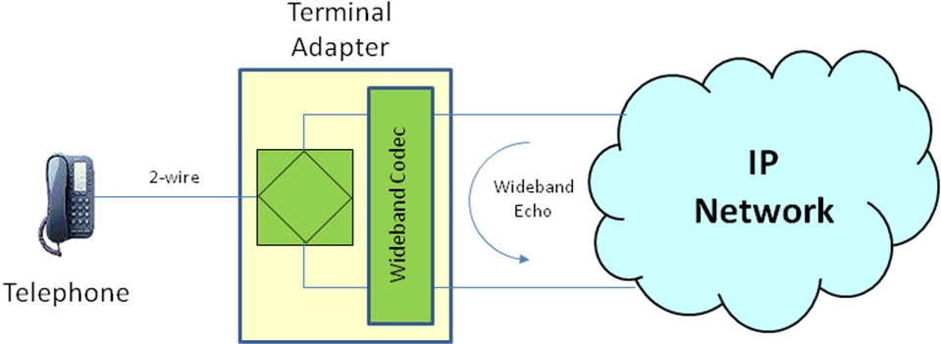
NB / WB Telephone
Figure 1 – Example Scenario
It should be emphasised that although this scenario has been identified, since our first discussion on this topic there have been no further contributions in this area. Therefore, SG16 will not be actively developing such a Recommendation until a clear market need has been identified. Should the need arise, it may be relatively simple to extend the present G.168 to cover wideband performance.
_________________

