INTERNATIONAL TELECOMMUNICATION UNION |  | Focus Group On  Car Communication
TELECOMMUNICATION  STANDARDIZATION SECTOR  STUDY PERIOD 2009-2012 |  | FG CarCOM-R-5
English only
Original: English
 |  | Kiel, 9-10 March 2011
REPORT
Source: | Chairman and Vice-Chairman
Title: | Report of FG CarCOM meeting held in Kiel, Germany on March 9-10, 2011

Abstract
ITU-T FG CarCOM meeting held its 5th meeting in Kiel, Germany on March 9-10, 2011. Incoming liaisons from ITU-T FG Future Networks, 3GPP TSG-SA4, ITU-T SG 12, and ITU-T SG 11 were reviewed, but no responses were needed. An output liaison to ERA GLONASS on speech communications requirements for eCall terminals was agreed by e-mail correspondence prior to the meeting. New contributions on the latest draft of FG.VSSR (Subsystem requirements for automotive speech services) and the relationship between Receive Loudness Ratings (RLRs) and absolute Sound Pressure Levels (SPLs) were received. Most of the meeting time was spent working on FG.VSSR. The next FG CarCOM meeting will be held in Aachen, Germany June 9-10, 2011.

1.0 Introduction
This document is a meeting report from the 5th meeting of ITU-T FG CarCOM which was hosted by Christian-Albrechts-Universitaet zu Kiel (CAU) in Kiel, Germany on March 9-10, 2011.

The meeting documents are available on the ITU-T website and may be downloaded for free at:
http://www.itu.int/md/T09-FG.CARCOM2-110309/sum/en

In this report, the participants are identified by their initials (see the table in Annex 1). Annex 2 provides the list of documents.

2.0 Review of Liaison Statements (LS)
2.1 LS “FG-FN final outputs on Future Networks” from ITU-T Focus Group on Future Networks (IL-8)
This liaison contains final deliverables from the ITU-T Focus Group on Future Networks (FG-FN) for information to FG CarCOM. These documents were acknowledged by the group, but were not reviewed in detail.

It was decided that no response was required.

2.2 LS “LS from 3GPP TSG-SA4 on Signalling Signal Processing Capabilities” from 3GPP TSG-SA4 (IL-9)
In this liaison 3GPP TSG-SA4 acknowledges tandeming of Signal Processing Functions (SPFs) should be avoided, implies that tandeming should not happen within the 3GPP network if current standards are followed, and states that no work on coordination of SPFs will occur within 3GPP until more data is provided on the extent of this problem is received. 3GPP TSG-SA4 requests that the ITU-T provide more information on this topic.

The group was disappointed that SA4 was not going to start development of a coordination mechanism or further investigate the reported problem.

It was decided that no response was required.

2.3 LS “New Focus Group on Driver Distraction” from ITU-T Study Group 12 (IL-10)
This liaison from ITU-T Study Group 12 to TSAG requests that a new focus group be created titled “Focus Group on Driver Distraction”. It was also sent to FG CarCOM for information.

SP provided an update on this topic. TSAG agreed to create the new focus group. It will report into ITU-T Study Group 12 and Scott Pennock (Research in Motion) was appointed the Chairman.

It was decided that no response was required.

2.4 LS “Signalling of signal processing capabilities between terminals and networks” from ITU-T Study Group 11 (IL-11)
In this liaison ITU-T Study Group 11 notes that existing protocols for wired and optical networks may already be able to support ITU-T G.799.2, and requests contributions on any required enhancements to these protocols.

It was decided that no response was required.

2.5 Outgoing LS “Reply to ERA GLONASS Terminal Mandatory Requirements. Draft version 1.8/1.9” to ERA GLONASS (OL-6)
This outgoing liaison to ERA GLONASS recommends objective speech communications performance requirements for eCall terminals.

This liaison was agreed through e-mail correspondence just prior to the current meeting.

3.0 New Contributions

3.1 “Draft 7 of FG.VSSR” from FG CarCOM Chairman (C-15)
This contribution contains the 7th draft of a new ITU-T recommendation on subsystem requirements for automotive speakerphones. This document was edited during the meeting and will form the basis of an 8th draft which will be submitted as a contribution to the next meeting.

3.2 “RLR - equivalent SPL” from Ingenjörsfirma Mats Forsen Data AB (C-16)
This contribution provides real measurement data of Receive Loudness Ratings (RLRs), Sound Pressure Levels (SPLs), receive distortion values, and receive frequency responses for several vehicle configurations. The goal was to verify the relationship between RLR and SPL values so that SPL could be specified instead of RLR to suppliers of loudspeaker subsystem who struggle with concept and measurement of RLR.

The group noted that fairly large departures in the assumptions of a flat frequency response and low distortion had only a small effect on the relationship between RLR and SPL values. Therefore, it was agreed to specify equivalent SPL values instead of RLR values for the loudspeaker subsystem. These new requirements were captured in the 8th draft of FG.VSSR.

4.0 Meeting discussions

4.1 Day 1 discussions
The Chairman welcomed participants and thanked GS for hosting the meeting. The agenda was discussed and approved. BS offered to host the next meeting in Holland, Michigan, USA. However, it was decided latter to have the next meeting in Aachen, Germany due to availability of attendees, and to have the following meeting in Holland, Michigan.

Liaison statements were then reviewed. Please see Section 3 for the discussions and decisions related to these liaisons.

The group spent the rest of day working on the latest draft of FG.VSSR (C-15). Discussion points and decisions were captured in a revision of this document which will be provided as a contribution to the next meeting.

4.2 Conference call discussions

At the end of Day 1 there was a conference call for those who could not attend the meeting in person. A list of conference call participants can be found in Annex 1.

During the call HG reviewed liaisons and previous discussions. There was agreement to add specify signal levels in FG.VSSR in units of “dBov”, rewrite the first paragraph of Section 9, and use Round-Trip Delay (RTD) requirements for the bi-directional signal transport subsystem instead of one-way requirements.

TF asked the group if it would be helpful to receive a contribution on simulating dynamic impulse responses at the next meeting. The group said it would welcome such a contribution and TF said he will try to provide such a contribution to the next meeting.

4.3 Day 2 discussions
The second day continued with work on FG.VSSR. GS and HG agreed to evaluate stability loss measures. HG will be responsible for providing ITU-T P.863 (POLQA) measurement capability and GS will be responsible for providing re-sampling scripts. MF agreed to provide a new Figure 12-3.

The need for crosstalk measures for the bi-directional signal transport subsystem was discussed and agreed.

The group reviewed C-16. An overview of the contribution and discussion can be found in Section 3.2.

SP agreed to work on the speech enhancement layer section of FG.VSSR for the next meeting. GS and SP agreed to work on acoustic interface section. MF agreed to work on the microphone section. MF and HG agreed to work on loudspeaker section. HG agreed to work on the signal transport sections.

It was decided to hold the next meeting in Aachen, Germany on June 9-10 at Head Acoustics. The following meeting is tentatively scheduled for Holland, Michigan, USA on August 25-26 at Johnson Controls.

5.0 Work plan
Below is the current work plan for FG CarCOM:
- June 9-10 meeting of FG CarCOM hosted by Head Acoustics in Aachen, Germany:
  - Work on 8th Draft of FG.VSSR
- Aug. 25-26 meeting of FG CarCOM hosted by Johnson Controls in Holland, Michigan, USA (tentative):
  - Agenda TBD

Action items:
- SP to draft QoS explanation for scope of FG.VSSR
- GS & HG to evaluate stability loss measures
- MF to provide new Figure 12-3
- SP to work on speech enhancement layer section
- GS & SP to work on acoustic interface section
- MF to work on microphone section
- MF & HG to work on loudspeaker section
- HG to work on signal transport sections
- HG to submit 8th draft of FG.VSSR as contribution to next meeting

Annex 1
List of participants
Attended meeting in person:
Hans Gierlich | HG | HEAD acoustics – FG CarCOM Chair- Germany
Scott Pennock | SP | QNX Software Systems- FG CarCOM Vice-Chair- Canada
Mats Forsen | MF | Forsen Data- Sweden
Yoji Ishikawa | YI | Asahi Kasei Corporation- Japan
Gerhard Schmidt | GS | CAU- Germany
Brian Servis | BS | Johnson Controls- USA
Yushi Naito | YN | Mitsubishi Electric Corporation, SG16 Chair - Japan
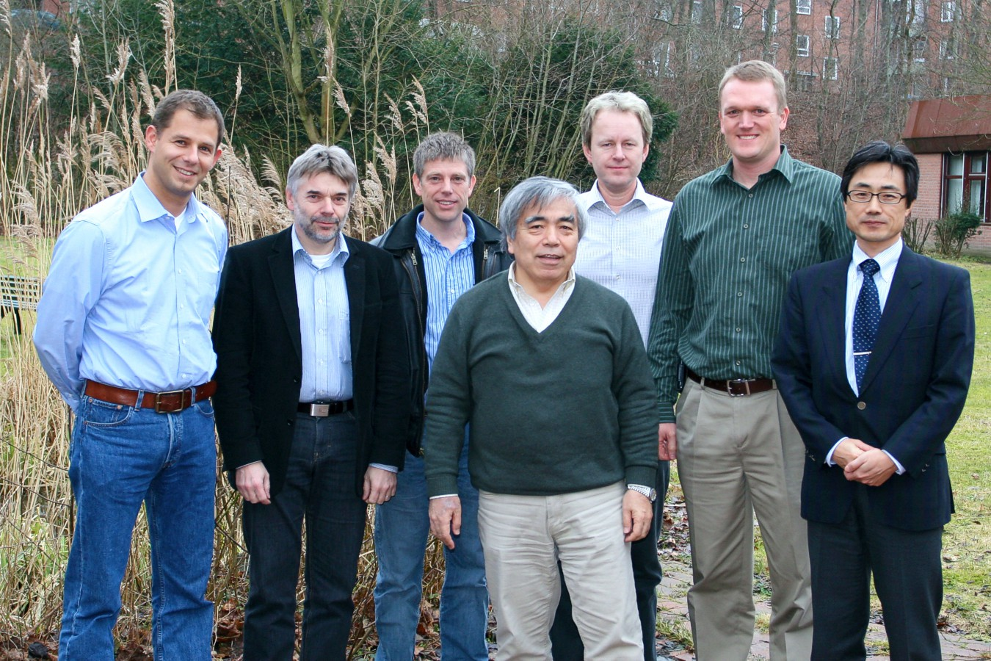
GS
HG
SP
YN
MF
BS
YI
Day 2 conference call participants:
Tim Fingscheidt | TF | Braunschweig Technical University - Germany

Annex 2
List of documents





