INTERNATIONAL TELECOMMUNICATION UNION |  | Focus Group on ICT&CC
TELECOMMUNICATION  STANDARDIZATION SECTOR  STUDY PERIOD 2009-2012 |  | FG ICT&CC-C-33
English only
Original: English
 |  | Geneva, 25-28 November 2008
CONTRIBUTION
Source: | Chairman
Title: | A Review of Lifecycle Analysis for FG on ICTs and Climate Change
1. Introduction
Deliverable 1 in as defined in the Terms of Reference for the FG shall “identify the terms and definitions (including units, see section 5.3) needed to analyze the three major relationships between ICTs and Climate Change”. The first of these relationships is “ICTs are contributing directly to Climate Change, in particular to the production of Greenhouse Gases (GHG) (e.g. power consumption, proliferation of ICT devices, recycling of material, etc.)”.
Deliverable 3 as defined in the ToR states ” The FG should develop a methodology to describe and estimate present and future user [energy] consumption of ICTs over their entire life-cycle. This should include the definition of basic units relevant to the cases considered.
2. Objective of this Contribution
For deliverable 3 to be able to identify a methodology for lifecycle analysis (LCA) two activities are required.
- A review of existing methodologies with a view of referencing the most appropriate methodology
- Definition of terms (e.g. in Deliverable1)
The objective of this contribution is to cite existing standards and references to LCA and to provide a reference diagram for LCA which can be adapted by Editors to identify items required in the Definitions.
3. ISO 14040 “Environmental Management-Life cycle Assessment-Principles and Framework
This standard outlines in general terms how a LCA may be carried out without specific reference to ICTs, climate change or carbon dioxide.
“LCA addresses the environmental aspects and potential environmental impacts (e.g. use of resources and the environmental consequences of releases) throughout a product's life cycle from raw material acquisition through production, use, end-of-life treatment, recycling and final disposal (i.e. cradle-to-grave). There are four phases in an LCA study:
a) the goal and scope definition phase,
b) the inventory analysis phase,
c) the impact assessment phase, and
d) the interpretation phase.
The scope, including the system boundary and level of detail, of an LCA depends on the subject and the intended use of the study. The depth and the breadth of LCA can differ considerably depending on the goal of a particular LCA”.
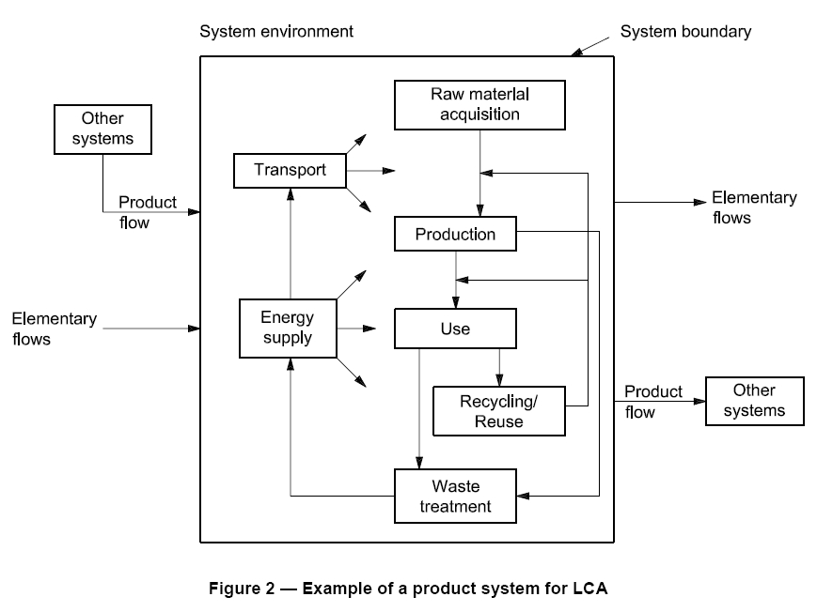
Figure 2 is copied directly from ISO 14040 which shows energy supply in the raw material, production, use, recycling and waste treatment phases. The energy supplied may be direct as in fossil fuels used for transport, or indirect as in energy used from suppliers of mains electricity.
So far the FG has concentrated on ‘use phase’ where indirect electrical energy (typically measured in kilowatt-hours, Watt-hours or Joules) is typically converted to heat which is vented to the environment.
As the work progresses direct emissions from fossil fuel burn in production or transport will need to be included. These emissions can be reduced by up to 90% by recycling.
4. Methods Review to support the PAS 2050 on measuring embodied GHG emissions in products and services - EV02074
This is a reference to a project supported by the UK Government Department for Environment Food and Rural affairs. Its work on “Climate change and energy” is cited here.
“Description
Defra and the Carbon Trust (CT) are co-sponsoring the British Standards Institution (BSI) to develop a Publically Available Specification (PAS) for the measurement of the embodied greenhouse gas emissions (GHG) of products and services across their life cycle. This is in response to market interest in understanding the contribution products and services make to climate change and a requirement for a standardised, consistent method organisations can use for this measurement. Existing methods e.g. Life Cycle Assessment (LCA) as per ISO14040 and the associated 14041-44, 48-49 suite, already provides a specification for doing this, but can be seen as resource intensive in certain instances especially for SMEs. The PAS aims to provide a simplified approach that could be used by a greater diversity of product types and organisations. Key criteria for the method defined in the PAS is to enable its use in a range of applications to include for comparison and communication e.g. labelling, Green Supply Chain Management (SCM), Ecodesign etc .
In support of PAS2050 and to inform the PAS team and Steering Group, Defra commissioned this independent fitness-for-purpose review of the current methods relevant to measuring embodied GHG of products and services. These were Process LCA (e.g. defined in ISO14040), Input Out (IO) LCA, Hybrid (H) LCA”.
This work is currently in final draft stage prior to its independent fitness-for-purpose review, which is most likely to be conducted by ISO. This methodology is here recommended to the FG.
5. Dynamic Carbon Labels
This section is included to show how product labelling could evolve in the future. An alternative LCA diagram is also cited in the reference. However this diagram suffers from a lack of feedback from recycling.
SAP Research Switzerland and SAP Research Palo Alto have publicised a demo using RFID tagged consumer goods and NFC enabled mobile phones. “The phone reads the information on the RFID chip from the bottle (product) which contains a unique identifier. It uses this identifier to look up the value of the CO2 label from a database, for example in the store.
“The PAS 2050 Standard Starting in 2007, the Carbon Trust has been developing their PAS 2050 standard for calculating carbon footprints of products which is based on life cycle analysis. It covers not only CO2, but also the other greenhouse gases, specifically N20 and CH4 (methane) which are an important factor in agricultural production.
The basic idea is to identify the complete process maps of the creation of goods, their usage and their recycling / disposal. In each process step the absorption and emission of greenhouse gases identified and measured. All the greenhouse gases are measured in grams, kg or metric tons of CO2e (CO2 equivalents – other greenhouse gases are expressed by the amount of CO2 which would have the same effect on global warming).
The ‘Carbon Label’ has been created by the Carbon Trust. The describes how much greenhouse gas is emitted during the lifecycle of a product. There have been a number of pilot programs in 2007, PepsiCo’s Walker subsidiary for example determined the CO2 footprint of one its chips and printed a label on the bag.”
Proposal
It is proposed that sections 2-4 in this contribution are included in Deliverables 1 and 3 to introduce the concept of life cycle analysis (LCA) by reviewing existing methodologies.
Further contributions can them be made on definitions for LCA in Deliverable 1.

http://www.iso.org/iso/iso_catalogue/catalogue_ics/catalogue_detail_ics.htm?csnumber=37456 Your corporation may already have a copy.
PRINTED CIRCUIT BOARD RECYCLING IN AUSTRALIA http://eprints.usq.edu.au/1501/1/Parsons_PCB_Recycling_OctFinal_2006.pdf
http://randd.defra.gov.uk/Default.aspx?Menu=Menu&Module=More&Location=None&Completed=0&ProjectID=15520#RelatedDocuments
http://www.defra.gov.uk/environment/climatechange/index.htm
https://www.sdn.sap.com/irj/sdn/go/portal/prtroot/docs/library/uuid/707118c4-e206-2b10-5d9d-b84f66966e57

