INTERNATIONAL TELECOMMUNICATION UNION |  | Focus Group on ICT&CC
TELECOMMUNICATION  STANDARDIZATION SECTOR  STUDY PERIOD 2009-2012 |  | FG ICT&CC-C-36
English only
Original: English
 |  | Geneva, 25-28 November 2008
CONTRIBUTION
Source: | British Telecom
Title: | Suggested Contribution for Deliverable 3

2.1.4. Issues of CO2 Emissions Calculation Aiming to Realize International Standardization
We will propose to using Energy (J: Joule) as a unit instead of CO2 emissions because of the significant difference in CO2 emissions depending on each country even from the same power consumption. Conversion to CO2 shall be based on CO2 emission intensity reflecting the electric power situation of each country.
Energy (J) is used as a unit to develop this document referring to the calculation procedures in the Study Group Report of the Ministry of Internal Affairs and Communications.
[Note:
One of the most important environmental issues which we now face and should tackle is the climate change, especially global warming caused mainly from GHG emissions. Then should we assess ICT impacts in GHG emissions unit? It is answered "No" to this question. One of the main environmental impacts of ICT is a electric power consumption. GHG emissions originated in electric power consumption depend on sources of electric power generations such as coals, oils, gasses, nuclear and so on. Conditions of the electric power generations are quite different among each country, which differences of the CO2 intensity in each country as an example are shown in the following figure. Therefore, we shall assess ICT impacts in energy unit for the sake of performing objective and fair ICT energy assessments, in particular, when we will compare the results of quantifying ICT impacts between countries. (However, this requirement to assess ICT impacts in energy units is NOT indicated to permit a comparative assertion.)
In addition, when we will intend to assess ICT impacts of GHG emissions without comparison, otherwise to make a comparison of ICT impacts between regions which are no dependence on the conditions other than ICT (e.g. regions which is supplied from the same electric power generation), we can convert the ICT impact in energy unit to one in GHG emission unit multiplied by each GHG emission intensity of energy resources.]
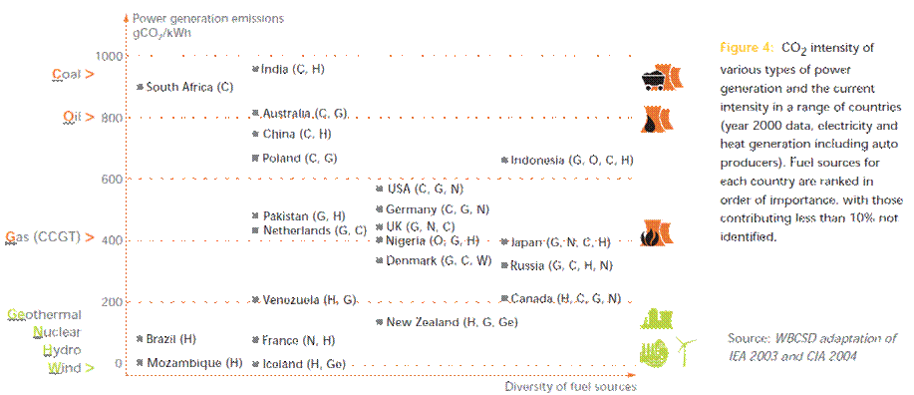

2.1.5 Procedure for Calculating CO2 Emissions Reduction
Since CO2 emissions even by the same power consumption significantly vary depending on the method of power generation, energy (J) consumption reduction shall be calculated first, and then the energy consumption reduction is converted into CO2 emissions reduction reflecting the situation in each country.

