INTERNATIONAL TELECOMMUNICATION UNION |  | Focus Group on ICT&CC
TELECOMMUNICATION  STANDARDIZATION SECTOR  STUDY PERIOD 2009-2012 |  | FG ICT&CC-C-40
English only
Original: English
 |  | Geneva, 25-28 November 2008
CONTRIBUTION
Source: | SAS
Title: | Carbon footprint modelling methodology for sustainability performance management
Introductory remarks
Following the contribution C-10 by SAS entitled “Industry Scoreboard Proposal” prepared for the first meeting of the ITU Focus Group of 1-3 September 2008 in Geneva and the powerpoint presentation prepared for this meeting, this is a contribution that elaborates on our previous proposal.
As the work of the Focus Group has evolved, we would like to provide more details on the idea of standards development for holistic, across-the-enterprise environmental performance management for the ICT industry on the basis of a proposed carbon footprint modelling methodology. This can also be a tool to support our previous contribution for the development of an Industry Scoreboard.
Sustainability performance management
SAS has previously discussed in the Focus Group the challenge of identifying, measuring and managing carbon emissions across the enterprise, especially when data sources are global in the case of international businesses.
Whether carbon footprint is evaluated with the application of e.g. the GHG Protocol framework whereby GHG emissions are calculated on the basis of Triple Bottom line indicators (people, profit, planet) or on the basis of other reporting frameworks/standards, it remains a challenge for a business to be able to gather the necessary data, manage it and report; but also go beyond compliance reporting requirements and thus manage and improve its overall sustainability performance.
“Management” of environmental performance or the wider notion of sustainability performance (i.e. essentially “management” of carbon footprint) goes beyond “Reporting” and allows for forecasting and what-if scenario analyses that empower the “Improvement” of sustainability performance.
Developing a carbon footprint modelling methodology
Sustainability performance management as described above, necessitates the use of a carbon footprint modelling methodology that can produce a multi-dimensional model that:
- Contains an inventory and rates for all raw sources of GHG and CO2 equivalents including Electricity, Jet Fuel, Natural gas, Bio-fuels, Refrigerant PLUS calculated CO2 emissions from other upstream suppliers (External Units Module).
- Creates GHG emissions based upon consumption of various fuels. Resources such as electricity place a demand on the CO2 sources catalogues at the previous stage. At this stage, a modeler enters volumes with different units of measure, and a carbon footprint us automatically calculated and aggregated (Resource Module)
- Converts emissions into estimates for the processes used. At this step of the methodology, carbon resources are either allocated to work activities based on drivers (common with indirect sources of emissions) or pulled based on the demand of activities (more common with direct sources emissions) using an assignment network (Activity Module).
- Drives the process related emissions to the goods and services produced. Here carbon based activities are allocated to products, customers, channels. (Cost Object Module)
The table describes graphically the various steps of the methodology outlined above. Dimensions for all modules are user-defined.
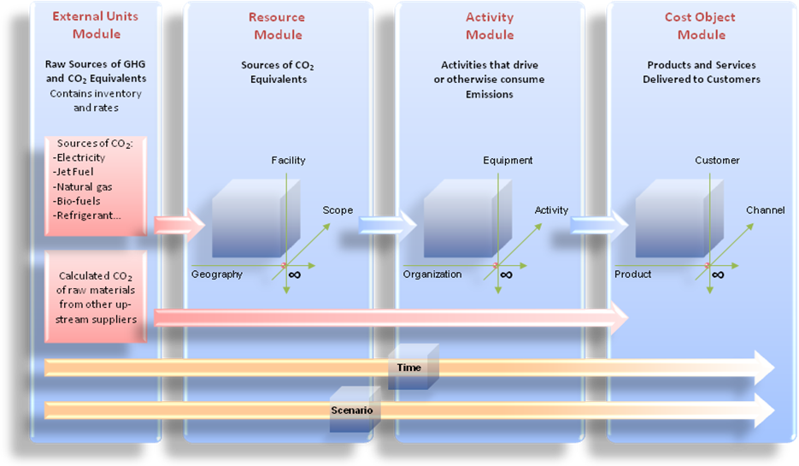
It is important to note that the metrics developed by this Focus Group to measure and report on carbon emissions should reflect the whole spectrum of activities of an enterprise and all pillars of sustainability including e.g. upstream suppliers’ emissions, waste management and Life Cycle Assessment aspects. Only if all activities, across the enterprise are reflected in a carbon footprint modelling, can the business profit from the “intelligence” that the applied model contains and go to the next step of sustainability performance management.
Once this methodology has been applied, it is the use of analytics and business intelligence-type analyses that enables the sustainability performance management described in the previous section.
Exploring a “follow the cost, find the carbon” approach
This methodology can ultimately allow an organisation to put a “cost” on its “carbon” which will drive the improvement of its environmental performance on the basis of financial incentives. Financial considerations are one of the primary drivers (and arguably the most sustainable in a long-term business strategy) to investing in “green” business strategies.
From a business perspective, the modelling of “cost” and “carbon” can be very similar, with the following differences:
- Allocating emissions instead of expenses
- Limited population of fuel sources which most organization’s consume
- Standard set of conversion tables to use in calculating GHG emissions
- Compliance reporting requirements

________________

“How Companies Think About Climate Change”, McKinsey 2008

