INTERNATIONAL TELECOMMUNICATION UNION |  | Focus Group on ICT&CC
TELECOMMUNICATION  STANDARDIZATION SECTOR  STUDY PERIOD 2009-2012 |  | FG ICT&CC-C-47
English only
Original: English
 |  | Geneva, 25-28 November 2008
CONTRIBUTION
Source: | Japan
Title: | Proposed Evaluation Method for the Environmental Impact of Work Efficiency Improved by Introducing ICT
1. Introduction
This contribution provides a “Evaluation method for the environmental impact of work efficiency improved by introducing ICT” as one of the calculation methods in contribution C-7 entitled “Proposed draft text for Methodology” submitted to the first meeting of the ITU Focus Group held on 1-3 September 2008 in Geneva.

2. Proposal
We propose that the improvement of work efficiency adopts the factors of environmental effects in case of assessing the environmental impact of ICT systems.

-----------------------------------------
(ANNEX attached)

ANNEX A

A1. Abstract
We propose that the improvement of work efficiency adopts the factors of environmental effects in case of assessing the environmental impact of ICT systems. This is based on the idea that a reduction of the number of person-hours required as a result of improving work efficiency will result in the reduction of floor area occupied for office work.
The reduction of CO₂ emissions achieved by improving work efficiency is assessed in the following manner: Person-hours when an office worker has worked in an office building for one year are converted to CO₂ emissions from the floor area of an office occupied by the office worker for office work and CO₂ emissions per unit area of office space generated by the consumption of energy required to maintain that office building.

A2. Discussion
The reduction of space required for performing office work can be cited as an environmental load reduction effect by the introduction of ICT. As well as the direct reduction of space required for installation of IT equipment, such as servers and PCs, and storage of documents or the like, such indirect reduction effects as mentioned below are possible.
By using ICT, an improvement in processing efficiency can be achieved. Since the person-hours can be reduced by this improvement, the space occupied for office work can be reduced. That is, the improvement of processing efficiency has the potential to reduce environmental load that will lead to office space reduction in the future.
Figure 1 shows methods for assessing the reduction of CO₂ emissions by the improvement of work efficiency. In office buildings, energy resources such as electricity, gas, and heavy oil are used for apparatus such as air conditioners, lighting, and elevators. The amount of CO₂ emitted from an office building annually can be calculated by multiplying the annual consumption of these energy resources by the basic unit of CO₂ for each kind of energy (CO₂ conversion factor). Also, it is
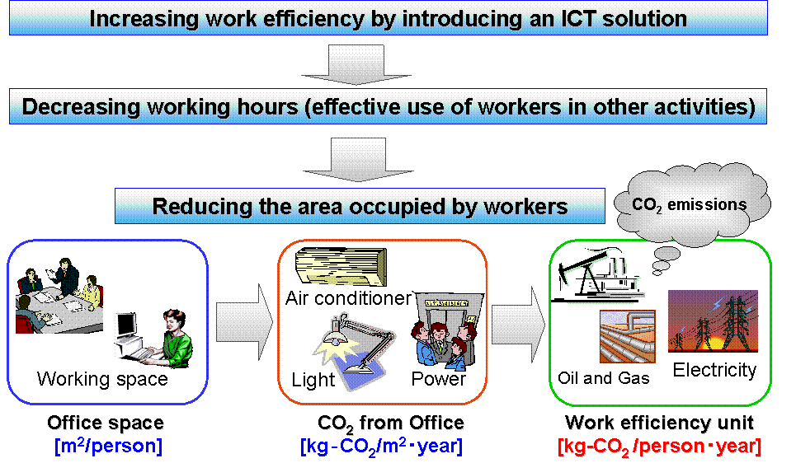
Fig.1 The concept of evaluation method for “work efficiency”
possible to calculate annual CO₂ emissions per unit area of office space from the floor area of the office building.
If space occupied by an office worker for office work is taken into account, the CO₂ emissions from the space occupied by one office worker for one year can be calculated. If annual working hours are specified, the CO₂ emissions from the space occupied by one office worker when working for one hour can be calculated. Using this value as CO₂ emissions per person-hour (per person per hour), the reduction of CO₂ emissions by the improvement of work efficiency can be estimated.
The following are examples of calculating the basic unit of CO₂ for the improvement of work efficiency using specific statistical data.

A2.1 Example 1: Japan
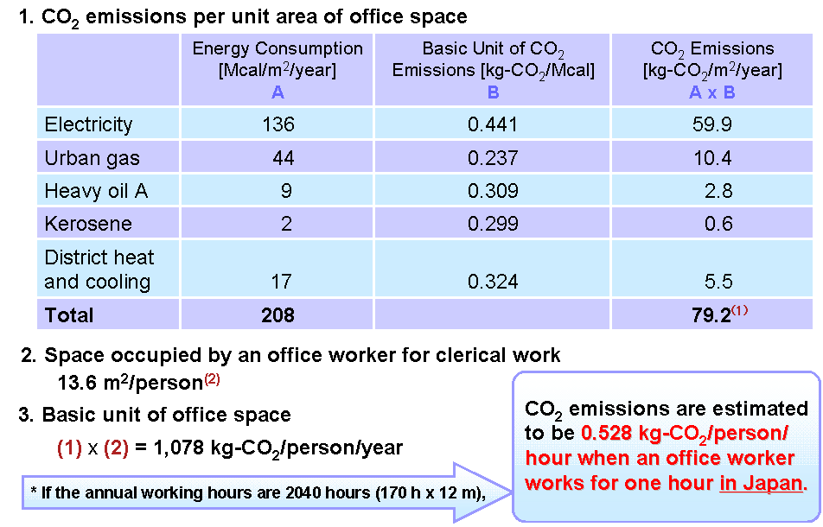
According to the fact-finding survey on energy in domestic operations departments^{[1]}, electricity, urban gas, and other energy sources are used in the amount of 208 Mcal/m²/year in offices. The amount of CO₂ emitted from an office building annually can be calculated by multiplying the above value by the basic unit of CO₂ for each kind of energy source, and the calculation result is 79.2 kg-CO₂/m²/year for air-conditioning and lighting. Meanwhile, the space occupied by an office worker for office work is 13.6 m²/person according to the data publicized by the Building Owners and Managers Association, Japan^{[2]}. The basic unit of CO₂ per person can be calculated by multiplying the basic unit of CO₂ of 79.2 kg-CO₂/m²/year by 13.6 m²/person, and the calculation result is 1,078 kg-CO₂/person/year as shown in Figure 2. If the annual working hours are 2040 hours (170 hour x 12 month) /year, CO₂ emissions are estimated to be 0.528 kg-CO₂/person/hour when an office worker works for one hour in Japan.
Fig.2 Calculation of Basic Unit for Office Space in Japan

A2.2 Example 2: The USA
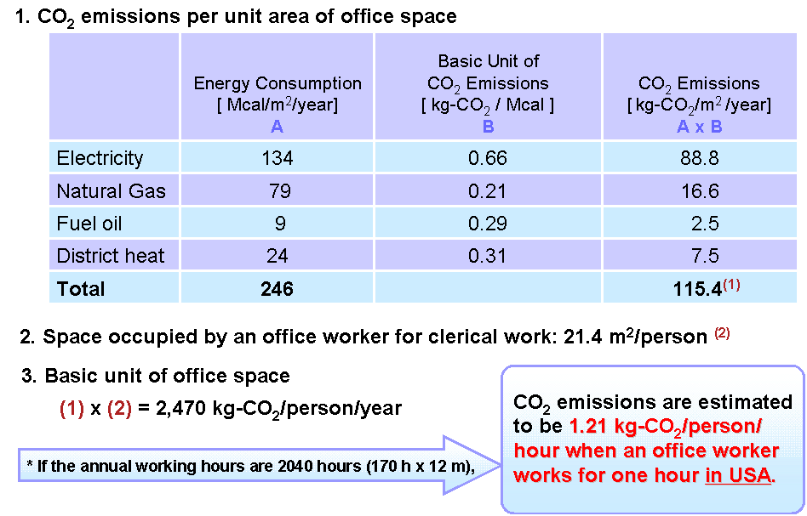
According to a survey on the 2003 energy consumption in commercial buildings (conducted by the Energy Information Administration) ^{[3]}, 246 Mcal/m²/year of electricity, gas, heavy oil, and other energy sources are used in office buildings annually. If this is multiplied by the basic unit of CO₂ emissions of each kind of energy source, the annual CO₂ emissions amount to 115.4 kg-CO₂/m²/year. Space occupied by an office worker for office work is 21.4 m²/person according to the data publicized by the General Service Administration^{[4]}. The basic unit of CO₂ per person can be calculated by multiplying the basic unit of CO₂ of 115.4 kg-CO₂/m²/year by 21.4 m²/person, and the calculation result is 2,470 kg-CO₂/person/year as shown in Figure 3. If the annual working hours are 2040 hours (170 hour x 12 month) /year, CO₂ emissions are estimated to be 1.21 kg-CO₂/person/hour when an office worker works for one hour in the USA.
Fig.3 Calculation of Basic Unit for Office Space in USA

A3. Conclusion and Proposal
It is possible to estimate the improvement of work efficiency achieved by introducing ICT as an indirect environmental load reduction based on the idea that the space occupied for office work (office space) can be reduced by reducing the number of person-hours as a result of improving work efficiency.
We propose that the improvement of work efficiency adopts the factors of environmental effects in case of assessing the environmental impact of ICT systems.

A4. References
[1] Report on Energy Consumption by Business Sectors, IEEJ, November 2001. (in Japanese).
[2] Japan Building Owners and Managers Association: Building Survey for Fiscal 2005, 2006. (in Japanese).
http://www.birukyo.or.jp/research/index.html#research01
[3] Energy Information Administration, 2003 Commercial Buildings Energy Consumption Survey, Detailed Tables, October 2006. http://www.eia.doe.gov/emeu/cbecs/cbecs2003/detailed_tables_2003/detailed_tables_2003.html
[4] Report on the Web site of General Services Administration.
http://www.gsa.gov/Portal/gsa/ep/contentView.do?contentType=GSA_OVERVIEW&contentId=14179&faq=yes&noc=T
ANNEX B
Example of Trial Calculation

A case of the environmental impact assessment of ICT system with the improvement of work efficiency included in the factors of the environmental effects is shown below.

B1. Outline of the assessed ICT system
A system for integrating systems such as those relating to document management, financial accounting, general affairs, and personnel and salary in the internal operations of a municipality, and realizing the upgrading of administrative management and improvement of work efficiency with the introduction of electronic account settlement.

B2. Effect of the introduction of the ICT systems
Before the introduction, the system used was a client-server system, and paper-based account settlement was made. This required a considerable number of person-hours for manual office work. Paper forms had to be used and storage space for documents was needed.
After introducing the new system, it is now a Web-type system and by realizing electronic account settlement, work efficiency has been improved while paperless operations have been achieved. Moreover, space for storing documents has been reduced by using an electronic library.

B3. Contents of evaluating reduction in CO₂ emissions
- We evaluated yearly document processing operations (finance and contract, general affairs, document management) in the Nakano City Office in Tokyo.
- We evaluated person-hours of operations by PC and of manual operations, whether or not paper was used, the amount of stored documents, and methods of storage for operations using systems (338 operations).
- The consumed electric energy and occupied space in offices were assessed for all ICT equipment involved in the systems.

B4. Summary of assessment evidence
Table 1 shows assessment evidence for each effect factor.

B5. Assessment results
Table 2 and 3 shows positive and negative effect as a result of introducing the ICT system.
Figure 4 shows total CO2 emissions before and after the introduction of the ICT system. The loads before and after the introduction were 149,662 kg-CO₂ and 81,646 kg-CO₂ respectively. CO₂ emissions were reduced by 68,016 kg-CO₂, or 45.4% in the introduction of ICT.
Table 1 Assessment Evidence

 | Effect Factor | Basic Data | Before Introduction | After Introduction
1 | Consumption of goods | Number of papers | 1,897,759 | 829,078
2 | Power consumption | Servers, PCs, etc. | 20,301kwh | 45,538kwh
3 | Movement of people | - | - | -
4 | Movement of goods | - | - | -
5 | Improved efficiency of office space | Equipment space | 24.2m² | 24.6m²
5 | Improved efficiency of office space | Document space | 15.6m² | 5.3m²
6 | Storage of goods | Warehouse space | 43.5m² | 25.9m²
7 | Improved work efficiency | Working hours | 261,325h | 117,607h
8 | Waste | - | - | -

Table 2 Positive Effects
Effect Factor | CO₂ reduction  (kg-CO₂/year)
Consumption of goods (paper) | 5,472
Improved efficiency of  office space | 752
Storage of goods | 813
Improved work efficiency | 70,140
Total | 77,177

Table 3 Negative Effects
Effect Factor | CO₂ increase  (kg-CO₂/year)
Power consumption  (ICT system) | 9,161
Total | 9,161

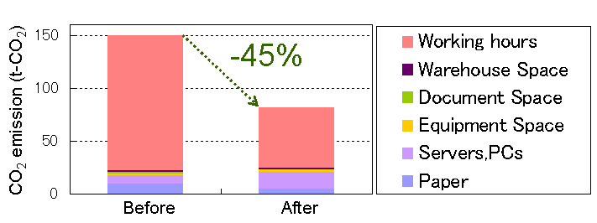

Fig.4 CO₂ reducing effect by introducing ICT system

