|  |  |
| --- | --- |
| **电信标准化局** | **logo_C_** |
|  |  |

2011年6月24日，日内瓦

|  |  |  |
| --- | --- | --- |
| 文号： | **电信标准化局第8/5号集体函** |  |
| 电话： 传真：  电子 邮件： | +41 22 730 5780 +41 22 730 5853  [tsbsg5@itu.int](mailto:tsbsg5@itu.int) | 致国际电联各成员国主管部门、 ITU-T部门成员和参加第5研究组 工作的ITU-T部门准成员和ITU-T学术成员 |

|  |  |
| --- | --- |
| 事由： | **第5研究组的会议 2011年9月20-28日**  **大韩民国首尔** |

尊敬的先生/女士：

1 根据国际电联电信标准化部门2011年的会议安排（见2009年12月14日第80号电信标准化局通函）以及第5研究组会议上达成的协议（2010年11月23日 - 12月1日，日内瓦），我谨通知您，应大韩民国通信委员会（KCC）邀请，第5研究组（环境与气候变化）将自2011年9月20日至28日在大韩民国首尔召开会议。

会议地点为韩国首尔乐天酒店。会议将于第一天9:30召开。与会代表注册工作将于8:30时开始。

请注意，ICT和气候变化的联合协调活动（JCA ICT&CC）将在第5研究组闭幕全会结束后召开会议，会议时间为9月28日当地时间17时。

在会议召开之前，国际电联和韩国通信委员会（KCC）将主办主题为“通过绿色信息通信技术（ICT）推进气候议程”的为期半天的研讨会。研讨会将于2011年9月19日13:30至18:00在韩国首尔新闻中心国际会议厅召开（见第204号电信标准化局通函）。

2 会议讨论语言为英语。

3 由第5研究组主席Ahmed Zeddam先生起草的议程草案见本函**附件1**。

4 由第5研究组管理层起草的时间表草案见本函**附件2**。

5 由主办机构提供的会议相关实用信息见本函**附件3**。

6 TSAG在2011年2月的会议上一致同意，将继续试行目前采用的须在电信标准化局会议召开日至少十二（12）个日历日以前提交文稿的截止日期。此类文稿将在第5研究组网站上发布，因而必须在**2011年9月7日之前**寄达电信标准化局。按照现行规定，对于在会议开始日至少两个月之前收到的文稿，可以应要求予以翻译。

欢迎与会者以第5研究组主页上提供的网上提交表格或电子邮件的方式向以下地址提交文稿：[tsbsg5@itu.int](mailto:tsbsg5@itu.int)。详尽指南见ITU-T网站。

我们大力提倡您使用已制作出的一套模版，它们既能够使ITU-T文件的格式保持一致，又可以方便文件制作、提高效率。这些模版可以在ITU-T各研究组网页中的“代表资源”（Delegate Resources）（[http://www.itu.int/ITU‑T/studygroups/templates/index.html](http://www.itu.int/ITUT/studygroups/templates/index.html)）处找到。

为了解决与文稿有关的问题，请在文稿上注明联系人的姓名、传真和电话号码以及电子邮件地址。因此，务请在所有文件的首页注明这些细节。

7 为了便于电信标准化局进行文件制作和会议组织方面的必要安排，我希望您能通过信函、传真（号码：+41 22 730 5853）或电子邮件（[tsbreg@itu.int](mailto:tsbreg@itu.int)）的方式尽早、但**不迟于2011年8月20日**将代表贵主管部门、部门成员、部门准成员、学术机构、区域性组织和/或国际组织或其它实体出席会议的人员名单发至我处，同时，希望各主管部门注明其代表团团长（如果有副团长，亦盼一并注明）的姓名。

**8 请注意，ITU-T会议的与会者只能通过ITU-T网址进行网上预注册：**[**http://www.itu.int/ITU-T/studygroups/com05/index.asp**](http://www.itu.int/ITU-T/studygroups/com05/index.asp)。

9 第5研究组与其主席Ahmed Zeddam先生达成一致意见，将采取进一步的步骤，努力实现全电子化的工作环境，因此，会议将以无纸会议的形式进行。

10 我们高兴地通知您，国际电联将提供数量有限的若干份非全额与会补贴（或是经济舱机票，**或是**住宿费和用于支付餐饮和杂项费用的每日生活补贴），以促进最不发达国家或低收入发展中国家代表的与会。申请时必须得到相关国际电联成员国主管部门的授权，而且一国仅能有一人申请。**附件5**中的与会补贴申请表应在**2011年8月20日**之前（会议召开日的一个月之前）填妥并交回国际电联。请注意，在2008年世界电信标准化全会（WTSA-08）上，各代表团团长做出了承诺，他们将向其正副主席候选人提供必要的资源，以便相关人员在四年任职期内能够履行职责，因此他们已认识到，正副主席不会从国际电联得到任何财务资助。

11 我们谨在此提醒您，一些国家的公民需要获得签证才能入境大韩民国并在此逗留。**签证必须至少在会议召开日的四（4）个星期前**向驻贵国的大韩民国代表机构（使馆或领事馆）申请，并随后领取。如果贵国没有此类机构，则请向驻离贵国最近的国家的此类机构申请并领取。

请需要邀请函和/或签证证明函入境大韩民国的与会代表与大韩民国联系人联系：

**Hye Young (Grace) Hwang女士**

电话：+82.2.338.1082

传真：+82.2.338-1083

电子邮件：[sg5\_visa@kcc.go.kr](mailto:sg5_visa@kcc.go.kr)

12 为方便起见，酒店预订表见本函**附件4**。

顺致敬意！

电信标准化局主任  
 马尔科姆•琼森

**附件：5 件**

ANNEX 1  
(to TSB Collective letter 8/5)

**Draft agenda for the meeting of Study Group 5  
(Seoul, 20 - 28 September 2011)**

1. Opening of the meeting
2. Adoption of the agenda
3. Approval of revised Question 17/5 and proposal to delete Question 20/5
4. Guidelines for Working Parties
5. Working Parties meetings
6. Report of the different SG5 Regional Groups
7. Report of the Home Network Special Group
8. Reports of the meetings of Working Parties
9. Consent/determination/deletion of Recommendations
10. Outgoing liaison statements/communications
11. Nomination of Rapporteurs, Associate Rapporteurs and Liaison Rapporteurs
12. Review of the work programme
13. Future activities
14. Other business
15. Closure of the meeting

ANNEX 2  
(to TSB Collective letter 8/5)

**Draft revised timetable for the meeting of Study Group 5  
(Seoul, 20 - 28 September 2011)**

|  |  |  |  |  |  |  |  |
| --- | --- | --- | --- | --- | --- | --- | --- |
|  | **Morning** | | | **Afternoon** | | | |
| Tuesday 20 September | Plenary | Working Party 1/5 | | Working Party 2/5 | | Working Party 3/5 | |
| Wednesday 21 September | Working Party 1/5; Working Party 3/5 & *ad-hoc* meetings of  WP 2/5 Questions | | | Working Party 2/5; Working Party 3/5 & *ad-hoc* meetings of  WP 1/5 Questions | | | |
| Thursday 22 September | Working Party 1/5; Working Party 3/5 & *ad-hoc* meetings of  WP 2/5 Questions | | | Working Party 2/5; Working Party 3/5 & *ad-hoc* meetings of  WP 1/5 Questions | | | |
| Friday 23 September | Working Party 2/5; Working Party 3/5 & *ad-hoc* meetings of  WP 1/5 Questions | | | Working Party 1/5; Working Party 3/5 & *ad-hoc* meetings of  WP 2/5 Questions | | | |
| Monday 26 September | Working Party 1/5; Working Party 3/5 & *ad-hoc* meetings of  WP 2/5 Questions | | | Working Party 2/5; Working Party 3/5 & *ad-hoc* meetings of  WP 1/5 Questions | | | |
| Tuesday 27 September | Working Party 1/5 | | Working Party 2/5 | | Working Party 3/5 | | |
| Wednesday 28 September | Plenary | | | Plenary | | | JCA ICT&CC |

ANNEX 3  
(to TSB Collective letter 8/5)

**Practical Information  
(Republic of Korea, 19-28 September 2011)**

## INFORMATION ABOUT THE MEETING AND WORKSHOP

1. **Venue**

## ITU-T SG5 Meeting

The ITU-T SG5 will be held from 20th of September to 28th of September 2011 at ‘Sapphire Ballroom’(3F) and meeting rooms on the 36th floor of Lotte Hotel, Seoul, Korea.

|  |  |
| --- | --- |
| Address | 1, Sogong-Dong, Jung-Gu, Seoul, Korea 100-721 |
| Facilities | Club Floor, Fitness Club, Business Center, Duty Free Shop |
| Telephone | +82-2-771-1000 |
| Fax | +82-2-752-3758 |
| Website | [www.lottehotelseoul.com](http://www.lottehotelseoul.com) |

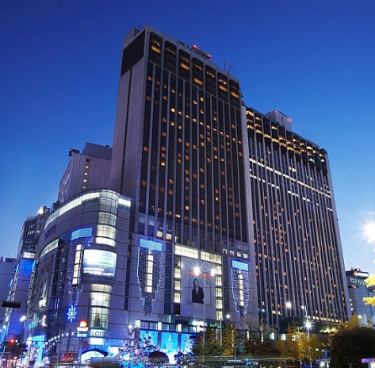

## Workshop on “Progressing the climate agenda through green ICTs”

|  |  |
| --- | --- |
| Address | 33, Taepyeongro, Jung-Gu, Seoul, Korea 100-721 |
| Facilities | VIP Room, Press Room |
| Telephone | +82-2-2001-7114 |
| Fax | +82-2-2001-7770 |
| Website | [www.kpf.or.kr](http://www.kpf.or.kr) |

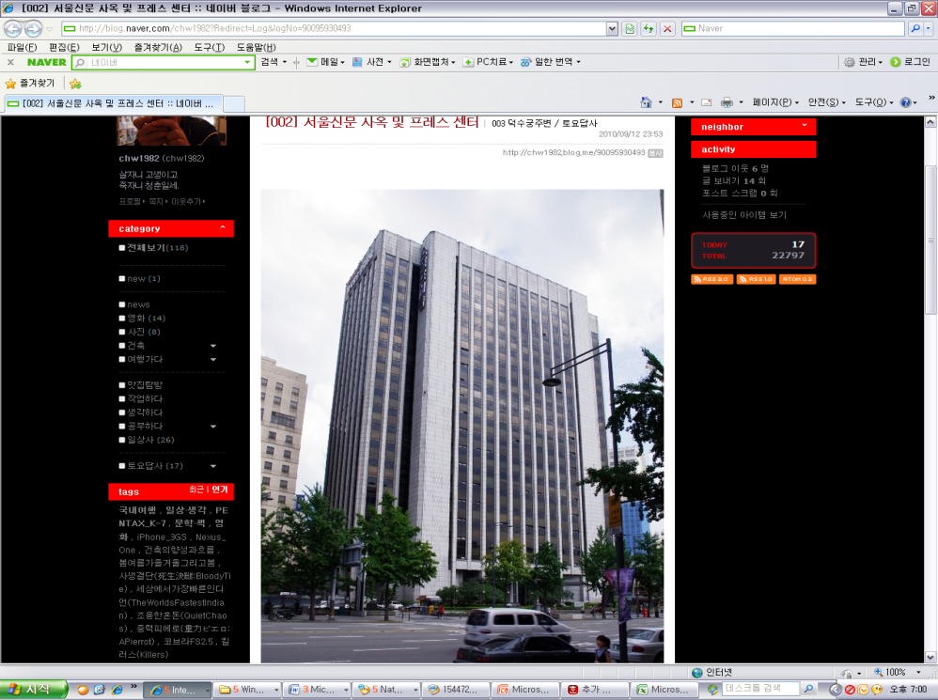The Workshop will be held on 19th of September 2011 at ‘International Conference Hall’(20F) in Korea Press Center, Seoul, Korea.

## How to get from Lotte Hotel to Press Center

It takes 10 minutes by walk and 5 minutes by taxi as below map.

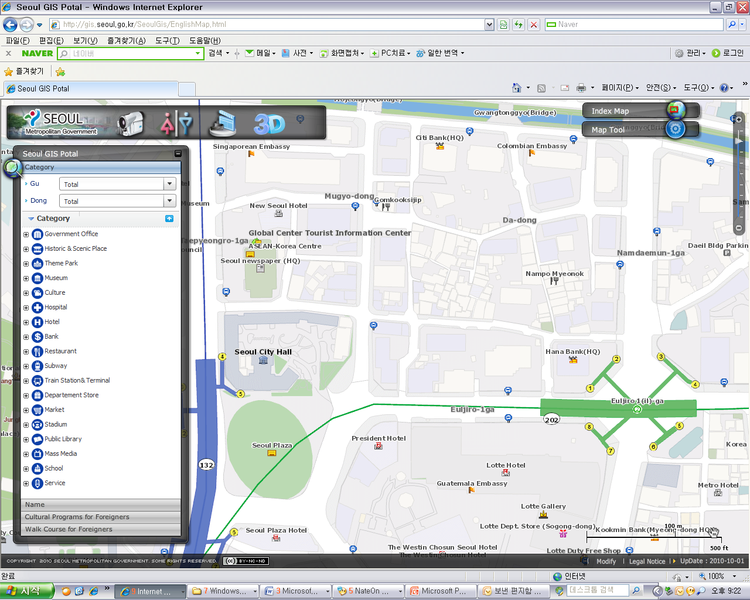

**Lotte**

**Hotel**

**Press**

**Center**

**Press Center**

**Lotte Hotel**

1. **National Coordinator**

**Dr. Sam Young CHUNG**

Tel. +82.2.710.6595

Fax. +82.2.710.6639

E-mail. [sychung@kcc.go.kr](mailto:sychung@kcc.go.kr)

**Ms. Hye Young (Grace) Hwang**

Tel. +82.2.338.1082

Fax. +82.2.338-1083

E-mail. [sg5\_general@kcc.go.kr](mailto:sg5_general@kcc.go.kr)

1. **Accommodation and hotel reservations**

The Korea Administration has obtained special rates in different downtown hotels. Next page shows a map indicating each hotel’s proximity to the meeting venue together with a chart including the corresponding hotel rates.

Delegates are kindly requested to fill out the corresponding reservation form, send it directly to the hotel, copy to Ms. Grace at: [sg5\_general@kcc.go.kr](mailto:sg5_general@kcc.go.kr) or fax. +82.2.338-1083

It is important to make your reservation as soon as possible**. All reservations must include a credit card number**. You shall receive a confirmation message once your reservation has been accepted by the hotel. In case of failure to attend the meeting, all reservations must be cancelled well in advance.

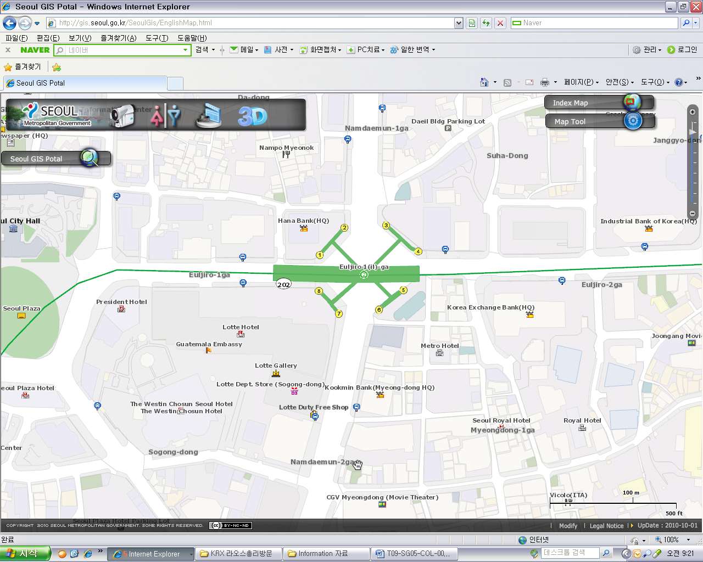

**President Hotel**

**Lotte Hotel**

**Ibis**

**Myeong dong**

**Hotel**

**Loyal Hotel**

|  |  |  |  |  |
| --- | --- | --- | --- | --- |
| **HOTEL** | **CATEG.** | **ROOM** | **RATE** | **NOTES** |
| **(1) Lotte Hotel (Venue)**  1 Sogong-dong Jung-gu Seoul  Tel: +82. 2-759-7311~6 Fax: +82. 2-773-4910 Check-In: 2:00 PM Check-Out: 12:00 PM reservation@hotellotte.co.kr www.lottehotelseoul.com/index.asp | Standard  (Basis on Single Occupancy) | Superior  Deluxe | KRW 254,100 (≒USD 234)  KRW 278,300 (≒USD 257) | Included Taxes  buffet breakfast  : KRW 30,250 (≒USD 29)  Double occupancy charge will be added KRW 24,200 (≒USD 25) |
| Deadline of Reservation | | 1st of August | |
| Cancelation Policy | | Inform to the hotel of any cancellations by 6:00 pm on the date of arrival or be charged for one night. | |
| **(2) Ibis-Myeongdong Hotel**  59-5 Myeongdong 1ga Jung-gu Seoul Tel: +82. 2-6361-8888 Fax: +82. 2-6361-8050 Check-In: 2:00 PM  Check-Out: 12:00 PM [ibismres@ambatel.com](mailto:ibismres@ambatel.com) ibis.ambatel.com/FrontSite/ibis/myeongdong/Default.aspx | Standard | Double  Twin | KRW 172,480 (≒USD 159)  KRW 188,650 (≒USD 174) | Included Taxes  buffet breakfast  : KRW 16,500 (≒USD 15) |
| Deadline of Reservation | | 29th of August | |
| Cancelation Policy | | 50% penalty fee from 14days prior to check in date.  100% penalty fee from 7days prior to check in date. | |
| **(3) Hotel President**  188-3 Euljiro 1ga Jung-gu Seoul Tel: +82. 2-753-3131 Fax: +82. 2-752-7417 Check-In: 2:00 PM  Check-Out: 12:00 PM [marketing@hotelpresident.co.kr](mailto:marketing@hotelpresident.co.kr) www.hotelpresident.co.kr/english | Standard | Twin or Double | KRW 165,000 (≒USD 152) | Included Taxes  buffet breakfast  : KRW 22,000 (≒USD 20) |
| Deadline of Reservation | | 19th of August | |
| Cancelation Policy | | 100% penalty fee from 7days prior to check in date. | |
| **(4) Royal Hotel**  6 Myeongdong 1ga Jung-gu Seoul Tel: +82. 2-2129-5754~7 Fax: +82. 2-2129-5880 Check-In: 2:00 PM  Check-Out: 12:00 PM reser@royal.co.kr www.royal.co.kr | Standard | Double  Twin | KRW 187,000 (≒USD 173)  KRW 203,500 (≒USD 188) | Included Taxes  buffet breakfast  : KRW 15,400 (≒USD 14) |
| Deadline of Reservation | | 19th of August | |
| Cancelation Policy | | 50% penalty fee from 28th of August  75% penalty fee from 5th of September  100% penalty fee from 12nd of September | |

Participants are requested to reserve a hotel on a first-come-first-served basis through E-mail or Fax. Please note that there is a limit of the number of available rooms of Hotels. Therefore, if the reservations are full, it will be shifted to nearby Hotel and the reservation counter of the hotel will inform the corresponding participants about the situation

1. **Flights and transportation**

Incheon International Airport handles all international air traffic and is 60 minutes away from the Seoul. Delegates have several transfer options from the airport to their hotel in the city of Seoul:

**ITU-T SG5 and Workshop on “Progressing the climate agenda through green ICTs” Information desk:** Korea Secretariat will open the Information desk for participants’ convenience at arrivals (see below map). It will be opened from 18th of September to 19th of September at 7:00AM to 7:00PM. (Operating hours can be changed to depend on the participant's schedule) If you need to help to go to Seoul, drop by the information desk and get information.

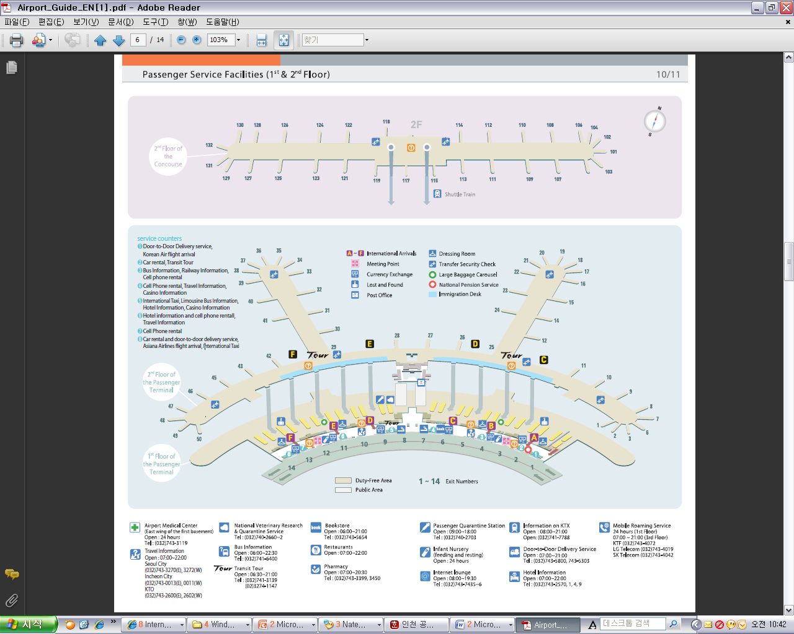

**KAL Stop**

**KAL Stop**

**ITU-T SG5 Information Desk**

**Car services and private taxis:** taxi is recommended if you arrive late at night and buses are no longer operating or if you have heavy baggage or there are many members in your party. If you go to Myeong-dong (near the main venue) by a deluxe taxi late at night, you need to pay about 100,000 won. The fare varies depending on distance (meters).

**Airport Bus:** Airport buses run from Incheon Int'l Airport to various parts of Seoul. You can buy a ticket for your destination at the ticket desk on the arrival floor (1st floor). You can get information on bus routes and bus stops at the Airport Information Desk. Also Korea Secretariat will be operating the ITU-T SG5 and Workshop Information desk for participants’ convenience. If you would like to go from Incheon International Airport to the Lotte Hotel (main venue) you can use a KAL limousine bus.

**Airport Railroad Express and Seoul Metro:** Incheon International Airport Station of AREX is located on the first underground level of the Transportation Center at Incheon International Airport. You can get to Seoul and Lotte Hotel (main venue) using Airport Railroad Express and Seoul Metro.

How to get from Incheon Int’l Airport to Lotte Hotel :

* Get on the Airport Railroad Express on 1st floor of Incheon International Airport
* Transfer to line number 2 (green line) at the Hongik University station
* Get off the train at the Uljiro1(il)-ga station

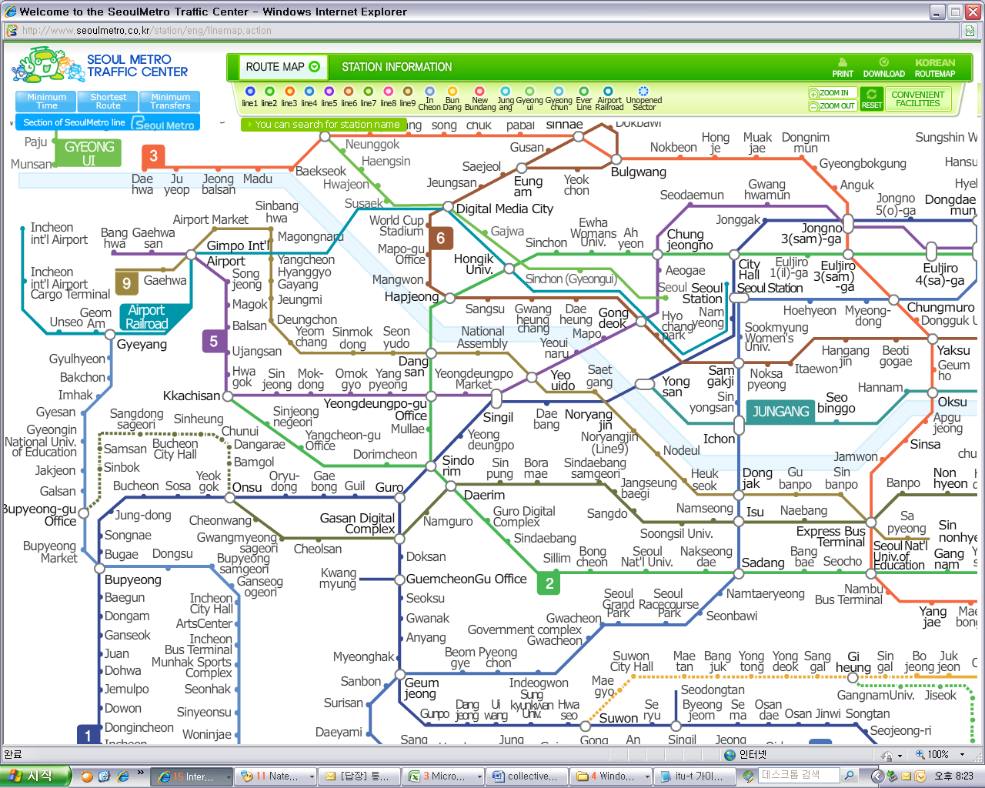

**Incheon**

**Int’l Airport**

**Hongik**

**Univ.**

(Transfer to line No.2)

**Euljiro**

**1(il)-ga**

(Destination)

If you want to further information, please visit below website :

Airport Railroad Express : <http://www.airport.kr/iiacms/pageWork.iia?_scode=C1203020000&fake=1308136787130>

Seoul Metro :

http://www.seoulmetro.co.kr/eng/

## Information for KAL limousine bus from Incheon Int’l Airport to the Lotte Hotel

- Course Time : About 1 hour and 20 min / Adult(15,000won), Child(10,000won)

- Boarding : KAL Stop - 4B or 11A

* Ticket Office : ITU-T SG 5 and Workshop Information desk at Incheon International Airport

(Ticket for the Bus departure from the entrance of the Hotel is sold at Front desk of Main building and New Wing)

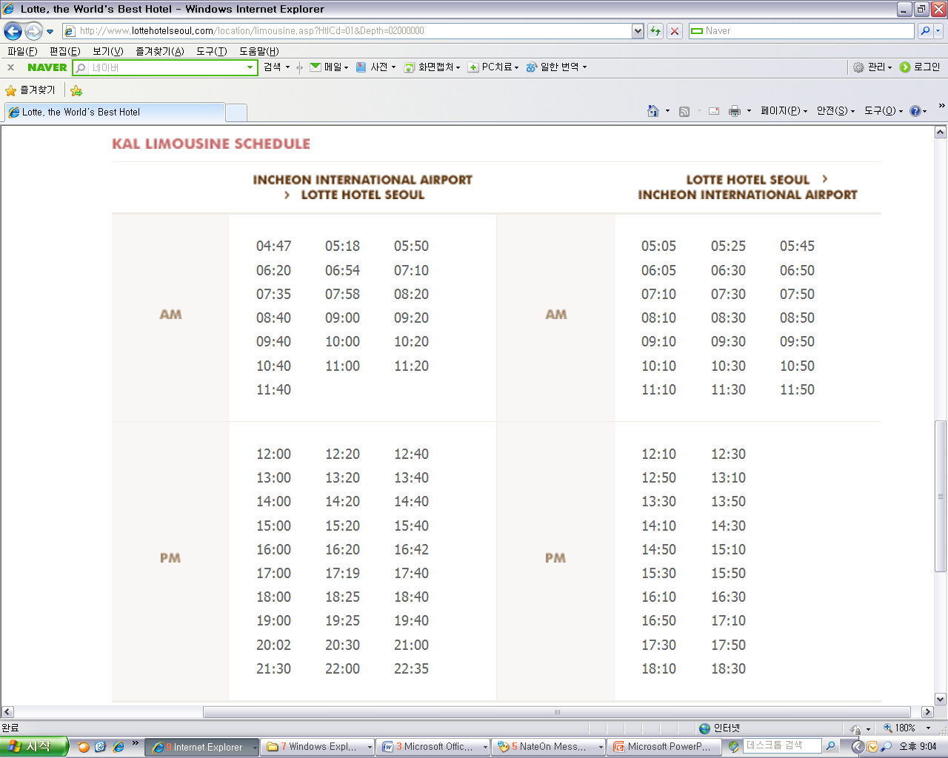

For further information, please visit the following web page: <http://english.visitkorea.or.kr/enu/GK/GK_EN_2_2_2_3.jsp>

1. **GENERAL INFORMATION**

Introduction

The Korean Peninsula is located in North-East Asia and roughly 1,030 km (612 miles) long and 175 km (105 miles) wide at its narrowest point. Korea's total land area is 100,140 sq km, and it has a population of 48.7 million people (2009). Korea is a culturally diverse and economically advanced country full of dynamism. Building upon incredible post-war economic growth, Korea is the 12th largest economy in the world, and is becoming a powerful focal point of the Asian economic block. With a history tracing back more than 5,000 years, Korea is also rightly proud of its dazzling culture. It possesses 8 UNESCO cultural heritage sites, which compares favourably with any other nation in the world.

1. **The City of Seoul**

Seoul is the capital and largest city of the Republic of Korea (South Korea). With a population of over 10 million, it is one of the world's largest cities and is by far the most densely populated city among OECD nations. The Seoul National Capital Area, which includes the Incheon metropolis and most of Gyeonggi province, has 24.5 million inhabitants, and is the world's second largest metropolitan area. Almost half of South Korea's population lives in the Seoul National Capital Area, and nearly a quarter in Seoul itself, making it the country's foremost economic, political, and cultural center

1. **Visa**

Most delegates do not require a visa to enter Korea. You can check all visa requirements at http://www.mofat.go.kr/english/visa/apply/[index](http://www.mofat.go.kr/english/visa/apply/index.jsp).jsp. However, for more certainty we recommend you consult your embassy or consulate.

Those who require a visa to enter Korea should contact Ms. Ellva or Grace at [sg5\_visa@kcc.go.kr](mailto:sg5_visa@kcc.go.kr) in order to request a personalized letter of invitation addressed to the petitioner via e-mail. This letter shall then be delivered to the petitioning country’s Korea Embassy in order to get the visa.

1. **Language**

Korean is the official language (English, Japanese and Chinese are also spoken).

1. **Power**

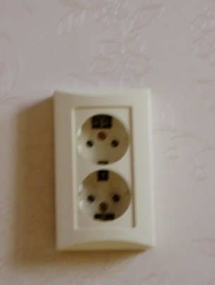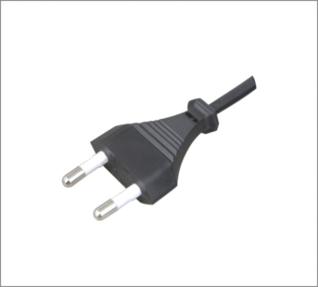Supply voltage is 220V, 50Hz~60Hz. Participants are requested to bring the A-type adapter which is two parallel pronged and requested to bring the electric transformer, if necessary, for your equipments

**Electrical Outlet**

1. **Climate**

The month of September is autumn that is well and truly in Seoul. In the mid September, Korea will be hot but less humid than August. Temperature is between 17 °C ~ 25°C.

1. **Currency**

The unit of Korean currency is Korean Won (KRW). Also the most widely accepted credit cards are American Express, VISA and Master card.

Examples of exchange rates as of 10 June, 2011 is US$1= 1083.00 KRW

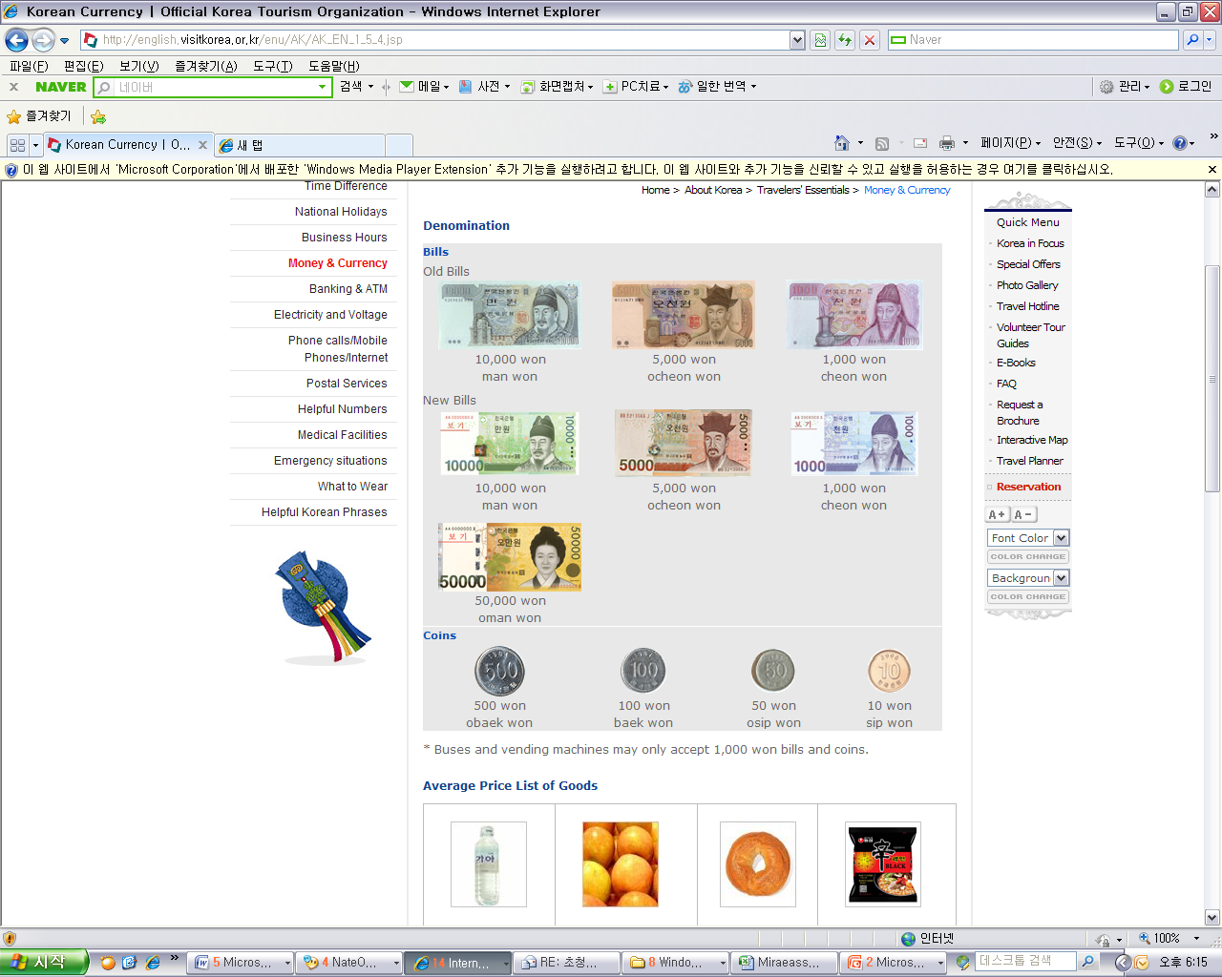

1. **Tax Refund**

At the airport, passengers can get a 10% refund of the amount paid for Value Added Tax (VAT), if they have bought national products for amounts over $ 30 (per purchase slip) at the shops and within 3 months of departure from Korea adhered to the “Global Refund” system.

For further information, please visit:

http://english.visitkorea.or.kr/enu/SH/SH\_EN\_7\_1\_4.jsp

1. **Business hours**

Banks, post offices, and public offices generally open from 09:30 to 16:00 on weekdays but are closed on Saturdays and Sundays. Most of the shops are open from 10:00 to 22:00 through the entire week. However, some shops in Itaewon and Dongdaemon Shopping Mall are opened all night.

1. **Customary Tip**

It is not customary tip in Korea. However, a 10% service charge and 10% taxes is added to your bill at all tourist hotels and some larger restaurants.

1. **Useful Information**

For further information on the city of Seoul, please visit the following web page: http://english.seoul.go.kr

1. **Attire**

Formal attire is recommended for officials attending the Meeting of Study Group 5 and the Workshop on “Progressing the climate agenda through green ICTs”throughout the event.

1. **Invitation to the Welcome Dinner**

*The Communications Secretary of the Republic of Korea are pleased to invite the officials attending the meeting to the Welcome Dinner to be celebrated on Tuesday 20 September 2011 at 6.30 pm at the Sapphire Ballroom of the venue.*

*Suggested attire: Formal*

ANNEX 4  
(to TSB Collective letter 8/5)

**ITU-T Study Group 5 meeting and Workshop**

**Seoul, Republic of Korea, 19-28 September 2011**

**\*\*\*\*\***

## HOTEL RESERVATION

Please type or print clearly. Retain a copy for your records. **Please send this form to the Hotel and one copy to Grace**, e-mail address: [sg5\_general@kcc.go.kr](mailto:sg5_general@kcc.go.kr) Tel: (+82 2) 338-1082, Fax: (+82 2) 338-1083

|  |  |  |  |  |  |  |  |  |  |  |  |  |  |
| --- | --- | --- | --- | --- | --- | --- | --- | --- | --- | --- | --- | --- | --- |
| **Last Name**: | |  | | | | | | **First Name**: | | | |  | |
| **Organization-Company:** | |  | | | | | | | | | | | |
| **Address**: | |  | | | | | | | | | | **Country** |  |
| Tel.: |  | | | Fax: | |  | | | | E-mail: |  | | |
| **Hotel Information** | | | | | **Please choose type of room** | | | | | | | | **Remarks** |
| **Hotel Name** | | | **Number** | | **Room Type** | | | | | **Breakfast** | | | **Remarks** |
|  | | |  | | **Double** | | | |  | Included |  | | *e.g. Smoking or*  *Non-Smoking* |
| **Twin** | | | |  | Excluded |  | |
| **Shared with**: | | | | | | |  | | | | | | |
| **Arrival date and time**: | | | | | | |  | | | | | | |
| **Airline and flight No.:** | | | | | | |  | | | | | | |
| **Departure date and time**: | | | | | | |  | | | | | | |

**I authorize the use of the following credit card to guarantee my hotel reservation:**

|  |  |  |  |
| --- | --- | --- | --- |
| **Type of Card**: |  | **Number:** |  |
| **Name on Card**: |  | **Expiration Date:** |  |

ANNEX 5  
(to TSB Collective letter 8/5)

|  |  |  |  |  |  |  |  |
| --- | --- | --- | --- | --- | --- | --- | --- |
|  | **ITU-T Study Group 5 meeting & Workshop**  **Seoul, Republic of Korea, 19 - 28 September 2011** | | | | | |  |
| **Please return to:** | | | **ITU/BDT**  **Geneva (Switzerland)** | | **E-mail :** [**bdtfellowships@itu.int**](mailto:bdtfellowships@itu.int)  **Tel: +41 22 730 5487**  **Fax: +41 22 730 5778** | | | |
| **Request for a partial fellowship to be submitted before 20 August 2011** | | | | | | | |
|  | | | | Participation of women is encouraged | | |  | |
| **Country: \_\_\_\_\_\_\_\_\_\_\_\_\_\_\_\_\_\_\_\_\_\_\_\_\_\_\_\_\_\_\_\_\_\_\_\_\_\_\_\_\_\_\_\_\_\_\_\_\_\_\_\_\_\_\_\_\_\_\_\_\_\_\_\_\_\_\_\_\_\_\_\_\_\_\_\_\_\_\_\_\_\_\_\_\_\_\_\_\_\_\_\_\_\_\_\_\_\_\_\_\_**  **Name of the Administration or Organization: \_\_\_\_\_\_\_\_\_\_\_\_\_\_\_\_\_\_\_\_\_\_\_\_\_\_\_\_\_\_\_\_\_\_\_\_\_\_\_\_\_\_\_\_\_\_\_\_\_\_\_\_\_\_\_\_\_\_\_\_\_\_\_\_\_\_\_\_\_\_**  **Mr. / Ms. \_\_\_\_\_\_\_\_\_\_\_\_\_\_\_\_\_\_\_\_\_\_\_\_\_\_\_\_\_\_\_\_\_\_\_\_\_\_\_(family name) \_\_\_\_\_\_\_\_\_\_\_\_\_\_\_\_\_\_\_\_\_\_\_\_\_\_\_\_\_\_\_\_\_\_\_\_\_\_(given name)**  **Title: \_\_\_\_\_\_\_\_\_\_\_\_\_\_\_\_\_\_\_\_\_\_\_\_\_\_\_\_\_\_\_\_\_\_\_\_\_\_\_\_\_\_\_\_\_\_\_\_\_\_\_\_\_\_\_\_\_\_\_\_\_\_\_\_\_\_\_\_\_\_\_\_\_\_\_\_\_\_\_\_\_\_\_\_\_\_\_\_\_\_\_\_\_\_\_\_\_\_\_\_** | | | | | | | | |
| **Address: \_\_\_\_\_\_\_\_\_\_\_\_\_\_\_\_\_\_\_\_\_\_\_\_\_\_\_\_\_\_\_\_\_\_\_\_\_\_\_\_\_\_\_\_\_\_\_\_\_\_\_\_\_\_\_\_\_\_\_\_\_\_\_\_\_\_\_\_\_\_\_\_\_\_\_\_\_\_\_\_\_\_\_\_\_\_\_\_\_\_\_\_\_\_\_\_\_\_\_\_**  **\_\_\_\_\_\_\_\_\_\_\_\_\_\_\_\_\_\_\_\_\_\_\_\_\_\_\_\_\_\_\_\_\_\_\_\_\_\_\_\_\_\_\_\_\_\_\_\_\_\_\_\_\_\_\_\_\_\_\_\_\_\_\_\_\_\_\_\_\_\_\_\_\_\_\_\_\_\_\_\_\_\_\_\_\_\_\_\_\_\_\_\_\_\_\_\_\_\_\_\_\_\_\_\_\_\_\_\_\_\_**  **Tel.: \_\_\_\_\_\_\_\_\_\_\_\_\_\_\_\_\_\_\_\_\_\_\_\_\_\_\_\_ Fax: \_\_\_\_\_\_\_\_\_\_\_\_\_\_\_\_\_\_\_\_\_\_\_\_\_\_\_\_ E-Mail:\_\_\_\_\_\_\_\_\_\_\_\_\_\_\_\_\_\_\_\_\_\_\_\_\_\_\_\_\_\_\_\_\_**  **PASSPORT INFORMATION :**  **Date of birth: \_\_\_\_\_\_\_\_\_\_\_\_\_\_\_\_\_\_\_\_\_\_\_\_\_\_\_\_\_\_\_\_\_\_\_\_\_\_\_\_\_\_\_\_\_\_\_\_\_\_\_\_\_\_\_\_\_\_\_\_\_\_\_\_\_\_\_\_\_\_\_\_\_\_\_\_\_\_\_\_\_\_\_\_\_\_\_\_\_\_\_\_\_\_\_**  **Nationality: \_\_\_\_\_\_\_\_\_\_\_\_\_\_\_\_\_\_\_\_\_\_\_\_\_\_\_\_\_\_\_\_\_\_\_\_\_\_\_\_\_\_ Passport number: \_\_\_\_\_\_\_\_\_\_\_\_\_\_\_\_\_\_\_\_\_\_\_\_\_\_\_\_\_\_\_\_\_\_\_\_\_\_\_\_**  **Date of issue: \_\_\_\_\_\_\_\_\_\_\_\_\_\_\_\_\_\_\_ In (place) : \_\_\_\_\_\_\_\_\_\_\_\_\_\_\_\_\_\_\_\_\_\_\_\_\_\_\_\_\_Valid until (date): \_\_\_\_\_\_\_\_\_\_\_\_\_\_\_\_\_\_\_\_\_\_\_** | | | | | | | | |
| CONDITIONS **(Please select your preference in “condition” 2 below)** | | | | | | | | |
| 1. One **partial** fellowship per eligible country. | | | | | | | | |
| 1. ITU will cover either one of the following: | | | | | | | | |
| □ **Economy class air ticket (duty station / Geneva / duty station).** | | | | | | | | |
| **□ Daily subsistence allowance intended to cover accommodation, meals & misc. expenses.**   1. It is imperative that fellows be present from the first day to the end of the meeting. | | | | | | | | |
| **Signature of fellowship candidate:** | | | | | | **Date:** | | |
| **TO VALIDATE FELLOWSHIP REQUEST, NAME, TITLE AND SIGNATURE OF CERTIFYING OFFICIAL DESIGNATING PARTICIPANT MUST BE COMPLETED BELOW WITH OFFICIAL STAMP.** | | | | | | | | |
| **Signature** | | | | | | **Date** | | |

\_\_\_\_\_\_\_\_\_\_\_\_\_\_\_\_