Telecommunication Standardization  Bureau | 

Geneva, 24 June 2011

Ref: | TSB Collective letter 8/5
Tel:  Fax:  E-mail: | +41 22 730 5780  +41 22 730 5853  tsbsg5@itu.int | To Administrations of Member States of the Union, to ITU-T Sector Members, to ITU-T Associates and to ITU-T Academia participating in the work of Study Group 5

Subject: | Meeting of Study Group 5  Seoul, Republic of Korea,  20 - 28 September 2011

Dear Sir/Madam,
1 In accordance with the schedule of ITU Telecommunication Standardization Sector meetings for 2011 (see TSB Circular 80 of 14 December 2009) and the agreement reached at the Study Group 5 meeting (Geneva, 23 November – 1 December 2010), I should like to inform you that, thanks to the kind invitation of the Korea Communications Commission (KCC), Republic of Korea, Study Group 5 (Environment and climate change) is to meet in Seoul, Republic of Korea, from 20 to 28 September 2011 inclusive.
The venue of the meeting will be the Lotte Hotel, Seoul, Korea. The meeting will open at 0930 hours on the first day. Participant registration will begin at 0830 hours.
Please note that the JCA ICT&CC will meet after the SG5 closing plenary meeting on 28 September at 1700 hours local time.
The meeting will be preceded by a half-day Workshop hosted by ITU and KCC on “Progressing the climate agenda through green ICTs” on 19 September 2011 from 1330 to 1800 hours at the International Conference Hall in Korea Press Center, Seoul, Korea (see TSB Circular 204).
2 The discussions will be held in English.
3 The draft agenda, as prepared by the Chairman of SG5, Mr Ahmed Zeddam, is set out in Annex 1 hereto.
4 The draft timetable, as prepared by the Management Team of SG5, is set out in Annex 2 hereto.
5 Practical information on the meeting provided by the host organization is given in Annex 3.
6 TSAG, at its February 2011 meeting, agreed that the trial of a deadline of 12 (twelve) calendar days for submitting contributions to TSB meetings would continue. Such contributions will be published on the Study Group 5 website and must therefore be received by TSB not later than 7 September 2011. Contributions received at least two months before the start of the meeting may be translated, if required, according to the provisions in force.
Participants are encouraged to submit contributions using the web-based submission form available on the Study Group 5 homepage, or by electronic mail to the following address: tsbsg5@itu.int. Detailed instructions can be found on the ITU-T website.
We would strongly encourage you to use the set of templates that has been created to harmonize the appearance of ITU-T documents while making their production easier and hence more efficient. The templates are accessible from each ITU-T study group web page, under “Delegate resources” (http://www.itu.int/ITU-T/studygroups/templates/index.html).
With a view to settling any questions that might arise concerning contributions, the name, fax and telephone numbers and e-mail address of the person to be contacted should be indicated on contributions. Accordingly, please include those details on the cover page of all documents.
7 To enable TSB to make the necessary arrangements concerning the documentation for, and organization of, the meeting, I should be grateful if you would send me, by letter, fax (+41 22 730 5853) or e-mail (tsbreg@itu.int), as soon as possible but not later than 20 August 2011, the list of people who will be representing your Administration, Sector Member, Associate, Academic Institution, regional and/or international organization or other entity. Administrations are requested also to indicate the name of their head of delegation (and deputy head, if applicable).
8 Please note that pre-registration of participants to ITU-T meetings is carried out online at the ITU-T website (http://www.itu.int/ITU-T/studygroups/com05/index.asp).
9 In agreement with its Chairman, Mr Ahmed Zeddam, Study Group 5 will take further steps towards working in a fully electronic environment. The meeting will therefore be run paperless.
10 We are pleased to inform you that ITU will provide a limited number of partial fellowships (either economy class air ticket or accommodation and a daily allowance to cover meals and incidental expenses) to facilitate participation from Least Developed or Low Income Developing Countries. An application must be authorized by the relevant Administration of the ITU Member State and be limited to only one person per country. The fellowship request form, enclosed as Annex 5, should be returned to ITU not later than 20 August 2011. Please note that at WTSA-08, the Heads of Delegation committed that their candidate chairmen and vice-chairmen would be provided with the necessary resources to fulfill the duties of their office for the full four year term and that it was therefore recognized that the chairmen and vice-chairmen will not receive financial assistance from ITU.
11 We would like to remind you that citizens of some countries are required to obtain a visa in order to enter and spend any time in the Republic of Korea. The visa must be requested at least four (4) weeks before the date of beginning of the meeting and obtained from the office (embassy or consulate) representing the Republic of Korea in your country or, if there is no such office in your country, from the one that is closest to the country of departure.
Participants who need an invitation letter and/or a visa supporting letter for entering the Republic of Korea are advised to get in touch with the contact person in the Republic of Korea:
Ms. Hye Young (Grace) Hwang
Tel. +82.2.338.1082
Fax. +82.2.338-1083
E-mail. sg5_visa@kcc.go.kr

12 For your convenience, a hotel reservation form is enclosed as Annex 4.
Yours faithfully,
Malcolm Johnson
Director of the Telecommunication
Standardization Bureau

Annexes: 5
ANNEX 1
(to TSB Collective letter 8/5)
Draft agenda for the meeting of Study Group 5
(Seoul, 20 - 28 September 2011)

- Opening of the meeting
- Adoption of the agenda
- Approval of revised Question 17/5 and proposal to delete Question 20/5
- Guidelines for Working Parties
- Working Parties meetings
- Report of the different SG5 Regional Groups
- Report of the Home Network Special Group
- Reports of the meetings of Working Parties
- Consent/determination/deletion of Recommendations
- Outgoing liaison statements/communications
- Nomination of Rapporteurs, Associate Rapporteurs and Liaison Rapporteurs
- Review of the work programme
- Future activities
- Other business
- Closure of the meeting

ANNEX 2
(to TSB Collective letter 8/5)
Draft revised timetable for the meeting of Study Group 5
(Seoul, 20 - 28 September 2011)

 | Morning |  |  | Afternoon
Tuesday  20 September | Plenary | Working Party 1/5 |  | Working Party 2/5 |  | Working Party 3/5
Wednesday  21 September | Working Party 1/5;  Working Party 3/5  & ad-hoc meetings of  WP 2/5 Questions |  |  | Working Party 2/5;  Working Party 3/5  & ad-hoc meetings of  WP 1/5 Questions
Thursday  22 September | Working Party 1/5;  Working Party 3/5  & ad-hoc meetings of  WP 2/5 Questions |  |  | Working Party 2/5;  Working Party 3/5  & ad-hoc meetings of  WP 1/5 Questions
Friday  23 September | Working Party 2/5;  Working Party 3/5  & ad-hoc meetings of  WP 1/5 Questions |  |  | Working Party 1/5;  Working Party 3/5  & ad-hoc meetings of  WP 2/5 Questions
Monday  26 September | Working Party 1/5;  Working Party 3/5  & ad-hoc meetings of  WP 2/5 Questions |  |  | Working Party 2/5;  Working Party 3/5  & ad-hoc meetings of  WP 1/5 Questions
Tuesday  27 September | Working Party 1/5 |  | Working Party 2/5 |  | Working Party 3/5
Wednesday  28 September | Plenary |  |  | Plenary |  |  | JCA ICT&CC

ANNEX 3
(to TSB Collective letter 8/5)
Practical Information
(Republic of Korea, 19-28 September 2011)

INFORMATION ABOUT THE MEETING AND WORKSHOP

- Venue

ITU-T SG5 Meeting
The ITU-T SG5 will be held from 20th of September to 28th of September 2011 at ‘Sapphire Ballroom’(3F) and meeting rooms on the 36th floor of Lotte Hotel, Seoul, Korea.
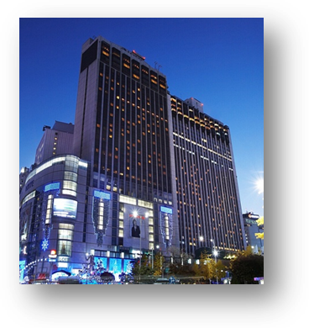
Address | 1, Sogong-Dong, Jung-Gu, Seoul, Korea 100-721
Facilities | Club Floor, Fitness Club, Business Center, Duty Free Shop
Telephone | +82-2-771-1000
Fax | +82-2-752-3758
Website | www.lottehotelseoul.com

Workshop on “Progressing the climate agenda through green ICTs”
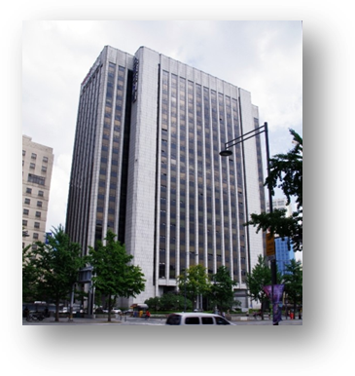
The Workshop will be held on 19th of September 2011 at ‘International Conference Hall’(20F) in Korea Press Center, Seoul, Korea.
Address | 33, Taepyeongro, Jung-Gu, Seoul, Korea 100-721
Facilities | VIP Room, Press Room
Telephone | +82-2-2001-7114
Fax | +82-2-2001-7770
Website | www.kpf.or.kr

How to get from Lotte Hotel to Press Center
It takes 10 minutes by walk and 5 minutes by taxi as below map.
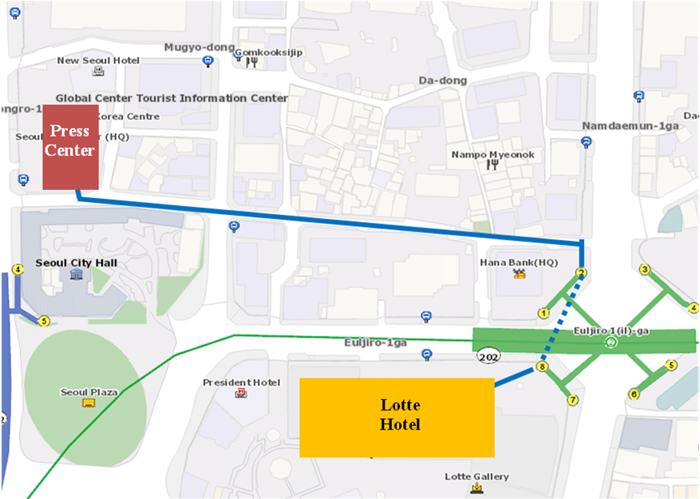

- National Coordinator

Dr. Sam Young CHUNG
Tel. +82.2.710.6595
Fax. +82.2.710.6639
E-mail. sychung@kcc.go.kr

Ms. Hye Young (Grace) Hwang
Tel. +82.2.338.1082
Fax. +82.2.338-1083
E-mail. sg5_general@kcc.go.kr

- Accommodation and hotel reservations
The Korea Administration has obtained special rates in different downtown hotels. Next page shows a map indicating each hotel’s proximity to the meeting venue together with a chart including the corresponding hotel rates.
Delegates are kindly requested to fill out the corresponding reservation form, send it directly to the hotel, copy to Ms. Grace at: sg5_general@kcc.go.kr or fax. +82.2.338-1083
It is important to make your reservation as soon as possible. All reservations must include a credit card number. You shall receive a confirmation message once your reservation has been accepted by the hotel. In case of failure to attend the meeting, all reservations must be cancelled well in advance.
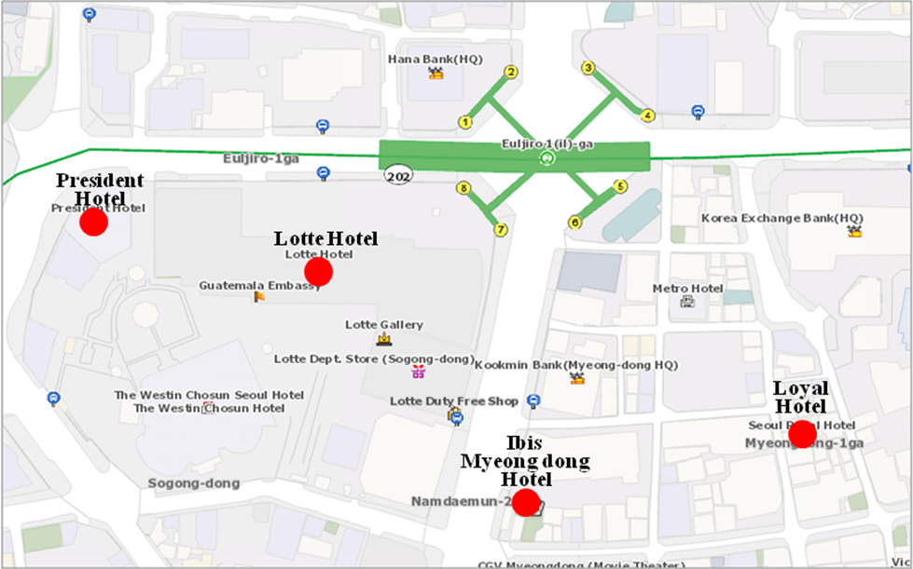

HOTEL | CATEG. | ROOM | RATE | NOTES
(1) Lotte Hotel (Venue)  1 Sogong-dong Jung-gu Seoul  Tel: +82. 2-759-7311~6  Fax: +82. 2-773-4910  Check-In: 2:00 PM  Check-Out: 12:00 PM  reservation@hotellotte.co.kr www.lottehotelseoul.com/index.asp | Standard  (Basis on Single Occupancy) | Superior  Deluxe | KRW 254,100 (≒USD 234)  KRW 278,300 (≒USD 257) | Included Taxes  buffet breakfast  : KRW 30,250 (≒USD 29)  Double occupancy charge will be added KRW 24,200 (≒USD 25)
 | Deadline of Reservation |  | 1st of August
 | Cancelation Policy |  | Inform to the hotel of any cancellations by 6:00 pm on the date of arrival or be charged for one night.
(2) Ibis-Myeongdong Hotel  59-5 Myeongdong 1ga Jung-gu Seoul  Tel: +82. 2-6361-8888  Fax: +82. 2-6361-8050  Check-In: 2:00 PM  Check-Out: 12:00 PM  ibismres@ambatel.com  ibis.ambatel.com/FrontSite/ibis/myeongdong/Default.aspx | Standard | Double  Twin | KRW 172,480 (≒USD 159)  KRW 188,650 (≒USD 174) | Included Taxes  buffet breakfast  : KRW 16,500 (≒USD 15)
 | Deadline of Reservation |  | 29th of August
 | Cancelation Policy |  | 50% penalty fee from 14days prior to check in date.  100% penalty fee from 7days prior to check in date.
(3) Hotel President  188-3 Euljiro 1ga Jung-gu Seoul  Tel: +82. 2-753-3131  Fax: +82. 2-752-7417  Check-In: 2:00 PM  Check-Out: 12:00 PM  marketing@hotelpresident.co.kr  www.hotelpresident.co.kr/english | Standard | Twin or Double | KRW 165,000 (≒USD 152) | Included Taxes  buffet breakfast  : KRW 22,000 (≒USD 20)
 | Deadline of Reservation |  | 19th of August
 | Cancelation Policy |  | 100% penalty fee from 7days prior to check in date.
(4) Royal Hotel  6 Myeongdong 1ga Jung-gu Seoul  Tel: +82. 2-2129-5754~7  Fax: +82. 2-2129-5880  Check-In: 2:00 PM  Check-Out: 12:00 PM  reser@royal.co.kr  www.royal.co.kr | Standard | Double  Twin | KRW 187,000 (≒USD 173)  KRW 203,500 (≒USD 188) | Included Taxes  buffet breakfast  : KRW 15,400 (≒USD 14)
 | Deadline of Reservation |  | 19th of August
 | Cancelation Policy |  | 50% penalty fee from 28th of August  75% penalty fee from 5th of September  100% penalty fee from 12nd of September

Participants are requested to reserve a hotel on a first-come-first-served basis through E-mail or Fax. Please note that there is a limit of the number of available rooms of Hotels. Therefore, if the reservations are full, it will be shifted to nearby Hotel and the reservation counter of the hotel will inform the corresponding participants about the situation

- Flights and transportation
Incheon International Airport handles all international air traffic and is 60 minutes away from the Seoul. Delegates have several transfer options from the airport to their hotel in the city of Seoul:
ITU-T SG5 and Workshop on “Progressing the climate agenda through green ICTs” Information desk: Korea Secretariat will open the Information desk for participants’ convenience at arrivals (see below map). It will be opened from 18th of September to 19th of September at 7:00AM to 7:00PM. (Operating hours can be changed to depend on the participant's schedule) If you need to help to go to Seoul, drop by the information desk and get information.
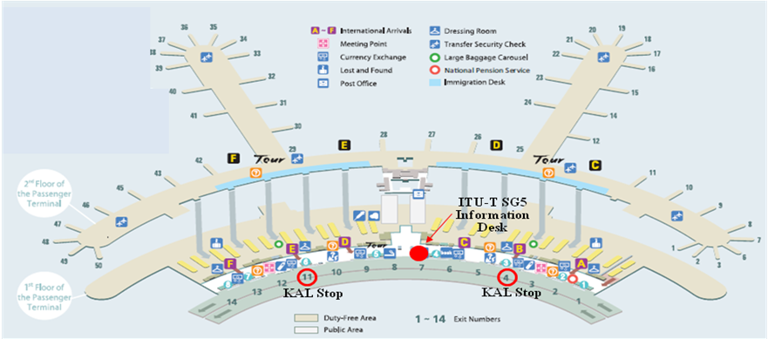
Car services and private taxis: taxi is recommended if you arrive late at night and buses are no longer operating or if you have heavy baggage or there are many members in your party. If you go to Myeong-dong (near the main venue) by a deluxe taxi late at night, you need to pay about 100,000 won. The fare varies depending on distance (meters).
Airport Bus: Airport buses run from Incheon Int'l Airport to various parts of Seoul. You can buy a ticket for your destination at the ticket desk on the arrival floor (1st floor). You can get information on bus routes and bus stops at the Airport Information Desk. Also Korea Secretariat will be operating the ITU-T SG5 and Workshop Information desk for participants’ convenience. If you would like to go from Incheon International Airport to the Lotte Hotel (main venue) you can use a KAL limousine bus.
Airport Railroad Express and Seoul Metro: Incheon International Airport Station of AREX is located on the first underground level of the Transportation Center at Incheon International Airport. You can get to Seoul and Lotte Hotel (main venue) using Airport Railroad Express and Seoul Metro.
How to get from Incheon Int’l Airport to Lotte Hotel :
- Get on the Airport Railroad Express on 1st floor of Incheon International Airport
- Transfer to line number 2 (green line) at the Hongik University station
- Get off the train at the Uljiro1(il)-ga station
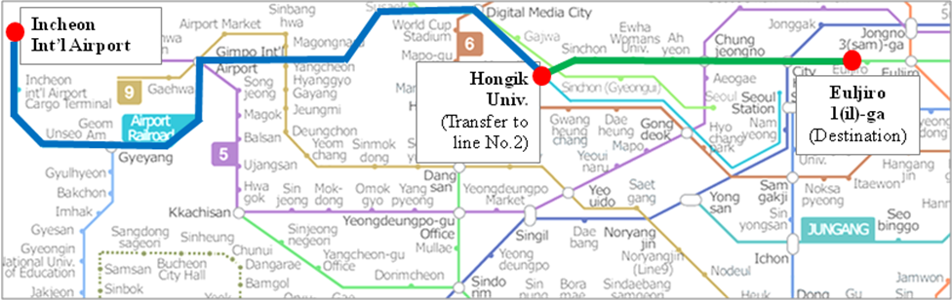
If you want to further information, please visit below website :
Airport Railroad Express : http://www.airport.kr/iiacms/pageWork.iia?_scode=C1203020000&fake=1308136787130
Seoul Metro :
http://www.seoulmetro.co.kr/eng/

Information for KAL limousine bus from Incheon Int’l Airport to the Lotte Hotel
- Course Time : About 1 hour and 20 min / Adult(15,000won), Child(10,000won)
- Boarding : KAL Stop - 4B or 11A
- Ticket Office : ITU-T SG 5 and Workshop Information desk at Incheon International Airport
(Ticket for the Bus departure from the entrance of the Hotel is sold at Front desk of Main building and New Wing)
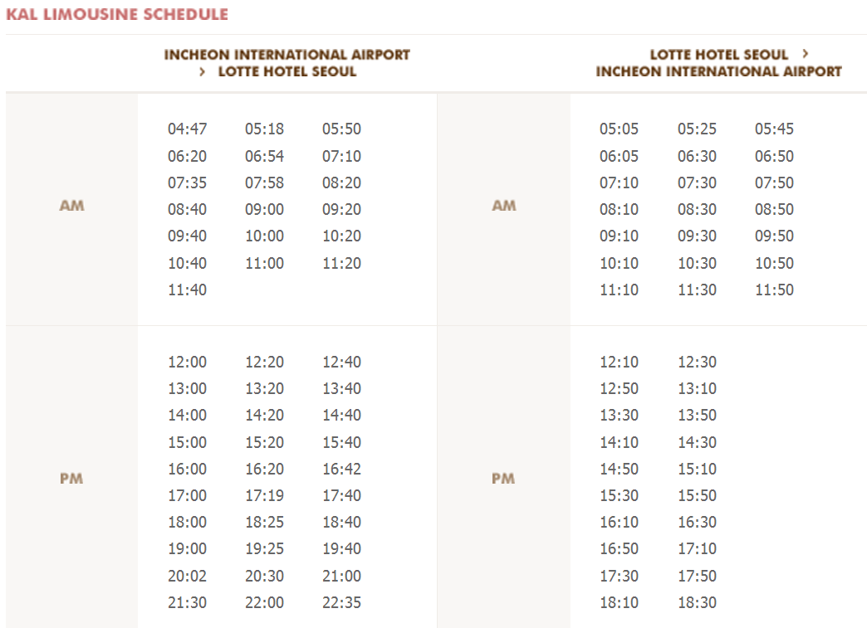
For further information, please visit the following web page: http://english.visitkorea.or.kr/enu/GK/GK_EN_2_2_2_3.jsp

- GENERAL INFORMATION
Introduction

The Korean Peninsula is located in North-East Asia and roughly 1,030 km (612 miles) long and 175 km (105 miles) wide at its narrowest point. Korea's total land area is 100,140 sq km, and it has a population of 48.7 million people (2009). Korea is a culturally diverse and economically advanced country full of dynamism. Building upon incredible post-war economic growth, Korea is the 12th largest economy in the world, and is becoming a powerful focal point of the Asian economic block. With a history tracing back more than 5,000 years, Korea is also rightly proud of its dazzling culture. It possesses 8 UNESCO cultural heritage sites, which compares favourably with any other nation in the world.

- The City of Seoul
Seoul is the capital and largest city of the Republic of Korea (South Korea). With a population of over 10 million, it is one of the world's largest cities and is by far the most densely populated city among OECD nations. The Seoul National Capital Area, which includes the Incheon metropolis and most of Gyeonggi province, has 24.5 million inhabitants, and is the world's second largest metropolitan area. Almost half of South Korea's population lives in the Seoul National Capital Area, and nearly a quarter in Seoul itself, making it the country's foremost economic, political, and cultural center

- Visa
Most delegates do not require a visa to enter Korea. You can check all visa requirements at http://www.mofat.go.kr/english/visa/apply/index.jsp. However, for more certainty we recommend you consult your embassy or consulate.
Those who require a visa to enter Korea should contact Ms. Ellva or Grace at sg5_visa@kcc.go.kr in order to request a personalized letter of invitation addressed to the petitioner via e-mail. This letter shall then be delivered to the petitioning country’s Korea Embassy in order to get the visa.

- Language
Korean is the official language (English, Japanese and Chinese are also spoken).

- Power
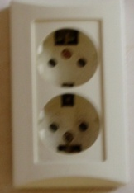
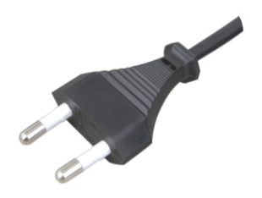
Supply voltage is 220V, 50Hz~60Hz. Participants are requested to bring the A-type adapter which is two parallel pronged and requested to bring the electric transformer, if necessary, for your equipments

Electrical Outlet
- Climate
The month of September is autumn that is well and truly in Seoul. In the mid September, Korea will be hot but less humid than August. Temperature is between 17 °C ~ 25°C.

- Currency
The unit of Korean currency is Korean Won (KRW). Also the most widely accepted credit cards are American Express, VISA and Master card.
Examples of exchange rates as of 10 June, 2011 is US$1= 1083.00 KRW
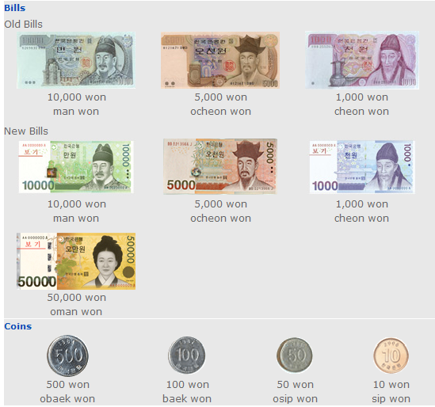

- Tax Refund
At the airport, passengers can get a 10% refund of the amount paid for Value Added Tax (VAT), if they have bought national products for amounts over $ 30 (per purchase slip) at the shops and within 3 months of departure from Korea adhered to the “Global Refund” system.
For further information, please visit:
http://english.visitkorea.or.kr/enu/SH/SH_EN_7_1_4.jsp
- Business hours
Banks, post offices, and public offices generally open from 09:30 to 16:00 on weekdays but are closed on Saturdays and Sundays. Most of the shops are open from 10:00 to 22:00 through the entire week. However, some shops in Itaewon and Dongdaemon Shopping Mall are opened all night.
- Customary Tip
It is not customary tip in Korea. However, a 10% service charge and 10% taxes is added to your bill at all tourist hotels and some larger restaurants.

- Useful Information
For further information on the city of Seoul, please visit the following web page: http://english.seoul.go.kr

- Attire
Formal attire is recommended for officials attending the Meeting of Study Group 5 and the Workshop on “Progressing the climate agenda through green ICTs” throughout the event.

- Invitation to the Welcome Dinner

The Communications Secretary of the Republic of Korea are pleased to invite the officials attending the meeting to the Welcome Dinner to be celebrated on Tuesday 20 September 2011 at 6.30 pm at the Sapphire Ballroom of the venue.

Suggested attire: Formal

ANNEX 4
(to TSB Collective letter 8/5)
ITU-T Study Group 5 meeting and Workshop
Seoul, Republic of Korea, 19-28 September 2011
*****

HOTEL RESERVATION

Please type or print clearly. Retain a copy for your records. Please send this form to the Hotel and one copy to Grace, e-mail address: sg5_general@kcc.go.kr Tel: (+82 2) 338-1082, Fax: (+82 2) 338-1083

Last Name: |  |  |  |  |  |  |  | First Name:
Organization-Company:
Address: |  |  |  |  |  |  |  |  |  |  |  | Country
Tel.: |  |  |  | Fax: |  |  |  |  |  | E-mail:
Hotel Information |  |  |  |  | Please choose type of room |  |  |  |  |  |  |  | Remarks
Hotel Name |  |  | Number |  | Room Type |  |  |  |  | Breakfast |  |  | Remarks
 |  |  |  |  | Double |  |  |  |  | Included |  |  | e.g. Smoking or  Non-Smoking
 |  |  |  |  | Twin |  |  |  |  | Excluded |  |  | e.g. Smoking or  Non-Smoking
Shared with:
Arrival date and time:
Airline and flight No.:
Departure date and time:
I authorize the use of the following credit card to guarantee my hotel reservation:
Type of Card: |  | Number:
Name on Card : |  | Expiration Date:

ANNEX 5
(to TSB Collective letter 8/5)

 |  | ITU-T Study Group 5 meeting  Seoul, Republic of Korea, 20 - 28 September 2011 |  |  |  |  |  | 
Please return to: |  |  | ITU/BDT  Geneva (Switzerland) |  | E-mail : bdtfellowships@itu.int  Tel: +41 22 730 5487  Fax: +41 22 730 5778
 | Request for a partial fellowship to be submitted before 20 August 2011
 |  |  |  | Participation of women is encouraged
Country: _____________________________________________________________________________________________________
Name of the Administration or Organization: ______________________________________________________________________

Mr. / Ms. _______________________________________(family name) ______________________________________(given name)

Title: ____________________________________________________________________________________________________

Address: ____________________________________________________________________________________________________
______________________________________________________________________________________________________________

Tel.: ____________________________ Fax: ____________________________ E-Mail:_________________________________

PASSPORT INFORMATION :
Date of birth: _______________________________________________________________________________________________

Nationality: __________________________________________ Passport number: ________________________________________

Date of issue: ___________________ In (place) : _____________________________Valid until (date): _______________________

CONDITIONS (Please select your preference in “condition” 2 below)
- One partial fellowship per eligible country.
- ITU will cover either one of the following:
□ Economy class air ticket (duty station / Seoul / duty station).
□ Daily subsistence allowance intended to cover accommodation, meals & misc. expenses.
- It is imperative that fellows be present from the first day to the end of the meeting.

Signature of fellowship candidate: |  |  |  |  |  | Date:
TO VALIDATE FELLOWSHIP REQUEST, NAME, TITLE AND SIGNATURE OF CERTIFYING OFFICIAL DESIGNATING PARTICIPANT MUST BE COMPLETED BELOW WITH OFFICIAL STAMP.

Signature |  |  |  |  |  | Date

