|  |  |
| --- | --- |
| **Бюро стандартизации  электросвязи** | Description: logo_R_ |
|  |  |

Женева, 24 июня 2011 года

|  |  |  |
| --- | --- | --- |
| Осн.: | **Коллективное письмо 8/5 БСЭ** |  |
| Тел.: Факс: Эл. почта: | +41 22 730 5780 +41 22 730 5853 [tsbsg5@itu.int](mailto:tsbsg5@itu.int) | – Администрациям Государств – Членов Союза, Членам Сектора МСЭ-Т, Ассоциированным членам МСЭ-Т и академическим организациям − Членам МСЭ‑Т, принимающим участие в работе 5‑й Исследовательской комиссии |

|  |  |
| --- | --- |
| Предмет: | **Собрание 5‑й Исследовательской комиссии Сеул, Республика Корея 20−28 сентября 2011 года** |

Уважаемая госпожа,  
уважаемый господин,

1 В соответствии с расписанием собраний Сектора стандартизации электросвязи МСЭ на 2011 год (см. Циркуляр 80 БСЭ от 14 декабря 2009 г.) и согласием, достигнутым на собрании 5‑й Исследовательской комиссии (Женева, 23 ноября – 1 декабря 2010 г.), хотел бы проинформировать Вас, что благодаря любезному приглашению Комиссии по связи Кореи (KCC), Республика Корея, собрание 5‑й Исследовательской комиссии (*Окружающая среда и изменение климата*) состоится в Сеуле, Республика Корея, с 20 по 28 сентября 2011 года включительно.

Местом проведения собрания будет гостиница Lotte Hotel, Сеул, Корея. Открытие собрания состоится в первый день его работы в 09 час. 30 мин. Регистрация участников начнется в 08 час. 30 мин.

Просьба принять к сведению, что собрание Группы JCA ICT&CC состоится после заключительного пленарного заседания 28 сентября в 17 час. 00 мин. по местному времени.

Собранию будет предшествовать принимаемый МСЭ и KCC семинар-практикум продолжительностью полдня на тему "Активизация работы по повестке дня в области климата благодаря экологически чистым ИКТ", который состоится 19 сентября 2011 года с 13 час. 30 мин. до 18 час. 00 мин. в зале международных конференций Пресс-центра Кореи, Сеул, Республика Корея (см. Циркуляр 204 БСЭ).

2 Обсуждения будут проходить только на английском языке.

3 Проект повестки дня, подготовленный Председателем ИК5 г-ном Ахмедом Зеддамом, приводится в **Приложении 1** к настоящему документу.

4 Проект графика, подготовленный руководящим составом ИК5, приводится в **Приложении 2** к настоящему документу.

5 Практическая информация о собрании, предоставленная принимающей организацией, приводится в **Приложении 3**.

6 На собрании КГСЭ в феврале 2011 года было принято решение о продолжении в порядке эксперимента действия предельного срока 12 (двенадцать) календарных дней для представления вкладов на собрания БСЭ. Такие вклады будут опубликованы на веб-сайте 5‑й Исследовательской комиссии, и, следовательно, они должны поступить в БСЭ **не позднее 7 сентября 2011 года**. Вклады, полученные не позднее чем за два месяца до начала работы собрания, если потребуется, могут быть переведены в соответствии с действующими положениями.

Участникам предлагается представлять вклады, используя для этого электронную форму, находящуюся на домашней странице 5‑й Исследовательской комиссии, или по электронной почте по следующему адресу: [tsbsg5@itu.int](mailto:tsbsg5@itu.int). Подробные указания приводятся на веб-сайте МСЭ-Т.

Настоятельно рекомендуем Вам использовать набор шаблонов, разработанных для унификации оформления документов МСЭ-Т, а также облегчения процесса производства документов и, следовательно, повышения его эффективности. Доступ к таким шаблонам предоставляется на веб‑странице каждой исследовательской комиссии МСЭ-Т в директории "Delegate resources" (<http://www.itu.int/ITU-T/studygroups/templates/index.html>).

Для урегулирования любых вопросов, которые могут возникнуть в связи со вкладами, вклады следует представлять с указанием фамилии, номеров факса и телефона, а также адреса электронной почты лица, к которому следует обращаться. В связи с этим просьба указывать такие сведения на титульном листе всех документов.

7 С тем чтобы БСЭ могло предпринять необходимые действия по обеспечению собрания документами и по его организации, был бы признателен Вам за направленный в мой адрес письмом, по факсу (+41 22 730 5853) или по электронной почте ([tsbreg@itu.int](mailto:tsbreg@itu.int)) в максимально короткий срок, однако **не позднее 20 августа 2011 года**, список лиц, которые будут представлять вашу администрацию, Члена Сектора, Ассоциированного члена, академическое учреждение, региональную и/или международную организацию либо другое объединение. Просим администрации также указывать фамилию главы делегации (и заместителя главы делегации, в надлежащих случаях).

8 **Просим принять к сведению, что предварительная регистрация участников собраний МСЭ‑Т проводится в *онлайновой форме* на веб-сайте МСЭ‑Т   
(**[**http://www.itu.int/ITU-T/studygroups/com05/index.asp**](http://www.itu.int/ITU-T/studygroups/com05/index.asp) **)**.

9 5-я Исследовательская комиссия по согласованию с Председателем г-ном Ахмедом Зеддамом предпримет дальнейшие шаги в направлении работы в полностью электронной среде. В связи с этим работа собрания будет проходить на безбумажной основе.

10 Нам приятно сообщить Вам, что для содействия участию представителей из наименее развитых стран или развивающихся стран с низким уровнем дохода МСЭ предоставит ограниченное количество частичных стипендий (**или** авиабилет экономического класса, **или** проживание в гостинице и суточные для покрытия расходов на питание и непредвиденных расходов). Заявка на предоставление стипендии должна быть утверждена соответствующей администрацией Государства – Члена МСЭ и оформлена только на одно лицо из каждой страны. Заполненную форму запроса на предоставление стипендии, которая представлена в **Приложении 5**, следует вернуть в МСЭ **не позднее 20 августа 2011 года**. Просьба принять к сведению, что на ВАСЭ-08 главы делегаций подтвердили, что их кандидатам на посты председателей и заместителей председателей будут предоставлены необходимые ресурсы для исполнения ими должностных обязанностей в течение полного четырехгодичного срока. Было признано, что председатели и заместители председателей не будут получать финансовую помощь от МСЭ.

11 Хотели бы напомнить Вам о том, что для въезда в Республику Корея и пребывания в ней в течение любого срока гражданам некоторых стран необходимо получить визу. **Визу следует запрашивать не менее чем за четыре (4) недели до даты начала собрания** и получать в учреждении (посольстве или консульстве), представляющем Республику Корея в вашей стране, или, если в вашей стране такое учреждение отсутствует, в ближайшем к стране выезда.

Участникам, которым необходимо получить пригласительное письмо и/или письмо с визовой поддержкой для въезда в Республику Корея, рекомендуется обратиться к контактному лицу в Республике Корея:

**г-жа Хе Ён (Грэйс) Хван (Ms Hye Young (Grace) Hwang)**

Тел.: +82 2 338 1082

Факс: +82 2 338 1083

Эл. почта: [sg5\_visa@kcc.go.kr](mailto:sg5_visa@kcc.go.kr).

12 Для Вашего удобства в **Приложении 4** содержится форма для бронирования номеров в гостиницах.

С уважением,

Малколм Джонсон  
Директор Бюро  
стандартизации электросвязи

**Приложения**: 5

ANNEX 1  
(to TSB Collective letter 8/5)

**Draft agenda for the meeting of Study Group 5  
(Seoul, 20−28 September 2011)**

1. Opening of the meeting
2. Adoption of the agenda
3. Approval of revised Question 17/5 and proposal to delete Question 20/5
4. Guidelines for Working Parties
5. Working Parties meetings
6. Report of the different SG5 Regional Groups
7. Report of the Home Network Special Group
8. Reports of the meetings of Working Parties
9. Consent/determination/deletion of Recommendations
10. Outgoing liaison statements/communications
11. Nomination of Rapporteurs, Associate Rapporteurs and Liaison Rapporteurs
12. Review of the work programme
13. Future activities
14. Other business
15. Closure of the meeting

ANNEX 2  
(to TSB Collective letter 8/5)

**Draft revised timetable for the meeting of Study Group 5  
(Seoul, 20−28 September 2011)**

|  |  |  |  |  |  |  |  |
| --- | --- | --- | --- | --- | --- | --- | --- |
|  | **Morning** | | | **Afternoon** | | | |
| Tuesday 20 September | Plenary | Working Party 1/5 | | Working Party 2/5 | | Working Party 3/5 | |
| Wednesday 21 September | Working Party 1/5; Working Party 3/5 & *ad-hoc* meetings of  WP 2/5 Questions | | | Working Party 2/5; Working Party 3/5 & *ad-hoc* meetings of  WP 1/5 Questions | | | |
| Thursday 22 September | Working Party 1/5; Working Party 3/5 & *ad-hoc* meetings of  WP 2/5 Questions | | | Working Party 2/5; Working Party 3/5 & *ad-hoc* meetings of  WP 1/5 Questions | | | |
| Friday 23 September | Working Party 2/5; Working Party 3/5 & *ad-hoc* meetings of  WP 1/5 Questions | | | Working Party 1/5; Working Party 3/5 & *ad-hoc* meetings of  WP 2/5 Questions | | | |
| Monday 26 September | Working Party 1/5; Working Party 3/5 & *ad-hoc* meetings of  WP 2/5 Questions | | | Working Party 2/5; Working Party 3/5 & *ad-hoc* meetings of  WP 1/5 Questions | | | |
| Tuesday 27 September | Working Party 1/5 | | Working Party 2/5 | | Working Party 3/5 | | |
| Wednesday 28 September | Plenary | | | Plenary | | | JCA ICT&CC |

ANNEX 3  
(to TSB Collective letter 8/5)

**Practical Information  
(Republic of Korea, 19−28 September 2011)**

## INFORMATION ABOUT THE MEETING AND WORKSHOP

1. **Venue**

## ITU-T SG5 Meeting

The ITU-T SG5 will be held from 20th of September to 28th of September 2011 at ‘Sapphire Ballroom’(3F) and meeting rooms on the 36th floor of Lotte Hotel, Seoul, Korea.

|  |  |
| --- | --- |
| Address | 1, Sogong-Dong, Jung-Gu, Seoul, Korea 100-721 |
| Facilities | Club Floor, Fitness Club, Business Center, Duty Free Shop |
| Telephone | +82-2-771-1000 |
| Fax | +82-2-752-3758 |
| Website | [www.lottehotelseoul.com](http://www.lottehotelseoul.com) |

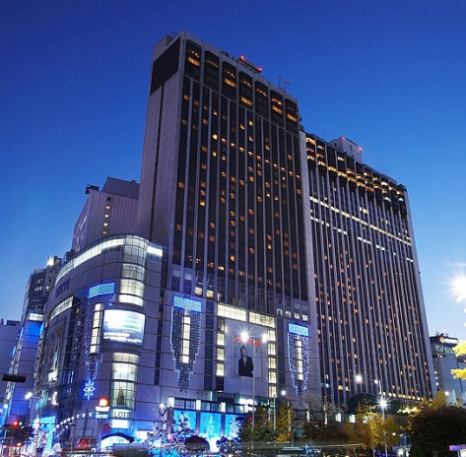

## Workshop on “Progressing the climate agenda through green ICTs”

|  |  |
| --- | --- |
| Address | 33, Taepyeongro, Jung-Gu, Seoul, Korea 100-721 |
| Facilities | VIP Room, Press Room |
| Telephone | +82-2-2001-7114 |
| Fax | +82-2-2001-7770 |
| Website | [www.kpf.or.kr](http://www.kpf.or.kr) |

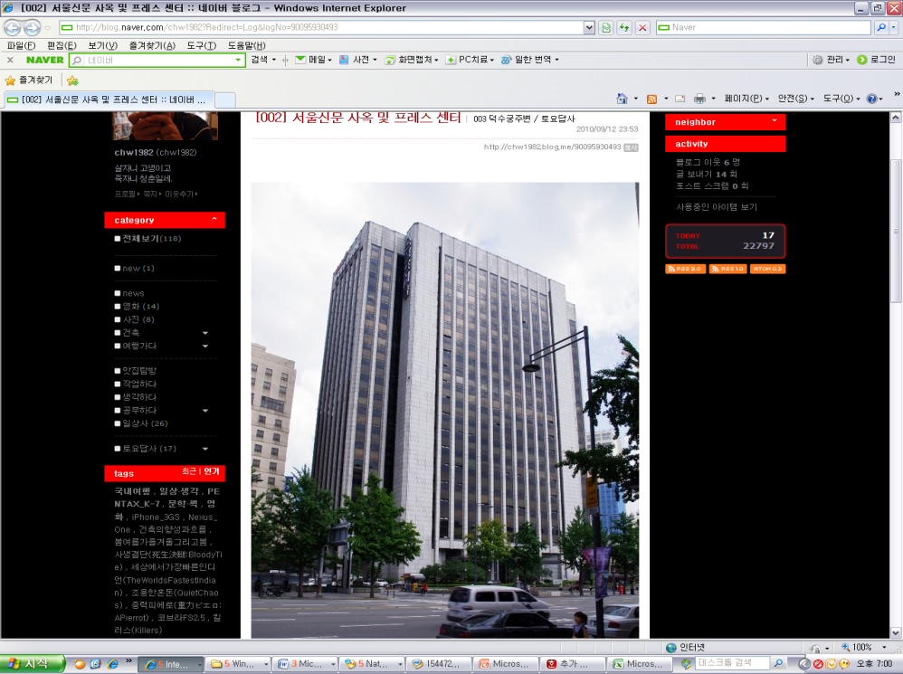The Workshop will be held on 19th of September 2011 at ‘International Conference Hall’(20F) in Korea Press Center, Seoul, Korea.

## How to get from Lotte Hotel to Press Center

It takes 10 minutes by walk and 5 minutes by taxi as below map.

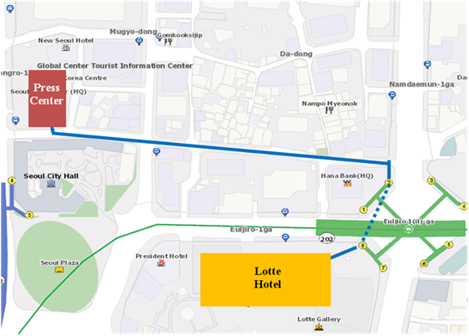

1. **National Coordinator**

**Dr. Sam Young CHUNG**

Tel. +82.2.710.6595

Fax. +82.2.710.6639

E-mail. [sychung@kcc.go.kr](mailto:sychung@kcc.go.kr)

**Ms. Hye Young (Grace) Hwang**

Tel. +82.2.338.1082

Fax. +82.2.338-1083

E-mail. [sg5\_general@kcc.go.kr](mailto:sg5_general@kcc.go.kr)

1. **Accommodation and hotel reservations**

The Korea Administration has obtained special rates in different downtown hotels. Next page shows a map indicating each hotel’s proximity to the meeting venue together with a chart including the corresponding hotel rates.

Delegates are kindly requested to fill out the corresponding reservation form, send it directly to the hotel, copy to Ms. Grace at: [sg5\_general@kcc.go.kr](mailto:sg5_general@kcc.go.kr) or fax. +82.2.338-1083

It is important to make your reservation as soon as possible. **All reservations must include a credit card number**. You shall receive a confirmation message once your reservation has been accepted by the hotel. In case of failure to attend the meeting, all reservations must be cancelled well in advance.

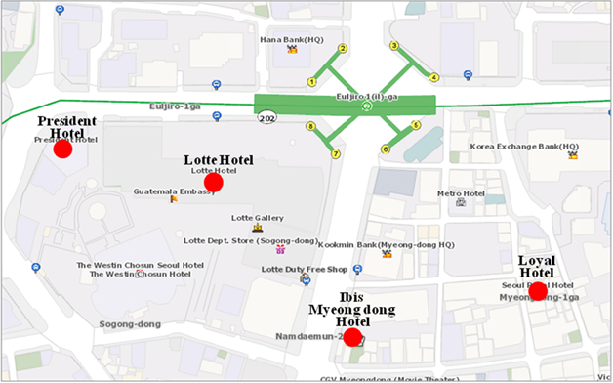

|  |  |  |  |  |
| --- | --- | --- | --- | --- |
| **HOTEL** | **CATEG.** | **ROOM** | **RATE** | **NOTES** |
| **(1) Lotte Hotel (Venue)**  1 Sogong-dong Jung-gu Seoul  Tel: +82. 2-759-7311~6 Fax: +82. 2-773-4910 Check-In: 2:00 PM Check-Out: 12:00 PM reservation@hotellotte.co.kr www.lottehotelseoul.com/index.asp | Standard  (Basis on Single Occupancy) | Superior  Deluxe | KRW 254,100 (≒USD 234)  KRW 278,300 (≒USD 257) | Included Taxes  buffet breakfast  : KRW 30,250 (≒USD 29)  Double occupancy charge will be added KRW 24,200 (≒USD 25) |
| Deadline of Reservation | | 1st of August | |
| Cancelation Policy | | Inform to the hotel of any cancellations by 6:00 pm on the date of arrival or be charged for one night. | |
| **(2) Ibis-Myeongdong Hotel**  59-5 Myeongdong 1ga Jung-gu Seoul Tel: +82. 2-6361-8888 Fax: +82. 2-6361-8050 Check-In: 2:00 PM  Check-Out: 12:00 PM [ibismres@ambatel.com](mailto:ibismres@ambatel.com) ibis.ambatel.com/FrontSite/ibis/myeongdong/Default.aspx | Standard | Double  Twin | KRW 172,480 (≒USD 159)  KRW 188,650 (≒USD 174) | Included Taxes  buffet breakfast  : KRW 16,500 (≒USD 15) |
| Deadline of Reservation | | 29th of August | |
| Cancelation Policy | | 50% penalty fee from 14days prior to check in date.  100% penalty fee from 7days prior to check in date. | |
| **(3) Hotel President**  188-3 Euljiro 1ga Jung-gu Seoul Tel: +82. 2-753-3131 Fax: +82. 2-752-7417 Check-In: 2:00 PM  Check-Out: 12:00 PM [marketing@hotelpresident.co.kr](mailto:marketing@hotelpresident.co.kr) www.hotelpresident.co.kr/english | Standard | Twin or Double | KRW 165,000 (≒USD 152) | Included Taxes  buffet breakfast  : KRW 22,000 (≒USD 20) |
| Deadline of Reservation | | 19th of August | |
| Cancelation Policy | | 100% penalty fee from 7days prior to check in date. | |
| **(4) Royal Hotel**  6 Myeongdong 1ga Jung-gu Seoul Tel: +82. 2-2129-5754~7 Fax: +82. 2-2129-5880 Check-In: 2:00 PM  Check-Out: 12:00 PM reser@royal.co.kr www.royal.co.kr | Standard | Double  Twin | KRW 187,000 (≒USD 173)  KRW 203,500 (≒USD 188) | Included Taxes  buffet breakfast  : KRW 15,400 (≒USD 14) |
| Deadline of Reservation | | 19th of August | |
| Cancelation Policy | | 50% penalty fee from 28th of August  75% penalty fee from 5th of September  100% penalty fee from 12nd of September | |

Participants are requested to reserve a hotel on a first-come-first-served basis through E-mail or Fax. Please note that there is a limit of the number of available rooms of Hotels. Therefore, if the reservations are full, it will be shifted to nearby Hotel and the reservation counter of the hotel will inform the corresponding participants about the situation

1. **Flights and transportation**

Incheon International Airport handles all international air traffic and is 60 minutes away from the Seoul. Delegates have several transfer options from the airport to their hotel in the city of Seoul:

**ITU-T SG5 and Workshop on “Progressing the climate agenda through green ICTs” Information desk:** Korea Secretariat will open the Information desk for participants’ convenience at arrivals (see below map). It will be opened from 18th of September to 19th of September at 7:00AM to 7:00PM. (Operating hours can be changed to depend on the participant's schedule) If you need to help to go to Seoul, drop by the information desk and get information.

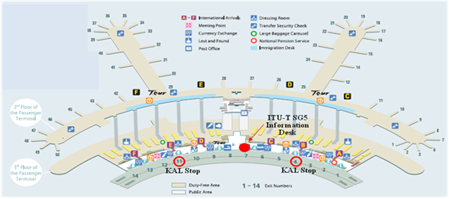

**Car services and private taxis:** taxi is recommended if you arrive late at night and buses are no longer operating or if you have heavy baggage or there are many members in your party. If you go to Myeong-dong (near the main venue) by a deluxe taxi late at night, you need to pay about 100,000 won. The fare varies depending on distance (meters).

**Airport Bus:** Airport buses run from Incheon Int'l Airport to various parts of Seoul. You can buy a ticket for your destination at the ticket desk on the arrival floor (1st floor). You can get information on bus routes and bus stops at the Airport Information Desk. Also Korea Secretariat will be operating the ITU-T SG5 and Workshop Information desk for participants’ convenience. If you would like to go from Incheon International Airport to the Lotte Hotel (main venue) you can use a KAL limousine bus.

**Airport Railroad Express and Seoul Metro:** Incheon International Airport Station of AREX is located on the first underground level of the Transportation Center at Incheon International Airport. You can get to Seoul and Lotte Hotel (main venue) using Airport Railroad Express and Seoul Metro.

How to get from Incheon Int’l Airport to Lotte Hotel :

* Get on the Airport Railroad Express on 1st floor of Incheon International Airport
* Transfer to line number 2 (green line) at the Hongik University station
* Get off the train at the Uljiro1(il)-ga station

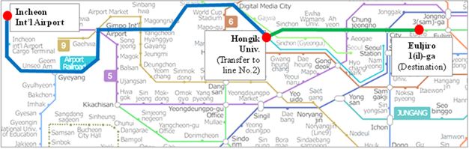

If you want to further information, please visit below website :

Airport Railroad Express : <http://www.airport.kr/iiacms/pageWork.iia?_scode=C1203020000&fake=1308136787130>

Seoul Metro :

http://www.seoulmetro.co.kr/eng/

## Information for KAL limousine bus from Incheon Int’l Airport to the Lotte Hotel

- Course Time : About 1 hour and 20 min / Adult(15,000won), Child(10,000won)

- Boarding : KAL Stop - 4B or 11A

- Ticket Office : ITU-T SG 5 and Workshop Information desk at Incheon International Airport

(Ticket for the Bus departure from the entrance of the Hotel is sold at Front desk of Main building and New Wing)

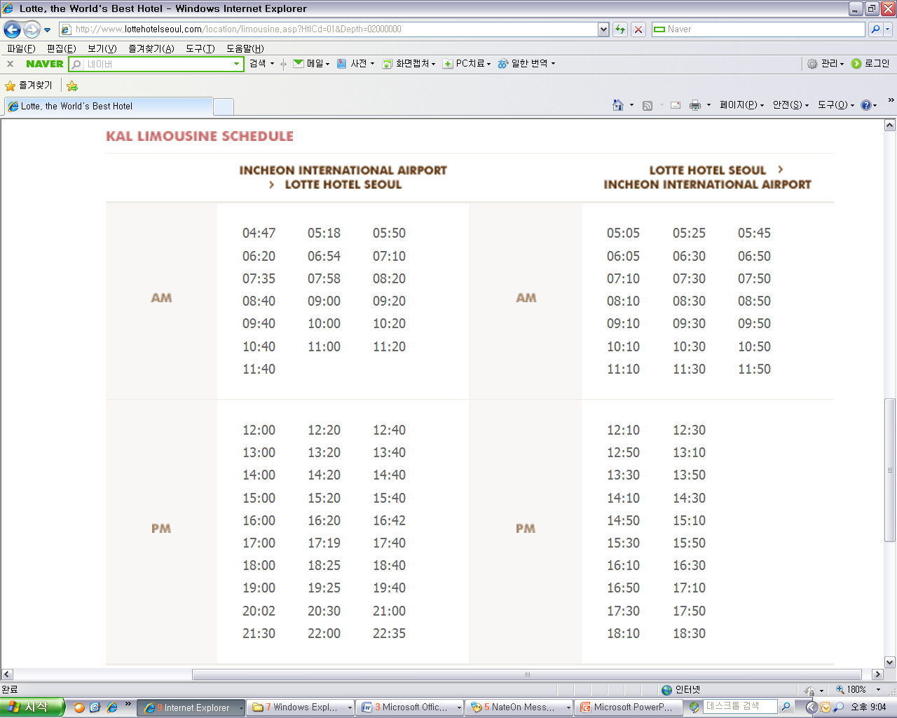

For further information, please visit the following web page: <http://english.visitkorea.or.kr/enu/GK/GK_EN_2_2_2_3.jsp>

1. **GENERAL INFORMATION**

Introduction

The Korean Peninsula is located in North-East Asia and roughly 1,030 km (612 miles) long and 175 km (105 miles) wide at its narrowest point. Korea's total land area is 100,140 sq km, and it has a population of 48.7 million people (2009). Korea is a culturally diverse and economically advanced country full of dynamism. Building upon incredible post-war economic growth, Korea is the 12th largest economy in the world, and is becoming a powerful focal point of the Asian economic block. With a history tracing back more than 5,000 years, Korea is also rightly proud of its dazzling culture. It possesses 8 UNESCO cultural heritage sites, which compares favourably with any other nation in the world.

1. **The City of Seoul**

Seoul is the capital and largest city of the Republic of Korea (South Korea). With a population of over 10 million, it is one of the world's largest cities and is by far the most densely populated city among OECD nations. The Seoul National Capital Area, which includes the Incheon metropolis and most of Gyeonggi province, has 24.5 million inhabitants, and is the world's second largest metropolitan area. Almost half of South Korea's population lives in the Seoul National Capital Area, and nearly a quarter in Seoul itself, making it the country's foremost economic, political, and cultural center

1. **Visa**

Most delegates do not require a visa to enter Korea. You can check all visa requirements at http://www.mofat.go.kr/english/visa/apply/[index](http://www.mofat.go.kr/english/visa/apply/index.jsp).jsp. However, for more certainty we recommend you consult your embassy or consulate.

Those who require a visa to enter Korea should contact Ms. Ellva or Grace at [sg5\_visa@kcc.go.kr](mailto:sg5_visa@kcc.go.kr) in order to request a personalized letter of invitation addressed to the petitioner via e-mail. This letter shall then be delivered to the petitioning country’s Korea Embassy in order to get the visa.

1. **Language**

Korean is the official language (English, Japanese and Chinese are also spoken).

1. **Power**

Supply voltage is 220V, 50Hz~60Hz. Participants are requested to bring the A-type adapter which is two parallel pronged and requested to bring the electric transformer, if necessary, for your equipments

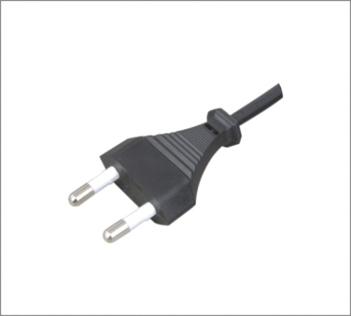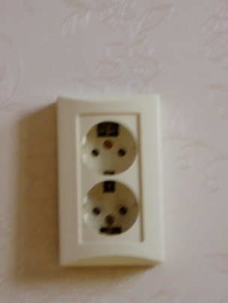

**Electrical Outlet**

1. **Climate**

The month of September is autumn that is well and truly in Seoul. In the mid September, Korea will be hot but less humid than August. Temperature is between 17 °C ~ 25°C.

1. **Currency**

The unit of Korean currency is Korean Won (KRW). Also the most widely accepted credit cards are American Express, VISA and Master card.

Examples of exchange rates as of 10 June, 2011 is US$1= 1083.00 KRW

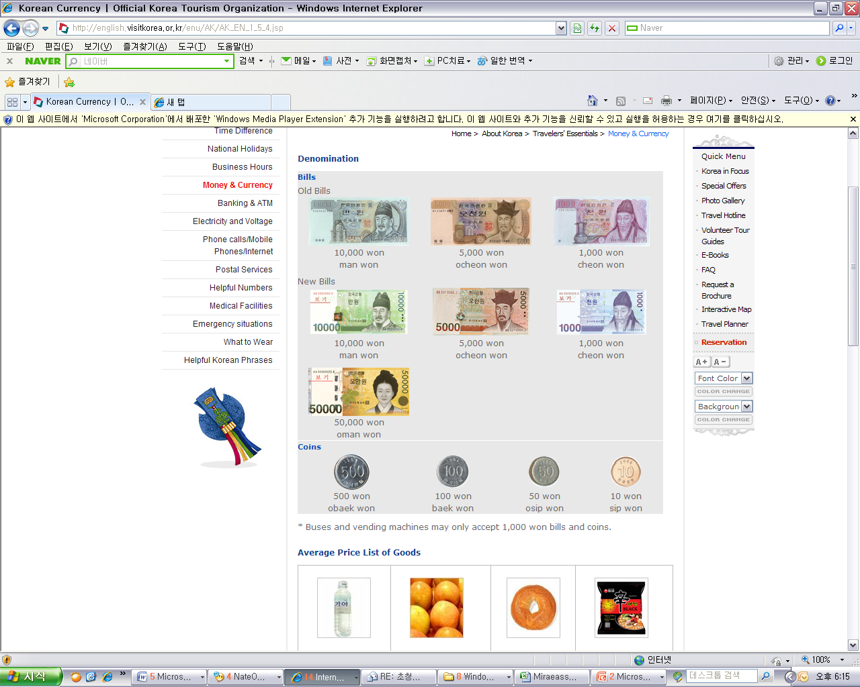

1. **Tax Refund**

At the airport, passengers can get a 10% refund of the amount paid for Value Added Tax (VAT), if they have bought national products for amounts over $ 30 (per purchase slip) at the shops and within 3 months of departure from Korea adhered to the “Global Refund” system.

For further information, please visit:

<http://english.visitkorea.or.kr/enu/SH/SH_EN_7_1_4.jsp>

1. **Business hours**

Banks, post offices, and public offices generally open from 09:30 to 16:00 on weekdays but are closed on Saturdays and Sundays. Most of the shops are open from 10:00 to 22:00 through the entire week. However, some shops in Itaewon and Dongdaemon Shopping Mall are opened all night.

1. **Customary Tip**

It is not customary tip in Korea. However, a 10% service charge and 10% taxes is added to your bill at all tourist hotels and some larger restaurants.

1. **Useful Information**

For further information on the city of Seoul, please visit the following web page: http://english.seoul.go.kr

1. **Attire**

Formal attire is recommended for officials attending the Meeting of Study Group 5 and the Workshop on “Progressing the climate agenda through green ICTs”throughout the event.

1. **Invitation to the Welcome Dinner**

*The Communications Secretary of the Republic of Korea are pleased to invite the officials attending the meeting to the Welcome Dinner to be celebrated on Tuesday 20 September 2011 at 6.30 pm at the Sapphire Ballroom of the venue.*

*Suggested attire: Formal*

ANNEX 4  
(to TSB Collective letter 8/5)

**ITU-T Study Group 5 meeting and Workshop**

**Seoul, Republic of Korea, 19−28 September 2011**

**\*\*\*\*\***

## HOTEL RESERVATION

Please type or print clearly. Retain a copy for your records. **Please send this form to the Hotel and one copy to Grace**, e-mail address: [sg5\_general@kcc.go.kr](mailto:sg5_general@kcc.go.kr) Tel: (+82 2) 338-1082, Fax: (+82 2) 338-1083

|  |  |  |  |  |  |  |  |  |  |  |  |  |
| --- | --- | --- | --- | --- | --- | --- | --- | --- | --- | --- | --- | --- |
| **Last Name**: | |  | | | | | **First Name**: | | |  | | |
| **Organization-Company**: | |  | | | | | | | | | | |
| **Address**: | |  | | | | | | | | **Country** | |  |
| Tel.: |  | | Fax: | |  | | | | E-mail: |  | | |
| **Hotel Information** | | | | **Please choose type of room** | | | | | | | **Remarks** | |
| **Hotel Name** | | **Number** | | **Room Type** | | | | | **Breakfast** | | **Remarks** | |
|  | |  | | **Double** | | | |  | Included |  | *e.g. Smoking or*  *Non-Smoking* | |
| **Twin** | | | |  | Excluded |  |
| **Shared with**: | | | | | |  | | | | | | |
| **Arrival date and time**: | | | | | |  | | | | | | |
| **Airline and flight No.**: | | | | | |  | | | | | | |
| **Departure date and time**: | | | | | |  | | | | | | |

**I authorize the use of the following credit card to guarantee my hotel reservation:**

|  |  |  |  |
| --- | --- | --- | --- |
| **Type of Card**: |  | **Number**: |  |
| **Name on Card**: |  | **Expiration Date**: |  |

ANNEX 5  
(to TSB Collective letter 8/5)

|  |  |  |  |  |  |  |  |
| --- | --- | --- | --- | --- | --- | --- | --- |
|  | **ITU-T Study Group 5 meeting & Workshop**  **Seoul, Republic of Korea, 19−28 September 2011** | | | | | |  |
| **Please return to:** | | | **ITU/BDT**  **Geneva (Switzerland)** | | **E-mail :** [**bdtfellowships@itu.int**](mailto:bdtfellowships@itu.int)  **Tel: +41 22 730 5487**  **Fax: +41 22 730 5778** | | | |
| **Request for a partial fellowship to be submitted before 20 August 2011** | | | | | | | |
|  | | | | Participation of women is encouraged | | |  | |
| **Country: \_\_\_\_\_\_\_\_\_\_\_\_\_\_\_\_\_\_\_\_\_\_\_\_\_\_\_\_\_\_\_\_\_\_\_\_\_\_\_\_\_\_\_\_\_\_\_\_\_\_\_\_\_\_\_\_\_\_\_\_\_\_\_\_\_\_\_\_\_\_\_\_\_\_\_\_\_\_\_\_\_\_\_\_\_\_\_\_\_\_\_\_\_\_\_\_\_\_\_\_\_**  **Name of the Administration or Organization: \_\_\_\_\_\_\_\_\_\_\_\_\_\_\_\_\_\_\_\_\_\_\_\_\_\_\_\_\_\_\_\_\_\_\_\_\_\_\_\_\_\_\_\_\_\_\_\_\_\_\_\_\_\_\_\_\_\_\_\_\_\_\_\_\_\_\_\_\_\_**  **Mr. / Ms. \_\_\_\_\_\_\_\_\_\_\_\_\_\_\_\_\_\_\_\_\_\_\_\_\_\_\_\_\_\_\_\_\_\_\_\_\_\_\_(family name) \_\_\_\_\_\_\_\_\_\_\_\_\_\_\_\_\_\_\_\_\_\_\_\_\_\_\_\_\_\_\_\_\_\_\_\_\_\_(given name)**  **Title: \_\_\_\_\_\_\_\_\_\_\_\_\_\_\_\_\_\_\_\_\_\_\_\_\_\_\_\_\_\_\_\_\_\_\_\_\_\_\_\_\_\_\_\_\_\_\_\_\_\_\_\_\_\_\_\_\_\_\_\_\_\_\_\_\_\_\_\_\_\_\_\_\_\_\_\_\_\_\_\_\_\_\_\_\_\_\_\_\_\_\_\_\_\_\_\_\_\_\_\_** | | | | | | | | |
| **Address: \_\_\_\_\_\_\_\_\_\_\_\_\_\_\_\_\_\_\_\_\_\_\_\_\_\_\_\_\_\_\_\_\_\_\_\_\_\_\_\_\_\_\_\_\_\_\_\_\_\_\_\_\_\_\_\_\_\_\_\_\_\_\_\_\_\_\_\_\_\_\_\_\_\_\_\_\_\_\_\_\_\_\_\_\_\_\_\_\_\_\_\_\_\_\_\_\_\_\_\_**  **\_\_\_\_\_\_\_\_\_\_\_\_\_\_\_\_\_\_\_\_\_\_\_\_\_\_\_\_\_\_\_\_\_\_\_\_\_\_\_\_\_\_\_\_\_\_\_\_\_\_\_\_\_\_\_\_\_\_\_\_\_\_\_\_\_\_\_\_\_\_\_\_\_\_\_\_\_\_\_\_\_\_\_\_\_\_\_\_\_\_\_\_\_\_\_\_\_\_\_\_\_\_\_\_\_\_\_\_\_\_**  **Tel.: \_\_\_\_\_\_\_\_\_\_\_\_\_\_\_\_\_\_\_\_\_\_\_\_\_\_\_\_ Fax: \_\_\_\_\_\_\_\_\_\_\_\_\_\_\_\_\_\_\_\_\_\_\_\_\_\_\_\_ E-Mail:\_\_\_\_\_\_\_\_\_\_\_\_\_\_\_\_\_\_\_\_\_\_\_\_\_\_\_\_\_\_\_\_\_**  **PASSPORT INFORMATION :**  **Date of birth: \_\_\_\_\_\_\_\_\_\_\_\_\_\_\_\_\_\_\_\_\_\_\_\_\_\_\_\_\_\_\_\_\_\_\_\_\_\_\_\_\_\_\_\_\_\_\_\_\_\_\_\_\_\_\_\_\_\_\_\_\_\_\_\_\_\_\_\_\_\_\_\_\_\_\_\_\_\_\_\_\_\_\_\_\_\_\_\_\_\_\_\_\_\_\_**  **Nationality: \_\_\_\_\_\_\_\_\_\_\_\_\_\_\_\_\_\_\_\_\_\_\_\_\_\_\_\_\_\_\_\_\_\_\_\_\_\_\_\_\_\_ Passport number: \_\_\_\_\_\_\_\_\_\_\_\_\_\_\_\_\_\_\_\_\_\_\_\_\_\_\_\_\_\_\_\_\_\_\_\_\_\_\_\_**  **Date of issue: \_\_\_\_\_\_\_\_\_\_\_\_\_\_\_\_\_\_\_ In (place) : \_\_\_\_\_\_\_\_\_\_\_\_\_\_\_\_\_\_\_\_\_\_\_\_\_\_\_\_\_Valid until (date): \_\_\_\_\_\_\_\_\_\_\_\_\_\_\_\_\_\_\_\_\_\_\_** | | | | | | | | |
| CONDITIONS **(Please select your preference in “condition” 2 below)** | | | | | | | | |
| 1. One **partial** fellowship per eligible country. | | | | | | | | |
| 1. ITU will cover either one of the following: | | | | | | | | |
| □ **Economy class air ticket (duty station / Geneva / duty station).** | | | | | | | | |
| **□ Daily subsistence allowance intended to cover accommodation, meals & misc. expenses.**   1. It is imperative that fellows be present from the first day to the end of the meeting. | | | | | | | | |
| **Signature of fellowship candidate:** | | | | | | **Date:** | | |
| **TO VALIDATE FELLOWSHIP REQUEST, NAME, TITLE AND SIGNATURE OF CERTIFYING OFFICIAL DESIGNATING PARTICIPANT MUST BE COMPLETED BELOW WITH OFFICIAL STAMP.** | | | | | | | | |
| **Signature** | | | | | | **Date** | | |

\_\_\_\_\_\_\_\_\_\_\_\_\_\_\_\_\_\_\_\_\_\_\_\_\_\_\_\_\_\_\_\_