Telecommunication Standardization  Bureau | 

Geneva, 22 July 2011

Ref: | Addendum 1 to  TSB Collective letter 8/5
Tel:  Fax:  E-mail: | +41 22 730 5780  +41 22 730 5853  tsbsg5@itu.int | To Administrations of Member States of the Union, to ITU-T Sector Members, to ITU-T Associates and to ITU-T Academia participating in the work of Study Group 5

Subject: | Meeting of Study Group 5  Seoul, Republic of Korea,  20 - 28 September 2011

Dear Sir/Madam,
Please find herewith in Annex 1 information on additional hotels provided by the host organization for the ITU-T SG 5 meeting, to be held in Seoul, Republic of Korea, from 20 to 28 September 2011 inclusive.
Yours faithfully,
Malcolm Johnson
Director of the Telecommunication
Standardization Bureau

Annex: 1
ANNEX 1
(to Addendum 1 to TSB Collective letter 8/5)
Please find below information on additional accommodation for delegates attending the SG5 meeting in Seoul, Korea. The map indicates each hotel’s proximity to the meeting venue together with a chart including the corresponding hotel rates.

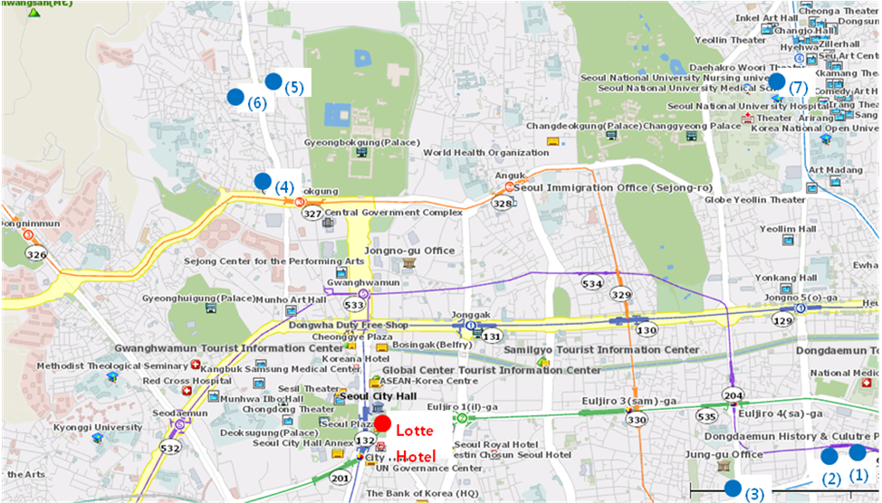

HOTEL | CATEG. |  | ROOM | RATE | NOTES
(1) Uljiro Coop Residence  32 Uljiro 6ga Jung-gu Seoul  Tel: +82. 2-2269-8411  Fax: +82. 2-2269-4209  Check-In: 2:00 PM  Check-Out: 12:00 PM  (Reservation only as a fax)  http://residences.co-op.co.kr/accommodations_17_4.htm  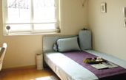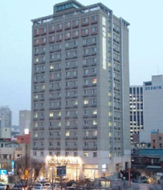 | Standard |  | Twin  Double | KRW 90,000 (≒USD 85) | Included Taxes  buffet breakfast  : KRW 6,600 (≒USD 6)
 | Distance from  Lotte Hotel (Venue) |  |  | 2 km, 10 min by taxi
 | Deadline of Reservation |  |  | 19th of August
 | Cancelation Policy |  |  | Notice to the hotel of any cancellations 2 days before on the date of arrival or be charged for one night.
(2) Western Coop Residence  77-2Uljiro 5ga Jung-gu Seoul  Tel: +82. 2-2269-8411  Fax: +82. 2-2269-4209  Check-In: 2:00 PM  Check-Out: 12:00 PM  (Reservation only as a fax)  http://residences.co-op.co.kr/accommodations_23_4.htm  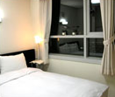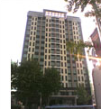 | Standard | Twin  Double |  | KRW 90,000 (≒USD 85) | Included Taxes  buffet breakfast  : KRW 6,600  (≒USD 6)
 | Distance from  Lotte Hotel (Venue) |  |  | 2.5 km, 10 min by taxi
 | Deadline of Reservation |  |  | 19th of August
 | Cancelation Policy |  |  | Notice to the hotel of any cancellations 2 days before on the date of arrival or be charged for one night.
(3) Hyundae Residence  22-5 Chungmooro 5ga Jung-gu Seoul  Tel: +82. 2-3406-8000  Fax: +82. 2-3406-8003  Check-In: 2:00 PM  Check-Out: 12:00 PM  reservation@hyundairs.com  http://hyundairs.com/rooms.htm  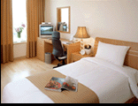 | Standard |  | Weekly  Double  Twin | KRW 100,000  KRW 103,000 | Included Taxes  buffet breakfast  : KRW 8,800 (≒USD 8)
 |  |  | Weekend  Double  Twin | KRW 135,000  KRW 138,000 | Included Taxes  buffet breakfast  : KRW 8,800 (≒USD 8)
 | Distance from  Lotte Hotel (Venue) |  |  | 2.5 km, 10 min by taxi
 | Deadline of Reservation |  |  | 19th of August
 | Cancelation Policy |  |  | 50% penalty fee from 28th of August  75% penalty fee from 5th of September  100% penalty fee from 12nd of September
(4) The SOHO Residence  90, Pirun-dong, Jongno-gu, Seoul  Tel: +82. 2-722-1999  Fax: +82. 2-722-3920  Check-In: 2:00 PM  Check-Out: 12:00 PM  hotelmoa@naver.com  http://www.thesoho.co.kr/  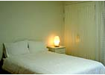 | Standard | Single |  | KRW 150,000 (≒USD 136) | None
 | Distance from  Lotte Hotel (Venue) |  |  | 3 km, 15 min by taxi
 | Deadline of Reservation |  |  | 19th of August
 | Cancelation Policy |  |  | 100% penalty fee from 7days prior to check in date.
(5) Tea Guest House  15-6 Gye-dong Jongno-gu Seoul  Tel: +82. 2-3675-9877  Check-In: 3:00 PM  Check-Out: 11:00 PM  tea@teaguesthouse.com  http://www.teaguesthouse.com/index.php  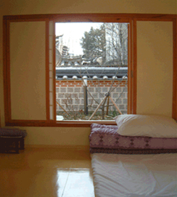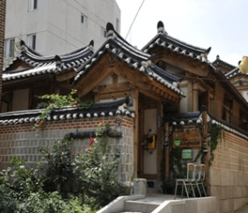 | Standard | Double |  | KRW 90,000  (≒USD 88) | buffet breakfast  : complimentary
 | Distance from  Lotte Hotel (Venue) |  |  | 2.5 km, 10 min by taxi
 | Deadline of Reservation |  |  | Booking is first-come-first-served due to a limit of the number of available rooms of accommodations.
 | Cancelation Policy |  |  | 100% penalty fee from 7days prior to check in date.
(6) Eugene Guest House  5-43 Hyewha-dong Jongno-gu Seoul  Tel: +82. 2-741-3338  Fax: +82. 70-4149-3308  Check-In: 15:00 PM  Check-Out: 11:00 AM  Yykim65@hotmail.com  http://www.eugenehouse.co.kr/index_en.php  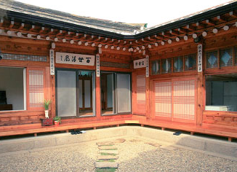 | Standard | Single |  | KRW 115,000 (≒USD 110) | buffet breakfast  : complimentary
 | Standard | Twin or Double |  | KRW 190,000 (≒USD 170) | buffet breakfast  : complimentary
 | Distance from  Lotte Hotel (Venue) |  |  | 5 km, 20 min by taxi
 | Deadline of Reservation |  |  | Booking is first-come-first-served due to a limit of the number of available rooms of accommodations.
 | Cancelation Policy |  |  | - NO-SHOW : Customers have to pay 100% of the whole payment.  - On the starting day : Customers have to pay 100% of the whole payment.  - 7 days before : Customers have to pay  70% of the whole payment.  - 12 days before : Customers have to pay  60% of the whole payment.  - 25 days before : Customers have to pay  50% of the whole payment.
(7) Sophia Guest House  59-5 Myeongdong 1ga Jung-gu Seoul  Tel: +82. 2-720-5467  Fax: +82. 2-6280-5469  Check-In: 15:00 PM  Check-Out: 12:00 PM  Sophia-house@hanmail.net  http://www.sophiagh.com/index.php  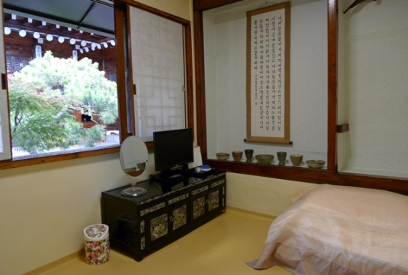 | Standard | Double |  | KRW 60,000 (≒USD 58) | buffet breakfast  : complimentary
 | Distance from  Lotte Hotel (Venue) |  |  | 2.5 km, 10 min by taxi
 | Deadline of Reservation |  |  | Booking is first-come-first-served due to a limit of the number of available rooms of accommodations.
 | Cancelation Policy |  |  | 50% penalty fee from 5 days prior to check in date.  100% penalty fee from 3days prior to check in date.
_______________

