|  |  |
| --- | --- |
| **Bureau de la normalisation des télécommunications** | **Description: logo_F_** |
|  |  |

Genève, le 22 juillet 2011

|  |  |  |
| --- | --- | --- |
| Réf.: | **Addendum 1 à la  Lettre collective TSB 8/5** |  |
| Tél.: | +41 22 730 5780 |  |
| Fax: E-mail: | +41 22 730 5853 [tsbsg5@itu.int](mailto:tsbsg5@itu.int) | Aux administrations des Etats Membres de l'Union, aux Membres du Secteur UIT-T, aux Associés de l'UIT-T et aux établissements universitaires de l'UIT-T participant aux travaux de la Commission d'études 5 |

|  |  |
| --- | --- |
| Objet: | **Réunion de la Commission d'études 5 Séoul (République de Corée),**  **20-28 septembre 2011** |

Madame, Monsieur,

Vous trouverez ci-joint dans l'**Annexe 1** des informations sur d'autres hôtels communiquées par l'organisation hôte pour la réunion de la CE 5 de l'UIT‑T qui aura lieu à Séoul (République de Corée) du 20 au 28 septembre 2011 inclus.

Veuillez agréer, Madame, Monsieur, l'assurance de ma considération distinguée.

Malcolm Johnson  
Directeur du Bureau de la  
normalisation des télécommunications

**Annexe**:1

ANNEX 1  
(to Addendum 1 to TSB Collective letter 8/5)

Please find below information on additional accommodation for delegates attending the SG5 meeting in Seoul, Korea. The map indicates each hotel’s proximity to the meeting venue together with a chart including the corresponding hotel rates.

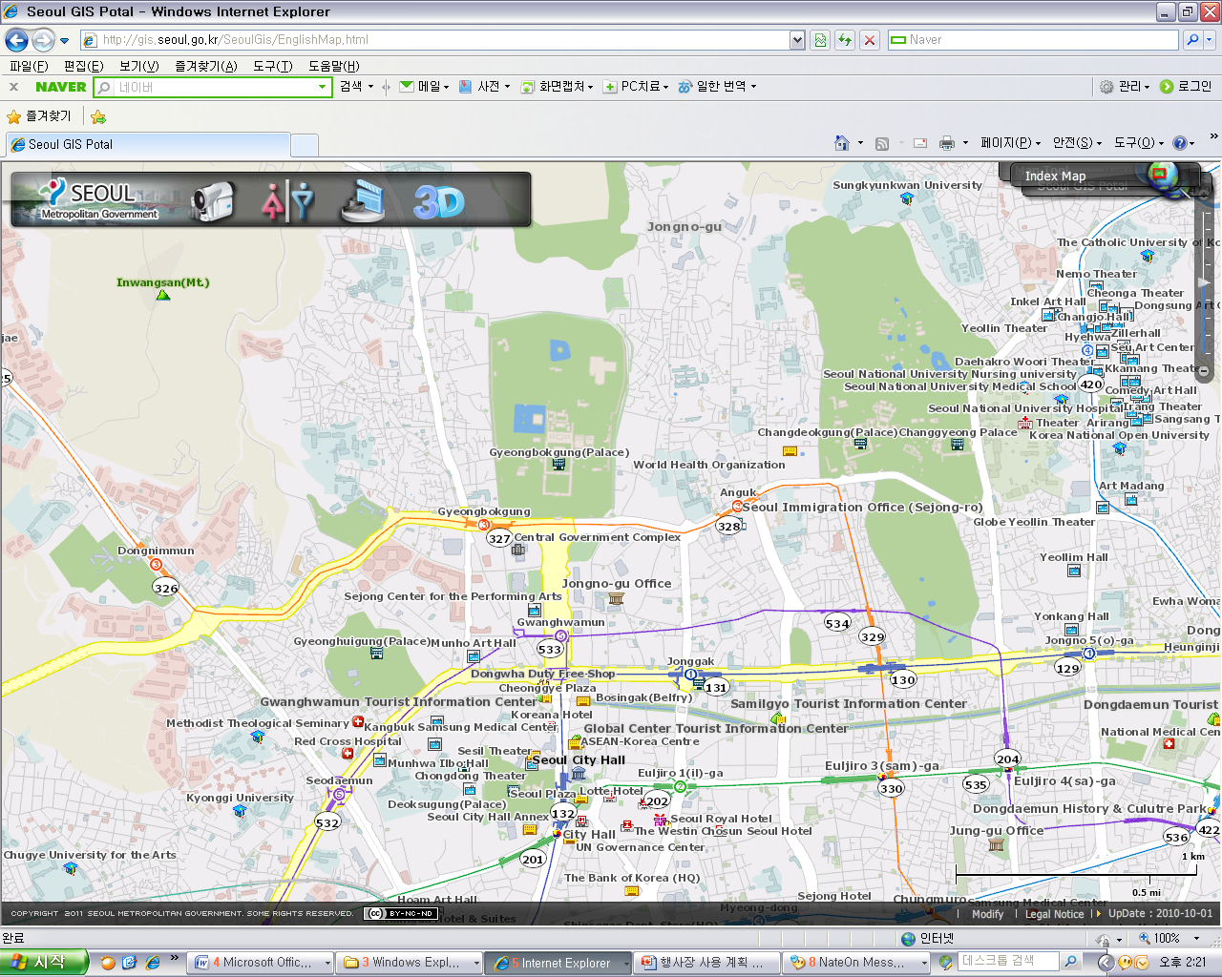

**Lotte Hotel**

**(1)**

**(2)**

**(3)**

**(4)**

**(5)**

**(6)**

**(7)**

|  |  |  |  |  |  |
| --- | --- | --- | --- | --- | --- |
| **HOTEL** | **CATEG.** | | **ROOM** | **RATE** | **NOTES** |
| **(1) Uljiro Coop Residence**  32 Uljiro 6ga Jung-gu Seoul  Tel: +82. 2-2269-8411 Fax: +82. 2-2269-4209 Check-In: 2:00 PM Check-Out: 12:00 PM  (Reservation only as a fax) <http://residences.co-op.co.kr/accommodations_17_4.htm> | Standard | | Twin  Double | KRW 90,000 (≒USD 85) | Included Taxes  buffet breakfast  : KRW 6,600 (≒USD 6) |
| Distance from  Lotte Hotel (Venue) | | | 2 km, 10 min by taxi | |
| Deadline of Reservation | | | 19th of August | |
| Cancelation Policy | | | Notice to the hotel of any cancellations 2 days before on the date of arrival or be charged for one night. | |
| **(2) Western Coop Residence**  77-2Uljiro 5ga Jung-gu Seoul Tel: +82. 2-2269-8411 Fax: +82. 2-2269-4209 Check-In: 2:00 PM Check-Out: 12:00 PM (Reservation only as a fax) <http://residences.co-op.co.kr/accommodations_23_4.htm> | Standard | Twin  Double | | KRW 90,000 (≒USD 85) | Included Taxes  buffet breakfast  : KRW 6,600  (≒USD 6) |
| Distance from  Lotte Hotel (Venue) | | | 2.5 km, 10 min by taxi | |
| Deadline of Reservation | | | 19th of August | |
| Cancelation Policy | | | Notice to the hotel of any cancellations 2 days before on the date of arrival or be charged for one night. | |
| **(3) Hyundae Residence**  22-5 Chungmooro 5ga Jung-gu Seoul Tel: +82. 2-3406-8000 Fax: +82. 2-3406-8003 Check-In: 2:00 PM  Check-Out: 12:00 PM  [reservation@hyundairs.com](mailto:reservation@hyundairs.com)    <http://hyundairs.com/rooms.htm> | Standard | | Weekly  Double  Twin | KRW 100,000  KRW 103,000 | Included Taxes  buffet breakfast  : KRW 8,800 (≒USD 8) |
| Weekend  Double  Twin | KRW 135,000  KRW 138,000 |
| Distance from  Lotte Hotel (Venue) | | | 2.5 km, 10 min by taxi | |
| Deadline of Reservation | | | 19th of August | |
| Cancelation Policy | | | 50% penalty fee from 28th of August  75% penalty fee from 5th of September  100% penalty fee from 12nd of September | |
| **(4) The SOHO Residence**  90, Pirun-dong, Jongno-gu, Seoul Tel: +82. 2-722-1999 Fax: +82. 2-722-3920 Check-In: 2:00 PM  Check-Out: 12:00 PM  hotelmoa@naver.com <http://www.thesoho.co.kr/> | Standard | Single | | KRW 150,000 (≒USD 136) | None |
| Distance from  Lotte Hotel (Venue) | | | 3 km, 15 min by taxi | |
| Deadline of Reservation | | | 19th of August | |
| Cancelation Policy | | | 100% penalty fee from 7days prior to check in date. | |
| **(5) Tea Guest House**  15-6 Gye-dong Jongno-gu Seoul Tel: +82. 2-3675-9877 Check-In: 3:00 PM  Check-Out: 11:00 PM  tea@teaguesthouse.com <http://www.teaguesthouse.com/index.php> | Standard | Double | | KRW 90,000  (≒USD 88) | buffet breakfast  : complimentary |
| Distance from  Lotte Hotel (Venue) | | | 2.5 km, 10 min by taxi | |
| Deadline of Reservation | | | Booking is first-come-first-served due to a limit of the number of available rooms of accommodations. | |
| Cancelation Policy | | | 100% penalty fee from 7days prior to check in date. | |
| **(6) Eugene Guest House**  5-43 Hyewha-dong Jongno-gu Seoul  Tel: +82. 2-741-3338 Fax: +82. 70-4149-3308 Check-In: 15:00 PM Check-Out: 11:00 AM  Yykim65@hotmail.com <http://www.eugenehouse.co.kr/index_en.php> | Standard | Single | | KRW 115,000 (≒USD 110) | buffet breakfast  : complimentary |
| Twin or Double | | KRW 190,000 (≒USD 170) |
| Distance from  Lotte Hotel (Venue) | | | 5 km, 20 min by taxi | |
| Deadline of Reservation | | | Booking is first-come-first-served due to a limit of the number of available rooms of accommodations. | |
| Cancelation Policy | | | - NO-SHOW : Customers have to pay 100% of the whole payment.  - On the starting day : Customers have to pay 100% of the whole payment.  - 7 days before : Customers have to pay  70% of the whole payment.  - 12 days before : Customers have to pay  60% of the whole payment.  - 25 days before : Customers have to pay  50% of the whole payment. | |
| **(7) Sophia Guest House**  59-5 Myeongdong 1ga Jung-gu Seoul Tel: +82. 2-720-5467 Fax: +82. 2-6280-5469 Check-In: 15:00 PM  Check-Out: 12:00 PM  Sophia-house@hanmail.net <http://www.sophiagh.com/index.php> | Standard | Double | | KRW 60,000 (≒USD 58) | buffet breakfast  : complimentary |
| Distance from  Lotte Hotel (Venue) | | | 2.5 km, 10 min by taxi | |
| Deadline of Reservation | | | Booking is first-come-first-served due to a limit of the number of available rooms of accommodations. | |
| Cancelation Policy | | | 50% penalty fee from 5 days prior to check in date.  100% penalty fee from 3days prior to check in date. | |

\_\_\_\_\_\_\_\_\_\_\_\_\_\_\_