Telecommunication Standardization  Bureau | 

Geneva, 30 November 2010

Ref: | TSB Collective letter 7/SG3RG-AO
Tel:  Fax:  E-mail: | +41 22 730 5887  +41 22 730 5853  tsbsg3@itu.int | – To the members of the Study Group 3 Regional Group for Asia and Oceania (SG3RG-AO)

Subject: | Meeting of the Study Group 3 Regional Group for Asia and Oceania (SG3RG-AO) (former TAS Group) and the associated BDT Workshop, 8-11 March 2011, Phuket, Thailand

Dear Sir/Madam,
1 I am pleased to inform you that the Study Group 3 Regional Group for Asia and Oceania (SG3RG-AO) is to meet in Phuket, Thailand, on 10 and 11 March 2011, at the kind invitation of the National Telecommunications Commission of Thailand. The meeting will take place at the Novotel Resort in Patong Beach, Phuket, and will be preceded by a two-day seminar focusing on tariff issues and country case studies.
2 The Seminar, organized with the cooperation of the Telecommunication Development Bureau (BDT), will start at 0930 hours on 8 March 2011. The meeting of the SG3RG-AO will start at 0930 hours on 10 March 2011 and will be restricted to delegates and representatives of administrations and operating agencies of the region, in conformity with §2.3.2 of Section 2 of Resolution 1 of the WTSA-08. The registration of delegates will take place in the morning of Tuesday, 8 March at the meeting venue as from 0830 hours.
3 In agreement with the Chairman of the SG3RG-AO, the seminar and the meeting will be conducted in English without interpretation.
4 The draft agenda of the SG3RG-AO meeting, as prepared by the Chairman of this group, may be found in Annex 1 hereto.
5 As it will be seen from the agenda, the purpose of the meeting will be to analyze the results of the cost study realized in the AO region and to study how this cost study can be reflected in the accounting rates negotiation. The SG3RG-AO should also give consideration to the new study items identified during its last meeting. In preparation for the meeting hereby convened, reference should be made to Report SG3RG-AO – R 2 (Beijing, April 2010).
6 Administrations and operating agencies are invited to submit contributions. Please send your contributions before 3 March 2011 to the email address tsbsg3@itu.int. After this date, please also copy your email to the contact person mentioned in point 10.
With a view to settling any questions which might arise concerning contributions, the name, the fax and telephone numbers and e-mail address of the person to be contacted should be indicated on contributions. Accordingly, please give those details on the cover page of all documents.
7 You will shortly be receiving a letter of invitation from BDT for the Regional Seminar to be held just before the SG3RG-AO meeting.
8 Would you please read carefully Annex 2 to this collective letter which contains practical information kindly provided by the host organization.
In particular, I would point out that you should announce your participation using Annex 4 (with a copy to the TSB) by 6 February 2011.
In addition, Annex 3 should be sent directly to the hotel of your choice, with copy to the host organization no later than 6 February 2011.
9 Pursuant to the provisions of Recommendation A.1 of the WTSA (Johannesburg, 2008) contributions to the work of the SG3RG-AO shall be submitted to the Director of the Telecommunication Standardization Bureau (TSB).
10 The contact person to send a copy of the hotel reservation, assistance requests regarding visa obtention and copy of contributions after 4 March 2011 is:
Ms. Chonlada Boonna-In
National Telecommunications Commission
Bangkok, Thailand
Tel: +66 2 272 7054
Fax: +66 2 278 1736
Email: chon.ntc@gmail.com / inter_org@ntc.or.th
It is important to note that participants should enquire in advance whether they need a visa to enter Thailand and apply to the Consulate or Embassy of Thailand in their respective country.
11 We are pleased to inform you that ITU will provide a limited number of partial fellowships (i.e., accommodation and a daily allowance to cover meals and incidental expenses) to facilitate participation from Least Developed or Low Income Developing Countries. An application must be authorized by the relevant Administration of the ITU Member State and be limited to only one person per country. If you wish to apply for a fellowship, please inform the TSB Secretariat no later than 6 February 2011, by Email to tsbsg3@itu.int or by Fax at +41 22 730 5853.

Yours faithfully,

Malcolm Johnson
Director of the Telecommunication
Standardization Bureau

Annexes: 4
ANNEX 1
(to TSB Collective letter 7/SG3RG-AO)
Meeting of the Study Group 3 Regional Group for Asia and Oceania (SG3RG-AO)
and associated BDT Seminar
8-11 March 2011, Phuket, Thailand

Draft agenda

- Opening of the meeting
- Adoption of the agenda
- Available documents
- Review of SG3RG-AO and ITU activities
- SG3RG-AO/TAS cost model enhancements (LRIC)
- Traffic declarations and settlement procedures
- Accounting rate issues:
7.1 Mobile termination charge and mobile roaming
7.2 Shortening of the settlement period (D.195) and establishment of a dispute resolution procedure
7.3 Discussion on network externalities
7.4 Settlement of mobile data communication including SMS, MMS, Video/Music
7.5 Financial aspects of network security
7.6 NGN Charging
- IP Telephony
- IP traffic recording
- International Internet Connectivity
- Effect of migration of traditional traffic to hubbing
- Review of International Telecommunication Regulations
- Future work programme
- Other business
- Next meeting

ANNEX 2
(to TSB Collective letter 7/SG3RG-AO)

 | Meeting of the Study Group 3 Regional Group for Asia and Oceania (SG3RG-AO) and associated BDT Seminar  8-11 March 2011, Phuket, Thailand

Practical Information
1 Venue

The meeting will take place at the Novotel Resort:

Novotel Resort
282 Phrabaramee Rd.
Patong Beach, Kathu,
Phuket 83150, Thailand
Tel: +66 76 342 777
Fax: +66 76 341 110
Web: www.novotelphuket.com
Contact: Ms. Pavarisa Chantra
Email: sales_1@novotelphuket.com
Phuket, the biggest island in Thailand, is located in the Andaman Sea, Southern Thailand. Patong Beach is one of the most popular tourist areas in Phuket. Most of Phuket nightlife and its cheap shopping is located in Patong, and the area has become increasingly developed. Other popular beaches are located South of Patong. There are several coral islands to the South of Phuket, the Similan Islands lie to the Northwest, and Phi Phi Islands to the Southeast.
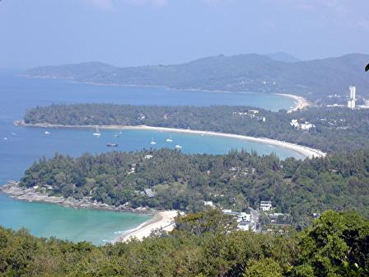 |  | 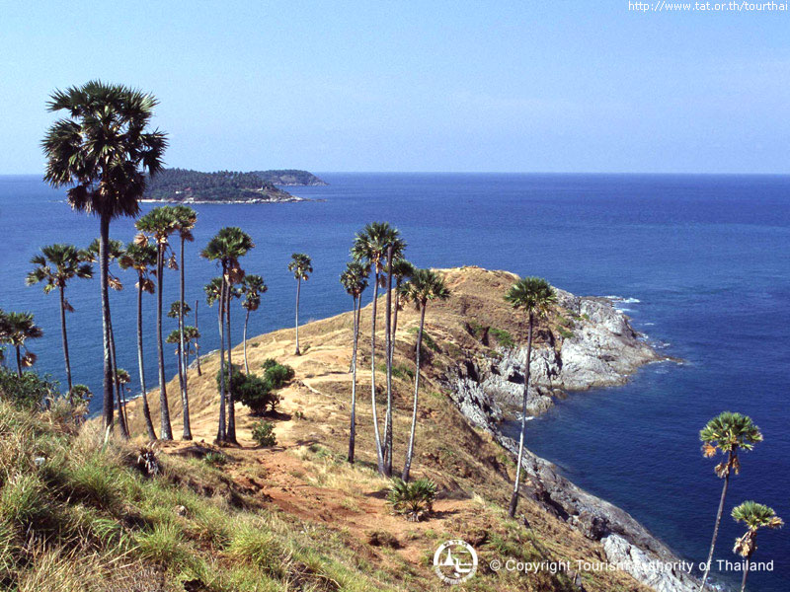

2 Hotels
a) Novotel Resort - The meeting venue is recommended for all participants. Special rates have been negotiated by NTC and will be applied to the participants.
Room category | NTC negotiated rate | Remarks
Superior Garden | THB 3,800.- | The room rates are inclusive of:  - 10% service charge and 7% value added tax;  - Daily American Buffet Breakfast;  - WiFi Internet Card (in case of bringing laptop)
Superior Seaview | THB 4,800.-
Deluxe Seaview | THB 5,800.-
Suite | THB 7,800.-
b) Ibis Hotel – It is 10 minutes by shuttle bus from the venue and is also recommended. The room rate is THB 1,740.-, inclusive of American breakfast, 10% service charge, VAP and applicable Government tax. The hotel’s address is:
Ibis Hotel
10 Chaloemphrakiat Rd., Patong
Kathu, Phuket 83150 Thailand
Tel: +66 76 303 888
Fax: +66 76 303 889
Contact: Ms. Pisarak Silanurak
Email: pisarak.silanurak@accor.com
Participants are kindly requested to send the hotel booking form to the hotel of their choice with a copy to NTC for finalizing necessary arrangements by the Host.
3 Travelling to Phuket
The following are recommended airlines from Bangkok to Phuket:
- Thai Airways International Airline (www.thaiairways.com);
- Air Asia (www.airasia.com);
- Nok Air (www.nikair.com);
- Bangkok Airways (www.bangkokair.com).
4 Transportation to and from Airport
Transfer bus from the Phuket airport and vice versa will be arranged by the Host for participants who indicate their arrival/departure details by the time of their registration. Transportation between the appointed hotel to the meeting venue and vice versa will also be organized.
Alterntively, participants wishing to arrange their own transportation from Phuket Airport are advised to contact the Information Desk at the Airport for assistance.
- Private limousine: THB 400-500 net each way (maximum of 3 persons);
- Van: THB 550-700 net each way (maximum of 6 persons);
- Private coach: THB 5,500 net each way (maximum 40 seats);
- Van rental: THB 3,300 net each way (maximum 10 hours).

5 Climate
Phuket has a tropical climate with a dry season from November to April and a rainy season from May to October. Average temperatures are consistent year-round. Average highs range from 29°C (84°F) to 33°C (91°F); average lows range from 23°C (73°F) to 26°C (79°F).

6 Visa and immigration requirements

As visa requirements change from time to time, please check with your nearest Embassy/Consulate for your visa requirements before departure. Advance submission of applications is recommended (at least 15 working days). For more details, kindly visit http://www.mfa.go.th/web/2637.php .

7 Time zone
GMT +7hours.

8 Currency

The unit of Thai currency is the Thai Bhat (THB). As an indication, the exchange rate in November 2010 is:

USD 1 = THB 30

9 Electricity

The standard supply is 220 volts, 50 Hz. Outlets for 220 volts are available at the hotels. The three following outlets are compatible with those available in Thailand.

Type A (used in, among others, North and Central America and Japan)



Type B (used in, among others, North and Central America and Japan)

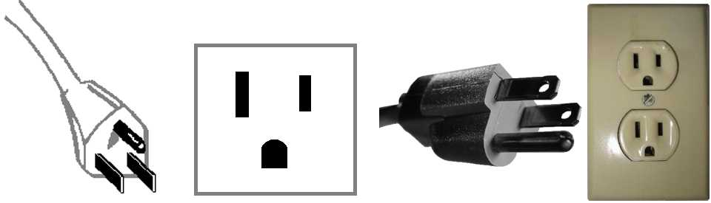

Type C (used in all countries of Europe except the United Kingdom, Ireland, Cyprus and Malta)



10 Emergencies
Police 191
Fire 195
Medical Emergencies 1554
Tourist Police 1155

11 Contact person
Ms. Chonlada Boonna-In
National Telecommunications Commission (NTC)
87 Phaholyothin Road
Phayathai, BANGKOK 10400
Thailand
Tel: +66 2 272 7054
Fax: +66 2 278 1736
Email: chon.ntc@gmail.com / inter_org@ntc.or.th

ANNEX 3
(to TSB Collective letter 7/SG3RG-AO)

Meeting of the Study Group 3 Regional Group for Asia and Oceania (SG3RG-AO) and associated BDT Seminar
8-11 March 2011, Phuket, Thailand

HOTEL RESERVATION FORM

This form should be sent to the hotel of your choice

For information about the hotels – see Annex 2

Family name
First name
Country
Organisation
Address Tel:
Fax:

E-mail:

Name of Hotel
single/double room(s) at the meeting preferential rate
from March 2011 to March 2011

Credit Card No Expiry Date

Date Signature

ANNEX 4
(to TSB Collective letter 7/SG3RG-AO)
Meeting of the Study Group 3 Regional Group for Asia and Oceania (SG3RG-AO) and associated BDT Seminar
8-11 March 2011, Phuket, Thailand

REGISTRATION FORM
Please complete a separate form for each delegate and return before 6 February 2011 to:
To: | With copy to:
Ms. Chonlada Boonna-In  National Telecommunications Commission  Bangkok, Thailand  Tel: +66 2 272 7054  Fax: +66 2 278 1736  Email: chon.ntc@gmail.com / inter_org@ntc.or.th | ITU/TSB  Geneva, Switzerland  Tel: +41 22 730 5887 / 5901  Fax: +41 22 730 5853  Email: tsbsg3@itu.int

With a copy to TSB - Fax: +41 22 730 5853 (Email: tsbsg3@itu.int)
I participate in the following (please tick as appropriate): | Seminar |  | SG3RG-AO  Meeting
 | Mr |  | Mrs |  | Miss |  | Ms

Family Name

First Name

Accompanied by – please specify name

Country

Name of Administration of Member State*

Name of Sector Member/Associate/Other

Complete address of administration or organization: | Tel:  Fax:  Email:

Private address during the meeting: | Tel:  Fax:  Email:

Date: | Signature:
________________

