Telecommunication Standardization
Bureau

Geneva, 5 April 2012

Ref: | Addendum 1 to  TSB Collective letter 8/SG3RG-AO
Tel:  Fax:  E-mail: | +41 22 730 5887  +41 22 730 5853  tsbsg3@itu.int | - To the members of the Study Group 3 Regional Group for Asia and Oceania (SG3RG-AO)

Subject: | Meeting of the Study Group 3 Regional Group for Asia and Oceania (SG3RG-AO) and associated Seminar, Bali, Indonesia, 28-30 May 2012

Dear Sir/Madam,
Further to TSB Collective letter 8/SG3RG-AO of 26 March 2012, please note that the 2012 meeting of the Group and the associated Seminar will take place in the resort of Kuta, Bali.
Practical information on the meeting, including information on the venue of the event, is attached in Annex 1 and, a hotel reservation form, in Annex 2.
Yours faithfully,
Malcolm Johnson
Director of the Telecommunication
Standardization Bureau
Annexes: 2
ANNEX 1
(to Addendum 1 to TSB Collective letter 8/SG3RG-AO)

Meeting of the Study Group 3 Regional Group for Asia and Oceania (SG3RG-AO)
and associated Seminar
28-30 May 2012, Bali, Indonesia

Practical Information
- Venue

The meeting will take place in Kuta, Bali:

Ramada Bintang Bali Resort
Jalan Kartika Plaza, PO Box 1068, Kuta, Bali, 80361 ID
Check in: After 2:00 PM Check out: Before 12:00 PM
Phone: +6-236-175-3292
Fax: +6-236-175-2015
Website: www.bintang-bali-hotel.com
Contact person: Paul Hanny – Sales Executive
Email: mice@bintang-bali-hotel.co
Bali is an Indonesian island located in the westernmost end of the Lesser Sunda Islands, lying between Java to the west and Lombok to the east. It is one of the country's 33 provinces with the provincial capital at Denpasar towards the south of the island (strictly speaking, the province covers a few small neighbouring islands as well as the isle of Bali).
With a population recorded as 3,891,000 in the 2010 census, the island is home to most of Indonesia's small Hindu minority. In the 2000 census about 92.29% of Bali's population adhered to Balinese Hinduism while most of the remainder follows Islam. It is also the largest tourist destination in the country and is renowned for its highly developed arts, including traditional and modern dance, sculpture, painting, leather, metalworking, and music. Bali, a tourist haven for decades, has seen a further surge in tourist numbers in recent years.
- Hotel
Ramada Bintang Bali Resort - The meeting venue is recommended for all participants. Special rates have been negotiated by MIC and Telkom International Indonesia (TII) as organizing committee and will be applied to the participants.
Room category | MIC and TII negotiated | Remarks
Deluxe Room | US$ 100/IDR 1.000.000 | The room rates are inclusive of:  - 21% government tax & services  - Daily American Buffet Breakfast for 2 person in each rooms;  - Wi-Fi in meeting room (in case of bringing laptop).
Contact Person: Putri Rianda A
Email: putririanda@telin.co.id
Participants are kindly requested to send the hotel booking form to the hotel of their choice with a copy to MIC for finalizing necessary arrangements by the Host.
- Travelling to Bali
The following are recommended airlines from Jakarta or Singapore to Bali:
- Garuda Indonesia (www.garuda-indonesia.com)
- Lionair Indonesia (www.lionair.com)
- Batavia air Indonesia (www.batavia-air.com)
- Sriwijaya air (www.sriwijaya-air.com)
- Transportation to and from Airport
Ramada Bintang Bali Hotel provides airport transfer for IDR 50.000 net/person/way.
Participants who need special assistance should get in touch with the contact person, as mentioned above.
Ngurah Rai Bali International airport is under renovation, so please check the airport information before you leave.
- Climate
The climate of Bali is tropical, with high temperatures throughout the year, being regulated by its relative proximity to the equator. Throughout the year, daytime temperatures in Bali rarely stray far from 30°C / 86°F. Sunshine is plentiful and daylight hours are especially long, with early morning sunrises and sunsets as the evening approaches, at around 18:30 or thereabouts.
- Visa and immigration requirements
As visa requirements change from time to time, please check with your nearest Embassy/Consulate for your visa requirements before departure. Advance submission of applications is recommended (at least 15 working days). For more details, kindly visit: http://www.deplu.go.id.
- Time zone
The Bali time zone is GMT +08:00.
- Currency
The unit of currency is the Rupiah (IDR). As an indication, the exchange rate in March 2012 is:

USD 1 = IDR. 9.150
- Electricity
The standard supply is 220 volts, 50 Hz. Outlets for 220 volts are available at the hotels. There is one electricity outlets are compatible with those available in Indonesia as follows:

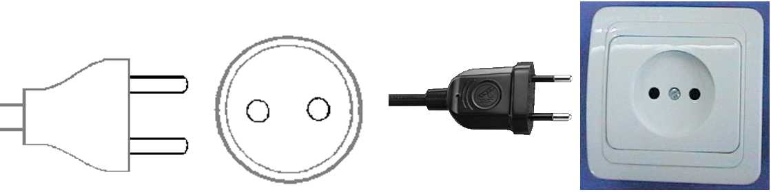
(Used in all countries of Europe except the United Kingdom, Ireland, Cyprus and Malta)
- Emergencies
Police 112
Fire 115
Medical Emergencies 118
Emergency 115
- Contact person
Mr Gunawan Hutagalung
Ministry of Communications and Information Technology
Tel: +62 21 3835882
Mobile +62 816 773432
Fax: +62 21 3862873
Email: hutagalung@postel.go.id or hutagalung@hotmail.com

ANNEX 2
(to Addendum 1 to TSB Collective letter 8/SG3RG-AO)

Meeting of the Study Group 3 Regional Group for Asia and Oceania (SG3RG-AO)
and associated Seminar
28-30 May 2012, Bali, Indonesia

HOTEL RESERVATION FORM

This form should be sent to the hotel of your choice

For information about the hotels – see Annex 1

Family name
First name
Country
Organisation
Address Tel:
Fax:

E-mail:

Name of Hotel
deluxe room(s) at the meeting preferential rate
from May 2012 to May 2012

Credit Card No Expiry Date

Date Signature

____________

