电信标准化局 | 

2011年7月13日，日内瓦

文号：  电话：  传真： | 电信标准化局第204号通函  +41 22 730 6301  +41 22 730 5853 | - 致国际电联各成员国主管部门；  - 致ITU-T部门成员；  - 致ITU-T部门准成员；  - 致ITU-T学术成员；
电子  邮件： | cristina.bueti@itu.int | 抄送：  - ITU-T第5研究组正副主席；  - 电信发展局主任；  - 无线电通信局主任

事由： | 有关通过绿色信息通信技术（ICT）标准推进气候议程的专题研讨会，2011年9月19日，大韩民国首尔

尊敬的先生/女士，
1 我谨通知您，题为“通过绿色信息通信技术（ICT）标准推进气候议程”的专题研讨会将于2011年9月19日13:30至18:00在韩国首尔新闻中心国际会议厅召开。专题研讨会将与计划于2011年9月20日至28日在大韩民国首尔召开的第5研究组（环境与气候变化）会议接续举行。
2 讨论将仅用英文进行。
3 国际电联成员国、部门成员、部门准成员和学术成员以及愿参加此工作的来自国际电联成员国的任何个人均可参加此专题研讨会。这里所指的“个人”亦包括作为国际、区域和国家组织成员的个人。专题研讨会不收取任何费用。
4 专题研讨会的议程草案见本文附件1。
5 由主办机构提供的会议相关实用信息见附件2。
6 有关专题研讨会的信息将在ITU-T网站提供，网址如下：http://www.itu.int/ITU-T/worksem/climatechange/201109/index.html。
7 为便于电信标准化局就该专题研讨会的组织做出必要安排，我希望您能通过http://www.itu.int/cgi-bin/htsh/edrs/ITU-T/workshop/edrs.registration.form?_eventid=3000286网址以在线形式向电信标准化局尽早、但不迟于2011年9月10日进行注册。请注意，专题研讨会与会者的预先注册仅在网上进行。
8 国际电联将在现有的预算范围内向亚太区域符合条件的国家提供数量有限的非全额与会补贴，每个国家仅限一名代表。申请时必须得到相关国际电联成员国主管部门的授权，代表须来自人均收入低于2000美元的最不发达国家和发展中国家。虽然提供的与会补贴每个国家仅限一名代表，但如果派出国可承担额外代表的参会费用，则国家代表的名额不受限制。请要求获得补贴的与会者填妥附件4中的与会补贴申请表，并最迟在2011年8月19日之前通过电子邮件：bdtfellowships@itu.int或通过传真：+41 22 730 5778交回国际电联。
9 我们谨在此提醒您，一些国家的公民需要获得签证才能入境大韩民国并在此逗留。签证必须至少在会议召开日的四（4）个星期前向驻贵国的大韩民国代表机构（使馆或领事馆）申请，并随后领取。如果贵国没有此类机构，则请向驻离贵国最近的国家的此类机构申请并领取。
请需要邀请函和/或签证证明函入境大韩民国的与会代表与大韩民国联系人联系：
Hye Young (Grace) Hwang女士
电话：+82.2.338.1082
传真：+82.2.338-1083
电子邮件：sg5_visa@kcc.go.kr

10 附件3中有一份酒店确认单（酒店清单见http://www.itu.int/travel/），供参考。

顺致敬意！

电信标准化局主任
马尔科姆•琼森

附件：4 件
ANNEX 1
(to TSB Circular 204)
Draft programme for the Symposium on progressing the Climate Agenda
through Green ICT Standards
(Seoul, 19 September 2011)

Monday, 19 September 2011
13:30 - 13:45 | Opening Session  Moderator: Dr. Hye Joo Yoon, KCC  - Dr. Yong-Sup Shin, Standing Committee Commissioner, KCC (Republic of Korea)  - Ms. Judit Katona Kiss, Counsellor, Study Group 5 (on behalf of Malcolm Johnson, Director, Telecommunication and Standardization Bureau, ITU)  - Mr. Ahmed Zeddam, ITU-T SG5 Chairman
13:45 -14:00 | Keynote Speaker: Ms. Cristina Bueti, Programme Coordinator, ITU activities on ICTs, the Environment and Climate Change
14:00 - 15:30 | Session I : Roadmap: “ICTs and Environmental Sustainability”  This session will provide an overview of ongoing activities and efforts to reduce GHG emissions and energy consumption through the use of ICTs and will shed light on national and regional policies and best practices on how ICTs can help to address climate change.
15:30 - 16:00 | Coffee Break
16:00 - 17:30 | Session II : Can the ICT Sector Save the Planet and Humanity?  It is estimated that the ICT sector produces directly some 2-2.5 per cent of total emissions of greenhouse gases, and this share will increase as ICTs make a larger contribution to the global economy. What ICT manufactures and service providers have done so far to reduce their own carbon footprint and energy consumption?
17:30 - 18:00 | Questions & Answers, Review and Wrap-up  This session will provide an opportunity for participants and speakers to share their views which will be summarized in the outcome of the symposium.  The outcome of the symposium will be a set of recommendations and actions which will be submitted for consideration to the upcoming UNFCCC conference of parties-17 which will be held in Durban, South Africa in December 2011 as well as to the next TSAG (ITU Telecommunication Standardization Advisory Group which will be held in Geneva in January 2012.

ANNEX 2
(to TSB Circular 204)
Practical Information
(Republic of Korea, 19-28 September 2011)

INFORMATION ABOUT THE MEETING AND SYMPOSIUM

- Venue

ITU-T SG5 Meeting
The ITU-T SG5 will be held from 20th of September to 28th of September 2011 at ‘Sapphire Ballroom’(3F) and meeting rooms on the 36th floor of Lotte Hotel, Seoul, Korea.
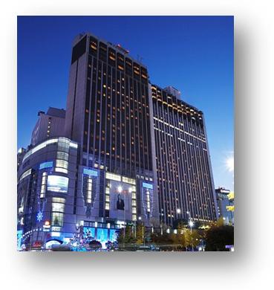
Address | 1, Sogong-Dong, Jung-Gu, Seoul, Korea 100-721
Facilities | Club Floor, Fitness Club, Business Center, Duty Free Shop
Telephone | +82-2-771-1000
Fax | +82-2-752-3758
Website | www.lottehotelseoul.com

Symposium on “Progressing the climate agenda through green ICT standards”
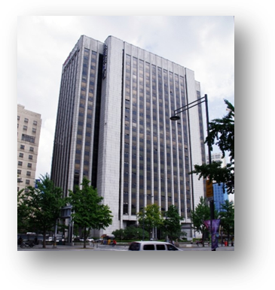
The Symposium will be held on 19th of September 2011 at ‘International Conference Hall’(20F) in Korea Press Center, Seoul, Korea.
Address | 33, Taepyeongro, Jung-Gu, Seoul, Korea 100-721
Facilities | VIP Room, Press Room
Telephone | +82-2-2001-7114
Fax | +82-2-2001-7770
Website | www.kpf.or.kr

How to get from Lotte Hotel to Press Center
It takes 10 minutes by walk and 5 minutes by taxi as below map.
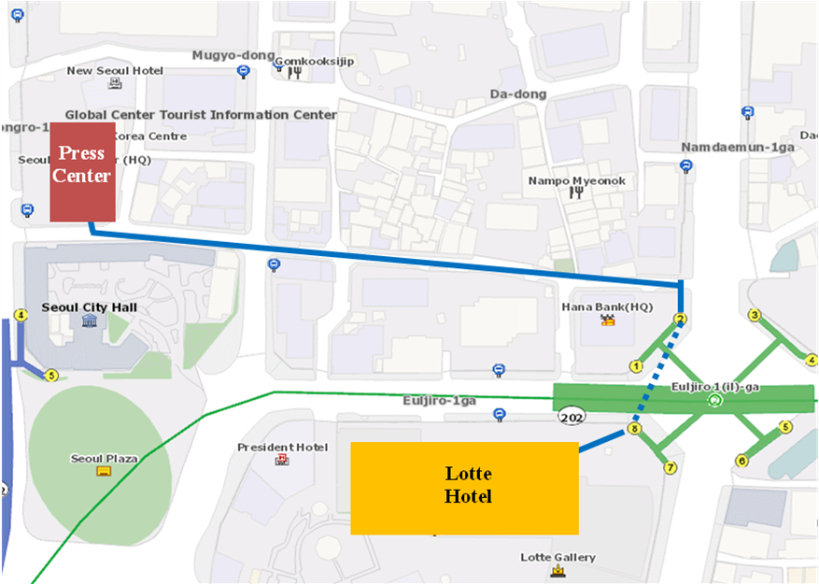

- National Coordinator

Dr. Sam Young CHUNG
Tel: +82 2 710 6595
Fax: +82 2 710 6639
E-mail: sychung@kcc.go.kr

Ms. Hye Young (Grace) Hwang
Tel: +82 2 338 1082
Fax: +82 2 338 1083
E-mail: sg5_general@kcc.go.kr

- Accommodation and hotel reservations
The Korea Administration has obtained special rates in different downtown hotels. Next page shows a map indicating each hotel’s proximity to the meeting venue together with a chart including the corresponding hotel rates.
Delegates are kindly requested to fill out the corresponding reservation form, send it directly to the hotel, copy to Ms. Grace at: sg5_general@kcc.go.kr or fax. +82 2 338 1083.
It is important to make your reservation as soon as possible. All reservations must include a credit card number. You shall receive a confirmation message once your reservation has been accepted by the hotel. In case of failure to attend the meeting, all reservations must be cancelled well in advance.
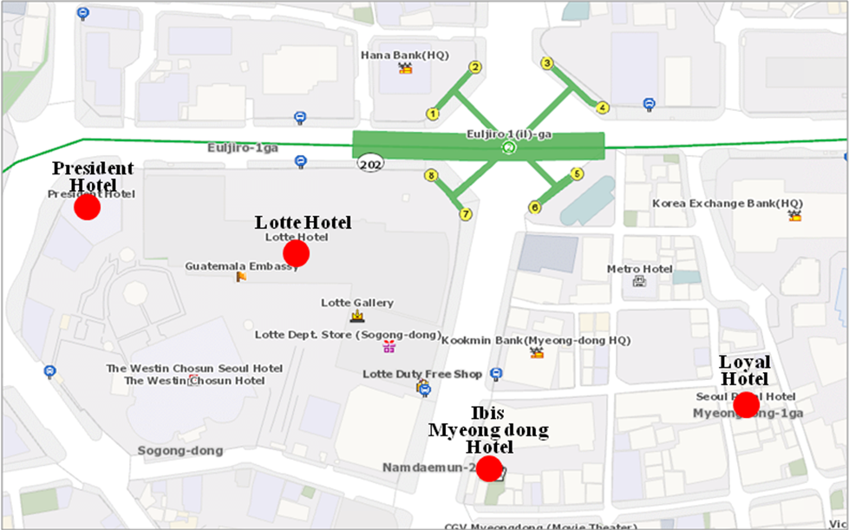

HOTEL | CATEG. | ROOM | RATE | NOTES
(1) Lotte Hotel (Venue)  1 Sogong-dong Jung-gu Seoul  Tel: +82. 2-759-7311~6  Fax: +82. 2-773-4910  Check-In: 2:00 PM  Check-Out: 12:00 PM  reservation@hotellotte.co.kr www.lottehotelseoul.com/index.asp | Standard  (Basis on Single Occupancy) | Superior  Deluxe | KRW 254,100 (≒USD 234)  KRW 278,300 (≒USD 257) | Included Taxes  buffet breakfast  : KRW 30,250 (≒USD 29)  Double occupancy charge will be added KRW 24,200 (≒USD 25)
 | Deadline of Reservation |  | 1st of August
 | Cancelation Policy |  | Inform to the hotel of any cancellations by 6:00 pm on the date of arrival or be charged for one night.
(2) Ibis-Myeongdong Hotel  59-5 Myeongdong 1ga Jung-gu Seoul  Tel: +82. 2-6361-8888  Fax: +82. 2-6361-8050  Check-In: 2:00 PM  Check-Out: 12:00 PM  ibismres@ambatel.com  ibis.ambatel.com/FrontSite/ibis/myeongdong/Default.aspx | Standard | Double  Twin | KRW 172,480 (≒USD 159)  KRW 188,650 (≒USD 174) | Included Taxes  buffet breakfast  : KRW 16,500 (≒USD 15)
 | Deadline of Reservation |  | 29th of August
 | Cancelation Policy |  | 50% penalty fee from 14days prior to check in date.  100% penalty fee from 7days prior to check in date.
(3) Hotel President  188-3 Euljiro 1ga Jung-gu Seoul  Tel: +82. 2-753-3131  Fax: +82. 2-752-7417  Check-In: 2:00 PM  Check-Out: 12:00 PM  marketing@hotelpresident.co.kr  www.hotelpresident.co.kr/english | Standard | Twin or Double | KRW 165,000 (≒USD 152) | Included Taxes  buffet breakfast  : KRW 22,000 (≒USD 20)
 | Deadline of Reservation |  | 19th of August
 | Cancelation Policy |  | 100% penalty fee from 7days prior to check in date.
(4) Royal Hotel  6 Myeongdong 1ga Jung-gu Seoul  Tel: +82. 2-2129-5754~7  Fax: +82. 2-2129-5880  Check-In: 2:00 PM  Check-Out: 12:00 PM  reser@royal.co.kr  www.royal.co.kr | Standard | Double  Twin | KRW 187,000 (≒USD 173)  KRW 203,500 (≒USD 188) | Included Taxes  buffet breakfast  : KRW 15,400 (≒USD 14)
 | Deadline of Reservation |  | 19th of August
 | Cancelation Policy |  | 50% penalty fee from 28th of August  75% penalty fee from 5th of September  100% penalty fee from 12nd of September

Participants are requested to reserve a hotel on a first-come-first-served basis through E-mail or Fax. Please note that there is a limit of the number of available rooms of Hotels. Therefore, if the reservations are full, it will be shifted to nearby Hotel and the reservation counter of the hotel will inform the corresponding participants about the situation

- Flights and transportation

Incheon International Airport handles all international air traffic and is 60 minutes away from the Seoul. Delegates have several transfer options from the airport to their hotel in the city of Seoul:
ITU-T SG5 and Symposium on “Progressing the climate agenda through green ICT standards” Information desk: Korea Secretariat will open the Information desk for participants’ convenience at arrivals (see below map). It will be opened from 18th of September to 19th of September at 7:00AM to 7:00PM. (Operating hours can be changed to depend on the participant's schedule) If you need to help to go to Seoul, drop by the information desk and get information.
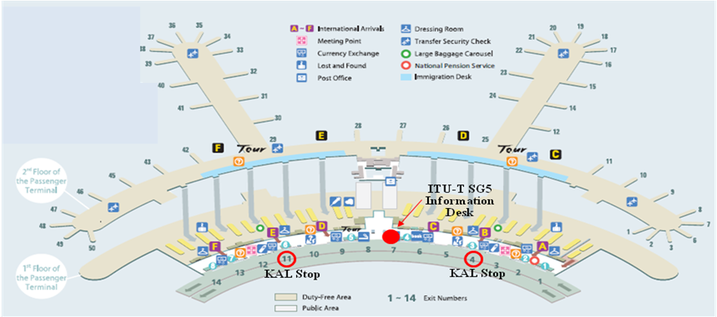
Car services and private taxis: taxi is recommended if you arrive late at night and buses are no longer operating or if you have heavy baggage or there are many members in your party. If you go to Myeong-dong (near the main venue) by a deluxe taxi late at night, you need to pay about 100,000 won. The fare varies depending on distance (meters).
Airport Bus: Airport buses run from Incheon Int'l Airport to various parts of Seoul. You can buy a ticket for your destination at the ticket desk on the arrival floor (1st floor). You can get information on bus routes and bus stops at the Airport Information Desk. Also Korea Secretariat will be operating the ITU-T SG5 and Symposium Information desk for participants’ convenience. If you would like to go from Incheon International Airport to the Lotte Hotel (main venue) you can use a KAL limousine bus.
Airport Railroad Express and Seoul Metro: Incheon International Airport Station of AREX is located on the first underground level of the Transportation Center at Incheon International Airport. You can get to Seoul and Lotte Hotel (main venue) using Airport Railroad Express and Seoul Metro.
How to get from Incheon Int’l Airport to Lotte Hotel :
- Get on the Airport Railroad Express on 1st floor of Incheon International Airport
- Transfer to line number 2 (green line) at the Hongik University station
- Get off the train at the Uljiro1(il)-ga station
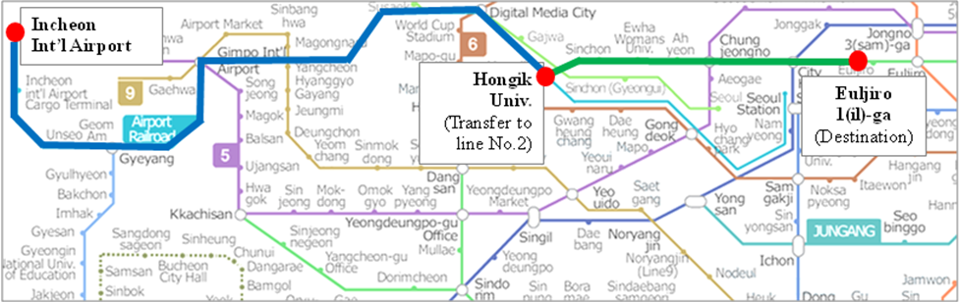
If you want to further information, please visit below website :
Airport Railroad Express : http://www.airport.kr/iiacms/pageWork.iia?_scode=C1203020000&fake=1308136787130
Seoul Metro :
http://www.seoulmetro.co.kr/eng/

Information for KAL limousine bus from Incheon Int’l Airport to the Lotte Hotel
- Course Time : About 1 hour and 20 min / Adult(15,000won), Child(10,000won)
- Boarding : KAL Stop - 4B or 11A
- Ticket Office : ITU-T SG 5 and Symposium Information desk at Incheon International Airport
(Ticket for the Bus departure from the entrance of the Hotel is sold at Front desk of Main building and New Wing)
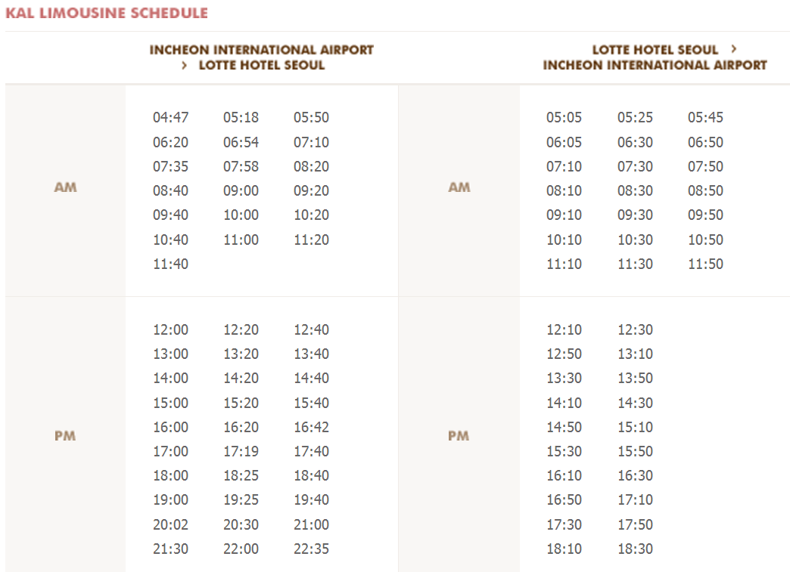
For further information, please visit the following web page: http://english.visitkorea.or.kr/enu/GK/GK_EN_2_2_2_3.jsp

- GENERAL INFORMATION

Introduction

The Korean Peninsula is located in North-East Asia and roughly 1,030 km (612 miles) long and 175 km (105 miles) wide at its narrowest point. Korea's total land area is 100,140 sq km, and it has a population of 48.7 million people (2009). Korea is a culturally diverse and economically advanced country full of dynamism. Building upon incredible post-war economic growth, Korea is the 12th largest economy in the world, and is becoming a powerful focal point of the Asian economic block. With a history tracing back more than 5,000 years, Korea is also rightly proud of its dazzling culture. It possesses 8 UNESCO cultural heritage sites, which compares favourably with any other nation in the world.

- The City of Seoul
Seoul is the capital and largest city of the Republic of Korea (South Korea). With a population of over 10 million, it is one of the world's largest cities and is by far the most densely populated city among OECD nations. The Seoul National Capital Area, which includes the Incheon metropolis and most of Gyeonggi province, has 24.5 million inhabitants, and is the world's second largest metropolitan area. Almost half of South Korea's population lives in the Seoul National Capital Area, and nearly a quarter in Seoul itself, making it the country's foremost economic, political, and cultural center

- Visa
Most delegates do not require a visa to enter Korea. You can check all visa requirements at http://www.mofat.go.kr/english/visa/apply/index.jsp. However, for more certainty we recommend you consult your embassy or consulate.
Those who require a visa to enter Korea should contact Ms. Ellva or Grace at sg5_visa@kcc.go.kr in order to request a personalized letter of invitation addressed to the petitioner via e-mail. This letter shall then be delivered to the petitioning country’s Korea Embassy in order to get the visa.

- Language
Korean is the official language (English, Japanese and Chinese are also spoken).

- Power
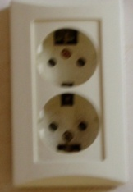
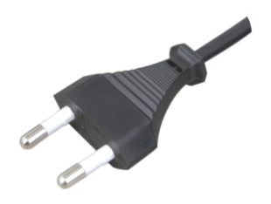
Supply voltage is 220V, 50Hz~60Hz. Participants are requested to bring the A-type adapter which is two parallel pronged and requested to bring the electric transformer, if necessary, for your equipments

Electrical Outlet

- Climate
The month of September is autumn that is well and truly in Seoul. In the mid September, Korea will be hot but less humid than August. Temperature is between 17 °C ~ 25°C.

- Currency
The unit of Korean currency is Korean Won (KRW). Also the most widely accepted credit cards are American Express, VISA and Master card.
Examples of exchange rates as of 10 June, 2011 is US$1= 1083.00 KRW
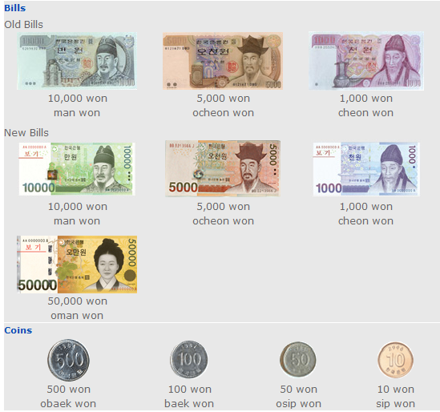

- Tax Refund
At the airport, passengers can get a 10% refund of the amount paid for Value Added Tax (VAT), if they have bought national products for amounts over $ 30 (per purchase slip) at the shops and within 3 months of departure from Korea adhered to the “Global Refund” system.
For further information, please visit: http://english.visitkorea.or.kr/enu/SH/SH_EN_7_1_4.jsp
- Business hours
Banks, post offices, and public offices generally open from 09:30 to 16:00 on weekdays but are closed on Saturdays and Sundays. Most of the shops are open from 10:00 to 22:00 through the entire week. However, some shops in Itaewon and Dongdaemon Shopping Mall are opened all night.
- Customary Tip
It is not customary tip in Korea. However, a 10% service charge and 10% taxes is added to your bill at all tourist hotels and some larger restaurants.

- Useful Information
For further information on the city of Seoul, please visit the following web page: http://english.seoul.go.kr

- Attire
Formal attire is recommended for officials attending the Meeting of Study Group 5 and the Symposium, on “Progressing the climate agenda through green ICT Standards” throughout the event.

- Invitation to the Welcome Dinner

The Communications Secretary of the Republic of Korea are pleased to invite the officials attending the meeting to the Welcome Dinner to be celebrated on Tuesday 20 September 2011 at 6.30 pm at the Sapphire Ballroom of the venue.

Suggested attire: Formal

ANNEX 3
(to TSB Circular 204)
ITU-T Study Group 5 meeting and Symposium
Seoul, Republic of Korea, 19-28 September 2011
*****

HOTEL RESERVATION

Please type or print clearly. Retain a copy for your records. Please send this form to the Hotel and one copy to Grace, e-mail address: sg5_general@kcc.go.kr Tel: (+82 2) 338-1082, Fax: (+82 2) 338-1083

Last Name: |  |  |  |  |  |  |  | First Name:
Organization-Company:
Address: |  |  |  |  |  |  |  |  |  |  |  | Country
Tel.: |  |  |  | Fax: |  |  |  |  |  | E-mail:
Hotel Information |  |  |  |  | Please choose type of room |  |  |  |  |  |  |  | Remarks
Hotel Name |  |  | Number |  | Room Type |  |  |  |  | Breakfast |  |  | Remarks
 |  |  |  |  | Double |  |  |  |  | Included |  |  | e.g. Smoking or  Non-Smoking
 |  |  |  |  | Twin |  |  |  |  | Excluded |  |  | e.g. Smoking or  Non-Smoking
Shared with:
Arrival date and time:
Airline and flight No.:
Departure date and time:
I authorize the use of the following credit card to guarantee my hotel reservation:
Type of Card: |  | Number:
Name on Card : |  | Expiration Date:

ANNEX 4
(to TSB Circular 204)

Symposium on Progressing the Climate Agenda Through Green ICT Standards
Seoul, Republic of Korea, 19 September 2011
Please return to: |  |  | ITU/BDT  Geneva (Switzerland) |  | E-mail : bdtfellowships@itu.int  Tel: +41 22 730 5487  Fax: +41 22 730 5778
 | Request for a partial fellowship to be submitted before 19 August 2011
 |  |  |  | Participation of women is encouraged
Country: _____________________________________________________________________________________________________
Name of the Administration or Organization: ______________________________________________________________________

Mr. / Ms. _______________________________________(family name) ______________________________________(given name)

Title: ____________________________________________________________________________________________________

Address: ____________________________________________________________________________________________________
______________________________________________________________________________________________________________

Tel.: ____________________________ Fax: ____________________________ E-Mail:_________________________________

PASSPORT INFORMATION :
Date of birth: _______________________________________________________________________________________________

Nationality: __________________________________________ Passport number: ________________________________________

Date of issue: ___________________ In (place) : _____________________________Valid until (date): _______________________

CONDITIONS (Please select your preference in “condition” 2 below)
- One partial fellowship per eligible country.
- ITU will cover either one of the following:
□ Economy class air ticket (duty station / Seoul / duty station).
□ Daily subsistence allowance intended to cover accommodation, meals & misc. expenses.
- It is imperative that fellows be present from the first day to the end of the meeting.
Signature of fellowship candidate: |  |  |  |  |  | Date:
TO VALIDATE FELLOWSHIP REQUEST, NAME, TITLE AND SIGNATURE OF CERTIFYING OFFICIAL DESIGNATING PARTICIPANT MUST BE COMPLETED BELOW WITH OFFICIAL STAMP.

Signature |  |  |  |  |  | Date

