INTERNATIONAL TELECOMMUNICATION UNION |  | STUDY GROUP 13
TELECOMMUNICATION  STANDARDIZATION SECTOR  STUDY PERIOD 2013-2016 |  | TD 136 Rev.1 (WP 1/13)
English only
Original: English
Question(s): | 2/13 | 4-15 November 2013
TD
Source: | Editors
Title: | Draft Recommendation ITU-T Y.1903 (Y.miptv-req) “Functional requirements of mobile IPTV”
Recommendation ITU-T Y.1903 (Y.miptv-req)
Functional requirements of mobile IPTV

Summary

This recommendation describes detailed functional requirements of mobile IPTV which is an application of IPTV [ITU-T Y.1901]. It applies to where the IPTV terminal device is connected to the IPTV service provider via an IPTV-enabled mobile network to provide the IPTV services irrespective of changes of the location or technical environment. This Recommendation focuses on the requirements for networking aspects of IPTV terminal device to the IPTV service provider. This recommendation does not address the common functional requirements of an IPTV service which are covered by [ITU-T Y.1901] but provides the requirements specific to mobile IPTV services only. Thus, these functional requirements are used to develop the detailed specifications of the IPTV functional components which are defined in [ITU-T Y.1910] for support of mobile IPTV.

Keywords

IPTV, mobile IPTV, functional requirements, multicast, broadcast

Table of Contents

1 Scope 4
2 References 4
3 Definitions 4
3.1 Terms defined elsewhere 4
3.2 Terms defined in this Recommendation 6
4 Abbreviations and Acronyms 6
5 Conventions 7
6 Overview 7
6.1 Architectural aspects of mobile IPTV 7
6.2 Technical issues of mobile IPTV 10
7 Functional requirements of mobile IPTV 11
7.1 General requirements of mobile IPTV 11
7.2 Functional requirements of service aspects 12
7.3 Functional requirements of networking aspects 12
7.4 Functional requirements of QoS and QoE aspects 15
7.5 Functional requirements of mobile IPTV terminal device aspects 16
8 Security considerations 16

Recommendation ITU-T Y.1903 (Y.miptv-req)
Functional requirements of mobile IPTV

Scope
This recommendation describes detailed functional requirements of mobile IPTV which is an application of IPTV [ITU-T Y.1901]. It applies to where the IPTV terminal device is connected to the IPTV service provider via an IPTV-enabled mobile network to provide the IPTV services irrespective of changes of the location or technical environment. This Recommendation focuses on the requirements for networking aspects between IPTV terminal device and an IPTV service provider. This recommendation does not address the common functional requirements of IPTV service which are covered by [ITU-T Y.1901] but provides the requirements specific to mobile IPTV services only. Thus, these functional requirements are used to develop the detailed specifications of the IPTV functional components which are defined in [ITU-T Y.1910] for support of mobile IPTV.

References
The following ITU-T Recommendations and other references contain provisions, which, through reference in this text, constitute provisions of this document. At the time of publication, the editions indicated were valid. All Recommendations and other references are subject to revision; users of this document are therefore encouraged to investigate the possibility of applying the most recent edition of the Recommendations and other references listed below. A list of the currently valid ITU-T Recommendations is regularly published. The reference to a document within this Recommendation does not give it, as a stand-alone document, the status of a Recommendation.
[ITU-T Y.1901] Recommendation ITU-T Y.1901 (2008), Requirements for the support of IPTV services
[ITU-T Y.1910] Recommendation ITU-T Y.1910 (2008), IPTV functional architecture.[ITU-T Y.2201] ITU-T Recommendation Y.2201 (2007), NGN release 1 requirements
[ITU-T X.1191] ITU-T Recommendation X.1191 (2009), Functional requirements and architecture for IPTV security aspects
[ITU-T X.1196] ITU-T Recommendation X.1196 (2012), Framework for the downloadable service and content protection system in the mobile Internet Protocol television environment

Definitions

3.1 Terms defined elsewhere
This Recommendation uses the following terms defined elsewhere:
3.1.1 Broadcast [b-ITU-T G.9959]: a type of communication where a node sends the same frame simultaneously to all other network nodes within a direct range.
3.1.2 Home network [b-ITU-T Q.1706]: The network to which a mobile user is normally connected, or the service provider with which the mobile user is associated, and where the user's subscription information is managed.
3.1.3 IPTV [ITU-T Y.1901]: Multimedia services such as television/video/audio/text/graphics/ data delivered over IP-based networks managed to support the required level of QoS/QoE, security, interactivity and reliability.
3.1.4 IPTV terminal function (ITF) [ITU-T Y.1901]: The end-user function(s) associated with a) receiving and responding to network control channel messages regarding session set-up, maintenance, and tear-down, and b) receiving the content of an IP transport from the network and rendering.
3.1.5 IPTV terminal device [ITU-T Y.1901]: A terminal device which has ITF functionality, e.g. a STB.
3.1.6 Linear TV [ITU-T Y.1901]: A television service in which a continuous stream flows in real time from the service provider to the terminal device and where the user cannot control the temporal order in which contents are viewed.
3.1.7 Mobile network [b-ITU.T Y.2091]: a network that provides wireless access to its services and supports mobility.
3.1.8 Mobility [b-ITU-T Y.2001]: The ability for the user or other mobile entities to communicate and access services irrespective of changes of the location or technical environment. The degree of service availability may depend on several factors including the access network capabilities, service level agreements between the user's home network and the visited network (if applicable), etc. Mobility includes the ability of telecommunication with or without service continuity.
3.1.9 Multicast [b-ITU-T G.9959]: a type of communication when a node sends the same frame simultaneously to one or more other nodes in the network.
3.1.10 Nomadism [b-ITU-T Q.1761]: Ability of the user to change his network access point after moving. When changing the network access point, the user's service session is completely stopped and then started again, i.e., there is no handover possible. It is assumed that the normal usage pattern is that users shutdown their service session before moving to another access point or changing terminal. This is the mobility alluded to in the case of fixed mobile convergence.
3.1.11 Personal mobility [b-ITU-T Q.1761]: Ability of a user to access telecommunication services at any terminal on the basis of a personal identifier, and the capability of the network to provide those services according to the user's service profile. Note that personal mobility involves the network capability to locate the terminal associated with the user for the purposes of addressing, routing and charging of the user's calls.
3.1.12 Service [ITU-T Y.1901]: A set of functionalities enabled by a provider for end-users.
NOTE - Example provisioned functionalities include IP connectivity with managed quality of service, video on demand.
3.1.13 Service mobility [b-ITU-T H.510]: The ability of a user to use the particular (subscribed) service irrespective of the location of the user and the terminal that is used for that purpose.
3.1.14 Terminal device (TD) [ITU-T Y.1901]: An end-user device which typically presents and/or processes the content, such as a personal computer, a computer peripheral, a mobile device, a TV set, a monitor, a VoIP Terminal or an audio-visual media player.
3.1.15 Terminal mobility [b-ITU-T Q.1761]: The ability of a terminal to access telecommunication services from different locations and while in motion, and the capability of the network to identify and locate that terminal.
3.1.16 Video-on-demand (VoD) [ITU-T Y.1901]: A service in which the end-user can , on demand, select and view a video content and where the end-user can control the temporal order in which the video content is viewed (e.g. the ability to start the viewing, pause, fast forward, rewind ...)
3.1.17 Visited network [b-ITU-T Q.1706]: The network outside a home network that provides service to a mobile user. This term is more business significant than geographically significant.
3.1.18 Wireless network characteristics [ITU-T Y.1901]: The characteristics of a wireless network expressed in terms of current available bandwidth, packet loss and possibly other wireless network information parameters for a specific wireless link type e.g. WLAN, Cellular, WPAN or WMAN.

3.2 Terms defined in this Recommendation
This Recommendation defines the following terms:
3.2.1 Broadcast service: a service using broadcast technology to deliver information simultaneously from single sender to every receiver on the network.
3.2.2 Broadcast service region: a service region providing broadcast service(s) to mobile IPTV TDs.
3.2.3 Mobile IPTV: An application of IPTV as specified in [ITU-T Y.1901]. It applies to where the IPTV terminal device is connected to the IPTV Service Provider via an IPTV-enabled mobile network. It must be able to communicate and access services irrespective of changes of the location or technical environment.
NOTE - There are multiple possible levels of mobility, from nomadism, where IPTV service is resumed only after the move is complete, to full mobility, where IPTV service is continuous throughout the movement.
3.2.4 Mobile IPTV TD: An IPTV terminal device supporting mobile IPTV.
3.2.5 Multicast service: a service using multicast technology to deliver information simultaneously from single sender to multiple receivers belonging to a specific service group.
3.2.6 Multicast service region: a service region providing multicast service(s) to mobile IPTV TDs.
3.2.7 Radio resources: Available bandwidth in the mobile access network to provide services to mobile IPTV TDs.
3.2.8 Service region: A logical area, consisting of more than one BS (Base Station) or AP (Access Point) of the mobile access network, used to provide in an efficient way the same services to all mobile IPTV TDs connected to that service region.
NOTE – As an example, in a 3G mobile access network, a service region consists of several neighbouring cells.

Abbreviations and Acronyms
This Recommendation uses the following abbreviations and acronyms:
AAA Authentication, Authorization, Accounting
AP Access Point
BS Base Station
IPTV Internet Protocol Television
ITF IPTV Terminal Functions
MBS Multicast and Broadcast Service
MBMS Multimedia Broadcast and Multicast Service
MCBCS MultiCast and BroadCast Service
QoE Quality of Experience
QoS Quality of Service
SVC Scalable Video Coding
TD Terminal Device
xDSL Any of the various types of Digital Subscriber Lines (DSL)

Conventions
In this Recommendation:
The keywords “is required to” indicate a requirement which must be strictly followed and from which no deviation is permitted if conformance to this document is to be claimed.
The keywords “is prohibited from” indicate a requirement which must be strictly followed and from which no deviation is permitted if conformance to this document is to be claimed.
The keywords “is recommended” indicate a requirement which is recommended but which is not absolutely required. Thus this requirement need not be present to claim conformance.
The keywords “is not recommended” indicate a requirement which is not recommended but which is not specifically prohibited. Thus, conformance with this specification can still be claimed even if this requirement is present.
The keywords “can optionally” indicate an optional requirement which is permissible, without implying any sense of being recommended. This term is not intended to imply that the vendor’s implementation must provide the option and the feature can be optionally enabled by the network operator/service provider. Rather, it means the vendor may optionally provide the feature and still claim conformance with the specification.

Overview

6.1 Architectural aspects of mobile IPTV
Mobile IPTV is defined as an IPTV application as specified in [ITU-T Y.1901] and applies to where the IPTV terminal devices (IPTV TD) of the end-user domain are connected to the IPTV service provider via an IPTV-enabled mobile network. With an IPTV-enabled mobile network, it is intended to indicate here a mobile network connecting mobile IPTV TDs which provides resource control capabilities to support the QoS required by the end user of mobile IPTV.
The basic network configuration of mobile IPTV is shown in Figure 1 in accordance with the IPTV domains as described in [ITU-T Y.1910].

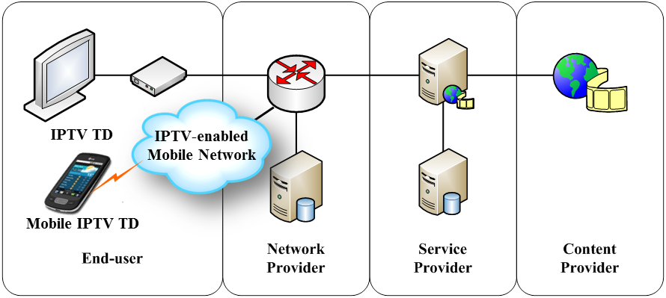
Figure 1 – Basic network configuration of mobile IPTV with the IPTV domains

The basic IPTV architectural overview diagram is shown in Figure 2 [ITU-T Y.1910].
NOTE - As detailed in Figure 2, the IPTV TD can also be connected to a home network through network attachment devices such as home gateways, access point devices, etc.

Figure 2 - IPTV architectural overview [ITU-T Y.1910]
Considering the generic IPTV architecture shown in Figure 2, the mobile IPTV end user can be connected to IPTV service providers using the mobile network interfaces through mobile access network functions of mobile IPTV TD. Most of the architectural components of mobile IPTV are the same than fixed IPTV, but it is required to have wireless connectivity between terminal device and network provider. The impact of mobile IPTV on the architectural components of IPTV is shown in Figure 3.

End-User Functions of Mobile IPTV

Mobile
Access Network
Functions

Mobile IPTV
Terminal
Functions

Network Functions

Mobile Access Network Functions

Transport Functions
…..
…..
Resource Control Functional Block

Figure 3 – The impact of mobile IPTV on the IPTV architectural components

Figure 3 shows that mobile IPTV terminal functions are connected to the transport functions of a network provider through mobile access network functions. All other functions and functional blocks of the IPTV architecture can be re-used to provide mobile IPTV service, however, some extensions for support of the mobile network environment and the mobility aspects of a mobile IPTV TD may need to be considered for those functions and functional blocks.
One of the key features of mobile IPTV is that it must be able to communicate and access the IPTV services irrespective of changes of the location or technical environment, such as various mobile access networks. These changes in the physical location and technical environment of mobile devices may derive differences in terms of network resources, network characteristics, network configurations, network policies, etc. among the home network and the visiting networks [b-ITU-T Q.1706]. Those differences may impact the QoS of the accessed IPTV services so that the configurations and operations of the IPTV functions need to adapt to the location and environment changes.

6.2 Technical issues of mobile IPTV
In order to describe the adaptation on the configurations and operations of IPTV functions, this recommendation provides the functional requirements of mobile IPTV to provide continuous IPTV services even if the mobile IPTV TD moves to different locations and/or technical environments.
The main technical issues of mobile IPTV are categorized as follows:
- Service continuity support for terminal mobility:
As an end-user IPTV TD moves to different locations, it should be expected to support the continuity of the on-going IPTV service in the visited network to minimize the impact on QoS or QoE.
- QoS support for transport over mobile networks:
Because the network resources of mobile network are mostly shared and limited, it should be considered to provide appropriate mechanisms to support QoS in mobile networks.
- Adaptability to dynamic resource changes in the mobile networks:
Mobile IPTV TDs receive IPTV content via mobile networks. Because the network resources and states are highly dynamic as the terminal device moves, it should be considered to adapt the mobile IPTV service to the changes of resources to meet the QoS requirements and optimize the resource usage of the mobile networks.
- Heterogeneity and portability support of IPTV terminal devices:
Mobile IPTV TDs are heterogeneous and portable so that it should be considered to support diverse capabilities and lightweight functions of terminal devices.

Functional requirements of mobile IPTV

7.1 General requirements of mobile IPTV
Recommendation ITU-T Y.1901 [ITU-T Y.1901] describes IPTV requirements in various aspects. The following requirements extracted from [ITU-T Y.1901] are applicable as general requirements for mobile IPTV.
- R 6.4.3-01: The IPTV architecture is required to support mechanisms for exchanging subscriber-related information between the visited network (where the end-user accesses the IPTV services) and the home IPTV service provider (where the end-user has its subscription to the IPTV services) in case mobility is supported.
- R 6.4.3-02: The IPTV architecture is required to support mechanisms for discovering and selecting end-user’s service profile from the IPTV terminal device or the home service provider that will be used by the end-user whenever accesses such IPTV services from a visited network in case mobility is supported.
- R 6.4.3-03: The IPTV architecture is required to support mechanisms for discovering and selecting IPTV services provided by the home IPTV service provider for roaming users in case mobility is supported.
- R 6.4.3-04: The IPTV architecture is required to support capturing relevant control context information from the originating terminal device, and transferring them to the target terminal device in case mobility is supported.
- R 6.4.3-05: IPTV architecture is required to support nomadism for both personal mobility and terminal mobility. Note: further information concerning nomadism, personal mobility and terminal mobility can be found in [ITU-T Y.2201].
- RR 6.1.1-01: The IPTV architecture is recommended to allow seamless IPTV service provision and operation across different networks supporting IPTV services.
- RR 6.1.4-03: The IPTV architecture is recommended to support capabilities for the end-user mobility allowing access to IPTV services by the end-user either in motion or not.
- RR 6.4-03: The IPTV architecture is recommended to support the ability to identify wireless network characteristics information sent by the IPTV terminal device.
- RR 6.4.1-02: The IPTV architecture is recommended to allow the delivery of IPTV services over different access networks (e.g. cable, optical, xDSL, wireless).
RR 6.4.3-01: Where support for terminal mobility with service continuity exists, such support is also recommended for IPTV.

7.2 Functional requirements of service aspects
- The IPTV architecture is recommended to use codecs which are robust to packet losses in order to maintain the minimum quality which is defined by QoS in case of some loss of multimedia data.
- The IPTV architecture is recommended to provide mechanisms to adapt the level of error protection in real time according to the related QoS parameters.
- The IPTV architecture is recommended to provide mechanisms to negotiate media coding scheme between the terminal device and IPTV service provider to select an appropriate coding scheme according to the terminal capability and wireless network characteristics.
- The IPTV architecture is recommended to use scalable video coding schemes in content delivery.
NOTE - The scalable video coding schemes such as H.264/AVC provide on-time adaptation to abrupt changes in the available bandwidths of mobile networks during handover.

7.3 Functional requirements of networking aspects

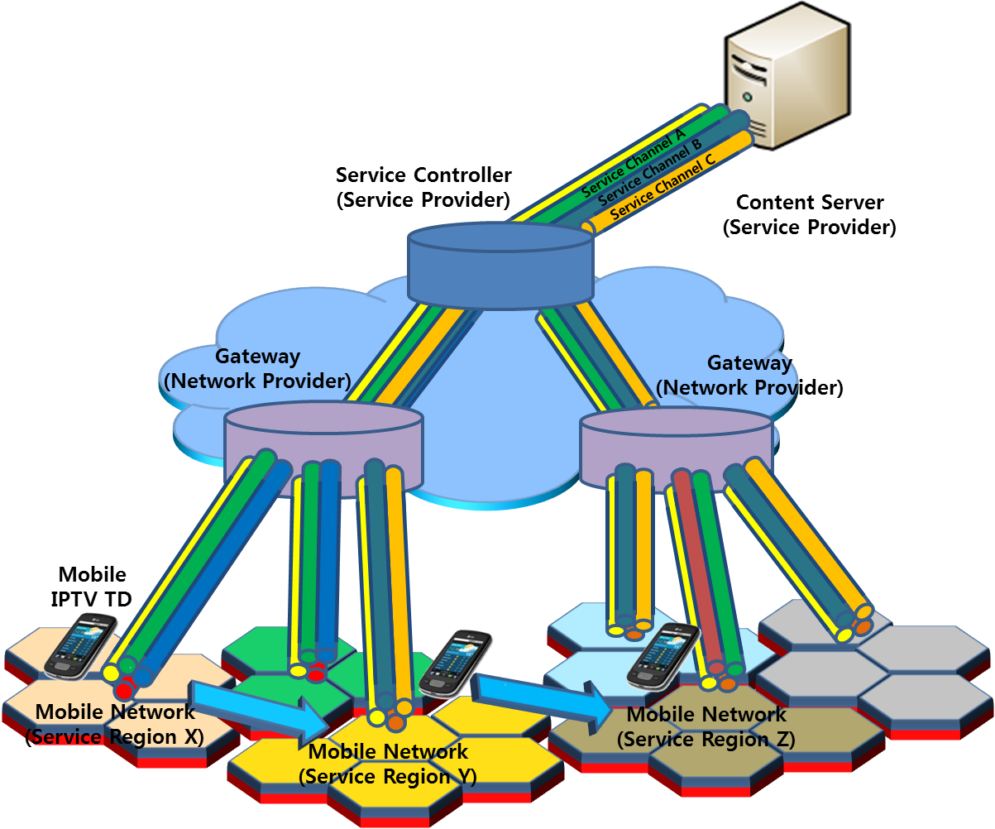
Figure 4 - An example architectural diagram concerning mobile access network operation for mobile IPTV

Figure 4 shows an example architectural diagram concerning mobile access network operation for mobile IPTV services. In Figure 4, the IPTV service controller is used by the IPTV service provider to manage and control the IPTV service. The gateways are used by the network provider to manage the service regions and to control mobile network facilities such as base stations for providing the required QoS to mobile IPTV TDs.
The mobile access network consists of cells (represented as hexagon in the figures) covered by a single base station. The cells can be grouped as service regions, each service region including more than one BS (Base Station). As an example, the mobile access network of figure 4 consists of six different service regions.
The IPTV service controller chooses some base station(s) to create each service region based on the location information of mobile terminals and base stations, as well as based on the available resources of mobile access network for the provision of the mobile IPTV service. A service region can be created, updated and removed by the IPTV service controller in collaboration with the related gateway. A service region can be differentiated as broadcast service region and multicast service region, according to the content delivery mechanisms used in the service region. Within each service region, IPTV contents are delivered to the mobile IPTV TDs using various delivery mechanisms such as unicast, broadcast and multicast technologies.
The relevant information for joining a specific multicast/broadcast channel to enjoy IPTV contents needs to be provided to the mobile IPTV TD using appropriate procedure. The mobile IPTV TD can move within a service region and it can also move to neighbour service regions. There is no service discontinuity due to the handover of mobile IPTV TD within the same service region because radio resources with the same characteristics are allocated to each base station, belonging to the same service region. The service discontinuity may take place when the mobile IPTV TD crosses the boundary of different service regions. The allocation of radio resources for a service region is managed by the IPTV service controller and enforced by the gateway to provide the required QoS to mobile IPTV TDs. In general, the usage of multicast and broadcast technologies is very useful due to scarcity of radio resources in the mobile network environments.
Considering this example architectural diagram concerning mobile access network operation for mobile IPTV services, the following requirements for provision of mobile IPTV service using multicast/broadcast technologies are specified:
- The IPTV architecture is required to support broadcast and multicast capabilities for efficient use of radio resources in mobile access network.
NOTE 1 - Multicast and broadcast technologies that can be used include MBS (Multicast and Broadcast Service) by IEEE [b-IEEE 802.16m], MBMS (Multimedia Broadcast and Multicast Service) by 3GPP [b-3GPP-TS23.246] and MCBCS (MultiCast and BroadCast Service) by mobile WiMAX forum [b-WMF-T23], etc.
- The IPTV architecture is required to be capable of managing service regions for mobile IPTV service.
NOTE 2 – Managing operations include group management and session management for the multicast/broadcast channel, and management of IPTV contents for each service region.
- The IPTV architecture is required to be capable of selecting BSs (or APs) to create a specific service region for mobile IPTV service.
- The IPTV architecture is required to be capable of changing a service region by newly adding/excluding one or more BSs (or APs) to/from an existing service region for mobile IPTV service.
NOTE 3 – The service region can be reconfigured, for example, when 1) a mobile IPTV TD moves to a new BS (or AP) in the middle of receiving IPTV content or 2) a mobile IPTV TD has turned off its power and by consequence there is no IPTV content to be delivered anymore to the associated BS (or AP).
- The IPTV architecture is required to be capable of distributing physical multicast/broadcast channel information of the mobile IPTV services associated with the service region.
- The IPTV architecture is required to be capable of transmitting the IPTV service information via all of the BSs and APs forming the service region for mobile IPTV service.
- The IPTV architecture is required to be capable of selecting those BSs (or APs) which participate in transmitting IPTV service traffic to the mobile IPTV TDs among the BSs (or APs) forming a single service region for mobile IPTV service.
NOTE 4 – A service region can be reconfigured with BSs (or APs) where mobile IPTV TDs exist in that area, for the efficient use of radio resources.
- The IPTV architecture is required to support mobile IPTV service regardless of power management of mobile IPTV TD.
NOTE 5 – Even if the communication status between a specific mobile IPTV TD and a BS (or AP) is idle or in sleep mode, the IPTV service needs to be provided continuously for other mobile IPTV TDs in that service region.
- The IPTV architecture is recommended to support multicarrier operations to increase data rate.
- The IPTV architecture is required to be capable to choose a limited number of IPTV services from all available IPTV services for a specific multicast/broadcast channel considering the resource limitations of mobile network.
- The IPTV architecture is required to support mapping between contents identifiers provided by IPTV service provider and channel identifiers provided by mobile network provider.
- The IPTV architecture is recommended to be capable to simultaneously transmit the same IPTV content using different transmission modes such as multicast, broadcast and unicast in mobile network.
NOTE 6 - For example, the same IPTV content may be provided via multiple video resolutions (e.g., SVC): high resolution video is transmitted to specific high quality terminal devices in unicast mode, andlow resolution video is transmitted to multiple low quality terminal devices in multicast/broadcast mode.
- The IPTV architecture is required to be capable to switch between multicast/broadcast and unicast transmission modes.
NOTE 7 - A terminal device selects the IPTV content in unicast mode first; as more terminal devices select the same IPTV content, the IPTV architecture switches from unicast mode to multicast/broadcast mode to deliver that IPTV content. When only one terminal device receives the IPTV content in multicast/broadcast mode, the IPTV architecture switches again from multicast/broadcast mode to unicast mode. If there is no spare broadcast/multicast channel, the IPTV architecture uses the unicast mode.
- The IPTV architecture is required to support synchronization of broadcast contents in the same multicast/broadcast service region.
- The IPTV architecture is required to support seamless handover between APs (or BSs) within the same multicast/broadcast service region.
- The IPTV architecture is recommended to support robustness in IPTV content delivery where high packet loss and error rates occur in mobile network.
- The IPTV architecture is recommended to use congestion control and/or flow control functions for the efficient delivery of mobile IPTV service when the network conditions change.
- The IPTV architecture can optionally support multiple mobile network connectivity.
- The IPTV architecture is recommended to support synchronization and merging of the content from multiple mobile network interfaces of an IPTV TD.
- The IPTV architecture is recommended to support N-screen services [b-ITU-T Y.nscreen-sc] among mobile IPTV TDs which may be connected to different access networks.
- The IPTV architecture is recommended to support terminal mobility with service continuity in the case of supporting mobile IPTV service.
- The IPTV architecture is recommended to support seamless mobile IPTV service provision and operation across different service regions.
- The IPTV architecture is required to be capable to monitor the status of the mobile IPTV TD in a given service region.
- The IPTV architecture is recommended to be capable of collecting and managing the channel usage information of BSs (or APs) in a given service region.
- The IPTV architecture is recommended to be capable of collecting and managing the user’s environmental information.
NOTE 8 – User's environmental information includes current user’s connected link state, location, status of terminal device, user’s channel usage information.
- The IPTV architecture is required to be capable of determining whether there is any mobile IPTV TD which uses the multicast/broadcast channel allocated to a specific BS (or AP) in a service region.

7.4 Functional requirements of QoS and QoE aspects
- The IPTV architecture is required to be capable to provide error control and radio resource management based on QoS/QoE requirements for mobile IPTV.
- The IPTV architecture is required to be capable to provide resource allocation function in access network to decide its availability between subscriber terminal and base station.
- The IPTV architecture is required to free allotted resources such as wireless channel, radio bandwidth in case of unicast when a session ends. Freed resources of mobile network can be used for another mobile IPTV TD for QoS enhancement.
- The IPTV architecture is required to be capable to measure the QoS between BS (or AP) and mobile IPTV TD necessary to support the required QoE of mobile IPTV service.
- The IPTV architecture is required to be capable to support resource allocation and negotiation in the mobile network according to location changes of mobile IPTV TD.
- The IPTV architecture is recommended to be capable to support mechanisms to inform service providers of the characteristics of mobile network (e.g., available bandwidth, bit error rate, signal-to-noise ratio).
- The IPTV architecture is required to be capable of allocating radio resources for a specific service region associated with mobile IPTV service.
- The IPTV architecture is required to be capable of managing the priority of traffic scheduling associated with mobile IPTV service.
- The IPTV architecture is required to be capable of reconfiguring the service region according to the quality of multicast/broadcast channel to maintain the required QoS/QoE of mobile IPTV service.
- The IPTV architecture is required to be capable of releasing and reusing the radio resources which are dedicated to a specific mobile IPTV service, if and when those dedicated radio resources are not used any more.
NOTE 1 - ITU-T G.1080 “Quality of experience requirements for IPTV services” [b-ITU-T G.1080] can be applied for mobile IPTV (the QoE requirements of ITU-T G.1080 are defined from an end user perspective and are agnostic to network deployment architectures and transport protocols).
NOTE 2 - ITU-T G.1082 “Measurement-based methods for improving the robustness of IPTV performance” [b-ITU-T G.1082] can be considered concerning solutions to provide QoS for mobile IPTV.

7.5 Functional requirements of mobile IPTV terminal device aspects
The following requirements of mobile IPTV terminal devices are related to their usage by an IPTV-enabled mobile network. NOTE - As far as general requirements of mobile IPTV terminal devices, these are out of scope of this document.

- The mobile IPTV TD is required to receive and process the IPTV contents transmitted over multicast/broadcast channel in the mobile network.
- The mobile IPTV TD is required to be able to select specific network interfaces among the available mobile network interfaces.
- The mobile IPTV TD is required to be capable of identifying the service region to which is currently associated.
- The mobile IPTV TD is required to be capable of measuring the quality of radio resources for the purpose of providing mobile IPTV service.
- The mobile IPTV TD is required to be capable of informing service provider or network provider about the measured quality information which is used to reconfigure the service region for mobile IPTV service.
- The mobile IPTV TD is required to be capable to measure the performance characteristics of the mobile network between BS (or AP) and mobile IPTV TD, and to be capable to inform the BS (or AP).
- The IPTV terminal device is required to be able to select and receive IPTV contents through the service region that is set up for that mobile IPTV TD.

Security considerations
As far as the security requirements of mobile IPTV are concerned, the requirements contained in [ITU-T X.1191] are applicable. Also, [ITU-T X.1196] may be considered depending on specific mobile IPTV service deployments.

Bibliography

[b-ITU-T H.510] ITU-T Recommendation H.510 (2002), Mobility for H.323 multimedia systems and services
[b-ITU-T H.701] ITU-T Recommendation H.701 (2009), Content delivery error recovery for IPTV services.
[b-ITU-T H.720] ITU-T Recommendation H.720 (2008), Overview of IPTV terminal devices and end systems.
[b-ITU-T H.IPTV-TDES.4] Draft Recommendation ITU-T H.IPTV-TDES.4, IPTV Terminal Device and End System (Mobile Model)
[b-ITU-T Y.1902] ITU-T Recommendation Y.1902 (2011), Framework for multicast based IPTV content delivery
[b-ITU-T Y.2001] ITU-T Recommendation Y.2001 (2004), General overview of NGN
[b-ITU-T Y.2091] Recommendation ITU-T Y.2091 (2008), Terms and definitions for Next Generation Networks
[b-ITU-T G.1080] Recommendation ITU-T G.1080 (2008), Quality of experience requirements for IPTV services
[b-ITU-T G.1082] Recommendation ITU-T G.1082 (2009), Measurement-based methods for improving the robustness of IPTV performance
[b-ITU-T Y.nscreen-sc] Supplement to ITU-T Y.2000-series Recommendations, N-Screen service scenarios over FMC
[b-ITU-T Q.1706] ITU-T Recommendation Q.1706 (2006), Mobility management requirements for NGN.
[b-ITU-T Q.1761] ITU-T Recommendation Q.1761 (2004), Principles and requirements for convergence of fixed and existing IMT-2000 systems
[b-IEEE 802.16m] IEEE 802.16m-2011, IEEE Standard for Local and metropolitan area networks - Part 16: Air Interface for Broadband Wireless Access Systems
[b-WMF-T23] WiMAX Forum, WMF-T23-001-R015v01 / Mobile System Profile Specification
[b-3GPP-TS23.246] 3GPP TS 23.246 / Multimedia Broadcast/Multicast Service: Architecture and Functional Description

_________________

