|  |  |
| --- | --- |
| **Telecommunication Standardization Bureau** |  |
|  |  |

Geneva, 30 September 2013

|  |  |  |
| --- | --- | --- |
| Ref: | **TSB Collective letter 1/SG3RG-ARB** |  |
| Tel: Fax:  E-mail: | +41 22 730 5884 +41 22 730 5853 [tsbsg3@itu.int](mailto:tsbsg3@itu.int) | To:   * Administrations of Member States of the Union, * ITU-T Sector Members, * ITU-T Associates participating in the work of Study Group 3 * ITU-T Academia * League of Arab States * ITU Arab Regional Office |

|  |  |
| --- | --- |
| **Subject:** | **First meeting of ITU-T Study Group 3 Regional Group for the Arab Region (SG3RG-ARB), Bahrain*,* 29-30 October 2013** |

Dear Sir/Madam,

We are pleased to inform you that, at the kind invitation of the Telecommunications Regulatory Authority of Bahrain, ITU-T Study Group 3 Regional Group for the Arab Region (SG3RG-ARB) will hold its first kick-off meeting at the Regency Intercontinental Hotel (Al Rifaa Ballroom), Manama, Bahrain, from 29 to 30 October 2013. The meeting will be held in parallel with the Regional Preparatory Meeting of the WTDC-14.

The meeting of the SG3RG-ARB will be from 1800 to 2000 hours on 29 October 2013 and   
from 1800 to 2000 on the following day, 30 October 2013.   
The Regional Group meeting will be restricted to delegates and representatives from Member States, Sector Members, Associates and Academic Institutions of the Study Group 3 in the region, in conformity with §2.3.3 of Section 2 of Resolution 1 of the WTSA-12.

Participant registration will begin at 1700 hours on 29 Octoberat the Regency Intercontinental Hotel. Detailed information concerning the meeting rooms will be displayed at the entrances of the venue. Additional information about the meeting is set forth in **Annex A.**

The draft **Agenda** of the meeting, as prepared by Mr. Ahmed Said, Vice Chairman of SG3, is set out in **Annex B**.

Practical information relating to the venue is enclosed as **Annex C** and **D.**

I wish you a productive and enjoyable meeting.

Yours faithfully,

Malcolm Johnson  
Director of the Telecommunication  
Standardization Bureau

Annexes: 4

**ANNEX A**(to TSB Collective letter 1/SG3RG-ARB)

**MEETING LOGISTICS AND FACILITIES**

The meeting will be conducted in Arabic and English without interpretation.

**WORKING HOURS:** 18:00 to 20:00

**TRANSLATION:** Given time constraints, only some documents for this meeting will be translated in Arabic and English.

**WIRELESS LAN:** Facilities and Internet access will be available at the venue of the event.

**REGISTRATION and FELLOWSHIPS**

**REGISTRATION:** To enable the organisers to make the necessary arrangements, please send by letter, fax (+41 22 730 5853) or e-mail ([tsbreg@itu.int](mailto:tsbreg@itu.int)) **not later than 24 October 2013**, the list of people who will be representing your Administration, Sector Member, Associate, Academic Institution, regional and/or international organization or other entity. Administrations are requested also to indicate the name of their head of delegation (and deputy head, if applicable).

**Please note that pre-registration of participants to this ITU-T meeting is carried out *online* at the ITU-T website**[**http://www.itu.int/en/ITU-T/studygroups/2013-2016/03/sg3rgarb/Pages/default.aspx**](http://www.itu.int/en/ITU-T/studygroups/2013-2016/03/sg3rgarb/Pages/default.aspx)

**FELLOWSHIPS:** Unfortunately, due to TSB budget constraints, we are not able to offer any fellowships for this event.

**ANNEX B**(to TSB Collective letter 1/SG3RG-ARB)

**Draft Agenda**

1 Opening of the meeting

2 Overview of ITU-T Study Group 3

3 Update on activities in SG3 Regional Groups SG3RG-AFR, SG3RG-AO, and   
SG3RG-LAC

4 Terms of Reference for SG3RG-ARB

5 Management Team for SG3RG-ARB

6 Date of next meeting

7 Other business

8 Close of meeting

**ANNEX C**(to TSB Collective letter 1/SG3RG-ARB)

**Practical information for participants**

**1. Dates and venue of the meeting**

**Dates:**

SG3RG-ARB: 29-30 October 2013

**Venue:   
Regency Intercontinental Hotel**

King Faisal Highway, PO Box 777

Manama - Bahrain

**Telephone:** (+973) 8000 0880 (+973) 1722 7777

**Website:** [**http://www.ihg.com/intercontinental/hotels/gb/en/manama/bahha/hoteldetail**](http://www.ihg.com/intercontinental/hotels/gb/en/manama/bahha/hoteldetail)

**2. Visa requirements**

A list of countries that **DO NOT REQUIRE VISA** for entry into Bahrain can be obtained at <http://www.evisa.gov.bh/>.

Possessors of ordinary passport of countries **NOT** included in the previous list will need visa to enter into Bahrain. In this case, participants are strongly advised to seek information on requirements applicable in their case from Bahraini diplomatic or consular missions in their home countries **at least 15 days prior to the trip**. The following documents are required:

* Valid passport.
* A round-trip airline or bus ticket. If travelling with a vehicle, title of the car or documentation that proves you are able to drive it.
* Hotel booking in your name or in the name of the person with address/phone number of the place where you will stay.
* If applicable, invitation letter received from Bahrain.

Eventually, the Consular Mission may ask for additional information. Please find the nearest

Consular mission: [http://www.mofa.gov.bh/](http://www.mofa.gov.bh/%20) .

Diplomatic or Official passport holders are requested to contact the nearest Bahraini Embassy or Consular Mission in order get additional information of visa necessity.

Those participants, whose flights **make a stop in other countries, must pay special attention to the requirements of these countries, since they may need an entry or transit Visa to the country or change of Airport.**

In case of special assistance to obtain visa, please contact **Mr. Musab Abdulla** at the Telecommunications Regulatory Authority.

**Mr. Musab Abdulla**

**Tel.: +973 1752 0000**

**Fax: +973 1753 2125**

**Email:** [**mabdulla@tra.org.bh**](mailto:mabdulla@tra.org.bh)

**3. Arrival at airport**

The airport has all necessary amenities to welcome participants properly. It is located 10 minutes from the city and the official hotels of the meeting and the airport is used for arrival and departure of international flights.

Delegates who have informed their flight details, through the corresponding forms, will be greeted at the airport by the staff of the event who, in addition to welcoming, may assist them upon their arrival to solve any problems and guide them on safe transportation to the hotels.

**Airport practical Information:**

At the airport you can find taxi service and currency exchange.

Taxi Airport  
-Speedy Motors Service: 1768 2999 [www.speedymotors.com](http://www.speedymotors.com)  
-Arabian Taxi: 1746 1746

**4. Transportation**

Hotels officially recommended are located close to the event. For those who wish to take taxi, it is strongly recommended that you only use black taxis with yellow stripes or white taxi with yellow stripes. The cost of a journey of 10 kilometers is BHD 7 (USD 18.50).

For social events, the event organizers will provide transport to participants from the recommended hotels or venue of the meeting to the corresponding place in accordance to the agenda of activities.

**5. Hotel reservation**

Special rates have been negotiated for participants in the hotels close to the venue of the event. Participants who choose hotels that are shown in the table below are kindly requested to fill out the attached form and **email it directly to the selected hotel** copying the following email: [mabdulla@tra.org.bh](mailto:mabdulla@tra.org.bh)

However, it is required to send the reservations form (**Annex D**) before **14 October 2013** in order to guarantee preferential rates. The account of the hotel will be paid directly by each participant at the end of your stay.

Find below a list of recommended hotels to the meeting including the distance from each one to the meeting.

**IT IS STRONGLY ADVISED TO MAKE HOTEL RESERVATION THROUGH THE FORM ATTACHED AND NOT THROUGH INTERNET BOOKING IN ORDER TO ASSURE THE NEGOTIATED RATE AND TO AVOID PROBLEMS IN CASE IT IS CANCELLED.**

**Recommended hotels for which special rates have been negotiated for RDF-ARB and RPM-ARB**

|  |  |  |  |
| --- | --- | --- | --- |
| **Hotel** | **Rates in USD** | **Services included** | **Cancellations** |
| Regency Intercontinental Hotel (5 stars) (Venue)  Tel: (+973) 17227777  Email: [reservation@icbahrain.com](mailto:reservation@icbahrain.com) | USD 190.00 | WiFi |  |
|  |  |  |  |

**Other Hotels:**

|  |  |  |  |
| --- | --- | --- | --- |
| **Hotel** | **Rates in USD** | **Services included** | **Cancellations** |
| Delmon International Hotel (4 stars) (550 meters to venue)  Tel: (+973) 17224000  Email: [delmonbn@batelco.com.bh](mailto:delmonbn@batelco.com.bh) | USD 92.80 | Breakfast, WiFi, Airport transfer (pickup + dropoff) |  |
| Bahrain International Hotel (3 stars) (650 meters to venue)  Tel: (+973) 17211313  Email: [byhot@batelco.com.bh](mailto:byhot@batelco.com.bh) | USD 66.30 | Breakfast, WiFi, Airport transfer (pickup + dropoff) |  |
| Awal Hotel Bahrain (2 stars) (400 meters to venue)  Tel: (+973) 17211321  Email: [awalhotel@batelco.com.bh](mailto:awalhotel@batelco.com.bh) | USD 53.00 | Breakfast, WiFi |  |

**Recommended hotels location map:**

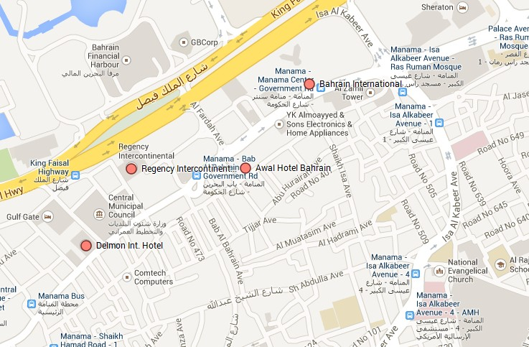

**6. Services available for participants during meetings**

**Information display:**

It will be located outside the main meeting room and will provide information on many issues of interest of the participants and will forward to other services, such as city tour and transfers, mail, medical care, communications, etc. It will also be the place where you should deliver or collect lost items.

**Communication center:**

Internet Access free of charge will be available at the event meeting room. Participants also will be provided with fax service.

**Security:**

For security reasons, all participants should be permanently using their badges during the meeting and in all social activities.

**Medical Assistance:** Emergency and urgency medical assistance will be provided free of charge within the premises where the meeting will take place. Nevertheless it is advised to take out international travel insurance to cover any medical expenses in case of medical treatment.

**7. Currency**

The official currency of Bahrain is the “*Bahrain Dinar (BHD)”*. American dollars are usually accepted in the market. Foreign currencies may be changed into Bahraini Dinar at banks or private exchange offices. Most banks are open from 8 am to 1pm, with some also open from 4 pm to 6 pm.

The exchange rate in Bahrain is pegged to the dollar, other currencies rate can be consulted at <http://www.bbkonline.com/Pages/CurrencyConvertor.aspx>or [www.xe.com](http://www.xe.com/). As of August 2013:

Dollar 0.376  
Euro 0.510

**8. General Information**

**General Information about Bahrain:**

|  |  |
| --- | --- |
| Government: | Unitary Constitutional Monarchy |
| King: | King Hamad bin Isa Al Khalifa |
| Crown Prince: | Sh. Salman bin Hamad Al Khalifa |
| Prime Minister: | Sh. Khalifa bin Salman Al Khalifa |
| Area: | 765.3 sq.km. |
| Population: | 1,234,000 (approx.) |
| Capital: | Manama |
| Language: | Arabic |

**Weather:**

The meeting will take place in the Bahrain Winter, with temperatures in Manama between 25 and 33 ° C (average).

**Time Zone:**

Bahrain is GMT + 0300 hours.

**Electricity:**

AC power voltage in Bahrain is 220 V, 50 Hz. Find below all outlets used.

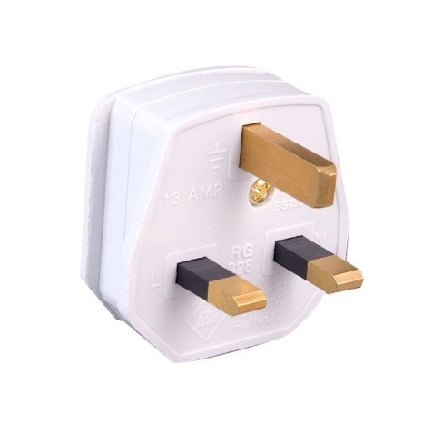

**ANNEX D**(to TSB Collective letter 1/SG3RG-ARB)

**Hotel reservation form**

We kindly ask you to fill out this form and send it to the chosen hotel before  
**18 October 2013** copying Musab Abdulla at [mabdulla@tra.org.bh](mailto:mabdulla@tra.org.bh)

|  |  |  |  |  |  |
| --- | --- | --- | --- | --- | --- |
| Name: | | | | | |
| Tel: | | Country: | | E-mail: | |
| Chosen Hotel: Selected rate: | | | | | |
| Type of  room | 🞏 Double room  🞏 Single room | | Check-in (dd/mm/aa): | | Check-out (dd/mm/aa): |
| **Travel information:**  Place and arrival date: Airline and flight number: Place and departure date: Airline and flight number: | | | | | |
| **Credit Card Information:**  Type of card: Number:  Expiration date: Name (as it is written on the card): | | | | | |
| **Venue: Date: Signature:** | | | | | |