|  |  |
| --- | --- |
| **Telecommunication Standardization Bureau** |  |
|  |  |

Geneva, 22 September 2014

|  |  |  |
| --- | --- | --- |
| Ref: | **TSB Collective letter 2/SG3RG-ARB** |  |
| Tel: Fax:  E-mail: | +41 22 730 5884 +41 22 730 5853 [tsbsg3@itu.int](mailto:tsbsg3@itu.int) | * To the members of the Study Group 3 Regional Group for the Arab Region (SG3RG-ARB) |

|  |  |
| --- | --- |
| **Subject:** | **Second meeting of ITU-T Study Group 3 Regional Group for the Arab Region (SG3RG-ARB), Kuwait City (Kuwait)*,* 24 and 25 November 2014** |

Dear Sir/Madam,

We are pleased to inform you that, at the kind invitation of the Ministry of Communications of Kuwait, [ITU-T Study Group 3 Regional Group for the Arab Region](http://www.itu.int/en/ITU-T/studygroups/2013-2016/03/sg3rgarb/Pages/default.aspx) (SG3RG-ARB) will hold its second meeting at the Hotel Regency Kuwait City, Kuwait, on 24 and 25 November 2014.

The meeting will be preceded on 23 November 2014 by a one-day meeting of the [ITU-D Regional Economic and Financial Forum of Telecommunications/ICTs for Arab States](http://www.itu.int/en/ITU-D/Regional-Presence/ArabStates/Pages/Events/2014/REAFF/Economic-Financial-Forum.aspx). In addition, on 25 November 2014, a parallel meeting of the Regional Standardization Forum in the Arab Region will be held. These meetings will be followed on the afternoon of 25 November 2014 by meetings of the ITU-T Study Group 2 Regional Group for the Arab Region ([SG2RG-ARB](http://www.itu.int/en/ITU-T/studygroups/2013-2016/02/sg2rgarb/Pages/default.aspx)) and ITU-T Study Group 5 Regional Group for the Arab Region ([SG5RG-ARB](http://www.itu.int/en/ITU-T/studygroups/2013-2016/05/sg5rgarb/Pages/default.aspx)). For ease of reference, a detailed schedule of the meetings is enclosed as **Annex D.**

The Regional Economic and Financial Forum for the ARB region will start at 0930 hours on Sunday 23 November 2014. The meeting of ITU-T SG3RG-ARB will start at 0930 hours on Monday 24 November. The event will be restricted to delegates and representatives of administrations and operating agencies of the Region, in conformity with §2.3.2 of Section 2 of Resolution 1 of the WTSA-12.

Participant registration will begin at 0830 hours at the Hotel Regency Kuwait. Detailed information concerning the meeting rooms will be displayed at the entrances of the venue. Additional information about the meeting is set forth in **Annex A.**

The draft **Agenda** of the meeting, as prepared by the Chairman of SG3RG-ARB, is set out in **Annex B**.

Practical information relating to the venue is enclosed as **Annex C.**

Please note that continuity of representation would be helpful to the group’s work.  
I wish you a productive and enjoyable meeting.

Yours faithfully,

Malcolm Johnson  
Director of the Telecommunication  
Standardization Bureau

**Annexes:** 4

**ANNEX A**(to TSB Collective letter 2/SG3RG-ARB)

**MAKING CONTRIBUTIONS**

**DEADLINES FOR CONTRIBUTIONS:** We invite you to submit your contributions by electronic mail to the following address [tsbsg3@itu.int](mailto:tsbsg3@itu.int). The deadline for contributions is 12 (twelve) calendar days before the meeting. Such contributions will be published on the Study Group 3RG-ARB website and must therefore be received by TSB **not later than 11 November 2014**.

**TEMPLATES:** Please use the provided set of templates to prepare your contribution. The templates are accessible at <http://itu.int/ITU-T/studygroups/templates>. The name, fax and telephone numbers and e-mail address of the person to be contacted about the contribution should be indicated on the cover page of all documents.

**WORK METHODS AND FACILITIES**

**INTERPRETATION:** In agreement with the Chairman of the SG3RG-ARB, the Forum and the meeting will be conducted in English, with interpretation to Arabic and French.

**WIRELESS LAN:** Facilities and Internet access will be available at the venue of the event.

**PAPERLESS MEETINGS:** The meeting will be run paperless.

**REGISTRATION and FELLOWSHIPS**

**REGISTRATION:** To enable the organisers to make the necessary arrangements, please send by letter, fax (+41 22 730 5853) or e-mail ([tsbreg@itu.int](mailto:tsbreg@itu.int)) **not later than 24 October 2014**, the list of people who will be representing your Administration, Sector Member, Associate, Academic Institution, regional and/or international organization or other entity. Administrations are requested also to indicate the name of their head of delegation (and deputy head, if applicable).

**Please note that pre-registration of participants to ITU-T meetings is carried out *online* at the ITU-T website   
(**[**http://www.itu.int/en/ITU-T/studygroups/2013-2016/03/sg3rgarb/Pages/default.aspx**](http://www.itu.int/en/ITU-T/studygroups/2013-2016/03/sg3rgarb/Pages/default.aspx)**).**

**FELLOWSHIPS:** We are pleased to inform you that one partial fellowship per administration will be awarded, **within the Arab Region only**, subject to available funding, to facilitate participation from Least Developed or Low Income Developing Countries (<http://itu.int/en/ITU-T/info/Pages/resources.aspx>). An application for a fellowship must be authorized by the relevant Administration of the ITU Member State. Fellowship requests (please use enclosed **Form 1)**, must be returned to ITU not later than **13 October 2014**. Please note that the decision criteria to grant a fellowship include: the available ITU budget; contributions by the applicant to the meeting; equitable distribution among countries; and gender balance.

**KEY DEADLINES (before meeting)**

13 October: - fellowship requests

11 November: - contributions

24 October: - registration

**FORM 1 - FELLOWSHIP REQUEST**

(to TSB Collective letter 2/SG3RG-ARB)

|  |  |  |  |  |  |  |  |
| --- | --- | --- | --- | --- | --- | --- | --- |
|  | **ITU-T Study Group 3RG-ARB meeting** and **Associated Forum**  Kuwait City, Kuwait, 24-25 November 2014 | | | | | |  |
| **Please return to:** | | | **ITU**  **Geneva (Switzerland)** | | **E-mail :** [**bdtfellowships@itu.int**](mailto:bdtfellowships@itu.int)  **Tel: +41 22 730 5227**  **Fax: +41 22 730 5778** | | | |
| **Request for one partial fellowship to be submitted before  13 October 2014** | | | | | | | |
|  | | | | Participation of women is encouraged | | |  | |
| Registration Confirmation I.D. No: …………………………………………………………………………… (Note: It is imperative for fellowship holders to pre-register via the on-line registration form at <http://www.itu.int/en/ITU-T/studygroups/2013-2016/03/sg3rgarb/Pages/default.aspx>)  **Country: _____________________________________________________________________________________________________**  **Name of the Administration or Organization: ______________________________________________________________________**  **Mr. / Ms. _______________________________________(family name) ______________________________________(given name)**  **Title: ____________________________________________________________________________________________________** | | | | | | | | |
| **Address: ____________________________________________________________________________________________________**  **______________________________________________________________________________________________________________**  **Tel.: ____________________________ Fax: ____________________________ E-Mail:_________________________________**  **PASSPORT INFORMATION :**  **Date of birth: _______________________________________________________________________________________________**  **Nationality: __________________________________________ Passport number: ________________________________________**  **Date of issue: ___________________ In (place) : _____________________________Valid until (date): _______________________** | | | | | | | | |
| **Please select your preference for one of the two options below:** | | | | | | | | |
|  | | | | | | | | |
| **□ Economy class air ticket (duty station / Kuwait City / duty station).**  **□ Daily subsistence allowance intended to cover accommodation, meals & misc. expenses.** | | | | | | | | |
|  | | | | | | | | |
| **Signature of fellowship candidate:** | | | | | | **Date:** | | |
| **TO VALIDATE FELLOWSHIP REQUEST, NAME, TITLE AND SIGNATURE OF CERTIFYING OFFICIAL DESIGNATING PARTICIPANT MUST BE COMPLETED BELOW WITH OFFICIAL STAMP.**  **N.B. IT IS IMPERATIVE THAT FELLOWS BE PRESENT FROM THE FIRST DAY TO THE END OF THE MEETING.** | | | | | | | | |
| **Signature** | | | | | | **Date** | | |

**ANNEX B**(to TSB Collective letter 2/SG3RG- ARB)

|  |
| --- |
| **DRAFT AGENDA OF ITU-T SG3RG-ARB**  **(Kuwait City, Kuwait, 24-25 November 2014)** |
| 1. **Opening of the meeting**    1. **Welcoming remarks**    2. **Accessing meeting documents online** |
| 1. **Adoption of the agenda** |
| 1. **Available documents (contributions and TDs)** |
| 1. **Overview of ITU-T Study Group 3 and its activities**   **4.1  Overview of the work and activities of ITU-T Study Group 3 and its regional groups**  **4.2 Mandate of SG3 under WCIT-12 and WTSA-12**  **4.3  Submitting contributions to ITU-T Study Group 3**  **4.4  Working methods for SG3RG-ARB, e.g. website and mailing lists** |
| 1. **Review of SG3 and SG3RG-ARB activities**   **5.1  Outcome of ITU-T Study Group 3 Meeting held in Geneva (26-30 May 2014)**  **5.2 Review of the last SG3RG-ARB Meeting Report (Bahrain, 28-29 October 2013)**  **5.3  Reports of the 2014 AFR, AO and LAC regional group meetings of ITU-T Study Group 3** |
| 1. **Report of ITU-T Review Committee (June 2014)** |
| 1. **International mobile roaming** |
| 1. **Economic impact of Spectrum pricing** |
| 1. **Relevant market definition and identification of operators with significant market power – SMP** |
| 1. **Alternative Calling Procedures & misappropriation & misuse of facilities and services** |
| 1. **International Internet Connectivity** |
| 1. **Economic Impact of OTTs** |
| 1. **Discussions on working methods and structure of ITU-T Study Group 3** |
| 1. **Future work programme and Action List for SG3RG-ARB** |
| 1. **SG3RG-ARB and member contributions to ITU-T Study Group 3 in March 2015** |
| 1. **Venue and date of 2015 meeting of SG3RG-ARB** |
| 1. **Any other business** |
| 1. **Closure of the meeting** |

**ANNEX C**(to TSB Collective letter 2/SG3RG- ARB)

**Practical information for participants**

1. **Venue**

**Hotel Regency Kuwait**

Al Bida'a, Al Tawoon Street, Salmiya

**Email:** [info@theregencykuwait.com](mailto:info@theregencykuwait.com)

**Telephone:** +965 2576 66 66

**Fax:** +965 2576 69 99

**Website:** [**http://www.theregencykuwait.com/default-en.html**](http://www.theregencykuwait.com/default-en.html)

**2. About Kuwait City**

**Kuwait City** is the capital and largest city of Kuwait. It has a population of 2.38 million in the metropolitan area. Located at the heart of the country on the shore of the Persian Gulf, and containing Kuwait's parliament, most governmental offices, the headquarters of most Kuwaiti corporations and banks, it is the political, cultural and economic center of Kuwait. Kuwait City is considered a **Beta -** Global city.

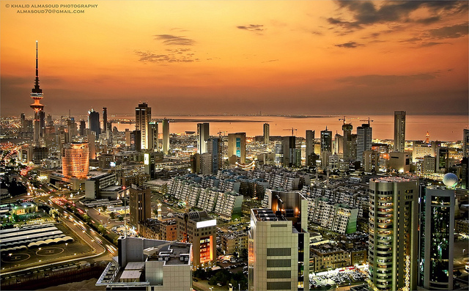

Kuwait City’s trade and transportation needs are served by Kuwait International Airport, Mina Al-Shuwaik (Shuwaik Port) and Mina Al Ahmadi (Ahmadi Port) 50 kilometres (31 miles) to the south, on the Persian Gulf coast. Kuwait City is ranked as one among the 25 largest GDP cities in the world along with New York, Tokyo, Moscow, Mumbai and other financial hubs including Singapore and Dubai.

**3. Weather**

Kuwait City has a hot desert climate and is one of the hottest cities in summers on earth. Its winters are warm with very little rainfall. Sand storms are quite frequent in mid-year.

The weather in November is moderate and approximate temperatures will vary between 20º-25ºC. Rain frequency does increase around November.

**4. Hotel Accommodation**

**Hotel Regency Kuwait (also meeting venue for the events)**

The Regency offers 203 luxurious rooms including 51 suites, as well as the largest meetings and convention facilities in Kuwait. It is a short 15 minute drive from Kuwait’s International Airport and close to the main downtown district of Kuwait City.

The white marble lobby with its 22 meter tall glass atrium offers beautifully landscaped ocean and garden views. This is where families and businessmen gather to sample light refreshments, savor refined pastries and enjoy a selection of gourmet coffees/teas at Regency Gourmet or simply sit on the sun terrace to enjoy The Regency's High Tea and gorgeous vistas.

Shady summer lounge areas are provided in summer and three swimming pools give guests a chance to cool off, while a further two pools are provided exclusively for female guests. In line with Sharia’a ethics, men and women are required to use conservative swimwear in the pools. The Ladies’ Lounge is the only one of its kind in Kuwait and provides a unique all-ladies rendezvous for special events or simply relaxation whether by the pool, in the lounge or by the beautiful beach.

The Regency is well known across Kuwait and the entire Gulf region for its extensive conference and banqueting facilities totalling over 8,000 square meter. A diverse range of meeting rooms are equipped with the latest technology including high speed Wi-Fi. The hotel’s versatility means it is prized for large-scale weddings, high level conferences and social events.

Website: <http://www.theregencykuwait.com/default-en.html>

Address: Al Bida'a, Al Tawoon Street, Salmiya

Email: [info@theregencykuwait.com](mailto:info@theregencykuwait.com)

Telephone: +965 2576 66 66

Fax: +965 2576 69 99

|  |  |
| --- | --- |
| ROOM TYPE | ROOM RATE |
| Single Room | **60 KD per night + 15% service + shuttle service from/to the airport** |

Check In Time: **14:00 hours**

Check Out Time: **12:00 noon**

Credit Cards Accepted: **Visa Card, Master Card, JCB International, American Express, and Diners Club**

**Recommended hotels location map:**

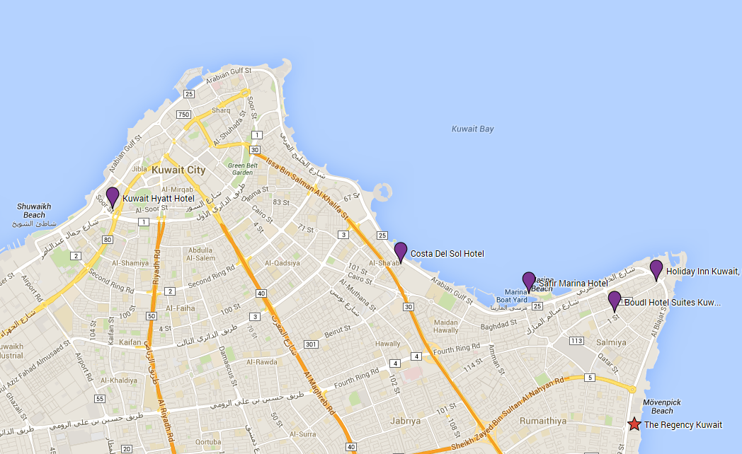

**Other Recommended Hotels**

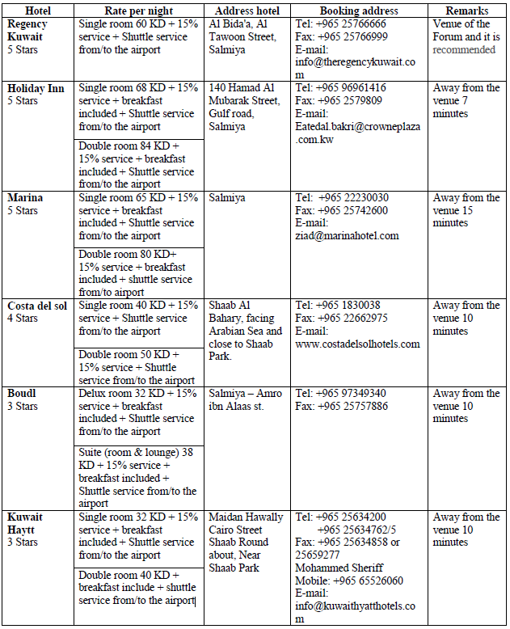

**5. Visa Information**

A valid passport & visa are required to enter The State of Kuwait except for nationalities from the following countries that will be issued entry permits upon arrival at the airport in the state of Kuwait:

United states of America, New Zealand, Australia, Canada, Germany, France, Luxembourg, Belgium, Netherlands, Japan, Norway, Sweden, Austria, Switzerland, Greece, Ireland, Portugal, Denmark, Vatican, Monaco, Spain, Finland, Tolkhstein, SanMarino, Andorra, Iceland, Hong Kong, Malaysia, Singapore, South Korea, China.

Each participant is requested to consult the Kuwaiti Embassy in his/her country of origin to obtain the visa.

Please note that the invitation letter will be circulated to all Kuwaiti Embassies abroad, in order to facilitate the procedures for obtaining a valid visa, furthermore, you can contact the hotel or the tour company you chose to apply for the visa at the following official website:

<http://www.e.gov.kw/MOI.en/Pages/ServiceContent/V2693StateVisit.aspx>

**Should you have any queries regarding obtaining a valid visa or need further assistance please feel free to contact:**

**Mr. Ali Alsalem**

Public Relations Dept.

Tel: + 965 969 665 04

Fax: +965 249 274 85

E-mail: [al.salem@hotmail.com](mailto:al.salem@hotmail.com)

**Very Important Note:**

To facilitate the procedures for obtaining a visa, you should send a copy of your passport [data page and validity of the passport page (special visas countries)] and send it at the above mentioned fax and E-mail.

**Official Working hours:**

Working days: Sunday - Thursday (From 8.00 am to 2.00 pm)

Weekends: Friday & Saturday (holidays)

**6. Transportation from Airport to Hotel**

In order to secure reception at the airport and transportation to hotels, participants are requested to fill the hotel reservation form (**Form 2**) and send it to the hotels, which they chose for accommodation.

The Ministry of Communications will provide transportation only from the hotels to the forum's venue and vice versa.

Tariff for Kuwait airport taxi services ranges between KD 4 for areas near the airport and KD 20 for border areas.

Regarding mobile taxis the fare will be according to the odometer.

Taxi fares in Kuwait city ranges between 2.5 - 3.5 KD.

There are two companies in Kuwait that run public buses: **Kuwait Public Transport Company (KPTC)** and **City Bus,** operating around 50 routes.

City Buses are slightly more expensive with prices around 150 - 250 fils for most trips. Travel on KPTC Buses range from as little as 50 - 150 fils.

**7. Time zone**

UTC/GMT + 0300 hours

**8. Currency**

The national currency of Kuwait is the “*Kuwaiti Dinar (*KD, KWD*)”*.

Banking hours are from 8.30am to 3.00pm, from Sunday to Thursday. Some branches open from 4pm to 6pm.

The exchange rate in Kuwait is pegged to the dollar, other currencies rate can be consulted at <http://www.bbkonline.com/Pages/CurrencyConvertor.aspx>or <http://www.xe.com/> .

As of September 2014:

**1 Euro = 0.383 KWD** (approx.).

**1 US$ = 0.282 KWD** (approx.).

**9. Electricity (voltage used)**

AC power voltage in Kuwait is 240V/50 Hz. Find below used outlets (UK plug):

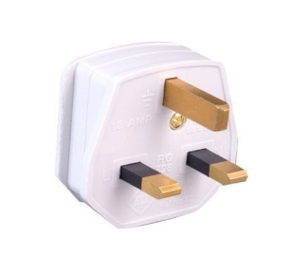

**10. General Information**

|  |  |
| --- | --- |
| Government: | Constitutional Monarchy |
| Emir: | Sabah al-Sabah |
| Crown Prince: | Nawaf al-Sabah |
| Prime Minister: | Jabber Al-Hamad al-Sabah |
| Area: | 17’820 sq.km. |
| Population: | 4,044,500 (approx.) |
| Capital: | Kuwait City |
| Language: | Arabic |

**ANNEX D**(to TSB Collective letter 2/SG3RG- ARB)



**Draft Schedule of ITU-T Regional Study Group Meetings   
(SG3RG-ARB, SG2RG-ARB and SG5RG-ARB),**

**Associated BDT and TSB Forums**(23-25 November 2014, Kuwait City, Kuwait)

|  |  |  |
| --- | --- | --- |
| **Sunday 23rd of November 2014**[1][1] | | |
| 9:30 – 17:00 | **ITU-D Regional Economic and Financial Forum of Telecommunications/ICTs for Arab States ​** | |
| *Lunch Break* | *12:30 – 14:00* | |
| **Monday 24th of November 2014**[2][1] | | |
| 9:30 – 17:00 | **ITU-T SG3RG-ARB:  ARB regional group for Study Group 3** | |
| *Lunch Break* | *12:30 – 14:00* | |
| **Tuesday 25th of November 2014**[3][1] | | |
| 9:30 – 12:30  (Parallel Sessions) | **ITU-T Regional Standardization Forum in the Arab Region** | **ITU-T SG3RG-ARB:  ARB regional group for Study Group 3** (cont’d, if required) |
| 14:00 - 15:30 | **ITU-T SG2RG-ARB:  ARB regional group for Study Group 2** | |
| 15:30 – 17:00 | **ITU-T SG5RG-ARB:  ARB regional group for Study Group 5** | |

Following the above ITU meetings, the Arab Standardization Team, ASTeam, will meet from 0930 to 1700 on Wednesday 26th and Thursday 27th November 2014, with lunch breaks from 1230-1400.

**FORM 2 – HOTEL RESERVATION FORM**

(to TSB Collective letter 2/SG3RG-ARB)

|  |
| --- |
| **HOTEL RESERVATION FORM**  ***(to be submitted before 10 November 2014)*** |

**(*CAPITAL LETTERS*)**

|  |
| --- |
| **1.**  **Mr. / Mrs.**  **(Family name) (First name)**  **2. Country :**    **3.Address :**    **4. Tel.:__________________ Fax: __________________ E-mail :** |

|  |
| --- |
| **PLEASE SEND DIRECTLY TO THE CHOSEN HOTEL** |

|  |
| --- |
| **5. Specify name of hotel**  **Hotel Fax No.**  **Booking of a single room**  **Booking of a double room**  **from to**  ***for*  *nights*** |
| **6. Arrival Date :**  ***Day:* _____________ *Time : _________________* *Flight No.* : ________________** |
| **7.Departure date :**  ***Day :* ____________ *Time : _________________* *Flight No.* : _______________** |

|  |
| --- |
| **Date : Signature :** |

|  |  |
| --- | --- |
| ***To be returned before 10/11/2014, to:***  **cc:** | the hotel chosen  **Mrs. Laila HUSSAIN Head of European & American affairs section External Relations Dept. MOC/Kuwait Tel:** [**+965 24820378**](tel:%2B965%2024820378) **Fax:** [**+ 965 24847058**](tel:%2B%20965%2024847058) **E-mail:** [**hussainl@ties.itu.int**](https://www.itu.int/horde/imp/compose.php?to=hussainl%40ties.itu.int) |

*___________________*

1. [1]  With A/E/F interpretation.
2.
3.