Telecommunication Standardization
Bureau

Geneva, 10 September 2013

Ref: | TSB Collective letter 1/SG5 RG-AMR
Tel:  Fax:  E-mail: | +41 22 730 6301  +41 22 730 5853  tsbsg5@itu.int | To:  - Administrations of Member States of the Union,  - ITU-T Sector Members,  - ITU-T Associates from the American countries participating in the work of Study Group 5 RG-AMR,  - ITU-T Academia,  - ITU Regional Office for Americas Region,  - ITU Area Office, Barbados,  - ITU Area Office, Chile and  - ITU Area Office, Honduras

Subject: | First meeting of ITU-T Study Group 5 Regional Group for the Americas  Mendoza, Argentina, 9 October 2013

Dear Sir/Madam,
We are pleased to inform you that, at the kind invitation of the government of Argentina, ITU-T Study Group 5 Regional Group for the Americas (SG5 RG-AMR) will hold its first meeting in Mendoza, Argentina, on 9 October 2013.
This meeting will be held immediately after the ITU/CITEL Workshop on “Environmentally sound management of E-waste”, which will take place on 9 October 2013.
In addition, a joint CITEL/ISOC/ITU Seminar on "Combating SPAM" will be held on 7 October 2013.
I should like to inform you that the meeting will open at 16:30 hours. Participant registration will begin at 8:30 hours at the venue. Detailed information concerning the meeting rooms will be displayed at the entrances of the venue. Additional information about the meeting is set forth in Annex A.
The draft Agenda of the meeting, as prepared by the Chairman of SG5 RG-AMR, is set out in Annex B.
These meetings are held in the framework of the XXIII meeting of PCC.I. Participants of these events who would like to attend the PCC.I meeting and have not registered on the CITEL website, please contact the Secretariat of CITEL (citel@oas.org).

I wish you a productive and enjoyable meeting.
Yours faithfully,
Malcolm Johnson
Director of the Telecommunication
Standardization Bureau

Annexes: 3

ANNEX A
(to TSB Collective letter 1/SG5 RG-AMR)

MAKING CONTRIBUTIONS
DEADLINES FOR CONTRIBUTIONS: We invite you to submit your contributions by electronic mail to the following address tsbsg5@itu.int. The deadline for contributions is 12 (twelve) calendar days before the meeting. Such contributions will be published on the Study Group 5 RG-AMR website and must therefore be received by TSB not later than 26 September 2013.
TEMPLATES: Please use the provided set of templates to prepare your contribution. The templates are accessible at http://itu.int/ITU-T/studygroups/templates. The name, fax and telephone numbers and e-mail address of the person to be contacted about the contribution should be indicated on the cover page of all documents.

WORK METHODS AND FACILITIES
INTERPRETATION: As agreed with the Chairmen of the Group, the working languages of the meeting will be English and Spanish.
WIRELESS LAN: Facilities and Internet access will be available at the venue of the event.
PAPERLESS MEETINGS: In agreement with its Chairman, Study Group 5 RG-AMR will take further steps towards working in a fully electronic environment. The meeting will therefore be run paperless.

REGISTRATION and FELLOWSHIPS
REGISTRATION: To enable the organisers to make the necessary arrangements, please send by letter, fax (+41 22 730 5853) or e-mail (tsbreg@itu.int) not later than 20 September 2013, the list of people who will be representing your Administration, Sector Member, Associate, Academic Institution, regional and/or international organization or other entity. Administrations are requested also to indicate the name of their head of delegation (and deputy head, if applicable).
Please note that pre-registration of participants to ITU-T meetings is carried out online at the ITU-T website http://itu.int/en/ITU-T/studygroups/2013-2016/05/sg5rgamr/.
FELLOWSHIPS:
Due to budgetary constraints for the remainder of this year, ITU is unfortunately not able to offer fellowships for the upcoming Study Group 5 RG-AMR.

KEY DEADLINES (before meeting)
20 September 2013 - online registration
26 September 2013 - final deadline for contributions

ANNEX B
(to TSB Collective letter 1/SG5 RG-AMR)

Draft Agenda

- Opening of the meeting
- Adoption of the agenda
- Main decisions taken by WTSA-12
- Organization of the work of SG5 RG-AMR
- Appointment of chairman and vice-chairmen
- Preparation of the next meeting
- Discussion on SG5 RG-AMR priorities for the next study period
- Review of work program
- Other business

ANNEX C
(to TSB Collective letter 1/SG5 RG-AMR)

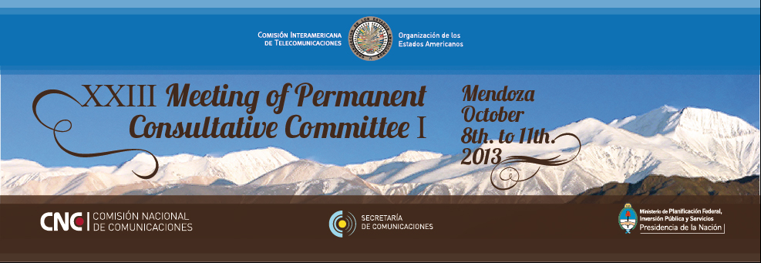

INFORMATION BULLETIN

- VENUE OF THE MEETING

Intercontinental Hotel Mendoza
Address: Blvd. Pérez Cuesta esq. Av. Acceso Este
Mendoza, Argentina
Tel. + (54) (261) 521-8800 - Fax: + (54) (261) 521-8801
Web: www.intercontinentalmendoza.com

- LOCAL CONTACT

Mr. Luis Carranza
Chief of the Communications & Corporate Image Area
International & Institutional Relations Department
Comisión Nacional de Comunicaciones (CNC)
Perú 103 – Piso 8, Ciudad de Buenos Aires – República Argentina
Tel: + (54) (11) 4347-9454 - Fax: + (54) (11) 4347-9546
E-mail: lcarranza@cnc.gov.ar

- ACcoMMODATION AND hotel RESERVATIONS

You should make your reservation as soon as possible.

As from 10 October, the city of Mendoza will be hosting a major medical congress that will limit accommodation availability. It is suggested that you return to Buenos Aires on Friday October 11, in the afternoon /evening.

The Argentine Administration has negotiated special rates in downtown hotels included in the table below. Participants are kindly requested to fill out the attached form and directly email it to the selected hotel.

Reservations are required to include a credit card number. You will receive a confirmation message once your reservation has been accepted by the hotel. In case of failure to attend the meeting, the reservation should be cancelled well in advance.

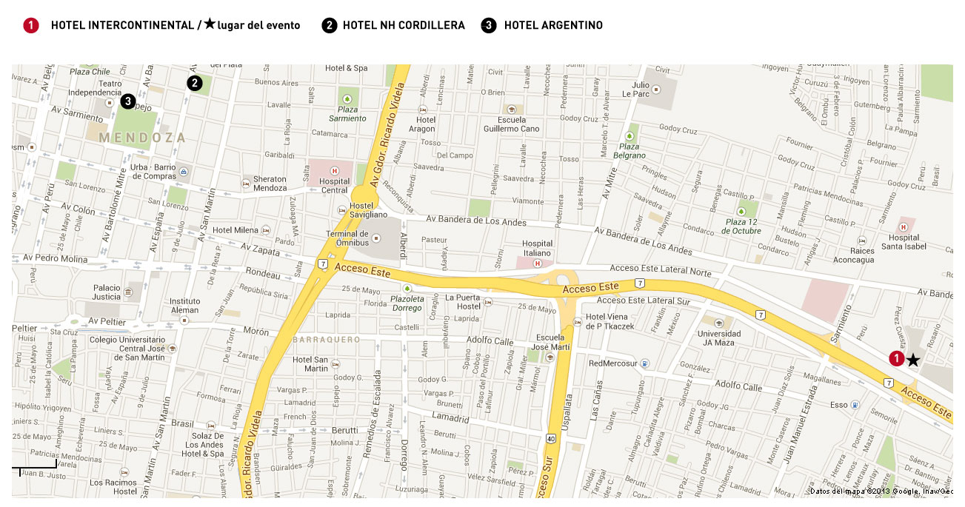

HOTEL | ROOM  RATE | OBSERVATIONS
(1) INTERCONTINENTAL MENDOZA * * * * *  Blvd. Pérez Cuesta esq. Av. Acceso Este  Tel. +54 0261 521-8822 / 8821  Check-In: 15:00 HS / Check-Out: 12:00 HS  reservas@intercontinentalmendoza.com  www.intercontinentalmendoza.com | Single or Double USD 157  Including taxes and breakfast buffet | - Venue of the event  - No availability Friday, October 11
(2) NH CORDILLERA * * * *  España 1324  Tel: +54 0261 441-6464  Check-In: 14:00 HS / Check-Out: 12:00 HS  rsvt.nhcordillera@nh-hotels.com  www.nh-hotels.com | Single or Double Standard USD 116  Including taxes and breakfast buffet | - Located in downtown area, 4km away from venue Hotel  - Taxi to Venue Hotel USD 7  - The hotel still has rooms available for Friday, 11 October. Reservations should be made as soon as possible.
(3) ARGENTINO * * *  Espejo 455  Tel: +54 261 405-6300  Check-In: 15:00 HS / Check-Out: 11:00 HS  reservas@argentino-hotel.com  www.argentino-hotel.com | Single Standard  USD 87  Double Standard USD 107  Including taxes and breakfast buffet | - Located in downtown area, 4km away from venue Hotel  - Taxi to Venue Hotel USD 7  - No availability Friday, October 11

4. INVITATIONS

Reception Cocktail: Tuesday, 8 October 7 pm at the Wine Club Lounge, Venue Hotel.
Suggested attire: Formal

Closing Dinner: Thursday, 10 October 8pm at the Venue Hotel.
Suggested attire: Formal

5- FLIGHTs AND transportATION

Ezeiza Airport: located 40 minutes away from the city of Buenos Aires; used for international air traffic.

Jorge Newbery Airport (Aeroparque): used mainly for domestic air traffic though it also handles many international flights; it is only 15 minutes away from the Buenos Aires downtown area.

Transfer from Ezeiza International Airport to Jorge Newbery Airport (Aeroparque):
Car services and private taxis:
Estimated cost for Ezeiza-Aeroparque transfer $ 270.- (USD 50) www.taxiezeiza.com.ar
Minibuses: Estimated cost Ezeiza-Aeroparque transfer $ 85.- (USD 16) www.tiendaleon.com.ar

“El Plumerillo” Airport (Mendoza): Car services and private taxis: the city of Mendoza is 11 km away from the airport. The estimated cost for a taxi or car service is $ 90.- (USD 17.-)

6. GENERAL INFORMATION

City of Mendoza

Mendoza is one of Argentina’s major cities. Located at the foot of the highest mountains of the Andes, it has a pleasant and mild climate, with scarce rains and very few windy days, thanks to the protection provided by the mountain.

Founded in 1561 by Pedro del Castillo, the city itself is a great attraction. Famous for its gastronomy, it offers a wide range of delicious dishes in hotels with international cuisine and in small typical restaurants with traditional delights. This feast of flavors goes from the traditional “asado and empanadas criollas” to ethnic food from the East and, Spanish and Italian food, all accompanied by the best wines.

It is also a bustling center of artistic and cultural activities: theaters, museums, art galleries and crafts exhibits enrich the daily calendar. Always inviting and vivacious, pubs, dance clubs, theaters, movie theaters and casinos remain open well into the early hours of the morning.

Entry formalities

Most of the delegates do not require a visa to enter Argentina. You can check all visa requirements at www.mrecic.gov.ar “temas consulares” (consular issues). However, make sure to consult with your embassy or consulate for further information.

Those who require a visa to enter Argentina should contact Mr. Luciano Intelesano at lintelesano@cnc.gov.ar to request a personalized letter of invitation addressed to the petitioner via e-mail. This letter will then be delivered to the petitioning country’s Argentine Embassy in order to get the visa.
Argentina does not require any vaccination certificates, except for the case of vaccination against cholera and yellow fever for passengers coming from countries in which these deceases are endemic.

Language

Spanish is the official language; English is widely spoken.

Electricity

AC power voltage in Argentina is 220 V, 50 Hz. Hotels usually have 110 V adaptors available.

Climate

October is springtime in Argentina and thus a great month to visit Mendoza. It tends to be the nicest time of the year since the winds from the Atlantic start to blow and the weather becomes less dry and warmer.
High temperatures during the day range between 26º C (78.8º F) and 28º C (82.4º F), and low temperatures during the night between 10º C (50º F) and 12º C (53.6º F)
For more information, please visit the National Weather Forecast Service website: http://www.smn.gov.ar/?mod=pron&id=4&provincia=Mendoza&ciudad=Mendoza

Currency

The peso ($) is Argentina’s official currency. Although dollars are usually accepted, foreign exchange can be obtained in banks and authorized foreign exchange offices. The most widely accepted credit cards are American Express, VISA, Diners and Mastercard.

Exchange rates may fluctuate. As of 08/01/2013 the dollar/peso rate was:
USD 1 = $ 5.50.

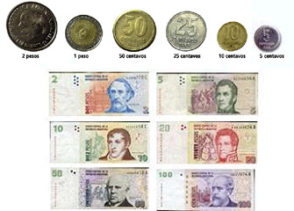

Shopping. Tax refunds
At the airport, tourists can get a 21% refund of the amount paid for Value Added Tax (VAT), if they have bought national products for amounts over $ 70 (per purchase slip) at the shops that have joined the “Global Refund” system.

For further information, please visit:
http://www.aa2000.com.ar/ip_dsv_internayregiona_partidas.aspx#P_9 “Tax-Refund”

Business hours
Banks and Foreign Exchange Offices: Monday to Friday, from 10 am to 3 pm.
Business offices: Monday to Friday, usually from 9 am to 12 noon and from 2 pm to 7 pm.
Shops: Monday to Friday from 9 am to 8 pm. Saturdays from 9 am to 1 pm
Cafés, bars and pizza restaurants: almost open round the clock, with a break between 2 and 6 in the morning.
Restaurants: lunch is served from 12.30 noon and dinner from 8.30 pm on. Many places offer fast food options at all times.

Tip
It is customary practice to leave a 10% tip in cafés and restaurants, as well as to tip porters, bell boys and ushers in theaters.

Useful information

For further information on the city of Buenos Aires, please visit the following web page: www.ciudaddemendoza.gov.ar

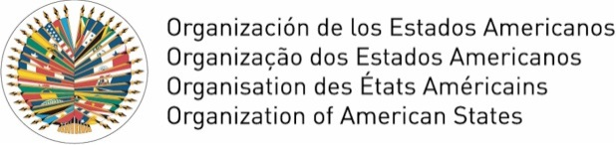 |  | Comisión Interamericana de Telecomunicaciones  Comissão Interamericana de Telecomunicações  Commission interaméricaine des télécommunications  Inter-American Telecommunication Commission
 | XXIII Reunión del Comité Consultivo Permanente I (CCP.I) //  XXIII Meeting of the Permanent Consultative I (PCC.I)  8 al 11 de octubre de 2013 // October 8 to 11, 2013 |  | Mendoza  Argentina
RESERVA DE HOTEL / HOTEL RESERVATION
Sírvase enviar este formulario al hotel seleccionado / Please send this form to the chosen hotel
Apellido / Last Name |  |  |  |  | Nombre / First Name
Organización - Compañía / Organization – Company
Dirección / Address
Tel. | Fax |  |  |  |  |  | E-mail
Hotel | Hab. / Room | Tarifa / Rate |  |  |  |  | Compartida con / Shared with
 |  | USD
Seleccionar hotel y habitación SGL (Single) - DBL (Doble) / Choose hotel and room SGL (Single) - DBL (Double)
Fecha de Llegada / Arrival date: | Hora / Time: |  | Aerolínea y N° vuelo / Airline and flight number
Fecha de Salida / Departure date: | Hora / Time:
Autorizo el uso de la siguiente tarjeta de crédito a fin de garantizar la reserva de hotel
I authorize the use of the following credit card to guarantee my hotel reservation
Tipo de tarjeta / Type of Card |  |  | Nombre / Name on Card
Número / Number |  |  | Fecha de expiración / Expiration Date
_______________________

