 |  | International telecommunication union  Telecommunication Standardization Bureau
 |  |  | Geneva, 14 November 2018
Ref: | Corrigendum 1 to  TSB Collective Letter 1/SG5RG-AP  SG5/CB |  | - To Administrations of Member States of the Union;  - To ITU-T Sector Members;  - To ITU-T Associates of Study Group 5;  - To ITU Academia;  - To the ITU Area Office for Asia and the Pacific
Tel: | +41 22 730 6301
Fax: | +41 22 730 5853
E-mail: | tsbsg5@itu.int
Web: | http://itu.int/go/tsg5rgap
Subject: | Meeting of ITU-T Study Group 5 Regional Group for Asia and the Pacific; Wuxi, China, 3 December 2018
Dear Sir/Madam,
Further to TSB Collective Letter 1/SG5RG-AP dated 11 July 2018, please be informed that the meeting of ITU-T Study Group 5 Regional Group for Asia and the Pacific has been postponed to 2019. The venue and date will be communicated at a later stage.
I am delighted to invite you to attend and contribute to an Information Session on "ITU-T Study Group 5 Activities on Environment, Climate Change and Circular Economy” which will take place on 3 December 2018 from 1730 to 1830 hours in Wuxi, China.
This event is held in conjunction the Forum on “ArtificiaI Intelligence, Internet of Things and Smart Cities” which will take place on 3 December 2018 from 0930 to 1500 hours. More details will be available on the Forum webpage.
It is also held in conjunction with the SG20 Opening Plenary, which will take place from 1530 to 1730 hours on
3 December 2018 and the Joint Coordination Activity on Internet of Things and Smart Cities and Communities (JCA-IoT and SC&C) which will take place from 1400 to 1600 hours on 6 December 2018.

Yours faithfully,  (signed)  Chaesub Lee  Director of the Telecommunication  Standardization Bureau | 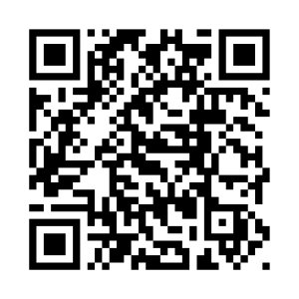 ITU-T SG5RG-AP
 | Latest meeting information

