国 际 电 信 联 盟
电信标准化局
2017年2月24日，日内瓦
 | 文号：  电话：  传真： |  | 电信标准化局第1/9号集体函  +41 22 730 5858  +41 22 730 5853 | 致：  – 国际电联各成员国主管部门；  – ITU-T部门成员；  – 参加ITU-T第9研究组工作的部门准成员；和  – ITU学术成员
 | 电子  邮件： |  | tsbsg9@itu.int
事由： |  | 第9研究组会议  2017年5月24-31日，中国杭州
尊敬的先生/女士：
我高兴地通知您，应中国广播科学研究院（ABS）、中国国家新闻出版广电总局（SAPPRFT）的盛情邀请，第9研究组（宽带有线与电视）将自2017年5月24日至31日（含）在中国杭州召开会议。
我谨通知您，第一天的会议将自9时30分开始。与会者的注册工作将自8时30分于会场入口处开始。有关会议厅安排的具体信息将通过第9研究组电子邮件列表发送并由主办单位在会场显示。有关该会议的补充信息见本函附件A，实用信息见附件D。
经研究组主席（Satoshi Miyaji先生，KKDI，日本）及管理团队同意起草的会议议程草案及时间表草案分别见附件B和C。
在杭州召开的第9研究组会议期间，将于2017年5月26日举办题为“通过集成宽带有线网提供电视和节目传送”的研讨会。研讨会的详细议程将通过第9研究组网页公布（http://itu.int/ITU-T/go/sg9）。
第9研究组会议期间可能将举办一个展览。承办方希望邀请专家展示在第9研究组标准化领域近期开展的研究，这将增加人们对研究组工作的兴趣，有助于推进研究组的未来工作。由于场地有限，将根据先到者优先的原则，仅批准有限数量的申请。请各申请方填写附件F中的表格并尽早在2017年4月15日之前将其提交承办方（ouyangfeng@abs.ac.cn）。请定期查询第9研究组网站的更新。
祝您与会顺利且富有成效。
顺致敬意！

电信标准化局主任
李在摄
附件：6件
（电信标准化局第1/9号集体函）
附件A
文稿
提交文稿的截止日期：提交文稿的截止日期为会议召开的12（十二）个日历日之前。此类文稿将在第9研究组的网站上发布，因而必须在2017年5月11日之前寄达电信标准化局。在会议开始日至少两个月之前收到的文稿，可以应要求予以翻译。
文件直接传送/文件提交：现已在线提供文稿直传系统（DDP）。该系统允许ITU-T成员保留文稿编号，并将文稿直接上传至ITU-T的网络服务器或进行修改。直传系统的更过信息和导则见以下网址：http://itu.int/net/ITU-T/ddp/。
模板：请使用提供的一系列模板起草您的文稿。可通过各ITU-T研究组网页的“Delegate resources”（代表资源）（http://itu.int/ITU-T/studygroups/templates）项访问模板。需在文稿首页上注明文稿联系人的姓名、传真号码、电话号码和电子邮件地址。
工作方法与设施
口译服务：根据与ITU-T第9研究组管理团队达成的一致意见，本次会议仅以英文进行。
无纸会议：会议将为无纸会议。
无线局域网设施：将在会场提供，供代表使用。详尽信息见附件D第6项。
打印机：将在会场提供，供代表使用。
注册和与会补贴
注册：为便于电信标准化局做出必要安排，请您通过信函、传真（+41 22 730 5853）或电子邮件（tsbreg@itu.int）的方式在2017年4月24日之前将代表贵主管部门、部门成员、部门准成员、学术机构、区域性组织和/或国际组织或其它实体出席会议的人员名单发至我处。同时亦请各主管部门注明其代表团团长的姓名（如果有副团长，亦盼一并注明）。
请注意，ITU-T会议的与会者只能通过ITU-T网址进行网上预注册：（http://itu.int/ITU-T/studygroups/com9）。
与会补贴：我们高兴地通知您，为促进最不发达国家或低收入发展中国家代表的与会，国际电联将视可用资金情况，向一相关主管部门提供两份非全额与会补贴（http://www.itu.int/en/ITU-T/info/Documents/list-ldc-lic.pdf）。请进一步注意，如申请两(2)份非全额补贴，至少有一份必须是经济舱机票。申请与会补贴时必须得到相关国际电联成员国主管部门的授权。与会补贴申请表（请使用所附表1）必须在2017年4月12日之前填妥并交回国际电联。请注意，决定是否颁发与会补贴的标准包括：电信标准化局的可用预算情况；申请人向会议提交文稿的情况；国家与区域间的平均分配；性别平衡。

（会前）重要截止日期
两个月前 | 2017-03-24 | – 提交需予以翻译的文稿  – 要求提供无障碍获取服务设施
六个星期前 | 2017-04-12 | – 申请与会补贴
一个月前 | 2017-04-24 | - 预注册（通过研究组主页在线进行）
12个日历日前 | 2017-05-11 | - 提交文稿的最后截止日期

访问中国
签证：入境中国，您可能需要承办方（SAPPRFT）的一封邀请函。您需将其提交驻贵地区的中国使馆/领事馆，以办理签证（邀请函见附件E）。签证必须向驻贵国的中国代表机构（使馆或领事馆）申请，并随后领取。如果贵国没有此类机构，则请向驻出发国最近的国家的此类机构申请并领取。请注意，签证的审批需要时间，因此请尽早提出签证申请。

FORM 1 - FELLOWSHIP REQUEST
(to TSB Collective letter 1/9)
ITU-T Study Group 9 meeting
Hangzhou, China, 24-31 May 2017
Please return to: |  | ITU  Geneva (Switzerland) |  | E-mail: fellowships@itu.int  Tel: +41 22 730 5227  Fax: +41 22 730 5778
Request for one partial fellowship to be submitted before 12 April 2017
 |  |  | Participation of women is encouraged
Registration Confirmation ID No: ……………………………………………………………………………
(Note: It is imperative for fellowship holders to pre-register via the online registration form at:
http://itu.int/go/tsg9)
Country: _____________________________________________________________________________________________
Name of the Administration or Organization: ______________________________________________________
Mr / Ms _______________________________ (family name) ________________________________ (given name)
Title: _________________________________________________________________________________________________
Address: _____________________________________________________________________________________________
_____________________________________________________________________________________________
Tel.: _________________________ Fax: _________________________ E-mail: __________________________________
PASSPORT INFORMATION:
Date of birth: ________________________________________________________________________________________
Nationality: ______________________________ Passport number: _______________________________________
Date of issue: ______________ In (place): _________________________ Valid until (date): __________________
Please select your preference
(which ITU will do its best to accommodate)
□ Economy class air ticket (duty station / Hangzhou / duty station)
□ Daily subsistence allowance intended to cover accommodation, meals & misc. expenses
Signature of fellowship candidate: |  |  |  |  | Date:
TO VALIDATE FELLOWSHIP REQUEST, NAME, TITLE AND SIGNATURE OF CERTIFYING OFFICIAL DESIGNATING PARTICIPANT MUST BE COMPLETED BELOW WITH OFFICIAL STAMP.
N.B. IT IS IMPERATIVE THAT FELLOWS BE PRESENT FROM THE FIRST DAY TO THE END OF THE MEETING.
Signature: |  |  |  |  | Date:

ANNEX B
(to TSB Collective letter 1/9)
Draft Agenda
# | Agenda items
Opening of the SG9 meeting including welcome from the host country
  - Approval of the agenda
  - Approval of the previous SG9 Reports
  - Approval of the work plan for the meeting
  - Document allocation
  - Incoming liaison statements
  - Meeting facilities and useful information
  - Newcomers’ welcome pack
 | Feedback on interim activities since the last meeting
 | SG9 responsibility and Questions assigned by WTSA-16, Hammamet, Tunisia
SG9 organization
  - SG9 Management team
  - Working Party structure and its Management
  - Questions Rapporteurs and Associates
  - Liaison Officers
SG9 plans for the 2017-2020 Study Period
  - WP1
  - WP2
  - Question 10/9
 | Other relevant outputs from WTSA-16
 | Report and liaison statements from other Groups/Workshops
 | Promotion of SG9 work, workshops organization
Documents planned for Approval/Consent/Determination/Agreement at this meeting
  - Intellectual Property Rights inquiry
 | AOB for opening Plenary
 | Intellectual Property Rights inquiry
Approval/Consent/Determination of draft Recommendations and agreement of other deliverables
  - Recommendations
  - Supplements
  - Technical Papers and Reports
  - Others
 | Approval of Working-Party reports and Question meeting report
 | Outgoing Liaison Statements
 | Agreement to start new work items
 | Update of the SG9 Work Programme
 | New/revised Questions (if any)
 | New appointment of Rapporteurs, Associate Rapporteurs, Liaison Officers
 | Date and place of the next SG9 meeting
 | Future Interim Activities (Working Party and Rapporteur meetings)
 | Future events related to SG9
 | AOB for closing Plenary
 | Closing
Note: Items 1 to 10 are expected to be addressed in the opening Plenary (24 May 2017) and items 11 to 23 are expected to be addressed in the closing Plenary (31 May 2017).

ANNEX C
(to TSB Collective letter 1/9)
Draft Timetable of SG9 meeting (24-31 May 2017, Hangzhou, China)
 | Wednesday 24  May |  |  |  | Thursday 25  May |  |  |  | Friday 26  May |  |  |  | Sat 27  May | Sun 28  May | Monday 29  May |  |  |  | Tuesday 30  May |  |  |  | Wednesday 31  May
Sessions | 1 | 2 | 3 | 4 | 1 | 2 | 3 | 4 | 1 | 2 | 3 | 4 |  |  | 1 | 2 | 3 | 4 | 1 | 2 | 3 | 4 | 1 | 2 | 3 | 4
PLEN | X | 2 |  |  |  |  |  |  |  |  |  |  |  |  |  |  |  |  |  |  |  |  |  |  | X | X
WPs |  | 2 |  |  |  |  |  |  |  |  |  |  |  |  |  |  |  |  |  |  |  |  | X | X
Workshop |  |  |  |  |  |  |  |  | 3 | 3 | 3 | 3
Q1/9 (ex.Q1/9) |  |  | X | X |  |  |  |  |  |  |  |  |  |  |  |  |  | X |  |  |  | X
Q2/9 (ex.Q3/9) |  |  |  |  | X | X |  |  |  |  |  |  |  |  |  | X |  |  |  |  | X
Q3/9 (ex.Q6/9) |  |  |  |  |  |  | X |  |  |  |  |  |  |  |  |  |  |  | X
Q4/9 (ex.Q11/9) |  |  |  |  |  |  |  |  |  |  |  |  |  |  | X |  |  |  |  | X
Q5/9 (ex.Q4/9) |  |  |  |  |  |  |  | X |  |  |  |  |  |  |  |  | X |  |  |  | X
Q6/9 (ex.Q5/9) |  |  | X |  |  |  |  |  |  |  |  |  |  |  | X
Q7/9 (ex.Q7/9) |  |  |  |  | X | X |  |  |  |  |  |  |  |  |  | X |  |  |  |  |  | X
Q8/9 (ex.Q8/9) |  |  |  | X |  |  |  |  |  |  |  |  |  |  |  |  |  |  | X
Q9/9 (ex.Q10/9) |  |  |  |  |  |  | X |  |  |  |  |  |  |  |  |  | X
Q10/9 (ex.Q13/9) |  |  |  |  |  |  |  | X |  |  |  |  |  |  |  |  |  | X |  | X
Newcomers |  |  |  |  |  | 1
Session 1: 0930-1045; Session 2: 1115-1230; Session 3: 1430-1545; Session 4: 1615-1730; Session 5: 1800-1915;
PLEN | SG9 Plenary sessions
WPs | Working Parties 1/9 and 2/9 Plenary sessions
X | Represents a meeting session
 | Indicates a lunch/evening session
1 | A newcomers orientation session will take place (1230-1330)
2 | WP1/9 and WP2/9 opening Plenary sessions will be held sequentially and will follow the SG9 opening Plenary
3 | Workshop on “TV and content delivery on the Integrated Broadband Cable Network”
Colour legend
 | SG and WP Plenary sessions |  | Workshop |  | Questions of WP1 |  | Questions of WP2 |  | Questions of Plenary
NOTE: An updated version of this timetable will be made available from the SG9 webpage as TD 2 (GEN/9).
ANNEX D

PRACTICAL INFORMATION
(Please see an updated version of this practical information on the SG9 webpage)

Meeting Venue
Zhejiang Hotel
Hotel Reservations：+86-571-87180808
Address：No. 278, Santaishan Road, Hangzhou. Zhejiang, China
http://www.zhejianghotel.com/en/reservation.html
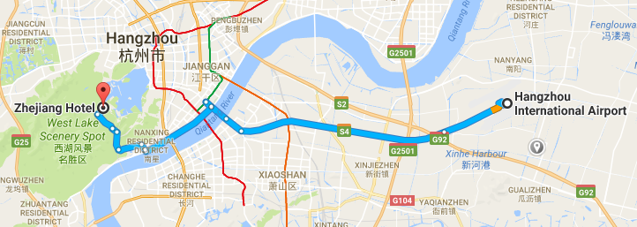

Transportation and site information
35 km to Xiao Shan International Airport; 10 km to the railway station; 20 km to the south railway station; 0 km to the West Lake.

Passports and Visas
All foreign visitors entering China must have a valid passport. Visitors from countries whose citizens require a visa should apply for a visa at a Chinese Embassy or consulate as early as possible and well in advance of travel.
For an invitation letter, please see Annex E.

Climate (end of May in Hangzhou)
Monthly average values of the temperature and precipitation in Hangzhou are given in the table below:
 | May
Average max temperature | 25C / 77F
Average minimum temperature | 17C / 63F
Average precipitation | 157 mm

Hotels
In addition to the hotel venue, Zhejiang Hotel, (see item 1 above) other close hotels are:
5.1 Hangzhou Sunday Sunny Resort
http://www.hzstsz-hotel.com
Hotel Reservations：+86-571-87975888
Address: No.200 Santaishan Road, Hangzhou, Zhejiang, China
The distance from Hangzhou Sunday Sunny Resort to the meeting venue is approximately 0.5 km.
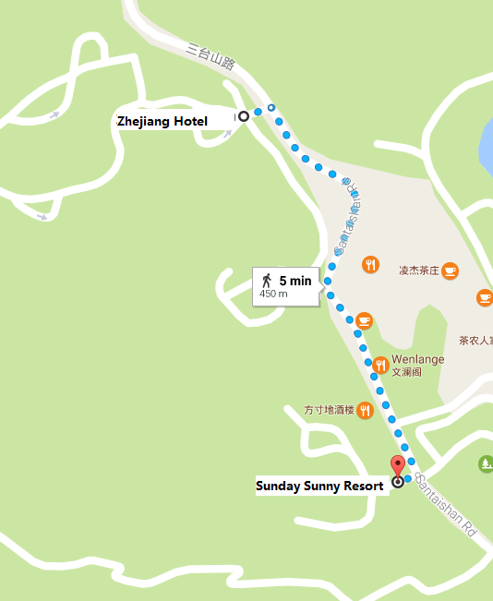

5.2 West Lake State Guest Hotel
http://www.xihusgh.com
Hotel Reservations：+86-571-87979889
Address: 18th Yanggongti Road, Hangzhou, Zhejiang, China
The distance from West Lake State Guest Hotel to the meeting venue is approximately 2 km.
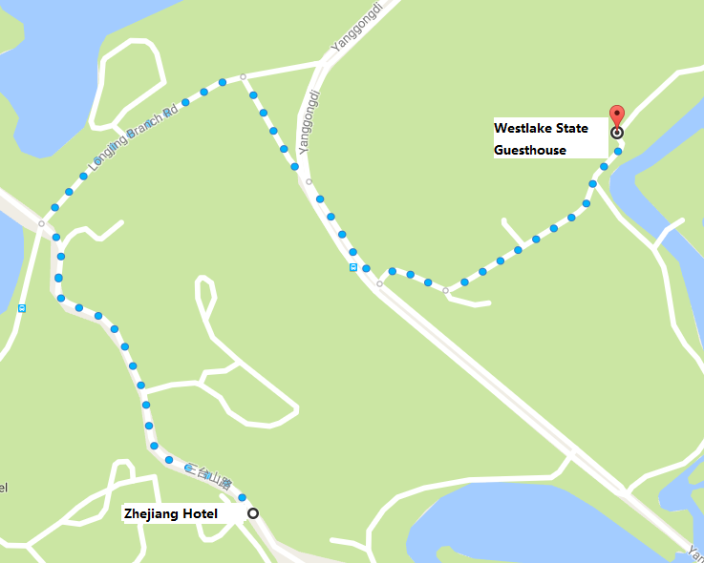

Internet access and wireless coverage at the venue
All meeting rooms will have a wireless network with access to the Internet. Every guest room offers high-speed Internet access free of charge. Internet access will be provided using the LAN technologies listed below:
Wireless via Wi-Fi: IEEE 802.11a/n on 5.2 GHz and 802.11g/n on 2.4 GHz.

Technical assistance
In case you have any technical problem at the venue (e.g., connecting to Internet, finding meeting rooms, etc.) please contact for help:
Mr Luo Xinqi: +86 13588774554 luoxq@wasu.com

Electricity
The electricity in China is generally 220V, 50 Hz. Please make sure you have the proper adapter.
Chinese standard
Such a socket is common in China, Australia, New Zealand and many other countries.

Currency exchange

The currency in China is the RMB Yuan (￥), the exchange rate of US$ and RMB is around 6.878. Please check the currency exchange rate in the local bank system or use the following link as a reference: http://www.xe.com/

Additional information
10.1 Mobile phone: GSM and CDMA, WCDMA, TD-SCDMA, TD-LTE services provided by China Mobile, China Unicom and China Telecom.
10.2 Tipping: Tipping is not necessary.
10.3 Time Zone: GMT+8:00.
10.4 Emergency Number: In case of emergency, please dial 110.
10.5 Sightseeing: For more information see http://en.gotohz.com/

Contact person
Mr OUYANG Feng: +86 13511029034 (ouyangfeng@abs.ac.cn)

ANNEX E
INVITATION LETTER REQUEST FORM
All foreign visitors entering China must have a valid passport. Visitors from countries whose citizens require a visa should apply for a visa at a Chinese Embassy or Consulate as early as possible and well in advance of travel. You may need a letter of invitation from the Chinese host, which you will need to present to the Chinese Embassy/Consulate in your area in order to obtain your visa. The visa must be requested as soon as possible and at least one month before the start date of the meeting and obtained from the office (Embassy or Consulate) representing China in your country or, if there is no such office in your country, from the one that is closest to the country of departure. In order to obtain an invitation letter, please:
- Fill out the form below
- Provide an electronic copy of your passport (name, date of birth, nationality, passport number, expiration date of passport, etc., must be seen clearly)
- Provide the electronic copy of previous Chinese visas and records (if you have been to China before)
- Send the info in a), b) and c) as email attachments to gebing@abs.ac.cn and ouyangfeng@abs.ac.cn ; please mark as reference in the subject “Invitation letter request for ITU-T SG9 meeting (24-31 May 2017).
(It is recommended to scan your passport and e-mail it to us so that it is discernible and can be used).
Company
Applicant Information |  |  |  | Mr Miss Ms Mrs
 |  |  |  | Date of birth :
 |  |  |  | Place of Issue:
 | Date of Issue: |  |  | Date of Expiry:
 | Marital Status:
 | If the country in which you'll obtain your visa is different from your nationality, please indicate it here:
Address | Telephone Number:  Fax Number:  E-mail:
Note
Date of arrival in China |  |  | Date of departure from China
(Please do not forget to attach a copy of your passport photograph page before sending.)
In order to receive an invitation letter, your request should reach the host before 24 April 2017.
ANNEX F
EXHIBITORS’ REQUIREMENT FORM
(Note: Please complete and return to ouyangfeng@abs.ac.cn by 15 April 2017 to reserve a booth. Considering the limited space and options, all participants should provide their own computers and storage, and please keep them to a minimum.)

Company Name | Contact person including contact details | E-mail address

Type of equip. to be displayed

Item(s) required | Description | Quantity
Tables
Chairs
Flat Screens
Network switch
Power supply
Space required
Panels
Power consumption expected for equipment:
Dimension, weight of equipment
Additional notes
(if any)

_____________________

