International telecommunication union
Telecommunication Standardization Bureau
 |  |  | Geneva, 24 February 2017
Ref: | TSB Collective letter 1/9 |  | - To Administrations of Member States of the Union;  - To ITU-T Sector Members;  - To ITU-T SG 9 Associates; and  - To ITU Academia
Tel: | +41 22 730 5858
Fax: | +41 22 730 5853
E-mail: | tsbsg9@itu.int
Subject: | Meeting of Study Group 9; Hangzhou, China, 24-31 May 2017
Dear Sir/Madam,
It is my pleasure to inform you that Study Group 9 (Broadband cable and TV) will meet in Hangzhou, China, from 24 to 31 May 2017 inclusive, at the kind invitation of the Academy of Broadcasting Science (ABS), State Administration of Press, Publication, Radio, Film and Television of the People’s Republic of China (SAPPRFT), China.
I should like to inform you that the meeting will open at 0930 hours on the first day. Participant registration will begin at 0830 hours at the venue entrance. Detailed information concerning the meeting rooms will be circulated via the SG9 e-mail list and displayed onsite by the host. Additional information about the meeting is set forth in Annex A, while practical information can be found in Annex D.
The draft Agenda of the meeting and the draft Timetable, prepared in agreement with the Chairman of Study Group 9 (Mr Satoshi Miyaji, KKDI, Japan) and its management team, are set out in Annex B and Annex C, respectively.
A workshop on “TV and content delivery on the Integrated Broadband Cable Network” will take place on 26 May 2017 in Hangzhou during the SG9 meeting. A detailed programme of the workshop will be available from the SG9 webpage (http://itu.int/ITU-T/go/sg9).
An exhibition may be held during the SG9 meeting. The host would like to invite experts to showcase recent research in the field of SG9 standardization, which will interest and energize future SG9 work. Only a limited number of applications will be accepted on a first-come, first-served basis, due to the limited space available. Applicants are requested to complete and submit to the host at ouyangfeng@abs.ac.cn, the application form to be found in Annex F, as soon as possible and before 15 April 2017. Please regularly check the SG9 website for updates.
I wish you a productive and enjoyable meeting.
Yours faithfully,

Chaesub Lee
Director of the Telecommunication
Standardization Bureau
Annexes: 6
ANNEX A
(to TSB Collective letter 1/9)
MAKING CONTRIBUTIONS
DEADLINES FOR CONTRIBUTIONS: The deadline for contributions is 12 (twelve) calendar days before the meeting. Such contributions will be published on the Study Group 9 website and must therefore be received by TSB not later than 11 May 2017. Contributions received at least two months before the start of the meeting may be translated, if requested.
DIRECT POSTING/DOCUMENT SUBMISSION: A direct posting system for contributions is available
online. The direct posting system allows ITU-T members to reserve contribution numbers and to upload/revise contributions directly to the ITU-T web server. Further information and guidelines for the direct posting system are available at the following address: http://itu.int/net/ITU-T/ddp/.
TEMPLATES: Please use the provided set of templates to prepare your meeting documents. The templates are accessible from each ITU-T study group web page, under “Delegate resources” (http://itu.int/ITU-T/studygroups/templates). The name, fax and telephone numbers and e-mail address of the person to be contacted about the contribution should be indicated on the cover page of all documents.
WORK METHODS AND FACILITIES
INTERPRETATION: As per agreement of the ITU-T SG9 management team, this meeting will be held in English only.
PAPERLESS MEETINGS: The meeting will be run paperless.
WIRELESS LAN facilities will be available for use by delegates at the venue. Detailed information is available in ANNEX D item 6.
PRINTERS: Printers will be made available to the delegates at the venue of the event.
REGISTRATION and FELLOWSHIPS
REGISTRATION: To enable the Host to make the necessary arrangements, please send by letter, fax (+41 22 730 5853), or e-mail (tsbreg@itu.int), not later than 24 April 2017, the list of people who will be representing your Administration, Sector Member, Associate, Academic Institution, regional and/or international organization, or other entity. Administrations are requested also to indicate the name of their head of delegation (and deputy head, if applicable).
Please note that pre-registration of participants for ITU-T meetings is carried out online on the ITU-T website (http://itu.int/ITU-T/studygroups/com9).
FELLOWSHIPS: We are pleased to inform you that two partial fellowships per administration will be awarded, subject to available funding, to facilitate participation from Least Developed or Low Income Developing Countries (http://www.itu.int/en/ITU-T/info/Documents/list-ldc-lic.pdf). Please further note that when two (2) partial fellowships are requested, at least one must be an economy class air ticket. An application for a fellowship must be authorized by the relevant Administration of the ITU Member State. Fellowship requests (please use enclosed Form 1) must be returned to ITU not later than 12 April 2017. Please note that the decision criteria to grant a fellowship include: the available TSB budget, contributions by the applicant to the meeting, equitable distribution among countries and regions, and gender balance.
KEY DEADLINES (before meeting)
Two months | 2017-03-24 | - submit contributions for which translation is requested  - request for accessibility accommodations
Six weeks | 2017-04-12 | - fellowship requests
One month | 2017-04-24 | - pre-registration (online via the study group homepage)  - requests for visa support letters
12 calendar days | 2017-05-11 | - final deadline for contributions
VISITING CHINA
VISAS: To enter China, you may need a letter of invitation from the host (SAPPRFT), which you will need to present to the Chinese Embassy/Consulate in your area in order to obtain your visa (see ANNEX E for the Invitation letter). The visa must be requested and obtained from the office (embassy or consulate) representing China in your country or, if there is no such office in your country, from the one that is closest to the country of departure. Please be aware that visa approval might take time so kindly make your visa request as soon as possible.

FORM 1 - FELLOWSHIP REQUEST
(to TSB Collective letter 1/9)
ITU-T Study Group 9 meeting
Hangzhou, China, 24-31 May 2017
Please return to: |  | ITU  Geneva (Switzerland) |  | E-mail: fellowships@itu.int  Tel: +41 22 730 5227  Fax: +41 22 730 5778
Request for one partial fellowship to be submitted before 12 April 2017
 |  |  | Participation of women is encouraged
Registration Confirmation ID No: ……………………………………………………………………………
(Note: It is imperative for fellowship holders to pre-register via the online registration form at:
http://itu.int/go/tsg9)
Country: _____________________________________________________________________________________________
Name of the Administration or Organization: ______________________________________________________
Mr / Ms _______________________________ (family name) ________________________________ (given name)
Title: _________________________________________________________________________________________________
Address: _____________________________________________________________________________________________
_____________________________________________________________________________________________
Tel.: _________________________ Fax: _________________________ E-mail: __________________________________
PASSPORT INFORMATION:
Date of birth: ________________________________________________________________________________________
Nationality: ______________________________ Passport number: _______________________________________
Date of issue: ______________ In (place): _________________________ Valid until (date): __________________
Please select your preference
(which ITU will do its best to accommodate)
□ Economy class air ticket (duty station / Hangzhou / duty station)
□ Daily subsistence allowance intended to cover accommodation, meals & misc. expenses
Signature of fellowship candidate: |  |  |  |  | Date:
TO VALIDATE FELLOWSHIP REQUEST, NAME, TITLE AND SIGNATURE OF CERTIFYING OFFICIAL DESIGNATING PARTICIPANT MUST BE COMPLETED BELOW WITH OFFICIAL STAMP.
N.B. IT IS IMPERATIVE THAT FELLOWS BE PRESENT FROM THE FIRST DAY TO THE END OF THE MEETING.
Signature: |  |  |  |  | Date:

ANNEX B
(to TSB Collective letter 1/9)
Draft Agenda
# | Agenda items
Opening of the SG9 meeting including welcome from the host country
  - Approval of the agenda
  - Approval of the previous SG9 Reports
  - Approval of the work plan for the meeting
  - Document allocation
  - Incoming liaison statements
  - Meeting facilities and useful information
  - Newcomers’ welcome pack
 | Feedback on interim activities since the last meeting
 | SG9 responsibility and Questions assigned by WTSA-16, Hammamet, Tunisia
SG9 organization
  - SG9 Management team
  - Working Party structure and its Management
  - Questions Rapporteurs and Associates
  - Liaison Officers
SG9 plans for the 2017-2020 Study Period
  - WP1
  - WP2
  - Question 10/9
 | Other relevant outputs from WTSA-16
 | Report and liaison statements from other Groups/Workshops
 | Promotion of SG9 work, workshops organization
Documents planned for Approval/Consent/Determination/Agreement at this meeting
  - Intellectual Property Rights inquiry
 | AOB for opening Plenary
 | Intellectual Property Rights inquiry
Approval/Consent/Determination of draft Recommendations and agreement of other deliverables
  - Recommendations
  - Supplements
  - Technical Papers and Reports
  - Others
 | Approval of Working-Party reports and Question meeting report
 | Outgoing Liaison Statements
 | Agreement to start new work items
 | Update of the SG9 Work Programme
 | New/revised Questions (if any)
 | New appointment of Rapporteurs, Associate Rapporteurs, Liaison Officers
 | Date and place of the next SG9 meeting
 | Future Interim Activities (Working Party and Rapporteur meetings)
 | Future events related to SG9
 | AOB for closing Plenary
 | Closing
Note: Items 1 to 10 are expected to be addressed in the opening Plenary (24 May 2017) and items 11 to 23 are expected to be addressed in the closing Plenary (31 May 2017).

ANNEX C
(to TSB Collective letter 1/9)
Draft Timetable of SG9 meeting (24-31 May 2017, Hangzhou, China)
 | Wednesday 24  May |  |  |  | Thursday 25  May |  |  |  | Friday 26  May |  |  |  | Sat 27  May | Sun 28  May | Monday 29  May |  |  |  | Tuesday 30  May |  |  |  | Wednesday 31  May
Sessions | 1 | 2 | 3 | 4 | 1 | 2 | 3 | 4 | 1 | 2 | 3 | 4 |  |  | 1 | 2 | 3 | 4 | 1 | 2 | 3 | 4 | 1 | 2 | 3 | 4
PLEN | X | 2 |  |  |  |  |  |  |  |  |  |  |  |  |  |  |  |  |  |  |  |  |  |  | X | X
WPs |  | 2 |  |  |  |  |  |  |  |  |  |  |  |  |  |  |  |  |  |  |  |  | X | X
Workshop |  |  |  |  |  |  |  |  | 3 | 3 | 3 | 3
Q1/9 (ex.Q1/9) |  |  | X | X |  |  |  |  |  |  |  |  |  |  |  |  |  | X |  |  |  | X
Q2/9 (ex.Q3/9) |  |  |  |  | X | X |  |  |  |  |  |  |  |  |  | X |  |  |  |  | X
Q3/9 (ex.Q6/9) |  |  |  |  |  |  | X |  |  |  |  |  |  |  |  |  |  |  | X
Q4/9 (ex.Q11/9) |  |  |  |  |  |  |  |  |  |  |  |  |  |  | X |  |  |  |  | X
Q5/9 (ex.Q4/9) |  |  |  |  |  |  |  | X |  |  |  |  |  |  |  |  | X |  |  |  | X
Q6/9 (ex.Q5/9) |  |  | X |  |  |  |  |  |  |  |  |  |  |  | X
Q7/9 (ex.Q7/9) |  |  |  |  | X | X |  |  |  |  |  |  |  |  |  | X |  |  |  |  |  | X
Q8/9 (ex.Q8/9) |  |  |  | X |  |  |  |  |  |  |  |  |  |  |  |  |  |  | X
Q9/9 (ex.Q10/9) |  |  |  |  |  |  | X |  |  |  |  |  |  |  |  |  | X
Q10/9 (ex.Q13/9) |  |  |  |  |  |  |  | X |  |  |  |  |  |  |  |  |  | X |  | X
Newcomers |  |  |  |  |  | 1
Session 1: 0930-1045; Session 2: 1115-1230; Session 3: 1430-1545; Session 4: 1615-1730; Session 5: 1800-1915;
PLEN | SG9 Plenary sessions
WPs | Working Parties 1/9 and 2/9 Plenary sessions
X | Represents a meeting session
 | Indicates a lunch/evening session
1 | A newcomers orientation session will take place (1230-1330)
2 | WP1/9 and WP2/9 opening Plenary sessions will be held sequentially and will follow the SG9 opening Plenary
3 | Workshop on “TV and content delivery on the Integrated Broadband Cable Network”
Colour legend
 | SG and WP Plenary sessions |  | Workshop |  | Questions of WP1 |  | Questions of WP2 |  | Questions of Plenary
NOTE: An updated version of this timetable will be made available from the SG9 webpage as TD 2 (GEN/9).
ANNEX D

PRACTICAL INFORMATION
(Please see an updated version of this practical information on the SG9 webpage)

Meeting Venue
Zhejiang Hotel
Hotel Reservations：+86-571-87180808
Address：No. 278, Santaishan Road, Hangzhou. Zhejiang, China
http://www.zhejianghotel.com/en/reservation.html
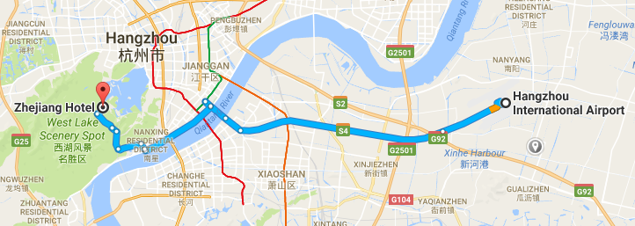

Transportation and site information
35 km to Xiao Shan International Airport; 10 km to the railway station; 20 km to the south railway station; 0 km to the West Lake.

Passports and Visas
All foreign visitors entering China must have a valid passport. Visitors from countries whose citizens require a visa should apply for a visa at a Chinese Embassy or consulate as early as possible and well in advance of travel.
For an invitation letter, please see Annex E.

Climate (end of May in Hangzhou)
Monthly average values of the temperature and precipitation in Hangzhou are given in the table below:
 | May
Average max temperature | 25C / 77F
Average minimum temperature | 17C / 63F
Average precipitation | 157 mm

Hotels
In addition to the hotel venue, Zhejiang Hotel, (see item 1 above) other close hotels are:
5.1 Hangzhou Sunday Sunny Resort
http://www.hzstsz-hotel.com
Hotel Reservations：+86-571-87975888
Address: No.200 Santaishan Road, Hangzhou, Zhejiang, China
The distance from Hangzhou Sunday Sunny Resort to the meeting venue is approximately 0.5 km.
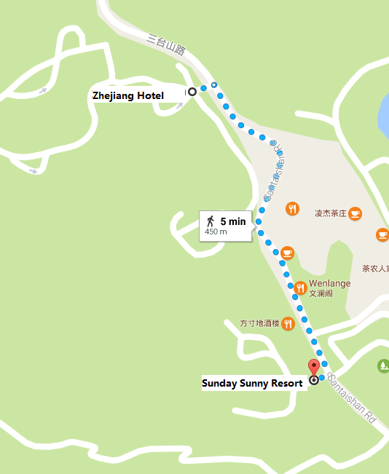

5.2 West Lake State Guest Hotel
http://www.xihusgh.com
Hotel Reservations：+86-571-87979889
Address: 18th Yanggongti Road, Hangzhou, Zhejiang, China
The distance from West Lake State Guest Hotel to the meeting venue is approximately 2 km.
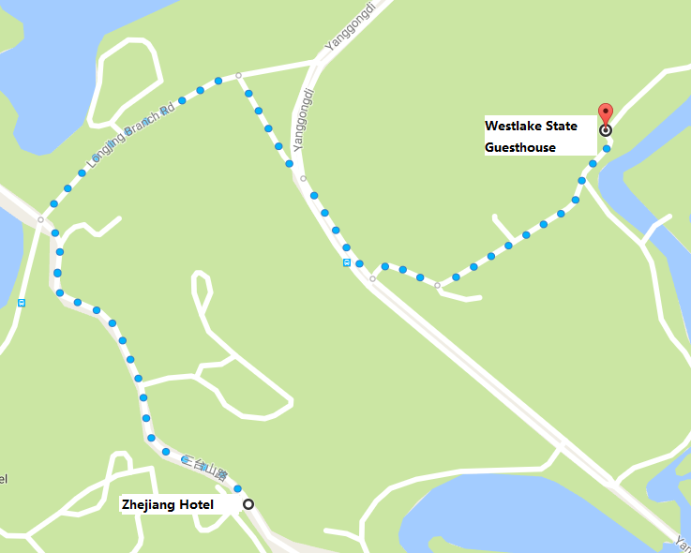

Internet access and wireless coverage at the venue
All meeting rooms will have a wireless network with access to the Internet. Every guest room offers high-speed Internet access free of charge. Internet access will be provided using the LAN technologies listed below:
Wireless via Wi-Fi: IEEE 802.11a/n on 5.2 GHz and 802.11g/n on 2.4 GHz.

Technical assistance
In case you have any technical problem at the venue (e.g., connecting to Internet, finding meeting rooms, etc.) please contact for help:
Mr Luo Xinqi: +86 13588774554 luoxq@wasu.com

Electricity
The electricity in China is generally 220V, 50 Hz. Please make sure you have the proper adapter.
Chinese standard
Such a socket is common in China, Australia, New Zealand and many other countries.

Currency exchange

The currency in China is the RMB Yuan (￥), the exchange rate of US$ and RMB is around 6.878. Please check the currency exchange rate in the local bank system or use the following link as a reference: http://www.xe.com/

Additional information
10.1 Mobile phone: GSM and CDMA, WCDMA, TD-SCDMA, TD-LTE services provided by China Mobile, China Unicom and China Telecom.
10.2 Tipping: Tipping is not necessary.
10.3 Time Zone: GMT+8:00.
10.4 Emergency Number: In case of emergency, please dial 110.
10.5 Sightseeing: For more information see http://en.gotohz.com/

Contact person
Mr OUYANG Feng: +86 13511029034 (ouyangfeng@abs.ac.cn)

ANNEX E
INVITATION LETTER REQUEST FORM
All foreign visitors entering China must have a valid passport. Visitors from countries whose citizens require a visa should apply for a visa at a Chinese Embassy or Consulate as early as possible and well in advance of travel. You may need a letter of invitation from the Chinese host, which you will need to present to the Chinese Embassy/Consulate in your area in order to obtain your visa. The visa must be requested as soon as possible and at least one month before the start date of the meeting and obtained from the office (Embassy or Consulate) representing China in your country or, if there is no such office in your country, from the one that is closest to the country of departure. In order to obtain an invitation letter, please:
- Fill out the form below
- Provide an electronic copy of your passport (name, date of birth, nationality, passport number, expiration date of passport, etc., must be seen clearly)
- Provide the electronic copy of previous Chinese visas and records (if you have been to China before)
- Send the info in a), b) and c) as email attachments to gebing@abs.ac.cn and ouyangfeng@abs.ac.cn ; please mark as reference in the subject “Invitation letter request for ITU-T SG9 meeting (24-31 May 2017).
(It is recommended to scan your passport and e-mail it to us so that it is discernible and can be used).
Company
Applicant Information |  |  |  | Mr Miss Ms Mrs
 |  |  |  | Date of birth :
 |  |  |  | Place of Issue:
 | Date of Issue: |  |  | Date of Expiry:
 | Marital Status:
 | If the country in which you'll obtain your visa is different from your nationality, please indicate it here:
Address | Telephone Number:  Fax Number:  E-mail:
Note
Date of arrival in China |  |  | Date of departure from China
(Please do not forget to attach a copy of your passport photograph page before sending.)
In order to receive an invitation letter, your request should reach the host before 24 April 2017.
ANNEX F
EXHIBITORS’ REQUIREMENT FORM
(Note: Please complete and return to ouyangfeng@abs.ac.cn by 15 April 2017 to reserve a booth. Considering the limited space and options, all participants should provide their own computers and storage, and please keep them to a minimum.)

Company Name | Contact person including contact details | E-mail address

Type of equip. to be displayed

Item(s) required | Description | Quantity
Tables
Chairs
Flat Screens
Network switch
Power supply
Space required
Panels
Power consumption expected for equipment:
Dimension, weight of equipment
Additional notes
(if any)

________________________

