Union internationale des télécommunications
Bureau de la Normalisation des Télécommunications
Genève, le 24 février 2017

Réf.: | Lettre collective TSB 1/9 | – Aux administrations des Etats Membres de l'Union;  – aux Membres du Secteur UIT-T;  – aux Associés de l'UIT-T participant aux travaux de la Commission d'études 9;  – aux établissements universitaires participant aux travaux de l'UIT
Tél.: | +41 22 730 5858
Fax:  E-mail: | +41 22 730 5853  tsbsg9@itu.int
Objet: | Réunion de la Commission d'études 9; Hangzhou (Chine), 24-31 mai 2017
Madame, Monsieur,
J'ai l'honneur de vous informer que la Commission d'études 9 (Réseaux câblés à large bande et télévision) se réunira à Hangzhou (Chine), du 24 au 31 mai 2017 inclus, à l’aimable invitation de l'Academy of Broadcasting Science (ABS), Administration d'Etat de la presse, de l'édition, de la radiodiffusion, du cinéma et de la télévision (SAPPRFT) (République populaire de Chine).
Je vous informe que la réunion s'ouvrira à 9 h 30 le premier jour. L'enregistrement des participants débutera à 8 h 30 à l'entrée du lieu de la réunion. Les précisions relatives aux salles de réunion seront diffusées via la liste d'adresses électroniques de la CE 9 et affichées sur place par l'organisme hôte. Des renseignements complémentaires sur la réunion sont donnés dans l'Annexe A, et des informations d'ordre pratique figurent dans l'Annexe D.
Le projet d'ordre du jour et le projet de calendrier de la réunion, établis en accord avec le Président (M. Satoshi Miyaji, KKDI, Japon) et l'équipe de direction de la Commission d'études 9, figurent respectivement dans les Annexes B et C.
Un atelier sur le thème "Services de télévision et diffusion de contenus sur le réseau câblé intégré à large bande" aura lieu le 26 mai 2017 à Hangzhou pendant la réunion de la CE 9. Un programme détaillé de l'atelier sera disponible depuis la page web de la CE 9 (http://itu.int/ITU-T/go/sg9).
Il se pourrait qu'une exposition soit organisée pendant la réunion de la CE9. L'organisme hôte de la réunion souhaiterait inviter des experts à présenter les activités de recherche récentes dans le domaine de normalisation de la CE 9, ce qui intéressera les membres de la commission d'études et les motivera pour leurs travaux futurs. Seules quelques propositions seront acceptées, par ordre d'arrivée des demandes, en raison du peu d'espace disponible. Les personnes intéressées doivent remplir le formulaire figurant en Annexe F et l'envoyer à l'organisme hôte (ouyangfeng@abs.ac.cn) dès que possible et en tout état de cause, avant le 15 avril 2017. Veuillez consulter régulièrement le site web de la CE 9 pour prendre connaissance des mises à jour.

Je vous souhaite une réunion constructive et agréable.
Veuillez agréer, Madame, Monsieur, l'assurance de ma considération distinguée.
Chaesub Lee
Directeur du Bureau de la normalisation
des télécommunications
Annexes: 6

ANNEXE A
(de la Lettre collective TSB 1/9)
PRÉSENTATION DES CONTRIBUTIONS
DÉLAI DE SOUMISSION DES CONTRIBUTIONS: Le délai pour la soumission des contributions est de 12 (douze) jours calendaires avant la tenue de la réunion. Ces contributions, qui seront publiées sur le site web de la Commission d'études 9, devront donc parvenir au TSB le 11 mai 2017 au plus tard. Les contributions reçues deux mois au moins avant le début de la réunion pourront être traduites sur demande.
POSTAGE DIRECT/SOUMISSION DES DOCUMENTS: Il existe un système de postage direct des contributions en ligne. Ce système permet aux Membres de l'UIT-T de réserver des numéros de contribution et de charger ou modifier les contributions directement sur le serveur web de l'UIT-T. Vous trouverez de plus amples informations et des indications sur ce système de postage direct à l'adresse suivante: http://itu.int/net/ITU-T/ddp/.
GABARITS: Pour élaborer vos documents de réunion, veuillez utiliser l'ensemble de gabarits mis à votre disposition. Ces gabarits sont accessibles depuis la page web de chaque commission d'études de l'UIT-T, sous "Ressources pour les délégués" (http://www.itu.int/ITU-T/studygroups/templates). Le nom de la personne à contacter au sujet de la contribution, ses numéros de télécopie et de téléphone ainsi que son adresse électronique doivent figurer sur la page de couverture de tous les documents.
MÉTHODES DE TRAVAIL ET INSTALLATIONS
INTERPRÉTATION: Comme convenu avec l'équipe de direction de la CE9 de l'UIT-T, cette réunion se tiendra en anglais seulement.
RÉUNIONS SANS PAPIER: Cette réunion se déroulera sans document papier.
RÉSEAU LOCAL SANS FIL (WLAN): Des équipements de réseau local sans fil seront à la disposition des délégués sur place. On trouvera des informations détaillées au point 6 de l'ANNEXE D.
IMPRIMANTES: Des imprimantes seront mises sur place à la disposition des délégués.
INSCRIPTION et BOURSES
INSCRIPTION: Afin de permettre à l'organisme hôte de prendre les dispositions nécessaires, je vous saurais gré de bien vouloir faire parvenir par lettre, par télécopie (+41 22 730 5853) ou par courrier électronique (tsbreg@itu.int) au plus tard le 24 avril 2017, la liste des personnes qui représenteront votre Administration, Membre de Secteur, Associé, établissement universitaire, organisation régionale et/ou internationale ou autre entité. Les administrations sont invitées à indiquer également le nom du Chef de délégation (et du Chef adjoint, le cas échéant).
Veuillez noter que l'inscription préalable des participants aux réunions de l'UIT-T se fait en ligne sur le site web de l'UIT-T (http://itu.int/ITU-T/studygroups/com9).

BOURSES: Nous avons le plaisir de vous informer que deux bourses partielles par administration seront accordées, en fonction des ressources financières disponibles, afin de faciliter la participation des pays les moins avancés ou des pays en développement à faible revenu (http://www.itu.int/en/ITU-T/info/Documents/list-ldc-lic.pdf). Veuillez noter en outre que lorsque deux (2) bourses partielles sont demandées, l'une au moins doit être sollicitée pour un billet d'avion en classe économique. Toute demande de bourse doit être agréée par l'Administration concernée de l'État Membre de l'UIT. Les demandes de bourses (établies à l'aide du Formulaire 1 ci-joint) doivent être retournées à l'UIT au plus tard le 12 avril 2017. Veuillez noter que les critères sur la base desquels il est décidé d'attribuer une bourse sont les suivants: budget disponible au TSB; contributions fournies à la réunion par le demandeur; répartition équitable entre les pays et régions; et parité hommes-femmes.
PRINCIPALES ECHÉANCES (avant la réunion)
Deux mois | 24 mars 2017 | – soumission des contributions dont la traduction est demandée  – demandes de commodités d'accessibilité
Six semaines | 12 avril 2017 | – demandes de bourses
Un mois | 24 avril 2017 | – inscription préalable (en ligne depuis la page d'accueil de la commission d'études)  – demandes de lettre pour faciliter l'obtention du visa
12 jours calendaires | 11 mai 2017 | – dernier délai pour la soumission des contributions
SÉJOUR EN CHINE
VISAS: Pour entrer en Chine, vous devrez peut-être avoir une lettre d'invitation de l'organisme hôte (SAPPFRT), que vous devrez présenter à l'Ambassade/au Consulat de Chine dans votre région afin d'obtenir votre visa (Voir l'ANNEXE E pour la lettre d'invitation). Le visa doit être demandé et obtenu auprès de la représentation de la Chine (ambassade ou consulat) dans votre pays ou, à défaut, dans le pays le plus proche de votre pays de départ. Nous vous rappelons que la délivrance du visa peut prendre un certain temps et vous recommandons d'effectuer votre demande le plus tôt possible.

FORM 1 - FELLOWSHIP REQUEST
(to TSB Collective letter 1/9)
ITU-T Study Group 9 meeting
Hangzhou, China, 24-31 May 2017
Please return to: |  | ITU  Geneva (Switzerland) |  | E-mail: fellowships@itu.int  Tel: +41 22 730 5227  Fax: +41 22 730 5778
Request for one partial fellowship to be submitted before 12 April 2017
 |  |  | Participation of women is encouraged
Registration Confirmation ID No: ……………………………………………………………………………
(Note: It is imperative for fellowship holders to pre-register via the online registration form at:
http://itu.int/go/tsg9)
Country: _____________________________________________________________________________________________
Name of the Administration or Organization: ______________________________________________________
Mr / Ms _______________________________ (family name) ________________________________ (given name)
Title: _________________________________________________________________________________________________
Address: _____________________________________________________________________________________________
_____________________________________________________________________________________________
Tel.: _________________________ Fax: _________________________ E-mail: __________________________________
PASSPORT INFORMATION:
Date of birth: ________________________________________________________________________________________
Nationality: ______________________________ Passport number: _______________________________________
Date of issue: ______________ In (place): _________________________ Valid until (date): __________________
Please select your preference
(which ITU will do its best to accommodate)
□ Economy class air ticket (duty station / Hangzhou / duty station)
□ Daily subsistence allowance intended to cover accommodation, meals & misc. expenses
Signature of fellowship candidate: |  |  |  |  | Date:
TO VALIDATE FELLOWSHIP REQUEST, NAME, TITLE AND SIGNATURE OF CERTIFYING OFFICIAL DESIGNATING PARTICIPANT MUST BE COMPLETED BELOW WITH OFFICIAL STAMP.
N.B. IT IS IMPERATIVE THAT FELLOWS BE PRESENT FROM THE FIRST DAY TO THE END OF THE MEETING.
Signature: |  |  |  |  | Date:

ANNEX B
(to TSB Collective letter 1/9)
Draft Agenda
# | Agenda items
Opening of the SG9 meeting including welcome from the host country
  - Approval of the agenda
  - Approval of the previous SG9 Reports
  - Approval of the work plan for the meeting
  - Document allocation
  - Incoming liaison statements
  - Meeting facilities and useful information
  - Newcomers’ welcome pack
 | Feedback on interim activities since the last meeting
 | SG9 responsibility and Questions assigned by WTSA-16, Hammamet, Tunisia
SG9 organization
  - SG9 Management team
  - Working Party structure and its Management
  - Questions Rapporteurs and Associates
  - Liaison Officers
SG9 plans for the 2017-2020 Study Period
  - WP1
  - WP2
  - Question 10/9
 | Other relevant outputs from WTSA-16
 | Report and liaison statements from other Groups/Workshops
 | Promotion of SG9 work, workshops organization
Documents planned for Approval/Consent/Determination/Agreement at this meeting
  - Intellectual Property Rights inquiry
 | AOB for opening Plenary
 | Intellectual Property Rights inquiry
Approval/Consent/Determination of draft Recommendations and agreement of other deliverables
  - Recommendations
  - Supplements
  - Technical Papers and Reports
  - Others
 | Approval of Working-Party reports and Question meeting report
 | Outgoing Liaison Statements
 | Agreement to start new work items
 | Update of the SG9 Work Programme
 | New/revised Questions (if any)
 | New appointment of Rapporteurs, Associate Rapporteurs, Liaison Officers
 | Date and place of the next SG9 meeting
 | Future Interim Activities (Working Party and Rapporteur meetings)
 | Future events related to SG9
 | AOB for closing Plenary
 | Closing
Note: Items 1 to 10 are expected to be addressed in the opening Plenary (24 May 2017) and items 11 to 23 are expected to be addressed in the closing Plenary (31 May 2017).

ANNEX C
(to TSB Collective letter 1/9)
Draft Timetable of SG9 meeting (24-31 May 2017, Hangzhou, China)
 | Wednesday 24  May |  |  |  | Thursday 25  May |  |  |  | Friday 26  May |  |  |  | Sat 27  May | Sun 28  May | Monday 29  May |  |  |  | Tuesday 30  May |  |  |  | Wednesday 31  May
Sessions | 1 | 2 | 3 | 4 | 1 | 2 | 3 | 4 | 1 | 2 | 3 | 4 |  |  | 1 | 2 | 3 | 4 | 1 | 2 | 3 | 4 | 1 | 2 | 3 | 4
PLEN | X | 2 |  |  |  |  |  |  |  |  |  |  |  |  |  |  |  |  |  |  |  |  |  |  | X | X
WPs |  | 2 |  |  |  |  |  |  |  |  |  |  |  |  |  |  |  |  |  |  |  |  | X | X
Workshop |  |  |  |  |  |  |  |  | 3 | 3 | 3 | 3
Q1/9 (ex.Q1/9) |  |  | X | X |  |  |  |  |  |  |  |  |  |  |  |  |  | X |  |  |  | X
Q2/9 (ex.Q3/9) |  |  |  |  | X | X |  |  |  |  |  |  |  |  |  | X |  |  |  |  | X
Q3/9 (ex.Q6/9) |  |  |  |  |  |  | X |  |  |  |  |  |  |  |  |  |  |  | X
Q4/9 (ex.Q11/9) |  |  |  |  |  |  |  |  |  |  |  |  |  |  | X |  |  |  |  | X
Q5/9 (ex.Q4/9) |  |  |  |  |  |  |  | X |  |  |  |  |  |  |  |  | X |  |  |  | X
Q6/9 (ex.Q5/9) |  |  | X |  |  |  |  |  |  |  |  |  |  |  | X
Q7/9 (ex.Q7/9) |  |  |  |  | X | X |  |  |  |  |  |  |  |  |  | X |  |  |  |  |  | X
Q8/9 (ex.Q8/9) |  |  |  | X |  |  |  |  |  |  |  |  |  |  |  |  |  |  | X
Q9/9 (ex.Q10/9) |  |  |  |  |  |  | X |  |  |  |  |  |  |  |  |  | X
Q10/9 (ex.Q13/9) |  |  |  |  |  |  |  | X |  |  |  |  |  |  |  |  |  | X |  | X
Newcomers |  |  |  |  |  | 1
Session 1: 0930-1045; Session 2: 1115-1230; Session 3: 1430-1545; Session 4: 1615-1730; Session 5: 1800-1915;
PLEN | SG9 Plenary sessions
WPs | Working Parties 1/9 and 2/9 Plenary sessions
X | Represents a meeting session
 | Indicates a lunch/evening session
1 | A newcomers orientation session will take place (1230-1330)
2 | WP1/9 and WP2/9 opening Plenary sessions will be held sequentially and will follow the SG9 opening Plenary
3 | Workshop on “TV and content delivery on the Integrated Broadband Cable Network”
Colour legend
 | SG and WP Plenary sessions |  | Workshop |  | Questions of WP1 |  | Questions of WP2 |  | Questions of Plenary
NOTE: An updated version of this timetable will be made available from the SG9 webpage as TD 2 (GEN/9).
ANNEX D

PRACTICAL INFORMATION
(Please see an updated version of this practical information on the SG9 webpage)

Meeting Venue
Zhejiang Hotel
Hotel Reservations：+86-571-87180808
Address：No. 278, Santaishan Road, Hangzhou. Zhejiang, China
http://www.zhejianghotel.com/en/reservation.html
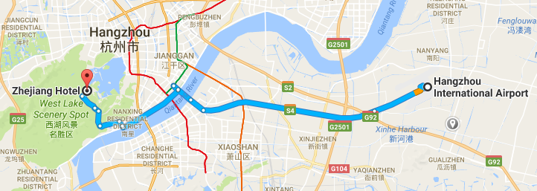

Transportation and site information
35 km to Xiao Shan International Airport; 10 km to the railway station; 20 km to the south railway station; 0 km to the West Lake.

Passports and Visas
All foreign visitors entering China must have a valid passport. Visitors from countries whose citizens require a visa should apply for a visa at a Chinese Embassy or consulate as early as possible and well in advance of travel.
For an invitation letter, please see Annex E.

Climate (end of May in Hangzhou)
Monthly average values of the temperature and precipitation in Hangzhou are given in the table below:
 | May
Average max temperature | 25C / 77F
Average minimum temperature | 17C / 63F
Average precipitation | 157 mm

Hotels
In addition to the hotel venue, Zhejiang Hotel, (see item 1 above) other close hotels are:
5.1 Hangzhou Sunday Sunny Resort
http://www.hzstsz-hotel.com
Hotel Reservations：+86-571-87975888
Address: No.200 Santaishan Road, Hangzhou, Zhejiang, China
The distance from Hangzhou Sunday Sunny Resort to the meeting venue is approximately 0.5 km.
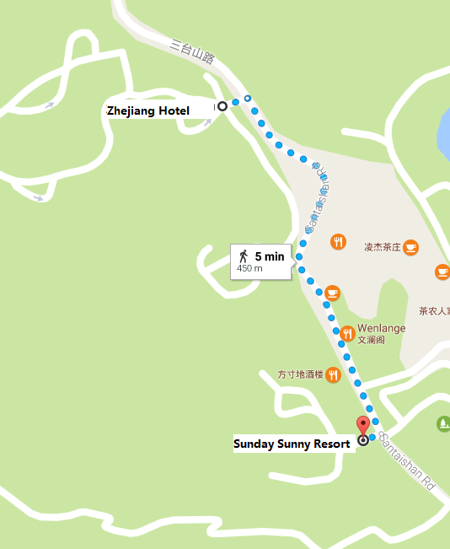

5.2 West Lake State Guest Hotel
http://www.xihusgh.com
Hotel Reservations：+86-571-87979889
Address: 18th Yanggongti Road, Hangzhou, Zhejiang, China
The distance from West Lake State Guest Hotel to the meeting venue is approximately 2 km.
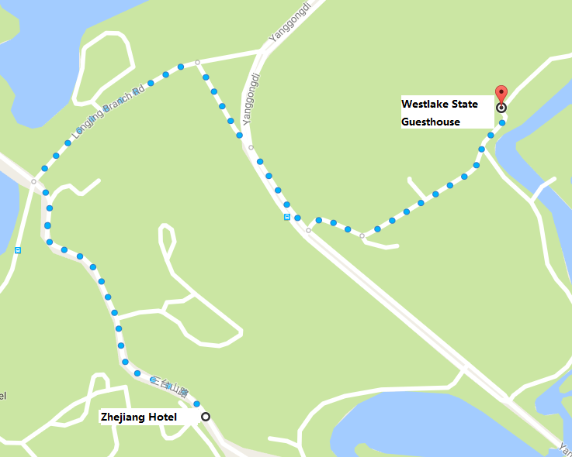

Internet access and wireless coverage at the venue
All meeting rooms will have a wireless network with access to the Internet. Every guest room offers high-speed Internet access free of charge. Internet access will be provided using the LAN technologies listed below:
Wireless via Wi-Fi: IEEE 802.11a/n on 5.2 GHz and 802.11g/n on 2.4 GHz.

Technical assistance
In case you have any technical problem at the venue (e.g., connecting to Internet, finding meeting rooms, etc.) please contact for help:
Mr Luo Xinqi: +86 13588774554 luoxq@wasu.com

Electricity
The electricity in China is generally 220V, 50 Hz. Please make sure you have the proper adapter.
Chinese standard
Such a socket is common in China, Australia, New Zealand and many other countries.

Currency exchange

The currency in China is the RMB Yuan (￥), the exchange rate of US$ and RMB is around 6.878. Please check the currency exchange rate in the local bank system or use the following link as a reference: http://www.xe.com/

Additional information
10.1 Mobile phone: GSM and CDMA, WCDMA, TD-SCDMA, TD-LTE services provided by China Mobile, China Unicom and China Telecom.
10.2 Tipping: Tipping is not necessary.
10.3 Time Zone: GMT+8:00.
10.4 Emergency Number: In case of emergency, please dial 110.
10.5 Sightseeing: For more information see http://en.gotohz.com/

Contact person
Mr OUYANG Feng: +86 13511029034 (ouyangfeng@abs.ac.cn)

ANNEX E

INVITATION LETTER REQUEST FORM
All foreign visitors entering China must have a valid passport. Visitors from countries whose citizens require a visa should apply for a visa at a Chinese Embassy or Consulate as early as possible and well in advance of travel. You may need a letter of invitation from the Chinese host, which you will need to present to the Chinese Embassy/Consulate in your area in order to obtain your visa. The visa must be requested as soon as possible and at least one month before the start date of the meeting and obtained from the office (Embassy or Consulate) representing China in your country or, if there is no such office in your country, from the one that is closest to the country of departure. In order to obtain an invitation letter, please:
- Fill out the form below
- Provide an electronic copy of your passport (name, date of birth, nationality, passport number, expiration date of passport, etc., must be seen clearly)
- Provide the electronic copy of previous Chinese visas and records (if you have been to China before)
- Send the info in a), b) and c) as email attachments to gebing@abs.ac.cn and ouyangfeng@abs.ac.cn ; please mark as reference in the subject “Invitation letter request for ITU-T SG9 meeting (24-31 May 2017).
(It is recommended to scan your passport and e-mail it to us so that it is discernible and can be used).
Company
Applicant Information |  |  |  | Mr Miss Ms Mrs
 |  |  |  | Date of birth :
 |  |  |  | Place of Issue:
 | Date of Issue: |  |  | Date of Expiry:
 | Marital Status:
 | If the country in which you'll obtain your visa is different from your nationality, please indicate it here:
Address | Telephone Number:  Fax Number:  E-mail:
Note
Date of arrival in China |  |  | Date of departure from China
(Please do not forget to attach a copy of your passport photograph page before sending.)
In order to receive an invitation letter, your request should reach the host before 24 April 2017.
ANNEX F
EXHIBITORS’ REQUIREMENT FORM
(Note: Please complete and return to ouyangfeng@abs.ac.cn by 15 April 2017 to reserve a booth. Considering the limited space and options, all participants should provide their own computers and storage, and please keep them to a minimum.)

Company Name | Contact person including contact details | E-mail address

Type of equip. to be displayed

Item(s) required | Description | Quantity
Tables
Chairs
Flat Screens
Network switch
Power supply
Space required
Panels
Power consumption expected for equipment:
Dimension, weight of equipment
Additional notes
(if any)

______________

