International telecommunication union
Telecommunication Standardization Bureau
 |  |  | Geneva, 8 September 2017
Ref: | Corrigendum 1 to  TSB Collective letter 3/11  SG11/DA |  | - To Administrations of Member States of the Union;  - To ITU-T Sector Members;  - To ITU-T Associates of Study Group 11;  - To ITU Academia
Tel: | +41 22 730 5780
Fax: | +41 22 730 5853
Email: | tsbsg11@itu.int
Web: | http://itu.int/go/tsg11
Subject: | Meeting of Study Group 11; Geneva, 8-17 November 2017
Dear Sir/Madam,

Please be informed that the JCA-IMT2020 meeting was moved to Friday, 10 November from 16:00 to 17:30.
A Bridging the Standardization Gap (BSG) hands-on training session will be held alongside the SG11 meeting.
It is tentatively planned for 8 November.
The sessions of the CASC meeting scheduled on 15 November 2017 have been cancelled. The CASC meeting will take place on 9 November 2017 (sessions 1, 2 and 4).
Further enhancements to the time plan will be published as a revision to TD175/GEN on the Study Group 11 website.
I wish you a productive and enjoyable meeting.
Yours faithfully,  Chaesub Lee  Director of the Telecommunication  Standardization Bureau | 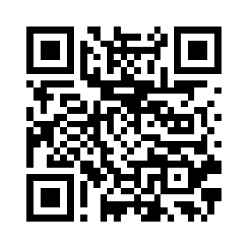
 | Latest meeting information

