|  |  |  |  |  |
| --- | --- | --- | --- | --- |
| itu_logo | | **International telecommunication union**  **Telecommunication Standardization Bureau** | |  |
|  | | | Geneva, 28 February 2017 | |
| Ref: | **Addendum 1 to**  **TSB Collective letter 1/SG11RG-AFR**  **TSB Collective letter 1/SG13RG-AFR** | | - To Administrations of Member States of the Union;  - To ITU-T Sector Members;  - To ITU-T Associates participating in the work of Study Groups 11 & 13;  - To the African Telecommunications Union;  - To the ITU Regional Office for the Africa Region;  - To the ITU Regional Office for the Arab Region;  - To the League of Arab States | |
| Tel: | +41 22 730 5126/5780 | |
| Fax: | +41 22 730 5853 | |
| E-mail: | [tsbsg11@itu.int](mailto:tsbsg11@itu.int); [tsbsg13@itu.int](mailto:tsbsg13@itu.int) | |
|  |  | |  | |
| Subject: | **Meetings of ITU-T Study Group 11 Regional Group for Africa (SG11RG-AFR), Study Group 13 Regional Group for Africa (SG13RG-AFR) and** **Bridging the Standardization Gap (BSG) Hands-on Training; Cairo, Egypt, 2-6 April 2017** | | | |

Dear Sir/Madam,

1 As stated in Collective letter 1/SG11RG-AFR and Collective letter 1/SG13RG-AFR of 3 February 2017, please find herewith additional information related to the meetings of ITU-T Study Group 11 Regional Group for Africa (SG11RG-AFR), Study Group 13 Regional Group for Africa (SG13RG-AFR) and Bridging the Standardization Gap (BSG) Hands-on Training, which will be held in Cairo, Egypt from 2 to 6 April 2017.

2 Practical information as provided by the host organization is given in **Annex 1**.

Yours faithfully,

Chaesub Lee  
Director of the Telecommunication  
Standardization Bureau

**Annex**: 1

|  |  |  |
| --- | --- | --- |
| itu_logo | **ANNEX 1**  (to Addendum 1 to  TSB Collective letter 1/SG11RG-AFR  TSB Collective letter 1/SG13RG-AFR)  ITU-T SG11 and SG13 Regional Groups for Africa meetings and workshops  Practical InformationUntitled for Participants | C:\Users\demoulin\AppData\Local\Microsoft\Windows\Temporary Internet Files\Content.Word\NTRA Logo 2016 CMYK.PNG |

**Venue**

# Novotel Cairo Airport

**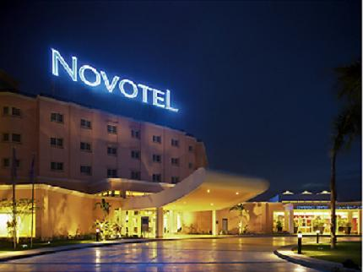**

# Untitled

Address: Cairo Airport Road, Heliopolis, 11776 Cairo, Egypt

Tel.:   +202 22918520

E-mail:  [H0502-SL2@accor.com](mailto:H0502-SL2@accor.com)

This upscale, modern hotel is near Cairo International Airport.

**Visa requirements and entry formalities**

A valid passport and a visa are required to enter Egypt. All participants are requested to send a copy of their passport together with the Registration Confirmation message from ITU to the Egyptian Embassy or Consulate in their country of origin or residence in order to obtain a visa.

Participants who are nationals of countries where there is no Egyptian representation should contact Mr Basel El-Tabei via e-mail: [Beltabie@tra.gov.eg](mailto:Beltabie@tra.gov.eg) or landline: +20235344261 for the special arrangements that have been made by the host country to facilitate the delivery of visas or entry permits, as required.

For more information on visas and entry permits, please visit the website of Egypt’s Ministry of Foreign Affairs at: <http://www.mfa.gov.eg/English/Embassies/Pages/Listing.aspx>.

**Vaccinations**

For information about vaccination requirements and health information for travelers, please consult the World Health Organization’s (WHO) website at:

<http://www.who.int/countries/egy/en/>.

**Transportation**

Transport from the venue to the hotels and vice versa will be provided by NTRA to all participants.

It is very important that participants send their exact hotel information to Mrs Maha Badr via e‑mail: [mahab@tra.gov.eg](mailto:mahab@tra.gov.eg) or landline: +20235344108.

A pick-up from and to the airport **is not provided** by the host. Local transportation can be found at the airport with reasonable fares.

**Accommodation**

Special rates have been negotiated with Novotel Cairo Airport Hotel (Venue) for the meeting participants.

Participants should book their own accommodation directly with the contact person mentioned below and must copy the National Telecommunication Regulatory Authority (NTRA), Mrs Noha Nashaat, via e-mail: nohan@tra.gov.eg when making their booking.

**Hotel list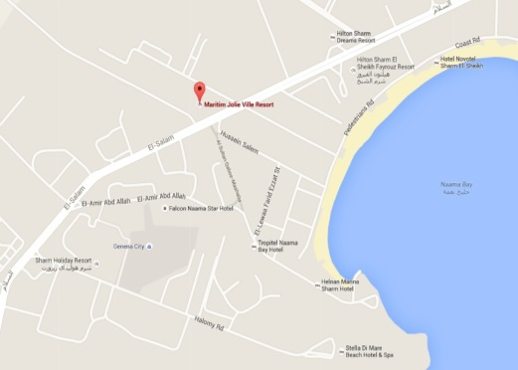**

The negotiated rates below are for bed and breakfast (taxes and service charges are included):

|  |  |  |  |  |  |
| --- | --- | --- | --- | --- | --- |
| **#** | **Name of hotel** | **Star rating** | **Single (USD)** | **Double (USD)** | **Contact person** |
| 1 | Novotel Cairo Airport (Venue) | 4 | Standard Room  70 | Standard Room  80 | **Mr Hisham Ramadan**| Sales Manager  NOVOTEL CAIRO AIRPORT  Mobile: +2 (010) 66624054  Reservation Direct: +2 (02)22 69 67 14  Bus: +2 (011) 47404400  [h0502-sl2@accor.com](mailto:h0502-sl2@accor.com)  [novotel.com](http://www.novotel.com/)  [accorhotels.com](http://www.accorhotels.com/gb/middle-east/index.shtml) |
| Superior Room  85 | Superior Room  95 |
| 2 | Le Passage Hotel & Casino | 5 | 47 | 60 | Through [www.booking.com](http://www.booking.com) |
| 3 | Le Méridien Cairo Airport | 5 | 145 | 195 | Through [www.booking.com](http://www.booking.com) |

**Good to know**

**About Cairo**

Cairo, Egypt’s sprawling capital, is set on the Nile River. At its heart is Tahrir Square and the vast Egyptian Museum, a trove of antiquities including the royal mummies and gilded King Tutankhamun artefacts. Nearby, Giza is the site of the iconic pyramids and Great Sphinx, dating to the 26th century B.C.E. In Gezira Island’s leafy Zamalek district, the 187m Cairo Tower affords panoramic city views.

**Weather**

In April, average temperatures in Cairo range between 13°C and 29°C. There are 10 hours of sunshine a day. The expected temperatures during the ITU-T SG11 and SG13 Regional Groups for Africa meetings are:

|  |  |  |  |  |
| --- | --- | --- | --- | --- |
| 2 April 2017 | 3 April 2017 | 4 April 2017 | 5 April 2017 | 6 April 2017 |
| Average  High: 29°C  Low: 11°C | Average  High: 25°C  Low: 12°C | Average  High: 25°C  Low: 10°C | Average  High: 24°C  Low: 13°C | Average  High: 28°C  Low: 13°C |

**Time zone**

The Arab Republic of Egypt is on Eastern Europe Time – Greenwich Mean Time (GMT) plus 2 hours.

**Currency and banking**

The official currency of Egypt is the Egyptian Pound (EGP). Visa, American Express, Access/MasterCard can be used. Banks are open from Sunday to Thursday, from 8.30 a.m. to 2.00 p.m. The exchange rates in Egypt can be found at the below link:

<http://www.cbe.org.eg/en/EconomicResearch/Statistics/Pages/ExchangeRatesListing.aspx>

**Electricity**

AC power voltage in Egypt is 220V, frequency ~50Hz. Most electrical outlets are as shown below.

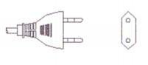

**Important telephone numbers**

|  |  |
| --- | --- |
| General emergency | 112 |
| Fire Department | 180 |
| Ambulance | 123 |
| Police | 122 |

**Host country contact**

**Mrs Shahira Selim**

Senior Manager, ITU Affairs, International Relations Department

The National Telecom Regulatory Authority (NTRA), Egypt

Tel: +20 2 35344259, Fax: +20 2 35344155, E-mail: [shahiras@ntra.gov.eg](mailto:basmaa@ntra.gov.eg)

\_\_\_\_\_\_\_\_\_\_\_\_\_\_\_\_\_\_