International telecommunication union
Telecommunication Standardization Bureau
 |  |  | Geneva, 23 September 2019
Ref: | Addendum 1 to  TSB Collective letter 9/13  SG13/TK |  | - To Administrations of Member States of  the Union;  - To ITU-T Sector Members;  - To ITU-T Associates of Study Group 13;  - To ITU Academia
Tel: | +41 22 730 5126
Fax: | +41 22 730 5853
E-mail: | tsbsg13@itu.int
Web: | http://itu.int/go/tsg13
Subject: | Meeting of ITU-T Study Group 13; Geneva, 14-25 October 2019
Dear Sir/Madam,
I wish to inform you that draft new Recommendation ITU-T Y.3800 “Framework for Networks supporting
Quantum Key Distribution”, received comments during the Additional Review period of AAP-65, dated
1 September 2019.
The comments resolution for this Recommendation is still in progress and since a planned study group meeting is sufficiently close, the Chairman of Study Group 13, in consultation with TSB, took the decision to consider this draft Recommendation for approval at the 14-25 October 2019 Study Group 13 meeting in Geneva, in accordance with Recommendation ITU-T A.8, § 4.5.2. This status will appear in the AAP announcement TSB AAP-67 of 1 October 2019. Corresponding documentation is available in TDs 287 – 290/WP3/13.
I wish you a productive and enjoyable meeting.
Yours faithfully,  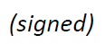  Chaesub Lee  Director of the Telecommunication  Standardization Bureau | 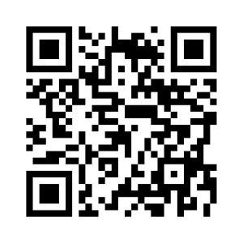 ITU-T SG13
 | Latest meeting information

