International telecommunication union
Telecommunication Standardization Bureau
 |  |  | Geneva, 5 June 2018
Ref: | Addendum 1 to  TSB Collective letter 4/16  SG16/SC |  | - To Administrations of Member States of the Union;  - To ITU-T Sector Members;  - To ITU-T Associates of Study Group 16;  - To ITU Academia
Tel: | +41 22 730 6805
Fax: | +41 22 730 5853
Email: | tsbsg16@itu.int
Web: | http://itu.int/go/tsg16
Subject: | Meeting of Study Group 16; Ljubljana, 9-20 July 2018
Dear Sir/Madam,

Please be informed that, as announced by TSB Circular 95, an ITU Workshop on “Multimedia applications and the future of digital society” will take place on Monday 9 July 2018 in Ljubljana in conjunction with the meeting of Study Group 16 to be held in Ljubljana, Slovenia, 9-20 July 2018. All information pertaining to the workshop can be found on its webpage at https://itu.int/en/ITU-T/Workshops-and-Seminars/20180709.
Accordingly, the opening plenary of the Study Group 16 meeting will take place on Tuesday 10 July 2018 from 0900 to 1015 hours, instead of Monday 9 July, to allow all delegates to attend this interesting workshop.
Referring to visa procedures, and in particular, for those participants that need an invitation letter form, please see the updated link as follows: http://www.kcmweb.de/conferences/uploads/conferences/Ljubljana/‌Visum%20MPEG%20123%20ITU%20SG16.doc.
Delegates are reminded that further enhancements to the SG16 time plan will be shortly available in the Study Group 16 website at http://itu.int/go/tsg16.
I wish you a productive and enjoyable meeting.
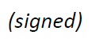  Yours faithfully,  Chaesub Lee  Director of the Telecommunication  Standardization Bureau | 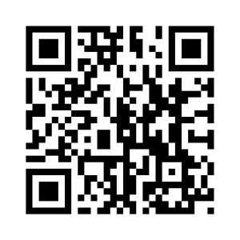ITU-T SG16
 | Latest meeting information

