International telecommunication union
Telecommunication Standardization Bureau
 |  |  | Geneva, 15 May 2020
Ref: | Corrigendum 1 to TSB Collective letter 9/16  SG16/SC |  | - To Administrations of Member States of  the Union;  - To ITU-T Sector Members;  - To ITU-T Associates of Study Group 16;  - To ITU Academia
Tel: | +41 22 730 6805
Fax: | +41 22 730 5853
E-mail: | tsbsg16@itu.int
Web: | http://itu.int/go/tsg16
Subject: | Meeting of ITU-T Study Group 16; fully virtual meeting, 22 June – 3 July 2020
Dear Sir/Madam,
Worldwide restrictions on travel and personal movement have been imposed due to the COVID-19 pandemic. This required extraordinary measures to be taken that also affect the meeting of Study Group 16 (Multimedia coding, systems and applications) originally announced to take place in Geneva, from 22 June to 3 July 2020 inclusive. In agreement with the SG16 Chairman and its management team, I wish to inform you that Study Group 16 will meet as a fully virtual meeting (no physical presence) on the same dates as originally announced.
The other collocated meetings mentioned in Collective 9/16 will also be virtual.
SG16 Management and TSB will develop an updated timetable, specially adapted to virtual meetings that will strive to minimize the impact of time difference amongst remote participants.
Additionally, no fellowships will be offered and, due to operational issues, the entire meeting (including the closing plenary) will be run only in English.
Please note that registration is mandatory (online at https://itu.int/go/tsg16/reg). Participation in the sessions will only be possible for registrations approved by the respective focal point.
All applicable deadlines remain unchanged as announced in Collective 9/16 and found for easier reference in the ITU-T SG16 website.
I wish you a safe, productive and enjoyable meeting.
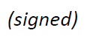  Yours faithfully,  Chaesub Lee  Director of the Telecommunication  Standardization Bureau | 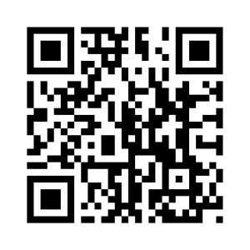ITU-T SG16
 | Latest meeting information

