|  |  |  |
| --- | --- | --- |
|  | **国 际 电 信 联 盟**  **电信标准化局** |  |

2017年1月25日，日内瓦

|  |  |  |
| --- | --- | --- |
| 文号： | **电信标准化局第1/20号集体函补遗1** | 致：  – 国际电联各成员国主管部门；  – ITU-T部门成员，  – 参加第20研究组工作的ITU-T部门准成员和  – 国际电联学术成员 |
| 电话： | +41 22 730 6301 |
| 传真： | +41 22 730 5853 |
| 电子邮件： | [tsbsg20@itu.int](mailto:tsbsg20@itu.int) |  |

|  |  |
| --- | --- |
| 事由： | **ITU-T第20研究组的会议，2017年3月13-23日，迪拜** |

尊敬的先生/女士：

继2016年12月15日的第1/20号集体函后，谨在此函后附上与将在2017年3月13至23日在迪拜举行的ITU-T第20研究组会议有关的更多信息。

上述第20研究组会议前夕的2017年3月12日，将召开“数据管理：化数据为价值”的论坛。物联网及智慧城市和社区联合协调活动（JCA-IoT and SC&C）也将于2017年3月16日下午在同一会址召开会议。

上述三项活动将在迪拜Meridien酒店和会议中心举行。

祝您与会愉快并富有成效。

顺致敬意！

电信标准化局主任  
李在摄

**附件：**1件

**Annex 1  
Le Meridien Dubai Hotel & Conference Centre**

**PRACTICAL INFORMATION**

## Meeting Venue

**Le Meridien Dubai Hotel & Conference Centre**<http://www.lemeridien-dubai.com/>

Airport Road, Dubai, UAE  
Contact: [sales.lmdubai@lemeridien.com](mailto:sales.lmdubai@lemeridien.com), Meeting Specialist, ‎(971)(4) 217 0000

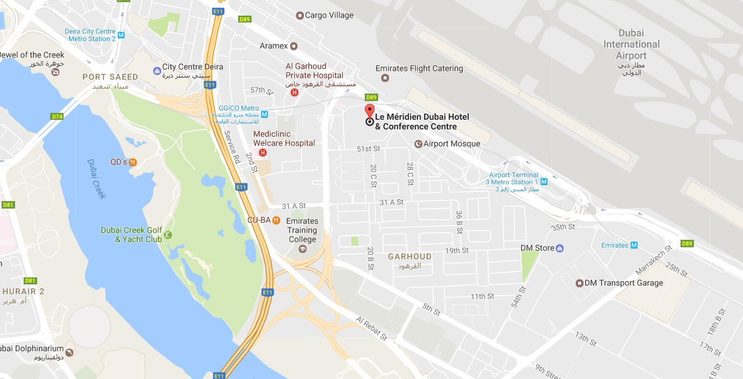

## Transportation and site information

**Transportation:**

## The venue is approximately 2 km (or about 5 minutes by car) from Dubai International Airport.

Taxis:

## Public taxis are readily available at all terminals at Dubai International Airport.

## All taxis are metered. Fares must be charged according to the taxi meter, plus applicable surcharges. More information can be found here: <http://www.dubaiairports.ae/before-you-fly/to-from-the-airport/by-taxi>

## Passports and Visas

A valid passport is required to enter the United Arab Emirates. Participants who require an entry visa are strongly advised to send, **by 26 February 2017**, a clear scanned electronic copy (PDF format) of a passport valid for at least six months prior to the date you plan to enter the UAE to   
Mr Saeed Al Warani ([saeed.alwarani@tra.gov.ae](mailto:saeed.alwarani@tra.gov.ae)) and copy ([sg20visa@tra.gov.ae](mailto:sg20visa@tra.gov.ae)) in order to assist you in issuing the entry visa.

Please note that the host country will not ensure any request for an entry visa and no requests will be accepted after 26 February 2017.

## Climate in March

The UAE enjoys very pleasant weather during its winter months, from October to April. The rest of the year, temperatures are in the low to mid-40º range. Lightweight summer clothing can be worn for most of the year but temperatures can drop quite sharply at night during the period from November to March.

Monthly average values of the temperature and precipitation in Dubai are given in the table below:

|  |  |
| --- | --- |
|  | March |
| Average Max Temperature | 27http://www.travelchinaguide.com/images/c-words/degree.gifC / 81http://www.travelchinaguide.com/images/c-words/degree.gifF |
| Average Minimum Temperature | 17http://www.travelchinaguide.com/images/c-words/degree.gifC / 63http://www.travelchinaguide.com/images/c-words/degree.gifF |
| Sunshine hours | 9 hours |
| Average Precipitation | 10 mm |

<http://www.holiday-weather.com/dubai/averages/march/>

## Hotels

Kindly be advised that it is recommended for participants to reserve their hotel accommodations via telephone, fax or e-mail directly with the hotels of preference. Please note that participants are requested to contact the hotels for hotel rates and booking is subject to availability. For any assistance with hotel bookings please contact:

Mr Mohamed Samaneh

Holidays Consultant, UAE

Tel: +971 2 6277997 Ext: 248

Mob: +971 569907314

Fax: +971 2 6277993

E-mail: [m.samaneh@ntravel.ae](mailto:m.samaneh@ntravel.ae)

## Internet access and wireless coverage

Internet Access free of charge will be available in the event’s meeting room.

## Electricity

In the United Arab Emirates the power sockets are usually type G. The standard voltage is 220/240 volts and the standard frequency is 50 Hz.

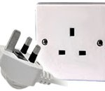

## Useful information

*Currency exchange*

The name of the currency in the United Arab Emirates is the dirham (AED or Arab Emirate Dirham – also commonly abbreviated to Dhs or DH). Notes come in denominations of 5, 10, 20, 50, 100, 200, 500 and 1,000 dirhams.

# Online exchange rates are shown at: <http://www.xe.com/>

Exchange rate as of 24 January 2017:

|  |  |
| --- | --- |
| US Dollar: 1$ | 3.67 AED |
| Euro: 1€ | 3.94 AED |

All banks operate from 8.00 am to 1.00 pm, Saturday through Wednesday; and 8.00 am to 12.00 pm on Thursdays. Currency exchange houses are open until late in the evening. All international credit and debit cards are widely accepted.

*Communication*

The telephone network operated by the national telecommunication organizations ETISALAT and DU is superb. The international dialing code for the UAE is +971. Discount rates for international direct calls apply from 9.00 pm to 7.00 am, and all day on Fridays and public holidays. There is a complete list of rates on the back of each telephone directory.

Here are some useful contacts to have at your fingertips while you are in the UAE:

* Police: 999
* Ambulance: 998
* Fire: 997
* Telephone Directory Enquiries: 181

## About the UAE

The United Arab Emirates is a constitutional federation of seven emirates: Abu Dhabi, Dubai, Sharjah, Ajman, Umm al-Qaiwain, Ras al-Khaimah and Fujairah. The federation was formally established on 2 December 1971.

The United Arab Emirates (UAE) occupies an area of 83,600 km2 along the south-eastern tip of the Arabian Peninsula. Qatar lies to the west, Saudi Arabia to the south and west, and Oman to the north and east. The capital and the largest city of the federation, Abu Dhabi, is located in the emirate of the same name. Four-fifths of the UAE is desert, yet it is a country of contrasting landscapes, from awe-inspiring dunes to rich oases, precipitous rocky mountains to fertile plains. The United Arab Emirates, one of the world's fastest-growing tourist destinations, has all the right ingredients for an unforgettable holiday: sun, sand, sea, sports, unbeatable shopping, top-class hotels and restaurants, an intriguing traditional culture, and a safe and welcoming environment.

## General information

|  |  |
| --- | --- |
| Government | Federal Government |
| President | H.H Sheik Khalifa bin Zayed bin Sultan Al Nahyan |
| Prime Minister | H.H Sheik Mohammed Bin Rashid Al Maktoum |
| Area | 83,600 km2 |
| Population | 8,264,000 |
| Capital | Abu Dhabi |
| Official Language | Arabic |
| Country Code | +971 / .ae |
| Time Zone | GMT+4 |

## Contact persons

|  |  |
| --- | --- |
| **ITU Coordinator** | **Visa requests Coordinator** |
| Ms Cristina Bueti  ITU-T  Tel: +41 22 730 6301  Fax: +41 22 730 5853  E-mail: [tsbsg20@itu.int](mailto:tsbsg20@itu.int) | Mr Saeed Al Warani  TRA - UAE  E-mail: [saeed.alwarani@tra.gov.ae](mailto:saeed.alwarani@tra.gov.ae) |
|  | **Hotel reservations Coordinator** |
|  | Mr Mohamed Samaneh  Holiday Consultant, UAE  Tel: +971 2 6277997 Ext: 248  Mob: +971569907314  Fax: +97126277993  E-mail: [m.samaneh@ntravel.ae](mailto:m.samaneh@ntravel.ae) |

______________