Union internationale des télécommunications
Bureau de la Normalisation des Télécommunications
Genève, le 25 janvier 2017

Réf.: | Addendum 1 à la  Lettre collective TSB 1/20
Tél.: | +41 22 730 6301
Fax:  E-mail: | +41 22 730 5853  tsbsg20@itu.int | – Aux administrations des Etats Membres de l'Union;  – aux Membres du Secteur UIT-T;  – aux Associés de l'UIT-T participant aux travaux de la Commission d'études 20;  – aux établissements universitaires participant aux travaux de l'UIT
Objet: | Réunion de la Commission d'études 20; Dubaï, 13-23 mars 2017
Madame, Monsieur,
En complément de la Lettre collective 1/20 du 15 décembre 2016, vous trouverez ci-joint des informations complémentaires concernant la réunion de la CE 20 de l'UIT-T, qui se tiendra à Dubaï du 13 au 23 mars 2017.
La réunion de la CE 20 sera précédée d'un Forum sur le thème "Gestion des données: transformer les données en valeur", qui aura lieu le 12 mars 2017. Par ailleurs, une réunion de l'Activité conjointe de coordination sur l'Internet des objets et les villes et les communautés intelligentes (JCA-IoT et SC&C) se tiendra le 16 mars 2017 après-midi au même endroit.
Ces trois événements auront lieu au Meridien Dubai Hotel & Conference Centre.
Je vous souhaite des réunions constructives et agréables.
Veuillez agréer, Madame, Monsieur, l'assurance de ma considération distinguée.

Chaesub Lee
Directeur du Bureau de la
normalisation des télécommunications

Annexe: 1
Annex 1
Le Meridien Dubai Hotel & Conference Centre
PRACTICAL INFORMATION

Meeting Venue
Le Meridien Dubai Hotel & Conference Centre
http://www.lemeridien-dubai.com/
Airport Road, Dubai, UAE
Contact: sales.lmdubai@lemeridien.com, Meeting Specialist, ‎(971)(4) 217 0000
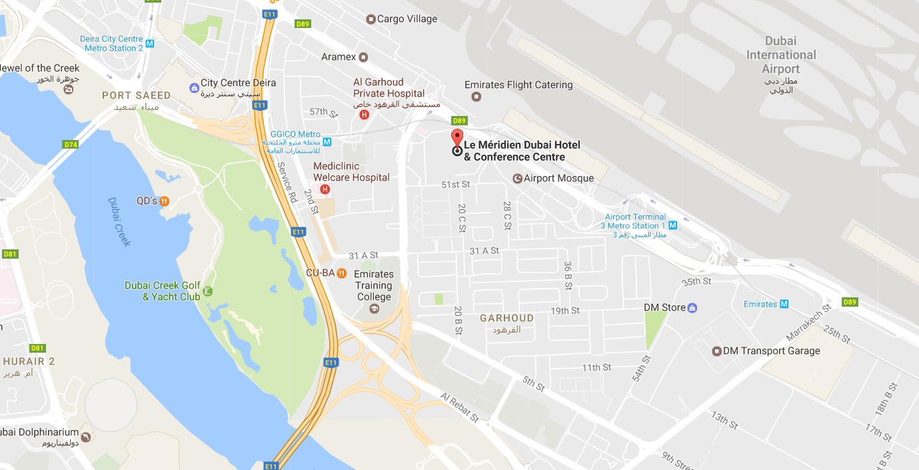

Transportation and site information
Transportation:

The venue is approximately 2 km (or about 5 minutes by car) from Dubai International Airport.
Taxis:

Public taxis are readily available at all terminals at Dubai International Airport.

All taxis are metered. Fares must be charged according to the taxi meter, plus applicable surcharges. More information can be found here:
http://www.dubaiairports.ae/before-you-fly/to-from-the-airport/by-taxi

Passports and Visas
A valid passport is required to enter the United Arab Emirates. Participants who require an entry visa are strongly advised to send, by 26 February 2017, a clear scanned electronic copy (PDF format) of a passport valid for at least six months prior to the date you plan to enter the UAE to
Mr Saeed Al Warani (saeed.alwarani@tra.gov.ae) and copy (sg20visa@tra.gov.ae) in order to assist you in issuing the entry visa.
Please note that the host country will not ensure any request for an entry visa and no requests will be accepted after 26 February 2017.

Climate in March
The UAE enjoys very pleasant weather during its winter months, from October to April. The rest of the year, temperatures are in the low to mid-40º range. Lightweight summer clothing can be worn for most of the year but temperatures can drop quite sharply at night during the period from November to March.
Monthly average values of the temperature and precipitation in Dubai are given in the table below:
 | March
Average Max Temperature | 27C / 81F
Average Minimum Temperature | 17C / 63F
Sunshine hours | 9 hours
Average Precipitation | 10 mm
http://www.holiday-weather.com/dubai/averages/march/

Hotels
Kindly be advised that it is recommended for participants to reserve their hotel accommodations via telephone, fax or e-mail directly with the hotels of preference. Please note that participants are requested to contact the hotels for hotel rates and booking is subject to availability. For any assistance with hotel bookings please contact:

Mr Mohamed Samaneh
Holidays Consultant, UAE
Tel: +971 2 6277997 Ext: 248
Mob: +971 569907314
Fax: +971 2 6277993
E-mail: m.samaneh@ntravel.ae

Internet access and wireless coverage
Internet Access free of charge will be available in the event’s meeting room.

Electricity
In the United Arab Emirates the power sockets are usually type G. The standard voltage is 220/240 volts and the standard frequency is 50 Hz.
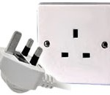

Useful information
Currency exchange
The name of the currency in the United Arab Emirates is the dirham (AED or Arab Emirate Dirham – also commonly abbreviated to Dhs or DH). Notes come in denominations of 5, 10, 20, 50, 100, 200, 500 and 1,000 dirhams.

Online exchange rates are shown at: http://www.xe.com/
Exchange rate as of 24 January 2017:
US Dollar: 1$ | 3.67 AED
Euro: 1€ | 3.94 AED
All banks operate from 8.00 am to 1.00 pm, Saturday through Wednesday; and 8.00 am to 12.00 pm on Thursdays. Currency exchange houses are open until late in the evening. All international credit and debit cards are widely accepted.
Communication
The telephone network operated by the national telecommunication organizations ETISALAT and DU is superb. The international dialing code for the UAE is +971. Discount rates for international direct calls apply from 9.00 pm to 7.00 am, and all day on Fridays and public holidays. There is a complete list of rates on the back of each telephone directory.
Here are some useful contacts to have at your fingertips while you are in the UAE:
- Police: 999
- Ambulance: 998
- Fire: 997
- Telephone Directory Enquiries: 181

About the UAE
The United Arab Emirates is a constitutional federation of seven emirates: Abu Dhabi, Dubai, Sharjah, Ajman, Umm al-Qaiwain, Ras al-Khaimah and Fujairah. The federation was formally established on 2 December 1971.
The United Arab Emirates (UAE) occupies an area of 83,600 km² along the south-eastern tip of the Arabian Peninsula. Qatar lies to the west, Saudi Arabia to the south and west, and Oman to the north and east. The capital and the largest city of the federation, Abu Dhabi, is located in the emirate of the same name. Four-fifths of the UAE is desert, yet it is a country of contrasting landscapes, from awe-inspiring dunes to rich oases, precipitous rocky mountains to fertile plains. The United Arab Emirates, one of the world's fastest-growing tourist destinations, has all the right ingredients for an unforgettable holiday: sun, sand, sea, sports, unbeatable shopping, top-class hotels and restaurants, an intriguing traditional culture, and a safe and welcoming environment.

General information
Government | Federal Government
President | H.H Sheik Khalifa bin Zayed bin Sultan Al Nahyan
Prime Minister | H.H Sheik Mohammed Bin Rashid Al Maktoum
Area | 83,600 km²
Population | 8,264,000
Capital | Abu Dhabi
Official Language | Arabic
Country Code | +971 / .ae
Time Zone | GMT+4

Contact persons
ITU Coordinator | Visa requests Coordinator
Ms Cristina Bueti  ITU-T  Tel: +41 22 730 6301  Fax: +41 22 730 5853  E-mail: tsbsg20@itu.int | Mr Saeed Al Warani  TRA - UAE  E-mail: saeed.alwarani@tra.gov.ae
 | Hotel reservations Coordinator
Mr Mohamed Samaneh
Holiday Consultant, UAE
Tel: +971 2 6277997 Ext: 248
Mob: +971569907314
Fax: +97126277993
E-mail: m.samaneh@ntravel.ae

______________

