International telecommunication union
Telecommunication Standardization Bureau
 |  |  | Geneva, 14 November 2018
Ref: | Addendum 1 to TSB Collective letter 5/20  SG20/CB |  | - To Administrations of Member States of the Union;  - To ITU-T Sector Members;  - To ITU-T Associates of Study Group 20;  - To ITU Academia
Tel: | +41 22 730 6301
Fax: | +41 22 730 5853
Email: | tsbsg20@itu.int
Web: | http://itu.int/go/tsg20
Subject: | Events in conjunction with the Meeting of Study Group 20; Wuxi, China, 3-13 December 2018
Dear Sir/Madam,
In addition to TSB Collective letter 5/20 of 29 June 2018, please find herewith additional information related to the ITU-T SG20 meeting to be held in Wuxi, China from 3 to 13 December 2018.
I would like to inform you that the Forum on “ArtificiaI Intelligence, Internet of Things and Smart Cities” will take place on 3 December from 0930 to 1500 hours. More details will be available on the Forum webpage.
The SG20 Opening Plenary will therefore take place from 1530 to 1730 hours and will be followed by an Information Session on "ITU-T Study Group 5 Activities on Environment, Climate Change and Circular Economy” from 1730 to 1830 hours.
The Joint Coordination Activity on Internet of Things and Smart Cities and Communities (JCA-IoT and SC&C) will also take place from 1400 to 1600 hours on 6 December 2018.
These websites will be regularly updated as new or modified information become available. Participants are requested to check periodically for new updates.
I wish you productive and enjoyable meetings.
Yours faithfully,  (signed)  Chaesub Lee  Director of the Telecommunication  Standardization Bureau | 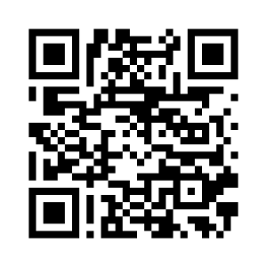
 | Latest meeting information

