International telecommunication union
Telecommunication Standardization Bureau
 |  |  | Geneva, 5 April 2019
Ref: | Corrigendum 1 to TSB Collective letter 6/20  SG20/CB |  | - To Administrations of Member States of the Union;  - To ITU-T Sector Members;  - To ITU-T Associates of Study Group 20;  - To ITU Academia
Tel: | +41 22 730 6301
Fax: | +41 22 730 5853
E-mail: | tsbsg20@itu.int
Web: | http://itu.int/go/tsg20
Subject: | Change of date for the Joint Coordination Activity on Internet of Things and Smart Cities and Communities (JCA-IoT and SC&C)
Dear Sir/Madam,
In addition to TSB Collective letter 6/20 of 28 January 2019, please find herewith information pertaining to a change of date and time for the Joint Coordination Activity on Internet of Things and Smart Cities and Communities (JCA-IoT and SC&C).
The Joint Coordination Activity on Internet of Things and Smart Cities and Communities (JCA-IoT and SC&C) will take place from 1630 to 1830 hours on 10 April 2019.
I wish you a productive and enjoyable meeting.
Yours faithfully,  (signed)  Chaesub Lee  Director of the Telecommunication  Standardization Bureau | 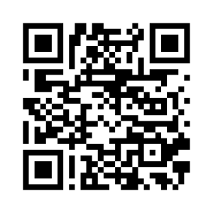
 | Latest meeting information

