International telecommunication union
Telecommunication Standardization Bureau
 |  |  | Geneva, 25 June 2019
Ref: | Addendum 1 to TSB Collective letter 7/20  SG20/CB |  | - To Administrations of Member States of the Union;  - To ITU-T Sector Members;  - To ITU-T Associates of Study Group 20;  - To ITU Academia
Tel: | +41 22 730 6301
Fax: | +41 22 730 5853
E-mail: | tsbsg20@itu.int
Web: | http://itu.int/go/tsg20
Subject: | Meeting of Study Group 20; Geneva, 25 November-6 December 2019
Dear Sir/Madam,
Further to Collective letter 7/20 of 17 May 2019, we would like to inform you that the following Work Item under AAP received comments during the Additional Review period and will be submitted for approval at the next meeting of ITU-T Study Group 20 (Geneva, 25 November-6 December 2019):
Draft New Recommendation ITU-T Y.4904 (ex Y.SSC-MM), Smart sustainable cities maturity model
(see TD1337).
I wish you a productive and enjoyable meeting.
Yours faithfully,  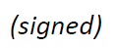  Chaesub Lee  Director of the Telecommunication  Standardization Bureau | 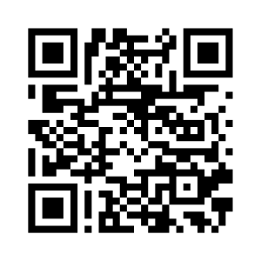
 | Latest meeting information

