|  |  |  |  |  |  |
| --- | --- | --- | --- | --- | --- |
| ITU Logo | INTERNATIONAL TELECOMMUNICATION UNION  **TELECOMMUNICATION STANDARDIZATION SECTOR**  STUDY PERIOD 2017-2020 | | TSAG-C0029 | | |
|  |  | | **TSAG** | | |
|  |  | | **Original: English** | | |
| **Question(s):** | | N/A | | Geneva, 26 February – 2 March 2018 | |
| **CONTRIBUTION** | | | | | |
| **Source:** | | FiberHome Technology Group | | | |
| **Title:** | | Strength standardization on IMT-2020/5G transport network and cooperation between SDOs | | | |
| **Purpose:** | | Proposal | | | |
| **Contact:** | | Xiang YUN | | | Tel:  Fax: +  E-mail: yunxig@fiberhome.com |
| **Contact:** | | Click here to enter text. | | | Tel:  Fax:  E-mail: |

|  |  |
| --- | --- |
| **Keywords:** | IMT-2020/5G transport, cooperation, standard developing organizations(SDO) |
| **Abstract:** | IMT-2020/5G transport network is one of the key factors of IMT-2020/5G network. Unified standardization should be set up in ITU-T. Continuous innovation for transport technology to meet the requirements of IMT-2020/5G services application and network evolution. Global opening ecosystem of IMT-2020/5G should be set up leading by ITU and 3GPP. This contribution proposes TSAG develop standard strategies of IMT-2020/5G core network and transport network standardization to corresponding ITU-T SGs. To improve the working efficiency of liaison activity, TSAG should setup management team to evaluate the IMT-2020/5G related liaisons activity of ITU-T SGs. It also proposes that TSAG send liaisons to other SDOs for extensive cooperation. |

# Introduction

With the IMT-2020/5G's commercial footsteps approaching, IMT-2020/5G network technology and services are increasingly becoming the focus of the industry. How to meet the requirements of IMT-2020/5G is a new challenge in the field of mobile transport network.

We think IMT-2020/5G is a revolution not only for mobile network but also in the whole ICT industry. At the beginning of 2G, it solved the rate problem of the wireless network. During 3G and 4G period, the mobile network rate is increasing from dozens of Kbit/s, hundreds of Kbit/s, several mega bit/s to hundreds mega bit/s. 5G will solve the speed problem which peak rate per user will be about 1Gb/s to 10Gb/s.

4G networks mainly solves the connection between people and people. 5G networks truly realize the interconnection of all things. It will set all in one with the unified interface and core network. All issues could be solved under one framework. 4G is facing the fast Ethernet interface while 5G will face 10G Ethernet interface. This is a great change and challenge.

IMT-2020/5G has a great increase in speed. The fronthaul speed is 25Gb/s. Service bandwidth of a base station is 3-5Gb/s. The midhaul and backhaul bandwidth will be N*100Gb/s. Low latency is becoming the selling point. Network of vehicles, VR, AR and industrial manufacture has more restrict requirements. IoT needs the transport speed is fast enough, the transport path can’t be too long and the node processing is very rapid.

The core competitiveness is setting up mesh connectivity, bandwidth and latency. Optical transport layer improves core performance and enhances routing forwarding function flexibility. Currently, the network slicing is at the exploratory stage. One slice or one wavelength for DU is attractive. 5G is not only the next generation of wireless communication technology, but also a revolution of information communication. 5G transport network is one of the key factors of 5G network and service development.

# Discussion

ITU-T should push the work in three ways to meet the requirements of IMT-2020/5G transport network for IMT-2020/5G commercial application.

* Firstly, the unified standardization should be set up.
* Secondly, continuous innovation for transport technology to meet the requirements of 5G services application.
* Thirdly, opening ecosystem of 5G should be set up.

As the deployment of mobile transport network should be 1-2 years early than wireless network and the whole industrial are looking forward to the commercial application of IMT-2020/5G, so IMT-2020/5G transport network should be capable to support commercial deployment.

The proposal of this contribution are the following notes to be considered:

* White paper on IMT-2020/5G transport network requirements and technical solutions should be issued by ITU-T SG15.
* Standard strategy should be issued by ITU-T TSAG, with the collaboration of SG13, SG15 and other related SGs.
* Cooperation between standard developing organizations (SDOs) should be enhanced to push new technology of IMT-2020/5G transport network. TSAG could send liaisons to other SDOs to encourage cooperation.

There are many technologies and international standards concerning IMT-2020/5G transport network. Figure 1 shows related technologies and standard organization. It suggests extensive cooperation between standard organizations, including 3GPP, IETF, IEEE, OIF, MEF, ITU-T and ONF.

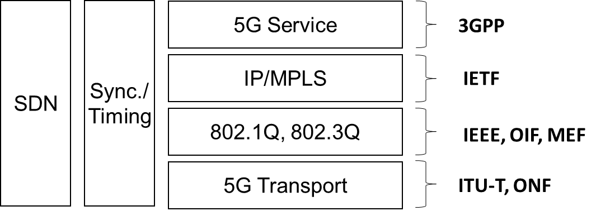

Figure 1 Cooperation between standard organizations

# Proposal

As leading organization of optical transport and access network standardization, ITU-T should has clear positioning in 5G transport technology. The detail standards working plan should be developed and discussed by ITU-T SG15, then reported to TSAG.

TSAG should push the working plan and check the progress of working plan in SGs. The following key check points are useful to check the progress of ITU-T.

1. If many sector members (including network operators and vendors) provide 5G transport requirements and technical solutions to ITU-T Study Group, ITU-T should discuss in detail and try best to get conclusion. No conclusion means low working efficiency. When facing competition from other standard organizations, ITU-T will loss core competitiveness in the global ecosystems.
2. The SG meeting report should have conclusion to avoid misleading the ITU members about the management team’s attitude and strategy on ITU-T’s 5G working program. It suggests that the ITU-T meeting report should be executable and checkable.
3. Among various SDOs, ITU-T should play the most important role in 5G transport technology. The 5G transport network recommendations issued by ITU-T should include network architecture, new technologies and operator’s requirements.

Based on the above discussion, our proposals are listed as following:

* It is recommended that ITU-T SG15 should develop white paper on IMT-2020/5G transport network to include the technology aspects mentioned above. Then TSAG could evaluates the white paper and update the IMT-2020 standard strategy.
* Corresponding SGs of ITU-T should report their working plans to TSAG regularly. TSAG should evaluate the IMT-2020/5G working report of ITU-T SGs.
* TSAG should provide strategy on IMT-2020/5G standardization to corresponding ITU-T SGs. The ITU-T’s IMT-2020/5G standard strategy should be shared among SGs.
* To improve the working efficiency of liaison activity, TSAG should setup management team to evaluate the IMT-2020/5G related liaisons activity among related ITU-T SGs.
* It also proposes that TSAG send liaisons to other SDOs to encourage extensive cooperation and setup opening standard ecosystem of IMT-2020/5G.

_______________________