|  |  |  |  |  |
| --- | --- | --- | --- | --- |
| ITU logo | INTERNATIONAL TELECOMMUNICATION UNION  **TELECOMMUNICATION STANDARDIZATION SECTOR**  STUDY PERIOD 2017-2020 | | TSAG-C033 | |
| **TSAG** | |
| **Original: English** | |
| **Question(s):** | | N/A | Geneva, 26 February-2 March 2018 | |
| **TD** | | | | |
| **Source:** | | India | | |
| **Title:** | | The importance of ITU-T Regional Groups in Bridging the Standardization Gap | | |
| **Purpose:** | | Proposal | | |
| **Contact:** | | Vinod Kotwal | | Email: [vinod.kotwal@nic.in](mailto:vinod.kotwal@nic.in) |
| **Contact:** | | Manish Gupta | | Email: [manishk.gupta81@nic.in](mailto:manishk.gupta81@nic.in) |

|  |  |
| --- | --- |
| **Keywords:** | WTSA-16 Resolution 44 |

**Introduction**

There are six regional groups of Study Group 3. From our experience of Asia-Oceania (AO) Region, we have seen that these regional groups provide a forum for exchange of views, determine regional priorities and build consensus for the overall success of the parent meeting. From the meeting reports of the other regional groups of SG3, it is evident that it is being done in all other regions of the world too. All these means should be encouraged by TSAG and different ITU bodies. Res.54 of WTSA 16also resolved to support on a case by case basis the coordinated creation of regional groups and to encourage cooperation and collaboration of regional groups with regional standardization entities (regional organizations, regional standardization bodies, and so forth). It also invited to create regional standardization bodies, joint meetings of regional groups.

With the rapidly changing technological environment, it is important to maximize the opportunities to collaborate and build consensus. Regional groups of ITU-T SG3 for example enabled wider participation in decision-making. SG3 parent meeting received written contributions from more than 70 Members to make it the most diverse Group in ITU-T.

**Role of ITU-T Regional Groups**

Regional Groups within ITU-T Study Groups have proven effective mechanisms to assist in bridging the standardization gap by stimulating effective participation in ITU-T Study Groups and increasing the number and quality of contributions from developing countries that could eventually lead to standards.

The ITU-T SG3 Regional Group for AO (SG3 RG-AO) has been quite active in shaping international standardization-making through an increase in the number and quality of written contributions from AO members to Study Group 3 parent meetings in Geneva. In the last meeting of SG3 AO held in Seoul in October 2017, nine contributions were sent for the main SG3 meeting. Among the key topics for discussions in the forthcoming meetings, AO group is actively involved in the MFS, economic and policy issues of big data, guidelines for digital identity, trans-multi country terrestrial circuits, IoT & M2M etc. It is also important to note that ITU-T SG3 Regional Group for AO (SG3 RG-AO) was one of the first Regional Groups that was created in 1968 by the IVth Plenary Assembly of the CITT together with the Regional Groups for Latin America, Africa and Europe.

**Bridging the Standardization efforts**

The close collaboration between the Management team of the Regional groups and the TSB secretariat for SG3 has enabled the implementation of BSG activities. Since the Sao Tome and Principe meeting, interactive hands-on session delivered by the Counsellor on working methods, drafting and presenting contribution have been implemented together with one-to-one coaching sessions. These efforts combined with a new Regional model for effective participation are leading to growth of the quantity of contributions from the AO region over a period of time.

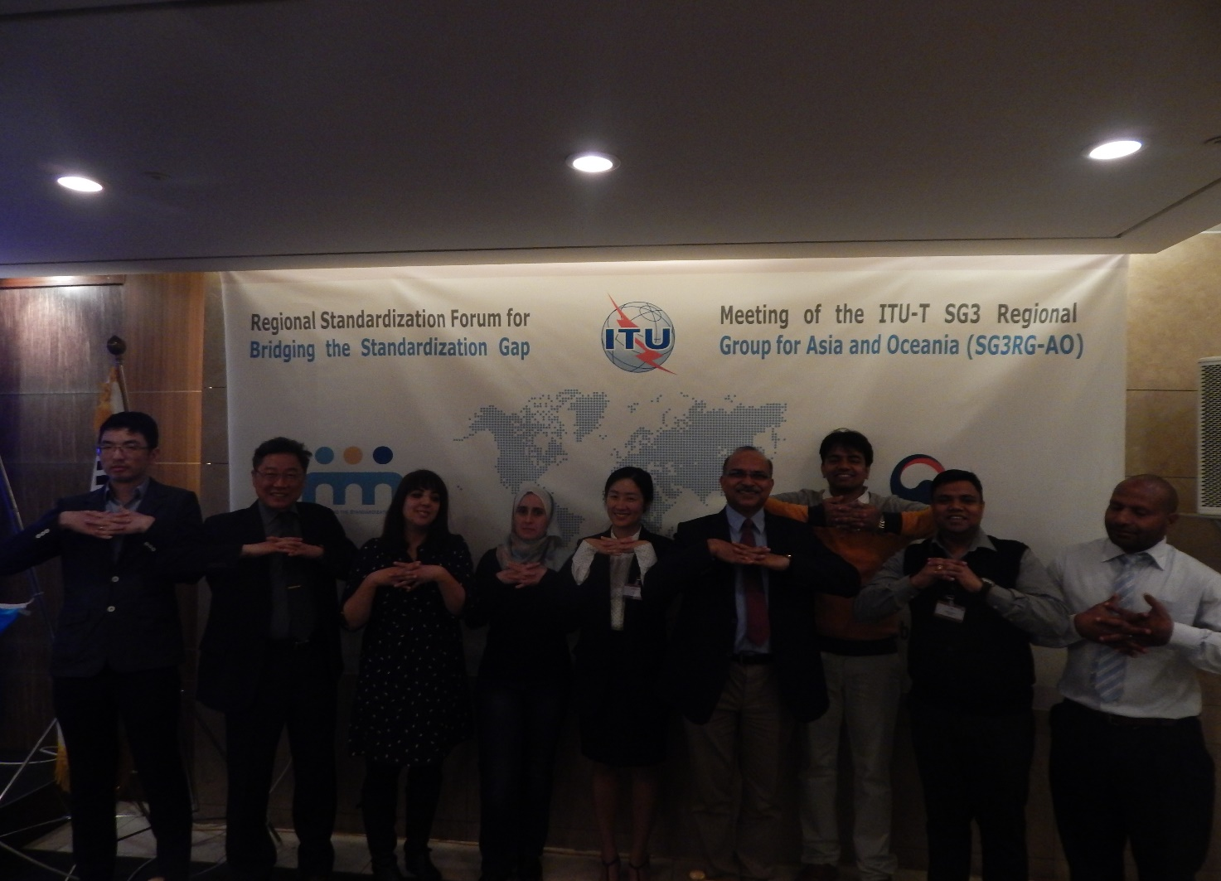

These efforts carried over the past 4 years enabled SG3 to become the most diverse group in ITU-T and to play its role of strengthening the ties between technology, business and policy

**Proposal**

It is proposed to TSAG to invite Chairmen of ITU-T Study Groups to disseminate information i.e. TDs to their respective SG members on the history and importance of Regional Groups in Bridging the Standardization Gap.

It is also requested to TSAG to recognize the unique nature of the pioneer regional groups of ITU-T SG3, in term of their long history, size, diversity, effective participation and ensure the allocation of appropriate/ proportionate support and resources. It is important to acknowledge that the success of SG3 RG under Res. 26 led to the genesis and the evolution of WTSA Resolutions 54 and 44.

__________________