|  |  |  |  |  |  |
| --- | --- | --- | --- | --- | --- |
| ITU Logo | INTERNATIONAL TELECOMMUNICATION UNION  **TELECOMMUNICATION STANDARDIZATION SECTOR**  STUDY PERIOD 2017-2020 | | TSAG-C59 | | |
| **TSAG** | | |
| **Original: English** | | |
| **Question(s):** | | N/A | | Geneva, 10-14 December 2018 | |
| **CONTRIBUTION** | | | | | |
| **Source:** | | Russian Federation | | | |
| **Title:** | | IPR transparency for Recommendations on the ITU web-site and at the meetings | | | |
| **Purpose:** | | Proposal | | | |
| **Contact:** | | Dmitry Cherkesov Russian Federation | | | Tel: +7 985 239 06 00 E-mail: [dcherkesov@gmail.com](mailto:dcherkesov@gmail.com) |

|  |  |
| --- | --- |
| **Keywords:** | Web-site; Recommendation; transparency; EWM; |
| **Abstract:** | It is proposed some enhancements of ITU-T EWM for transparency of IPR information when presenting/downloading ITU-T Recommendations and Draft Recommendations from ITU web-site. |

**Introduction**

In ITU Recommendations, a special place is given to intellectual property rights and patent statements. All claimed intellectual property rights (patent statements) contained in developed, adopted and published ITU Recommendations are collected by TSB and stored in a specialized database. If necessary, this information can be found on the ITU website.  
However, the search for such information is performed manually, and the visibility and transparency of the existing presentation is not convenient enough.

**Proposal**

There are proposed

1. For approved Recommendations, on the page with a list of Recommendations, after its name, present the number of patent statements received (only if statements were received, if no statements were made, then it is not necessary to indicate a zero value) (see Appendix 1, instead of xxx, indicate the number)

2. For approved Recommendations on the page of each Recommendation indicate the number of patent statements received (see Appendix 2, instead of xxx indicate the number)

3. For draft Recommendations, on the page of the work program after the name of the draft Recommendation (or the working document, for example, Amd to the Recommendation) or in a separate column, present the number of patent statements received (only if statements were received, if there were no statements, then it is not necessary to indicate a zero value) (see Appendix 3, instead of xxx specify the number).

**Annex 1**

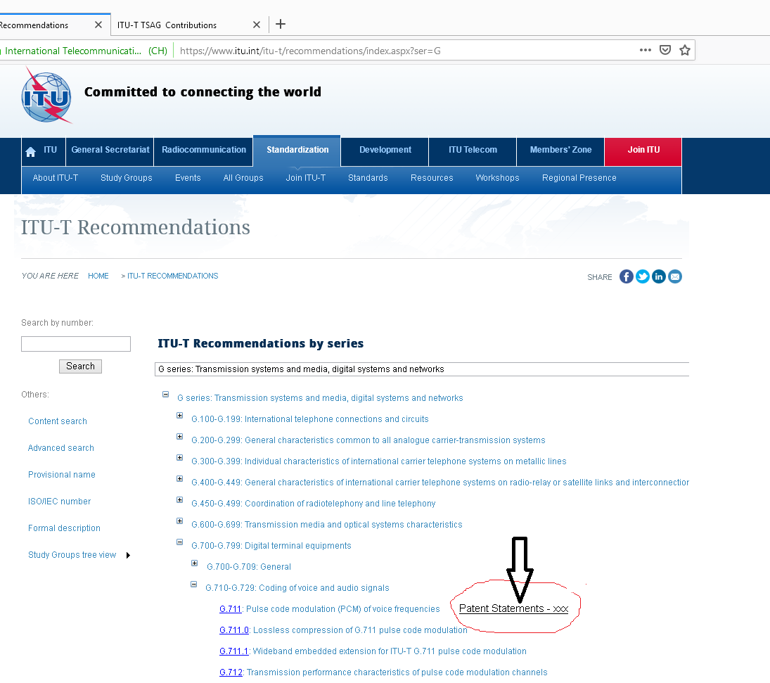

**Annex 2**

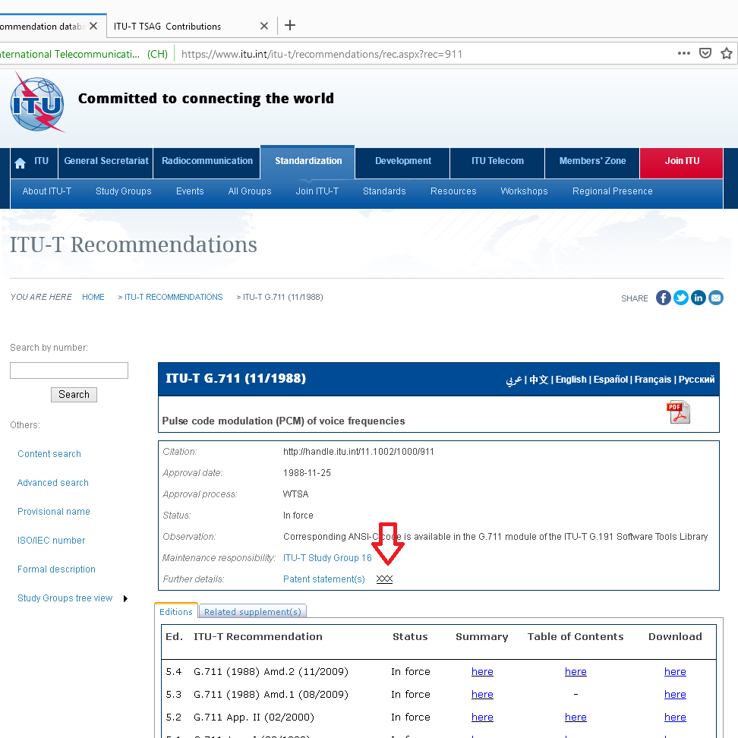

**Annex 3**



