 | INTERNATIONAL TELECOMMUNICATION UNION  TELECOMMUNICATION  STANDARDIZATION SECTOR  STUDY PERIOD 2017-2020 |  |  | TD 048
 |  |  |  | TSAG
 |  |  |  | Original: English
Question(s): |  |  | N/A | Geneva, 1-4 May 2017
TD
Source: |  |  | TSB
Title: |  |  | TSAG meeting facilities and information
Purpose: |  |  | Information
Contact: |  | TSB TSAG |  | Email: tsbtsag@itu.int

Keywords: | TSAG meeting facilities; practical information
Abstract: | This TD provides useful information to help participants benefit from all provided services during the meeting.

1 Printers
As indicated in Collective letter 1/TSAG, the meeting is paperless; however, printers are available in the delegates’ lounges and near all major meeting rooms. To avoid the need to install drivers on your computer, documents may be “e-printed” by emailing them to the desired printer.
Details at: http://itu.int/ITU-T/go/e-print.
2 Registration
The meeting will open at 0930 hours on 1 May 2017. Participant registration will begin at 0830 hours. Please note that all participants must register via ITU’s Montbrillant entrance.
3 Room allocation
Meeting rooms allocation will be displayed on the screens.
Moreover, please refer to the online ITU-T Meeting Schedule.
Offices (Tower building):
- T078 Tel.: 5446 Mr Bruce Gracie, Chairman of TSAG
- T074 Tel.: 5352 Vice-Chairmen of TSAG
- T079 Tel.: 5779 Vice-Chairmen of TSAG

4 Webcast link
Webcast links will be made available on the TSAG homepage.

5 Remote participation in the UN languages
Remote participation in the six UN languages will be carried out during the plenaries (1 and 4 May 2017). Details are described in TD 046.

When making an intervention remotely, please remember that your remarks are being interpreted into six languages and keep the following points in mind:

- speak from a quiet office without background noise;
- use a landline and not a mobile phone;
- speak slowly and clearly so the interpreters can compensate any audio problem;
- speak into your handset and not into a speaker phone;
- when you speak, make sure your computer speakers are muted or turned down;
- start by stating your name and the country or organization that you represent;
- end your remarks with the phrase "This concludes my intervention";
- be prepared to type your question or comment in the chat window, if connection is poor;
- be sure to send by email a copy of any presentation, speech or material you intend to deliver.

Despite their rigorous training and extensive experience, ITU interpreters may occasionally be hindered in their ability to provide a smooth rendering, should the audio become substandard.
In extreme cases, they may even have to refrain from interpreting altogether. Please note that for an interpreter the audio signal has to be near-perfect.

6 Captioning
Captioning links will be made available on the TSAG homepage.

7 WIFI facilities
Wireless LAN facilities are available for use by delegates in all ITU meeting rooms and in the CICG (Geneva International Conference Centre) building.
To connect to ITUwifi:
- Click the WiFi icon in the notification tray. This will show a list of available WiFi networks.
- Choose "ITUwifi" and click the Connect button.
- Enter the security code: "itu@GVA1211".
Detailed information is available on the ITU-T website: http://itu.int/ITU-T/edh/faqs-support.html.
8 Audio Controls in Room Popov
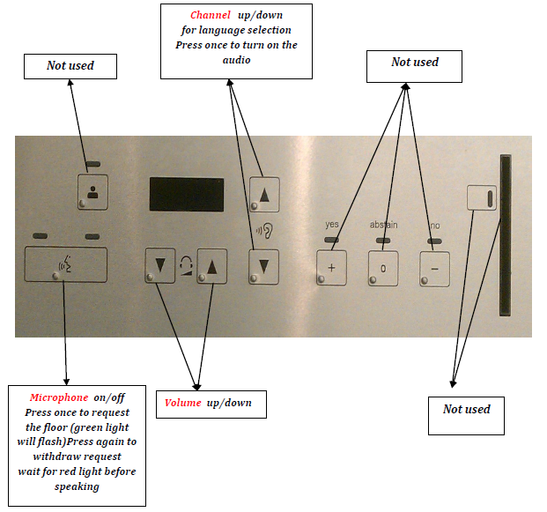
9 Newcomer information
An electronic version of the welcome pack for this meeting is available in TD 047. It is intended to help delegates − particularly newcomers − to quickly set up and make best use of their time during the meeting.
The welcome pack contains:
1. ITU building plan
2. ITU-T delegate guide
3. Newcomer presentation slides
The Guided Tour on 1 May at 09h00 at Montbrillant reception area.
The Newcomer session will take place on 1 May 2017 from 12h45 to 13h45 in meeting Room A (ITU Tower, level -2).
10 Synchronization of TSAG documents
The documents synchronization application is available for staff and delegates for TSAG. It allows you to keep a structured local copy of files as they evolve during the meeting. There is a link on the TSAG homepage that takes you here: http://www.itu.int/en/ITU-T/studygroups/2017-2020/Pages/syncdocs.aspx
Follow the on-screen instructions and you will be able to view all TSAG meeting documents for this meeting. You can resynchronize at any time, allowing you to access these documents offline.
11 Contact information
- Reinhard Scholl
Tel. +41 79 249 48 46 (mobile) (79 5860 from an ITU phone)
E-mail: reinhard.scholl@itu.int
- TSAG Assistant : Lara Al-Mnini
Office ITU Montbrillant M406
Tel. 022 730 6247 (6247 from any ITU phone)
E-mail: tsbtsag@itu.int

- Ties Help Desk
ITU Office Varembé Building V29
Tel. 022 730 6666 (6666 from any ITU phone)
- Medical Service
Office V319
Tel. 022 730 5397 (5397 from any ITU phone)

___________________

