 | INTERNATIONAL TELECOMMUNICATION UNION  TELECOMMUNICATION  STANDARDIZATION SECTOR  STUDY PERIOD 2017-2020 |  |  | TSAG-TD293
 |  |  |  | TSAG
 |  |  |  | Original: English
Question(s): |  |  | N/A | Geneva, 10-14 December 2018
TD
Source: |  |  | Director, TSB
Title: |  |  | Draft four-year rolling operational plan for the telecommunication standardization sector for 2020-2023
Purpose: |  |  | Discussion
Contact: |  | Reinhard Scholl  Hugues Dépoisier |  |  | Email: reinhard.scholl@itu.int  Email: hugues.depoisier@itu.int

Keywords: | ITU-T Operational Plan 2020-2023; goals; objectives; outputs;
Abstract: | TSAG is invited to review the draft four-year Operational Plan for the Telecommunication Standardization Sector for 2020-2023.

1 Introduction
The 4-year rolling Operational plan for the ITU Telecommunication Standardization Sector (ITU-T Operational Plan) is prepared in full alignment with the ITU Strategic Plan for 2020-2023, within the limits of the Financial plan for 2020-2023, and the biennial budgets. The structure follows the ITU-T results framework, outlining the ITU-T objectives, the corresponding outcomes and the indicators to measure their progress, as well as the outputs (products and services) produced by the activities of the Sector.
The planning, implementation and monitoring and evaluation process for the Telecommunication Standardization Bureau (TSB) will be complemented by the following internal mechanisms:
- the Work Plans of the Departments and Divisions of the Telecommunication Standardization Bureau (TSB), and
- the Service Level Agreements (SLAs) for the planning, monitoring and evaluation of the support services.

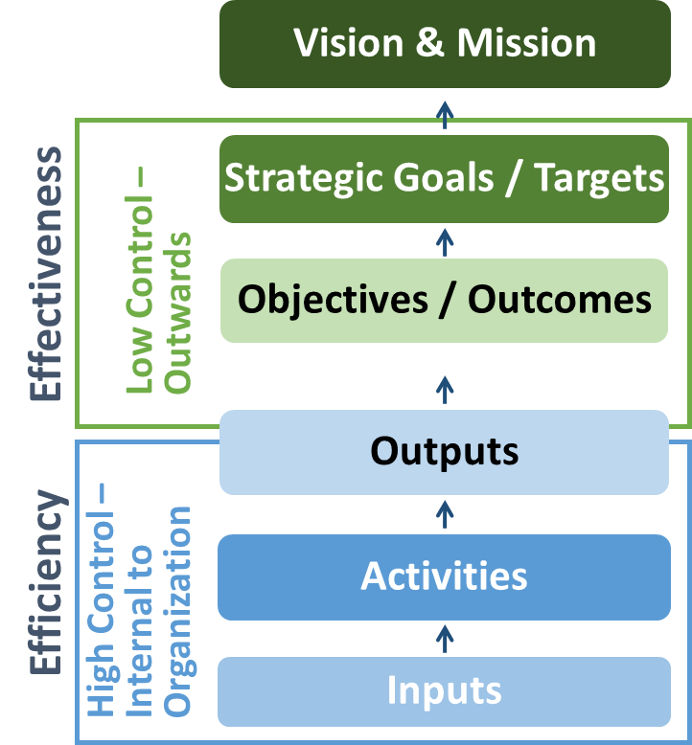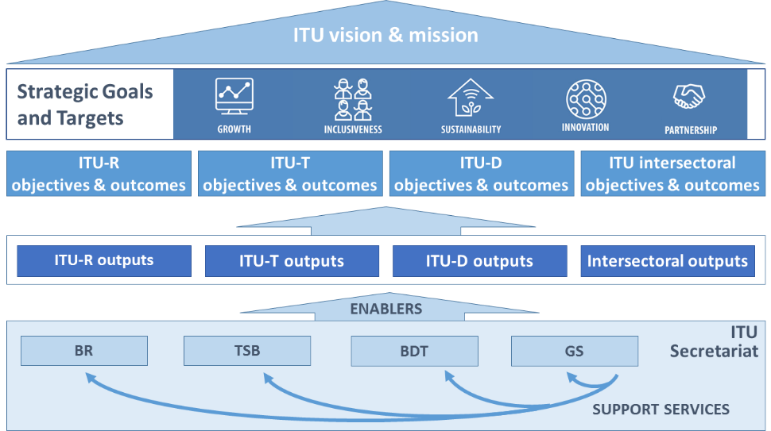
Figure 1: ITU-T OP and the ITU strategic framework for 2020-2023

2 Context and key priorities for the ITU-T Sector
The ITU Telecommunication Standardization Sector (ITU-T) operates in a competitive, complex and rapidly evolving environment and ecosystem.
There is a need for high-quality, demand-driven international standards, which should be developed rapidly in line with the principles of global connectivity, openness, affordability, reliability, interoperability and security. Key technologies, enabling new services and applications and promoting the building of the information society are emerging and should be taken into account in the work of ITU-T.
While retaining current ITU-T members, new members from industry and academia need to be attracted and encouraged, and the participation of developing countries in the standardization process (“Bridging the standardization gap”) needs to be boosted.
Cooperation and collaboration with other standardization bodies and relevant consortia and forums are key to minimize conflict of work and achieve efficient use of resources, as well as to incorporate expertise from outside ITU.
The review of the International Telecommunication Regulations will set a renewed worldwide framework for ITU-T activities.

3 ITU-T results framework for 2020-2023

3.1 Linkage with the ITU Strategic Goals
ITU-T objectives | Goal 1: Growth | Goal 2: Inclusiveness | Goal 3: Sustainability | Goal 4: Innovation | Goal 5 : Partnership
T.1 (Development of standards): Develop non-discriminatory international standards (ITU-T recommendations), in a timely manner, and foster interoperability and improved performance of equipment, networks, services and applications
T.2 (Bridging the standards gap): Promote the active participation of the membership, in particular developing countries, in the definition and adoption of non-discriminatory international standards (ITU-T recommendations) with a view to bridging the standardization gap
T.3 (Telecommunication resources): Ensure effective allocation and management of international telecommunication numbering, naming, addressing and identification resources in accordance with ITU-T recommendations and procedures
T.4 (Knowledge sharing): Foster the acquisition, awareness, sharing of knowledge and know how on the standardization activities of ITU-T
T.5 (Cooperation with standardization bodies) Extend and facilitate cooperation with international, regional and national standardization bodies

3.2 ITU-T objectives, outcomes and outputs
Objectives | T.1 (Development of standards): Develop non-discriminatory international telecommunication/ICT standards (ITU-T recommendations), in a timely manner, and foster interoperability and improved performance of equipment, networks, services and applications | T.2 (Bridging the standards gap): Promote the active participation of the membership, in particular developing countries, in the definition and adoption of non-discriminatory international telecommunication/ICT standards (ITU-T recommendations) with a view to bridging the standardization gap | T.3 (Telecommunication resources): Ensure effective allocation and management of international telecommunication numbering, naming, addressing and identification resources in accordance with ITU-T recommendations and procedures | T.4 (Knowledge sharing): Foster the acquisition, awareness, sharing of knowledge and know how on the standardization activities of ITU-T | T.5 (Cooperation with standardization bodies) Extend and facilitate cooperation with international, regional and national standardization bodies
Outcomes | T.1-a: Increased utilization of ITU-T recommendations  T.1-b: Improved conformance to ITU-T recommendations  T.1-c: Enhanced standards in new technologies and services | T.2-a: Increased participation in the ITU-T standardization process, including attendance of meetings, submission of contributions, taking leadership positions and hosting of meetings/workshops, especially from developing countries  T.2-b: Increase of the ITU-T membership, including Sector Members, Associates and Academia | T.3-a: Timely and accurate allocation of international telecommunication numbering, naming, addressing and identification resources, as specified in the relevant recommendations | T.4-a: Increased knowledge on ITU-T standards and on best practices in their implementation of ITU-T standards  T.4-b: Increased participation in ITU-T's standardization activities and increased awareness of the relevance of ITU-T standards  T.4-c: Increased Sector visibility | T.5-a: Increased communications with other standards organizations  T.5-b: Decreased number of conflicting standards  T.5-c: Increased number of memoranda of understanding/collaboration agreements with other organizations  T.5-d: Increased number of ITU-T A.4, A.5 and A.6 qualified organizations  T.5-e: Increased number of workshops/events organized jointly with other organizations
Outputs | T.1-1: Resolutions, recommendations and opinions of the World Telecommunication Standardization Assembly (WTSA)  T.1-2: WTSA regional consultation sessions  T.1-3: Advice and decisions of the Telecommunication Standardization Advisory Group (TSAG)  T.1-4: ITU-T recommendations and related results of ITU-T study groups  T.1-5: ITU-T general assistance and cooperation  T.1-6: Conformity database  T.1-7: Interoperability test centers and events  T.1-8: Development of test suites | T.2-1: Bridging the standardization gap  T.2-2: Workshops and seminars, including offline and online training activities, complementing the capacity-building work on bridging the standardization gap  T.2-3: Outreach and promotion | T.3-1: Relevant TSB databases  T.3-2: Allocation and management of international telecommunication numbering, naming, addressing and identification resources in accordance with ITU-T recommendations and procedures | T.4-1: ITU-T publications  T.4-2: Database publications  T.4-3: Outreach and promotion  T.4-4: ITU Operational Bulletin | T.5-1: Memoranda of understanding (MoUs) and collaboration agreements  T.5-2: ITU-T A.4/A.5/A.6 qualifications  T.5-3: Jointly organized workshops/events
The following outputs of the activities of the ITU governing bodies contribute to the implementation of all the objectives of the Union:
– Decisions, resolutions, recommendations, and other results of the Plenipotentiary Conference
– Decisions and resolutions of the Council, as well as results of the Council working groups

3.3 Allocation of resources to ITU-T objectives and outputs for 2020-2023
 |  | Planned allocation of resources per Output  T.1-1 Resolutions, Recommendations and opinions of the WTSA  T.1-2 WTSA regional consultation sessions  T.1-3 Advice and decisions of the TSAG  T.1-4 ITU-T Recommendations and related results of ITU-T study groups  T.1-5 ITU-T general assistance and cooperation  T.1-6 Conformity database  T.1-7 Interoperability test centres and events  T.1-8 Development of test suites  T.2-1 Bridging the standardization gap  T.2-2 Workshops and seminars, incl. offline and online training activities, (…)  T.2-3 Outreach and promotion  T.3-1 Relevant TSB databases  T.3-2 Allocation and mgmt. of int’l. telecommunication numbering, naming, addressing and identification resources in accordance with ITU-T Recommendations and procedures  T.4-1 ITU-T publications  T.4-2 Database publications  T.4-3 Outreach and promotion  T.4-4 ITU Operational Bulletin  T.5-1 Memoranda of understanding (MoUs) and collaboration agreements  T.5-2 ITU-T A.4/A.5/A.6 qualifications  T.5-3 Jointly organized workshop/events  PP: Decisions, resolutions, Recommendations and other results of the Plenipotentiary Conference *  Council/CWGs: Decisions and resolutions of the Council, as well as results of the Council working groups * | % of total  2.1%  0.3%  2.0%  38.0%  3.4%  1.2%  0.9%  0.4%  4.6%  9.3%  7.2%  4.6%  4.5%  9.5%  0.9%  4.6%  0.4%  0.5%  0.5%  1.6%  1.5%  2.2% | % of objective  4.1%  0.6%  4.0%  75.9%  6.7%  2.4%  1.8%  0.7%  21.0%  42.4%  32.9%  48.9%  47.3%  59.3%  5.7%  28.7%  2.5%  19.4%  18.4%  58.5%  1.5%  2.2%
T.1 (Development of standards): Develop non-discriminatory international telecommunication/ICT standards (ITU-T recommendations), in a timely manner, and foster interoperability and improved performance of equipment, networks, services and applications  T.2 (Bridging the standards gap): Promote the active participation of the membership, in particular developing countries, in the definition and adoption of non-discriminatory international telecommunication/ICT standards (ITU-T recommendations) with a view to bridging the standardization gap  T.3 (Telecommunication resources): Ensure effective allocation and management of international telecommunication numbering, naming, addressing and identification resources in accordance with ITU-T recommendations and procedures  T.4 (Knowledge sharing): Foster the acquisition, awareness, sharing of knowledge and know how on the standardization activities of ITU-T  T.5 (Cooperation with standardization bodies) Extend and facilitate cooperation with international, regional and national standardization bodies | 50%  22%  9%  16%  3%
* Cost of these Outputs is allocated to all the Objectives of the Union.

4 Risk analysis
Moving from strategy to implementation, the following top-level operational risks presented in the Table below have been identified, analysed, and evaluated. The Bureaux and each Department will manage all the risks associated with the achievement of the corresponding outcomes.
Perspective | Description of risk | Probability | Impact level | Mitigation1
Organizational | Physical inability to operate the headquarters.  Physical inability to organize events or travel (e.g. the host country of an event has to be changed at the last minute because of political instability or because of a major impact crisis, such as a pandemic or public security concerns) | Low  Medium | High  Medium | - Strengthen remote participation means  - ITU/TSB wide business contingency plan
Infrastructure | ICT services disruption | Low | High | - ICT continuity plan
Human resources | Scarcity of staff/skills for key tasks | Medium | Medium | - HR strategic plan addressing training, career paths and replacement of staff/competencies.  - Contingency plan for sick leaves  - TSB wide business continuity plan
Financial | Inefficient spending  Significant number of membership denunciations  Substantive decrease of cost recovery income | Low  Medium  Low | Medium  High  Low | - Internal control system/mechanism  - Position ITU-T as an attractive place to do cutting edge standardization work  - Implementation of monitoring and evaluation system

5 ITU-T objectives, outcomes and outputs for 2020-2023
ITU-T Sector objectives will be met by achieving the related outcomes, through the implementation of the outputs. ITU-T objectives, in the context of the remit of the Sector, contribute to the overarching goals of the Union. The Telecommunication Standardization Bureau is also contributing to the implementation of the Intersectoral objectives, outcomes, and outputs (presented in the General Secretariat’s Operational Plan).

5.1 T.1 (Development of standards) Develop non-discriminatory international telecommunication/ICT standards (ITU-T recommendations), in a timely manner, and foster interoperability and improved performance of equipment, networks, services and applications
Outcome | Outcome Indicator | 2016 figures | 2017 figures | 2018 figures  (1 Jan. to 30 Sept) | Means of measurement
T.1-a: Increased utilization of ITU-T recommendations | - # of visits to ITU-T website  - # of participants in study groups (incl. Reg. Groups)  - # of downloads of ITU-T recommendations | 8’288’568  2’953  3’403’995 | 11'263’260  2’971  3’598’199 | to come  2’490  2’474’263 | ITU statistics  ITU statistics  ITU statistics
T.1-b: Improved conformance to ITU-T recommendations | - # of test events  - # of entries in conformity database  - # of Recommendations describing test specifications | 4  500+  156 | 3  3  211 | 0  7  172 | ITU statistics
T.1-c: Enhanced standards in new technologies and services | - # of new areas of work (Study Group Questions, work items and resulting standards, either in ITU-T or in collaboration with other groups) | # of new Questions: 5  # of new work items: 442 | # of new Questions: 5  # of new work items: 480 | # of new Questions: 2  # of new work items: 406 | ITU statistics

Output | Financial resources1 (in kCHF)
 | 2020 | 2021 | 2022 | 2023
T.1-1 Resolutions, recommendations and opinions of the World Telecommunication Standardization Assembly (WTSA) | 2,246 | 188 | - | -
T.1-2 WTSA regional consultation sessions | 361 | - | - | -
T.1-3 Advice and decisions of the TSAG | 596 | 600 | 589 | 581
T.1-4 ITU-T Recommendations and related results of ITU-T study groups | 11,003 | 11,155 | 11,251 | 11,354
T.1-5 ITU-T general assistance and cooperation | 1,024 | 1,028 | 955 | 964
T.1-6 Conformity database | 502 | 506 | 206 | 210
T.1-7 Interoperability test centers and events | 397 | 401 | 143 | 146
T.1-8 Development of test suites | 128 | 129 | 80 | 81
Cost allocation to Plenipotentiary Conference and Council activities (PP, Council/CWGs) | 520 | 491 | 766 | 388
Total for Objective T.1 | 16,776 | 14,499 | 13,991 | 13,724

5.2 T.2 (Bridging the standards gap) Promote the active participation of the membership, in particular developing countries, in the definition and adoption of non-discriminatory international telecommunication/ICT standards (ITU-T recommendations) with a view to bridging the standardization gap
Outcome | Outcome Indicator | 2016 figures | 2017 figures | 2018 figures  (1 Jan. to 30 Sept) | Means of measurement
T.2-a: Increased participation in the ITU-T standardization process, including attendance of meetings, submission of contributions, taking leadership positions and hosting of meetings/workshops, especially from developing countries | - # of SG meetings, WP meetings, Regional Group meetings and workshops held (in and outside Geneva)  - # of Rapporteur meetings and # of participants  - # of e-Meetings and # of participants  - % of leadership positions (Study Group Chair/Vice-chair, Rapporteur Chair, editor) held by developing countries and LDC | 54  229 RGM  1’085 (5’977 participants)  33% | 59  206 RGM  1'072 e-meetings (5'245 participants)  39% | 71  205 RGM  1’177 e-meetings (6’256 participants)  38% | ITU statistics
T.2-b: Increase of the ITU-T membership, including Sector Members, Associates and Academia | - # of (net) Sector Member, Associate, Academia members for developed and developing countries (separately); | 311 (developed); net - 4  217 (developing); net + 12 | 317 (developed); net +6  209 (developing); net -8 | 322 (developed); net +5  246 (developing); net +37 | ITU statistics

Output | Financial resources1 (in kCHF)
 | 2020 | 2021 | 2022 | 2023
T.2-1: Bridging the standardization gap | 1,131 | 1,128 | 1,608 | 1,533
T.2-2: Workshops and seminars, including offline and online training activities, complementing the capacity-building work on bridging the standardization gap | 2,532 | 2,515 | 2,922 | 2,941
T.2-3 Outreach and promotion | 2,120 | 2,140 | 2,090 | 2,102
Cost allocation to Plenipotentiary Conference and Council activities (PP, Council/CWGs) | 185 | 203 | 383 | 191
Total for Objective T.2 | 5,968 | 5,986 | 7,005 | 6,768

5.3 (Telecommunication resources) Ensure effective allocation and management of international telecommunication numbering, naming, addressing and identification resources in accordance with ITU-T recommendations and procedures
Outcome | Outcome Indicator | 2016 figures | 2017 figures | 2018 figures  (1 Jan. to 30 Sept) | Means of measurement
T.3-a: Timely and accurate allocation of international telecommunication numbering, naming, addressing and identification resources, as specified in the relevant recommendations | # of assignments within a given period of time | 672 | 629 | 384 | ITU statistics

Output | Financial resources1 (in kCHF)
 | 2020 | 2021 | 2022 | 2023
T.3-1 Relevant TSB databases | 1,162 | 1,181 | 1,543 | 1,557
T.3-2 Allocation and management of international telecommunication numbering, naming, addressing and identification resources in accordance with ITU-T recommendations and procedures | 1,207 | 1,223 | 1,410 | 1,424
Cost allocation to Plenipotentiary Conference and Council activities (PP, Council/CWGs) | 76 | 84 | 171 | 87
Total for Objective T.3 | 2,444 | 2,488 | 3,124 | 3,067

5.4 T.4 (Knowledge sharing) Foster the acquisition, awareness, sharing of knowledge and know how on the standardization activities of ITU-T
Outcome | Outcome Indicator | 2016 figures | 2017 figures | 2018 figures  (1 Jan. to 30 Sept) | Means of measurement
T.4-a: Increased knowledge on ITU-T standards and on best practices in their implementation of ITU-T standards | See T.1-a | See T.1-a | See T.1-a | See T.1-a | See T.1-a
T.4-b : Increased participation in ITU-T’s standardization activities and increased awareness of the relevance of ITU-T standards | See T.1-a and T.1-b | See T.1-a and T.1-b | See T.1-a and T.1-b | See T.1-a and T.1-b | See T.1-a and T.1-b
T.4-c: Increased Sector visibility | See T.1-a and T.2-a | See T.1-a and T.2-a | See T.1-a and T.2-a | See T.1-a and T.2-a | See T.1-a and T.2-a

Output | Financial resources¹(in kCHF)
 | 2020 | 2021 | 2022 | 2023
T.4-1 ITU-T publications | 2,822 | 2,765 | 2,823 | 2,756
T.4-2 Database publications | 275 | 273 | 265 | 267
T.4-3 Outreach and promotion | 1,264 | 1,279 | 1,429 | 1,440
T.4-4 ITU Operational Bulletin | 63 | 63 | 182 | 165
Cost allocation to Plenipotentiary Conference and Council activities (PP, Council/CWGs) | 141 | 154 | 272 | 135
Total for Objective T.4 | 4,565 | 4,533 | 4,972 | 4,763

5.5 T.5 (Cooperation with standardization bodies) Extend and facilitate cooperation with international, regional and national standardization bodies
Outcome | Outcome Indicator | 2016 figures | 2017 figures | 2018 figures  (1 Jan. to 30 Sept) | Means of measurement
T.5-a: Increased communications with other standards organizations | - # of jointly organized or hosted meetings/workshops with other organizations;  - # of liaison statements | 20  983 (incoming) and 1’287 (outgoing) | 25  1’129 (incoming) and 1’596 (outgoing) | 22  806 (incoming) and 1’060 (outgoing) | ITU statistics
T.5-b: Decreased number of conflicting standards | - # of jointly developed standards with other organizations | 20 | 14 | 9 | ITU statistics
T.5-c: Increased number of memoranda of understanding / collaboration agreements with other organizations | - # of agreements with other organizations | 2 SDOs | 2 SDOs | - | ITU statistics
T.5-d: Increased number of ITU-T A.4, A.5 and A.6 qualified organizations | - # of ITU-T A.4/5/6 qualifications | A.4: 35 as of 17 February 2017  A.5: 47 as of 17 February 2017  A.6: 17 as of 17 February 2017 | A.4: 36 as beginning December 2017  A.5: 48 as beginning December 2017  A.6: 17 as beginning December 2017 | A.4: 34 as of end Sept. 2018  A.5: 48 as of end Sept. 2018  A.6: 18 as of end Sept. 2018 | ITU statistics
T.5-e: Increased number of workshops/events organized jointly with other organizations | already in T.5-a | See T.5-a | See T.5-a | See T.5-a | See T.5-a

Output | Financial resources1 (in kCHF)
 | 2020 | 2021 | 2022 | 2023
T.5-1 Memoranda of Understanding (MoUs) and collaboration agreements | 158 | 159 | 145 | 146
T.5-2 ITU-T A.4/A.5/A.6 qualifications | 239 | 239 | 50 | 50
T.5-3 Jointly organized workshop/events | 272 | 273 | 646 | 648
Cost allocation to Plenipotentiary Conference and Council activities (PP, Council/CWGs) | 21 | 24 | 49 | 25
Total for Objective T.5 | 691 | 693 | 889 | 869

6 Implementation of the Operational Plan
The outputs defined in this Operational Plan will be delivered by the responsible Departments of the Telecommunication Standardization Bureau, implementing the activities of the internal work plans of the Bureau and each department; the regional offices will participate in the implementation of this operational plan. The support services are delivered by the Telecommunication Standardization Bureau and the General Secretariat, subject to predefined and agreed annual Service Level Agreements (for the provision of internal services). The Support Services delivered by the General Secretariat are described in the General Secretariat Operational Plan. The delivery of the outputs and support services is planned, monitored, and evaluated by ITU management, with a view to link the Personal Performance Appraisals of the staff, to the objectives of the ITU strategic plan. The annual report on the implementation of the strategic plan will report on the progress made towards achieving these objectives and the overall goals. With regard to risk management, apart from the operational risks included in this operational plan that will be reviewed periodically by senior management, each Department is identifying, assessing, and managing risks associated with the delivery of the respective outputs and support services, following a multi-level risk management approach.

Annex 1: Allocation of resources to ITU-T objectives and ITU Strategic Goals
 |  |  |  |  |  |  |  |  |  |  | In % |  |  |  |  |  | CHF 000
ITU Strategic Objectives for 2020 |  | Total  Cost | Cost of TSB/ Direct Cost | Cost Reallocated from GS | Cost allocated from BR/BDT |  | Goal 1  Growth | Goal 2  Inclusiveness | Goal 3  Sustainability | Goal 4  Innovation | Goal 5  Partnership |  | Goal 1  Growth | Goal 2  Inclusiveness | Goal 3  Sustainability | Goal 4  Innovation | Goal 5  Partnership
T1 | ITU-T Obj. 1 | 16,776 | 10,207 | 6,514 | 54 |  | 40% | 20% | 10% | 20% | 10% |  | 6,710 | 3,355 | 1,678 | 3,355 | 1,678
T2 | ITU-T Obj. 2 | 5,968 | 3,406 | 2,558 | 4 |  | 15% | 75% | - | 10% | - |  | 895 | 4,476 | - | 597 | -
T3 | ITU-T Obj. 3 | 2,444 | 1,186 | 1,256 | 2 |  | 50% | 30% | 10% | 5% | 5% |  | 1,222 | 733 | 244 | 122 | 122
T4 | ITU-T Obj. 4 | 4,565 | 2,262 | 2,301 | 3 |  | 30% | 50% | 10% | 5% | 5% |  | 1,370 | 2,283 | 457 | 228 | 228
T5 | ITU-T Obj. 5 | 691 | 147 | 517 | 26 |  | 25% | 20% | 10% | 10% | 35% |  | 173 | 138 | 69 | 69 | 242
Total Cost |  | 30,443 | 17,208 | 13,147 | 89 |  |  |  |  |  |  |  | 10,3700 | 10,985 | 2,448 | 4,371 | 2,270
 |  |  |  |  |  |  |  |  |  |  |  |  | 34% | 36% | 8% | 14% | 8%

 |  |  |  |  |  |  |  |  |  |  | In % |  |  |  |  |  | CHF 000
ITU Strategic Objectives for 2021 |  | Total  Cost | Cost of TSB/ Direct Cost | Cost Reallocated from GS | Cost allocated from BR/BDT |  | Goal 1  Growth | Goal 2  Inclusiveness | Goal 3  Sustainability | Goal 4  Innovation | Goal 5  Partnership |  | Goal 1  Growth | Goal 2  Inclusiveness | Goal 3  Sustainability | Goal 4  Innovation | Goal 5  Partnership
T1 | ITU-T Obj. 1 | 14,499 | 8,822 | 5,630 | 47 |  | 40% | 20% | 10% | 20% | 10% |  | 5,799 | 2,900 | 1,450 | 2,900 | 1,450
T2 | ITU-T Obj. 2 | 5,986 | 3,416 | 2,566 | 4 |  | 15% | 75% | - | 10% | - |  | 898 | 4,490 | - | 599 | -
T3 | ITU-T Obj. 3 | 2,488 | 1,208 | 1,487 | 2 |  | 50% | 30% | 10% | 5% | 5% |  | 1,244 | 746 | 249 | 124 | 124
T4 | ITU-T Obj. 4 | 4,533 | 2,245 | 2,284 | 3 |  | 30% | 50% | 10% | 5% | 5% |  | 1,360 | 2,266 | 453 | 227 | 227
T5 | ITU-T Obj. 5 | 693 | 148 | 520 | 26 |  | 25% | 20% | 10% | 10% | 35% |  | 173 | 139 | 69 | 69 | 243
Total Cost |  | 28,199 | 15,839 | 12,279 | 82 |  |  |  |  |  |  |  | 9,475 | 10,541 | 2,221 | 3,919 | 2,044
 |  |  |  |  |  |  |  |  |  |  |  |  | 34% | 37% | 8% | 14% | 7%
_________________________

1 Risk owners will be appointed by the Director of the Bureau.
1 Estimates for 2020, 2021, 2022and 2023. Allocation of resources is subject to change upon Senior Management decisions.
1 Estimates for 2020, 2021, 2022 and 2023. Allocation of resources is subject to change upon Senior Management decisions.
1 Estimates for 2020, 2021, 2022, and 2023. Allocation of resources is subject to change upon Senior Management decisions.
1 Estimates for 2020, 2021, 2022 and 2023. Allocation of resources is subject to change upon Senior Management decisions.

