 | INTERNATIONAL TELECOMMUNICATION UNION  TELECOMMUNICATION  STANDARDIZATION SECTOR  STUDY PERIOD 2017-2020 |  | TSAG-TD322
 |  |  | TSAG
 |  |  | Original: English
Question(s): |  | N/A | Geneva, 10-14 December 2018
TD
Source: |  | TSB
Title: |  | TSAG Remote Participation - Adobe Connect Guide
Purpose: |  | Information
Contact: |  | TSB |  | Email: tsbemeetings@itu.int

Keywords: | Remote participation
Abstract: | This TD contains a step-by-step description of Adobe Connect for new users.

TSAG Remote participation
ITU-T’s TSAG meeting (10 – 14 December 2018) will be made available as a live audio and video in order that remote participants can see and hear presentations.
In order to be able to participate remotely, please make sure you are registered to the TSAG Meeting: (https://www.itu.int/net4/CRM/xreg/web/Registration.aspx?Event=C-000051655).
Kindly follow these steps:
Logging In The Room:
a) The list of the TSB e-Meetings can be found at: http://www.itu.int/en/ITU-T/events/Pages/emeetings.aspx
b) Click on the session that you wish to attend
c) Login with your TIES credentials

Note: Please login to the meeting room at least 15 minutes before the session is due to start. This will ensure that we can start the meeting on time.

Audio connection:
There are two options to join the meeting:

Option 1: Listen through computer speakers (listen mode only)
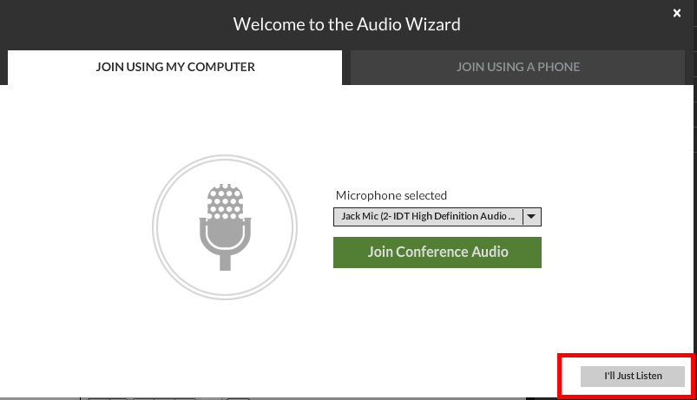

By choosing this option, you can only listen to the conference. You will not be able to speak.
A chat box is available if you wish to make some comments.

Option 2: Dial-in or dial-out to yourself over the phone

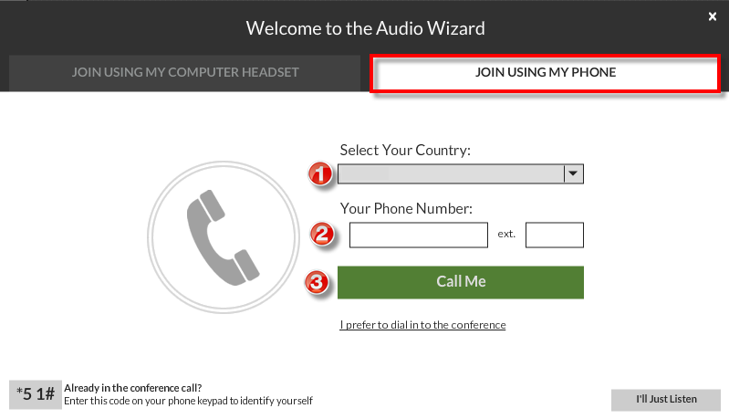

- Click on Audio Options button (on the top right of the virtual meeting room).
- Select the country
- Type in your number
- Click on “Call Me”

The system will then call you on the specified number.

Meeting Participation

By default, you will be on the Floor Channel and muted until you request the floor by clicking on the “raise hand” button.
The meeting host then will give you the floor and you will hear a short audio message on your phone stating that you can speak now.

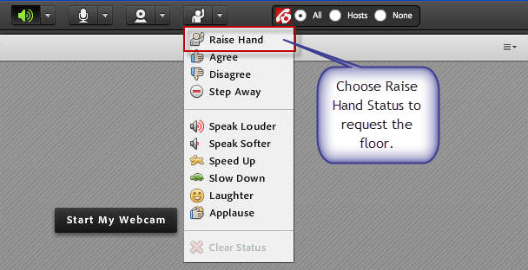

When you make your intervention, please start by stating your name and the entity you are representing. Please click on the Lower Hand button when you finish your intervention.

Listening to your preferred language

If the meeting you are virtually attending is multilingual, you can do so by selecting it from the drop-down menu that will appear on the top of the screen.

For more information concerning remote participation, please send an e-mail to tsbemeetings@itu.int.
_______________

