|  |  |  |  |  |  |
| --- | --- | --- | --- | --- | --- |
| ITU logo | INTERNATIONAL TELECOMMUNICATION UNION  **TELECOMMUNICATION STANDARDIZATION SECTOR**  STUDY PERIOD 2017-2020 | | | TSAG-TD480 | |
| **TSAG** | |
| **Original: English** | |
| **Question(s):** | | | N/A | Geneva, 23-27 September 2019 | |
| **TD** | | | | | |
| **Source:** | | | Chairman, ITU-T SG9 | | |
| **Title:** | | | ITU-T SG9 Lead Study Group Report | | |
| **Purpose:** | | | Information | | |
| **Contact:** | | Satoshi Miyaji KDDI Corporation Japan | | | Tel: +81 3 6328 1905 Fax: +81 3 6757-1271 E-mail: [sa-miyaji@kddi.com](mailto:sa-miyaji@kddi.com) |

|  |  |
| --- | --- |
| **Keywords:** | Study Group 9; report; |
| **Abstract:** | This document provides the SG9 report for lead study group activities on integrated broadband cable and television networks. |

# Lead study group activities on integrated broadband cable and television networks

Since the last TSAG meeting where Study Group 9 reported its third meeting on 21 – 28 November 2018 in Bogota, Colombia, SG9 held the fourth meeting on 6 – 13 June 2019 in Geneva, Switzerland. The SG9 meeting was attended by 55 participants from 18 countries. Along with face-to-face meetings, a few sessions were supported by remote participation, as requested by SG9 Management.

Co-located with the SG9 meeting, ITU hosted a workshop on “[*The Future of Television for Europe*](https://www.itu.int/en/ITU-T/Workshops-and-Seminars/20190607/Pages/default.aspx)” on 7 June 2019, which was jointly organized by the three Sectors of the ITU (Radiocommunication: ITU-R; Standardization: ITU-T; and Development: ITU-D). Approximately 100 participants (plus remote attendance) attended the workshop. All presentations given at the workshop are available from the programme website at: <http://itu.int/go/39KQ>. Photos are available [here](https://www.itu.int/ifa/t/2017/sg9/temp/).

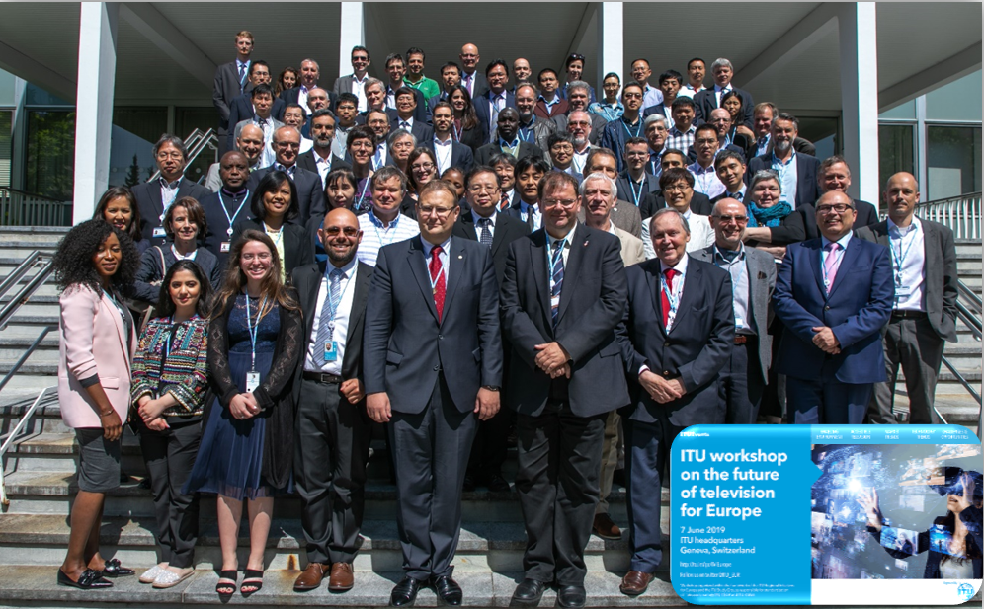

Figure 1 – Group Photo from ITU Workshop on “the future of TV for Europe”, 7 June 2019, Geneva, Switzerland

During the SG9 meeting in June 2019, the following ten (10) draft Recommendations were consented as per the AAP procedure. All of them were further approved with the exception of ITU‑T J.1600, which received comments from Huawei. The comments were further resolved and the draft Recommendation is now under Additional Review period (AAP).

| Q | Recommendation | Status | Title |
| --- | --- | --- | --- |
| Q1/9 | **J.288** (J.288-rev) | Rev | Encapsulation of type length value (TLV) packet for cable transmission systems |
| Q1/9  Q7/9 | **J.224** (ex.J.5GDOCSIS) | New | Fifth-generation transmission systems for interactive cable television services – IP cable modems |
| Q1/9  Q7/9 | **J.216**  (ex. J.MHAv2) | New | Second-generation Modular Headend Architecture in transmission systems for interactive cable television services – IP cable modems |
| Q2/9 | **J.1026**  (J.oneway-dcas-part1) | New | Downloadable Conditional Access System for Unidirectional Network; Requirements |
| Q2/9 | **J.1027**  (J.oneway-dcas-part2) | New | Downloadable Conditional Access System for Unidirectional Network; System Architecture |
| Q2/9 | **J.1028**  (J.oneway-dcas-part3) | New | Downloadable Conditional Access System for Unidirectional Network; The Terminal |
| Q5/9 | **J.207** | Rev | Specification for integrated broadcast and broadband digital television application control framework |
| Q5/9 | **J.1202**  (ex J.stvos-spec-arch) | New | The architecture of smart TV operating system |
| Q7/9 | **J.1210 (**ex J.ipvb-req) | New | Requirements of IP Video Broadcast (IPVB) for CATV Networks |
| Q9/9 | **J.1600**  (ex J.pcnp-fmw) | New | Premium Cable Network Platform (PCNP) – Framework |

In addition, SG9 is involved in resolving the approval process of five draft Recommendations ITU‑T J.1012 – J.1015 and J.1015.1, which were determined by TAP but were not approved yet. After the determination at the second SG9 meeting held in January 2018, through the consultation process by [TSB Circular 79](https://www.itu.int/md/T17-TSB-CIR-0079/en), there was one Member State (UK) opposing to assignment of authority to SG9 to proceed with the approval process for these draft Recommendations. At the subsequent meeting, which was the third SG9 meeting held in November 2018 in Bogota, Colombia, several concerns were raised by UK and Israel, and SG9 was unable to reach consensus by the end of the meeting, and agreed to postpone the approval of those draft Recommendations to the fourth SG9 meeting.

At the fourth SG9 meeting held on 6 – 13 June 2019 in Geneva, there were still concerns continuously expressed by UK, Israel and US, and no constructive contributions for compromise were provided by those parties. To step out from this deadlock situation, the SG9 Chairman proposed those three parties that concrete proposals, including but not limited to, additional requirements, technical modifications, etc., should be prepared by a deadline. The meeting agreed the Chairman’s proposal. There are three interim meetings planned between the June SG9 meeting and the next SG9 meeting (one informal on 17-18 September in Bonn and two Q2 rapporteur e-Meetings in October and November 2019), and improvement of these draft Recommendations and compromise are going to be sought at these meetings toward the desired approval of these TAP texts at next SG9 meeting:

|  |  |  |  |
| --- | --- | --- | --- |
| **Q** | **Recommendation** | **Status** | **Title** |
| Q2 | J.1012 (ex. J.dmcd-part3) | Determined 2018-01-30 | Embedded Common Interface (ECI) for exchangeable CA/DRM solutions; CA/DRM Container, Loader, Interfaces, Revocation |
| Q2 | J.1013 (ex. J.dmcd-vm) | Determined 2018-01-30 | Embedded Common Interface (ECI) for exchangeable CA/DRM solutions; The Virtual Machine |
| Q2 | J.1014 (ex. J.dmcd-eci-as) | Determined 2018-01-30 | Embedded Common Interface (ECI) for exchangeable CA/DRM solutions; Advanced Security - ECI-specific functionalities |
| Q2 | J.1015 (ex. J.dmcd-kl-as) | Determined 2018-01-30 | Embedded Common Interface (ECI) for exchangeable CA/DRM solutions;  The Advanced Security system - Key Ladder |
| Q2 | J.1015.1 (ex. J.dmcd-kl-as) | Determined 2018-01-30 | Embedded Common Interface (ECI) for exchangeable CA/DRM solutions; The Advanced Security system - Key Ladder – Annex A |

In addition, SG9 is pleased to inform TSAG that:

– The number of participants increased fifteen (15) compared to the previous meeting (40 → 55). Although the location difference between these two meetings should be taken into consideration, we recognize that the interest in SG9 by ITU Members is growing also thanks to the proactive and continued attempts of SG9 Management to increase the momentum of SG9 from the beginning of this Study Period.

– Ten (10) draft new or revised Recommendations were consented at the June SG9 meeting, which is the larger number of the consented draft Recommendations per meeting during this Study Period.

– MovieLabs (USA) and Synamedia (Israel) newly joined ITU-T as Associate Members of SG9 in addition to the new members joined in SG9 in 2018, i.e., Shenzhen Skyworth Digital Technology (China), Jishi Huitong (China), CableLabs (USA) and Indian Institute of Science (India).

– SG9 drafted new Question related to Accessibility, and agreed to submit to TSAG for their endorsement.

# Interim Rapporteur meetings

SG9 organized on 2-6 September 2019 the following Joint Rapporteur meetings and workshop at the kind invitation of Synamedia in Guangzhou, China

**– Joint meetings of Q1, Q2, Q5, Q6, Q7, Q8 & Q9/9**

**– Special session on WTSA 20 restructuring**

**– Workshop on “the Future of Cable TV for Asia & Pacific”**

The meeting in Guangzhou was an occasion to start brainstorming on the future of SG9 to be proposed to WTSA-20. Initial contributions in this regards are available at the [share point site](https://extranet.itu.int/meetings/ITU-T/T17-SG09RGM/17486-190904/_layouts/15/start.aspx#/SitePages/Welcome.aspx). More discussion will be done in an additional interim e-meeting before next SG9 meeting. The date of the interim meeting to discuss restructuring is TBD.

The events were very successful with more than 30 participants at the Rapporteur meetings and more than 80 participants at the workshop. About 20 Chinese cable companies from China joined the workshop plus few other cable companies from other Asian countries. The workshop webpage, including programme and presentations is available at: <https://www.itu.int/en/ITU-T/Workshops-and-Seminars/20190903/Pages/default.aspx>

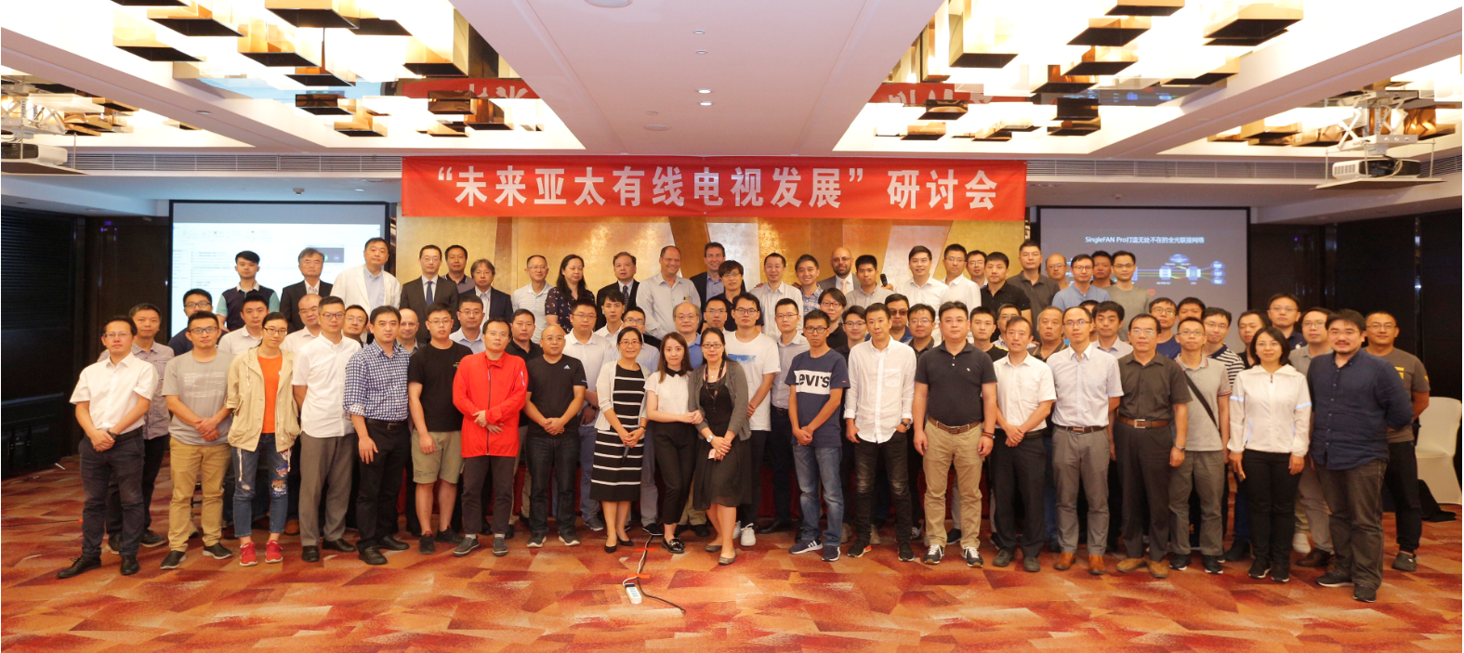

Figure 2 Group Photo from ITU Workshop on “The Future of Cable TV for Asia & Pacific”, 3 September 2019, Guangzhou, China

More photos are available [here](https://www.itu.int/ifa/t/2017/sg9/temp/).

# Collaboration with external organizations

SG9 has agreed on the appointment of SG9 liaison officers for the Study Period 2017-2020 as found in [SG9-TD523R3](https://www.itu.int/md/T17-SG09-190606-TD-GEN-0523/en).

SG9 also agreed to continue its involvement with two of the three Inter-sector Rapporteur Groups between ITU-T and ITU-R, as mentioned in the table below.

NOTE – As described in [SG9-TD523R3](https://www.itu.int/md/T17-SG09-190606-TD-GEN-0523/en), SG9 updated the IRG-IBB co-chair from SG9 as shown below.

|  |  |  |  |  |
| --- | --- | --- | --- | --- |
| **IRG** | **Title** | **Co-chair from SG9** | **Parent SGs** | **Website** |
| IRG-IBB | Integrated Broadcast-Broadband systems | Masayoshi Ohnishi (NHK, Japan) | ITU-R SG6 ITU-T SG16 | <https://itu.int/en/irg/ibb> |
| IRG-AVA | Audiovisual Media Accessibility | Pradipta Biswas (Indian Institute of Science, India) | ITU-R SG6 ITU-T SG16 | <https://itu.int/en/irg/ava> |

# Work programme

There are twenty-nine (29) draft new/revised Recommendations, Supplements and Technical Papers for progressing in ITU-T SG9.

| **Work item** | **Question** | **Status** | **Timing** | **Subject / Title** |
| --- | --- | --- | --- | --- |
| [J.cable-rf-ip](http://www.itu.int/itu-t/workprog/wp_item.aspx?isn=15165) | Q1/9 | Under study | 2020-09 | Requirements of cable network for RF and IP secondary distribution of television programmes |
| [J.1012 (ex J.dmcd-part3)](http://www.itu.int/itu-t/workprog/wp_item.aspx?isn=13992) | Q2/9 | Determined 2018-01-30 | 2018-11 | Embedded Common Interface (ECI) for exchangeable CA/DRM solutions; CA/DRM Container, Loader, Interfaces, Revocation |
| [J.1013 (ex J.dmcd-vm)](http://www.itu.int/itu-t/workprog/wp_item.aspx?isn=14179) | Q2/9 | Determined 2018-01-30 | 2018-11 | Embedded Common Interface (ECI) for exchangeable CA/DRM solutions; The Virtual Machine |
| [J.1014 (ex J.dmcd-eci-as)](http://www.itu.int/itu-t/workprog/wp_item.aspx?isn=14180) | Q2/9 | Determined 2018-01-30 | 2018-11 | Embedded Common Interface (ECI) for exchangeable CA/DRM solutions; Advanced Security - ECI-specific functionalities |
| [J.1015 (ex J.dmcd-kl-as)](http://www.itu.int/itu-t/workprog/wp_item.aspx?isn=14181) | Q2/9 | Determined 2018-01-30 | 2018-11 | Embedded Common Interface for exchangeable CA/DRM solutions; The Advanced Security system - Key Ladder Block |
| [J.1015.1 (ex J.dmcd-kl-as Annex A)](http://www.itu.int/itu-t/workprog/wp_item.aspx?isn=14935) | Q2/9 | Determined 2018-01-30 | 2018-11 | Embedded Common Interface (ECI) for exchangeable CA/DRM solutions; Advanced Security system - Key Ladder block: Authentication of control word-usage rules information and associated data 1 |
| [J.Suppl.7 (ex J.sup-eg)](http://www.itu.int/itu-t/workprog/wp_item.aspx?isn=14920) | Q2/9 | Under study | 2019 | Embedded Common Interface (ECI) for exchangeable CA/DRM solutions; ECI guide (EG) |
| [J.Suppl.8 (ex J.sup-te)](http://www.itu.int/itu-t/workprog/wp_item.aspx?isn=14921) | Q2/9 | Under study | 2019 | Embedded Common Interface (ECI) for exchangeable CA/DRM solutions; Trust Environment (TE) |
| [J.Suppl.9 (ex J.sup-val)](http://www.itu.int/itu-t/workprog/wp_item.aspx?isn=14922) | Q2/9 | Under study | 2019 | Embedded Common Interface (ECI) for exchangeable CA/DRM solutions; System Validation (VAL) |
| [J.dtc-dist-req](http://www.itu.int/itu-t/workprog/wp_item.aspx?isn=14182) | Q4/9 | Under study | 2020 | Television Content Distribution Platforms: Requirements for Open Access and Signal Quality |
| [Sup-digTV](http://www.itu.int/itu-t/workprog/wp_item.aspx?isn=13717) | Q4/9 | Under study | 2019 | Installing a digital TV service for cable networks and relating Recommendations |
| [J.acf-hrm](http://www.itu.int/itu-t/workprog/wp_item.aspx?isn=13722) | Q5/9 | Under study | 2019 | Harmonization of Integrated Broadcast-Broadband DTV application control framework |
| [J.stvos-hal](http://www.itu.int/itu-t/workprog/wp_item.aspx?isn=14924) | Q5/9 | Under study | 2020 | The HAL API of smart TV operating system |
| [J.stvos-sec](http://www.itu.int/itu-t/workprog/wp_item.aspx?isn=14923) | Q5/9 | Under study | 2020 | The security of smart TV operating system |
| [J.stvos-spec](http://www.itu.int/itu-t/workprog/wp_item.aspx?isn=15166) | Q5/9 | Under study | 2020 | The specification of smart TV operating system |
| [J.acs-stb](http://www.itu.int/itu-t/workprog/wp_item.aspx?isn=14927) | Q6/9 | Under study | 2020-03 | Functional Requirements for interface between Auto Configuration Server (ACS) and STB |
| [J.pcnp-smgw](http://www.itu.int/itu-t/workprog/wp_item.aspx?isn=14926) | Q6/9 | Under study | 2020-03 | Functional requirements for Smart Home Gateway |
| [J.fdx-fspec](http://www.itu.int/itu-t/workprog/wp_item.aspx?isn=15170) | Q7/9 | Under study | 2020-02 | Functional specification for in-band full-duplex in HFC based network |
| [J.ipvb-spec](http://www.itu.int/itu-t/workprog/wp_item.aspx?isn=15167) | Q7/9 | Under study | 2020-09 | Specifications of IP Video Broadcast (IPVB) for CATV Networks |
| [J.uoc](http://www.itu.int/itu-t/workprog/wp_item.aspx?isn=15168) | Q7/9 | Under study | 2020-09 | Unified Optical and Coaxial Platform for Cabinet-DOCSIS |
| [TP.fdx-asi](http://www.itu.int/itu-t/workprog/wp_item.aspx?isn=14928) | Q7/9 | Under study | 2019-06 | Analysis of the spectrum interference of In-band Full Duplex |
| [TP.ipvb-acc](http://www.itu.int/itu-t/workprog/wp_item.aspx?isn=14999) | Q7/9 | Under study | 2019-06 | Analysis of the cost and complexity of IPVB technology |
| [TP.ipvb-ucase](http://www.itu.int/itu-t/workprog/wp_item.aspx?isn=15169) | Q7/9 | Under study | - | User case and service scenario of IP Video Broadcast (IPVB) for CATV Networks |
| [J.qamip-req](http://www.itu.int/itu-t/workprog/wp_item.aspx?isn=14032) | Q8/9 | Under study | 2019-06 | Requirements on QAM to IP Conversion for IP Multi-Room/House Services |
| [J.1600 (ex J.pcnp-fmw)](http://www.itu.int/itu-t/workprog/wp_item.aspx?isn=14930) | Q9/9 | Consented 2019-06-13 | 2019-06 | Premium Cable Network Platform (PCNP) - Framework |
| [J.cable-ott](http://www.itu.int/itu-t/workprog/wp_item.aspx?isn=14931) | Q9/9 | Under study | 2020-02 | System architecture and interfaces between a cable television operator and an OTT service provider |
| [J.cloud-vr](http://www.itu.int/itu-t/workprog/wp_item.aspx?isn=15171) | Q9/9 | Under study | 2020-09 | Functional requirement of the cable network platform to deliver 360/VR video services |
| [TP.b-catv](http://www.itu.int/itu-t/workprog/wp_item.aspx?isn=14932) | Q9/9 | Under study | 2020-02 | Broadband CATV system using server-side reception and processing |
| [J.1](http://www.itu.int/itu-t/workprog/wp_item.aspx?isn=15172) | Q10/9 | Under study | - | Terms, definitions and acronyms for television and sound transmission and integrated broadband cable networks |

# Future meetings

The next (fifth) SG9 meeting is currently planned to take place in April 2020 in the Asian region. TSB is currently discussing with Japan for possibly hosting the meeting. The date is TBD.

__________________