|  |  |  |  |  |
| --- | --- | --- | --- | --- |
| ITU logo | INTERNATIONAL TELECOMMUNICATION UNION  **TELECOMMUNICATION STANDARDIZATION SECTOR**  STUDY PERIOD 2017-2020 | | | TSAG-TD728 |
| TSAG |
| **Original: English** |
| **Question(s):** | | | N/A | Geneva, 10-14 February 2020 |
| **TD** | | | | |
| **Source:** | | | TSB | |
| **Title:** | | | ITU-T Environment and Smart Sustainable Cities: Year in Review and Upcoming Activities for 2019-2020 brochure | |
| **Purpose:** | | | Information | |
| **Contact:** | | Cristina Bueti  TSB | | Tel: +41 22 730 6301 E-mail: [cristina.bueti@itu.int](mailto:cristina.bueti@itu.int) |

|  |  |
| --- | --- |
| **Keywords:** | ITU-T; environment; smart sustainable cities; SG5; SG20; FG-AI4EE; U4SSC; |
| **Abstract:** | This TD contains the ITU-T Environment and Smart Sustainable Cities: Year in Review and Upcoming Activities for 2019-2020 brochure. |

[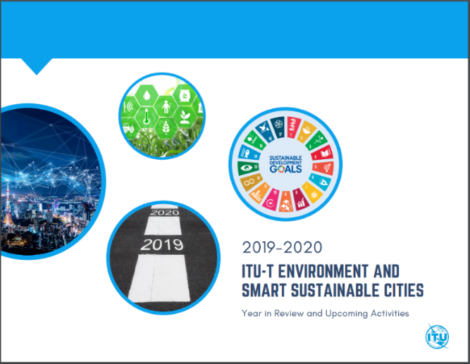](https://www.itu.int/en/ITU-T/climatechange/Documents/Year%20in%20Review/year-in-review-and-upcoming-activities-2019-2020.pdf)We would like to share with you our new [**“Year in Review and Upcoming Activities”**](https://www.itu.int/en/ITU-T/climatechange/Documents/Year%20in%20Review/year-in-review-and-upcoming-activities-2019-2020.pdf) for 2019-2020 brochure.

It provides a comprehensive overview of our diverse **activities advocating the progressive use of digital technologies** to:

* Help curb climate change
* Protect the environment
* Foster smart sustainable cities all around the world
* Encourage circularity as a fundamental building

We hope you will find it an informative read and we look forward to engaging with you once again on all these, plus new endeavours in 2020!

__________________