 | INTERNATIONAL TELECOMMUNICATION UNION  TELECOMMUNICATION  STANDARDIZATION SECTOR  STUDY PERIOD 2017-2020 |  | TSAG-TD1015
 |  |  | TSAG
 |  |  | Original: English
Question(s): |  | N/A | Virtual, 11-18 January 2021
TD
Source: |  | TSB
Title: |  | Current and next Study Period designation
Purpose: |  | Information
Contact: |  | Bilel Jamoussi  Chief of ITU-T Study Group Department |  | Tel: +41 22 730 6311  E-mail: bilel.jamoussi@itu.int
Contact: |  | Simão Campos  Counsellor, Study Group Department |  | E-mail: simao.campos@itu.int

Keywords: | ITU-T Study Period;
Abstract: | Historical data concerning identification of the study period (SP) ranges point to designating the current study period (SP16) planned to end 9 March 2022 as 2016-2021; and the next study period (SP17) planned to end in the 2nd half of 2024 as 2022-2024. Despite 2017-2021 being now the official year range for SP16, for best business continuity, documentation will continue to bear the range 2017-2020, and existing IT resources will continue to use the same SP range until the end of SP16.

Background
TSB investigated the issues concerning the designation of the study periods and identified a practical way forward concerning the identification of the study periods no.16 (current) and 17 (next).
Table 1 provides a summary of all CCITT and ITU-T study periods (SPs) and the respective assemblies and conferences. For simplicity, we refer to Assemblies hereinafter to designate the CCITT and ITU-T Assemblies and Conferences.
Assemblies have historically taken place every four years in their 2nd half. Exceptions to the 2nd year-half pattern were the IIIrd Plenary Assembly of the CCITT in June 1964 and the First World Telecommunication Standardization Conference (WTSC-93) in March 1993. Another exception was the Special Assembly during the 1st study period. Due to the COVID-19 pandemic, WTSA-20 will also be an exception in both the time spacing and the year-half it takes place.

When does the study period start and end?
The boundary of a study period is defined by the Assembly closing date.
However, as it can be observed in Table 1, the designation of the study period year range in the documentation follows a rounding pattern, depending on the half of the year that the assembly took place. Other codes used in ITU databases, systems and webpages are derived from this range.
- The start year for SPs with Assemblies in the 2nd year-half are labeled as the year after their closing.
- The end year for SPs with Assemblies in the 2nd year-half are labeled as same the year their closing.
- The start year for SPs with Assemblies in the 1st year-half are labeled with the same year of their closing.
- The end year for SPs with Assemblies in the 1st year-half are labeled with the year preceding their closing.
Examples:
- 2nd year-half rule: WTSA-12 for SP14 closed in November 2012. Accordingly, the range for SP14 was 2008-2012 and the range for SP15 it is 2013-2016., which is used in the header of documents for that SP. Additionally, the respective DMS code is T13 and the URL for the study group home pages have 2013-2016 in its path (e.g. https://www.itu.int/en/ITU-T/studygroups/2013-2016/16).
- 1st year-half rule: WTSC-93 for SP9 closed in March 1993. Accordingly, the range for SP9 was 1989-1992 and the range for SP10 was 1993-1996. Documentation used this range, as illustrated in Figure 1 for SP9 and Figure 2 for SP10.
Accordingly, assuming that WTSA-20 will take place in March 2022 and that the subsequent Assembly would take place in the 2nd half of 2024 (or 1st half of 2025), the following ranges would apply for SP16 and SP17:
- SP16: End on 9 March 2022. Year range 2017-2021. DMS code: T17 (already in place)
- SP17: Start on 10 March 2022. Year range 2022-2024. DMS code: T22

Practicalities
Considering that documentation and IT systems for SP16 have been in place for four years already, there is a substantial amount of documentation and cross-linked resources that used the historically presumed study period duration of four years, namely 2017-2020. Updates to existing systems could consume a good amount of time and resources, and still be prone to unresolved resources (e.g., broken document links).
Therefore, it is impractical to change for this exceptional, approximately one-year long transition period how documentation and IT systems refer to the range for usage.
Accordingly, it is proposed to keep unchanged IT resources (such as webpage URLs, templates, existing documentation and databases) related to SP16 until the end of the study period. That is, they will continue to use the study period range 2017-2020 till the end of SP16.
These measures, in addition to facilitate business continuity, will serve as remembrance and homage in the future to those that suffered the difficulties and losses brought by the pandemic.

Conclusion
Based on the historical data, the following will be applied:
- Under the assumption WTSA-20 will take place in March 2022 and that the subsequent Assembly would take place in the 2nd half of 2024 (or 1st half of 2025), the following ranges would apply for SP16 and SP17:
- SP16: End on 9 March 2022. Year range 2017-2021. DMS code: T17 (already in place)
- SP17: Start on 10 March 2022. Year range 2022-2024. DMS code: T22
- Designation of the study period range for the current period (SP16) will be kept as 2017-2020 in the various existing documents and documents to be produced in the period from now till the end of the study period.
- Existing online resources will be kept as they currently are till the end of the current study period.
Figure 1– Example of document header in SP9
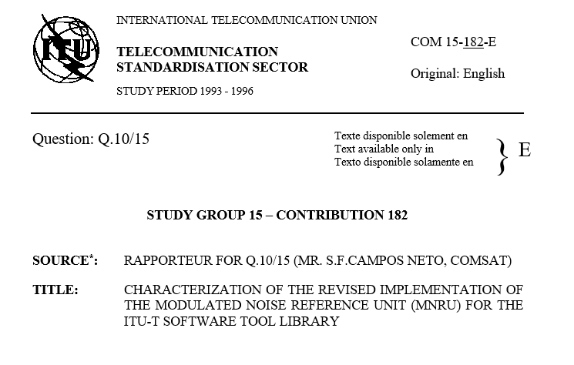
Figure 2 – Example of document header in SP10

Table 1 – CCITT and ITU-T study periods and respective Assemblies and Conferences
SP number | SP range* | Start date  (dd.mm.yyyy) | End date  (dd.mm.yyyy) | Colour | DMS, IFA, MLs** | Event | Date | Location
1 | 1956-1960 | 21.12.1956 | 16.12.1960 | R | – | Ist Plenary Assembly of the CCITT | 10-20 December 1956 | Geneva, Switzerland
 |  |  |  |  |  | Special Assembly | 22-27 September 1958 | Geneva, Switzerland
2 | 1961-1964 | 17.12.1960 | 26.06.1964 | B | – | IInd Plenary Assembly of the CCITT | 8-16 December 1960 | New Delhi, India
3 | 1965-1968 | 27.06.1964 | 25.10.1968 | W | – | IIIrd Plenary Assembly of the CCITT | 15-26 June 1964 | Geneva, Switzerland
4 | 1969-1972 | 26.10.1968 | 15.12.1972 | G | – | IVth Plenary Assembly of the CCITT | 14-25 October 1968 | Mar del Plata, Argentina Lt.
5 | 1973-1976 | 16.12.1972 | 08.10.1976 | O | – | Vth Plenary Assembly of the CCITT | 4-15 December 1972 | Geneva, Switzerland
6 | 1977-1980 | 09.10.1976 | 21.11.1980 | Y | – | VIth Plenary Assembly of the CCITT | 27 September – 8 October 1976 | Geneva, Switzerland
7 | 1981-1984 | 22.11.1980 | 19.10.1984 | R | – | VIIth Plenary Assembly of the CCITT | 10-21 November 1980 | Geneva, Switzerland
8 | 1985-1988 | 20.10.1984 | 25.11.1988 | B | – | VIIIth Plenary Assembly of the CCITT | 8-19 October 1984 | Málaga-Torremolinos, Spain
9 | 1989-1992 | 26.11.1988 | 12.03.1993 | W | – | IXth Plenary Assembly of CCITT | 14-25 November 1988 | Melbourne, Australia
10 | 1993-1996 | 13.03.1993 | 18.10.1996 | G | – | First World Telecommunication Standardization Conference - WTSC-93 | 1-12 March 1993 | Helsinki, Finland
11 | 1997-2000 | 19.10.1996 | 06.10.2000 | O | – | WTSC-96 | 9-18 October 1996 | Geneva, Switzerland
12 | 2001-2004 | 07.10.2000 | 14.10.2004 | Y | T01 | WTSA-2000 | 27 September – 6 October 2000 | Montréal, Canada
13 | 2005-2008 | 15.10.2004 | 30.10.2008 | R | T05 | WTSA-04 | 5-14 October 2004 | Florianópolis, Brazil
14 | 2009-2012 | 31.10.2008 | 29.11.2012 | B | T09 | WTSA-08 | 21-30 October 2008 | Johannesburg, South Africa
15 | 2013-2016 | 30.11.2012 | 03.11.2016 | W | T13 | WTSA-12 | 20-29 November 2012 | Dubai, UAE
16 | 2017-2020 | 04.11.2016 | 09.03.2022 TBC | G | T17 | WTSA-16 | 25 October – 3 November 2016 | Hammamet, Tunisia
NOTES:
* The Study Period range is used in the header of documentation (Contributions, TDs, etc) to identify the study period, as well as in various IT systems (e.g. URL path for study group home pages and collaboration sites).
** DMS: Document Management System (where SG and WP meeting documents are stored); IFA: informal FTP area; MLs: mailing lists.

__________________

